Reference: BJN-2011-016547: Cholesterol lowering efficacy of a microencapsulated BSH-active Lactobacillus reuteri NCIMB 30242 yogurt formulation in hypercholesterolemic adults
Appendix A: Supplemental Data:
Analysis #1: Cell viability of free and APA microencapsulated L. reuteri NCIMB 30242 in simulated upper GI tract conditions:
Free and APA microencapsulated L. reuteri NCIMB 30242 were analysed for cell viability after sequential incubation in simulated gastric fluid (SGF) and simulated intestinal fluid (SIF). L. reuteri NCIMB 30242 was microencapsulated in an alginate-poly-L-lysine-alginate membrane as described ⁽¹⁾. SGF and SIF were based on the standard U.S. Pharmacopeia solutions for simulated gastric fluid (pH 1.2 + 0.32% w/v pepsin) and simulated intestinal fluid (pH 6.8 + 1.0% w/v pancreatin). Free and APA microencapsulated L. reuteri NCIMB 30242 were incubated in SGF for 120 minutes followed by SIF for 300 minutes. Cell viability was measured after 0 and 120 minutes exposure to SGF, and after an additional 30, 60, 120, 240 and 300 minutes exposure to SIF.
The cell viability of free and APA microencapsulated L. reuteri NCIMB 30242 when exposed to sequential SGF and SIF conditions is shown in Figure 1. The initial cell viability of APA microencapsulated L. reuteri NCIMB 30242 was 1.15 x 10⁹ CFU/g, after 120 minutes exposure to SGF it was 1.05 x 10⁷ CFU/g, and after 420 minutes exposure to SGF and SIF it was 2.40 x 10⁷ CFU/g. In comparison, initial cell viability of free L. reuteri NCIMB 30242 was 1.35 x 10⁹ CFU/g, after 120 minutes exposure to SGF it was 1.57 x 10⁵ CFU/g, and after 420 minutes exposure to SGF and SIF it was 6.00 x 10⁵ CFU/g. These results confirm that APA microencapsulation of L. reuteri NCIMB 30242 improves cell survival by ~1.9 log units, as compared to free L. reuteri NCIMB 30242, when exposed to SGF at pH 1.2 + 0.32% pepsin for 120 minutes. After transfer to SIF, at pH 6.8 + 1.0% pancreatin, no further losses were observed over an additional 300 minute exposure time. Further, the pH of human gastric juice has been reported to be in the range of 1.35 to 3.5 ⁽²⁾ and in other experiments, APA microencapsulated L. reuteri NCIMB 30242 were exposed to SGF at pH 2.0 and showed little loss in viability after 120 minutes (data not shown). Therefore, it was postulated that the cell viability of APA microencapsulated L. reuteri NCIMB 30242 would be retained at efficacious levels when exposed to the upper GI tract of humans and that microencapsulation was an important component for maintaining cell viability above an efficacious threshold. In conclusion, a cell viability >10⁷ CFU/g is maintained through passage in simulated upper GI conditions and a dose of 10g of microcapsules will deliver >10⁸ CFU/dose to the site of action.

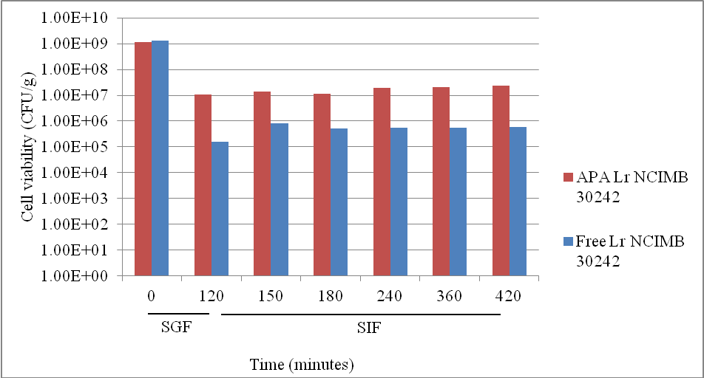
Figure 1: shows the cell viability of APA microencapsulated L. reuteri NCIMB 30242 and free L. reuteri NCIMB 30242 when exposed to sequential simulated gastric fluid (SGF), at pH 1.2 + 0.32% w/v pepsin, for 120 minutes and simulated intestinal fluid (SIF), at pH 6.8 + 1.0% w/v pancreatin, for 300 minutes.
Analysis #2: Bile salt hydrolase activity of free and microencapsulated L. reuteri NCIMB 30242 in simulated upper GI tract conditions:
Free and APA microencapsulated L. reuteri NCIMB 30242 were analysed for bile salt hydrolase (BSH) activity after sequential incubation in simulated gastric fluid (SGF) and simulated intestinal fluid (SIF). L. reuteri NCIMB 30242 was microencapsulated in an alginate-poly-L-lysine-alginate membrane, as described ⁽¹⁾. SGF and SIF were based on the standard U.S. Pharmacopeia solutions for simulated gastric fluid (pH 1.2 + 0.32% w/v pepsin) and simulated intestinal fluid (pH 6.8 + 1.0% w/v pancreatin). For the assessment of BSH activity, approximately 1 x 10⁹ CFU of either free L. reuteri NCIMB 30242 or APA microencapsulated L. reuteri NCIMB 30242 were incubated in 20ml of de Mann, Rogosa and Sharpe (MRS) media supplemented with 5mM sodium glycodeoxycholate (GDCA) and 5mM sodium taurodeoxycholate (TDCA). Incubation was performed anaerobically at 37°C and supernatant sampling occurred after 0, 2.5, 5.0 and 7.5 hours for the determination of conjugated bile acid concentrations in the reaction vessels. Supernatant samples (500µl) were acidified with 6N HCl (5µl) after removing residual bacteria cells by centrifugation at 10,000g for 3 minutes. Supernatant samples were then supplemented with methanol (500µl) containing 4mM GCA (glycocholic acid) as internal standard. Samples were vortexed for 10 minutes and centrifuged at 1,000g for 15 minutes. The samples were filtered through a 0.45µM filter before being analysed by HPLC. HPLC analysis of bile acids followed the procedure described by Jones et al. ⁽³⁾.
The BSH activity, expressed as the disappearance of glycodeoxycholate (GDCA) over time of free or APA microencapsulated L. reuteri NCIMB 30242, prior to SGF or SIF exposure, post-exposure to SGF for 120 minutes and post-exposure to SGF for 120 minutes and SIF for 300 minutes is shown in Figure 2. When APA microencapsulated L. reuteri NCIMB 30242 was added to physiologically relevant levels of bile acid, 0.00 mM, 0.28 mM and 0.02 mM GDCA remained after 2.5 hours, prior to SGF exposure, post-SGF exposure and post-SGF and SIF exposure, respectively. In comparison, when free L. reuteri NCIMB 30242 was added to physiologically relevant levels of bile acid, 0.65 mM, 4.63 mM and 3.96 mM GDCA remained after 2.5 hours, prior to SGF exposure, post-SGF exposure and post-SGF and SIF exposure, respectively. Thus, APA microencapsulated L. reuteri NCIMB 30242 showed no significant loss in enzymatic activity after sequential exposure to SGF for 120 minutes and SIF for 300 minutes. In contrast, free L. reuteri NCIMB 30242 showed significant losses of BSH activity post-exposure to SGF for 120 minutes. Therefore, BSH activity of APA microencapsulated L. reuteri NCIMB 30242 is maintained when exposed to simulated upper GI conditions, confirming previous results on APA microencapsulated BSH active Lactobacillus^{(1,4)}.
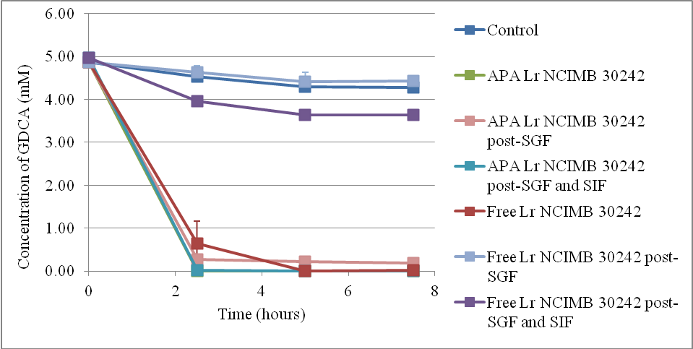
Figure 2: shows the bile salt hydrolase activity, expressed as the disappearance of glycodeoxycholate (GDCA) over time, of APA microencapsulated L. reuteri NCIMB 30242 or free L. reuteri NCIMB 30242 prior to simulated gastric fluid (SGF) or simulated intestinal fluid (SIF) exposure, post-exposure to SGF, at pH 1.2 + 0.32% w/v pepsin, for 120 minutes and post-exposure to SGF, at pH 1.2 + 0.32% w/v pepsin, for 120 minutes and SIF, at pH 6.8 + 1.0% w/v pancreatin, for 300 minutes.
In summary, these data are in line with previous published work ^{(1,4)} on the viability and BSH enzymatic activity of Lactobacillus in simulated upper GI conditions and confirm that both the survival and BSH enzymatic activity of L. reuteri NCIMB 30242 can be maintained by APA microencapsulation in the upper GI tract of humans.
References

1. Martoni C, Bhathena J, Urbanska AM et al. (2008) Microencapsulated bile salt hydrolase producing Lactobacillus reuteri for oral targeted delivery in the gastrointestinal tract. Applied Microbiology and Biotechnology 81, 225-233.
2. Marieb E & Hoehn K (2010) Human anatomy & physiology. San Francisco: Benjamin Cummings.
3. Jones ML, Chen HM, Wei OY et al. (2004) Microencapsulated genetically engineered Lactobacillus plantarum 80 (pCBH1) for bile acid deconjugation and its implication in lowering cholesterol. Journal of Biomedicine and Biotechnology 1, 61-69.
4. Martoni C, Bhathena J, Jones ML et al. (2007) Investigation of microencapsulated BSH active Lactobacillus in the simulated human GI tract. Journal of Biomedicine and Biotechnology DOI: 10 1155/2007/13684.

