Cell viability analysis
Material and Method
HUVEC were seeded and allowed to proliferate until they reached 60-70% confluence. The medium was then replaced to expose HUVEC for 24 h to an experimental medium containing either flavonone aglycones or metabolites both at 10 µM or a flavanone-free control solution (0.5‰ ethanol). Cell viability was assessed by Hoechst 33342 reagent assay (Sigma) [1]. Briefly, wells were rinsed using PBS 1X, 500 µl of Hoechst (2 µg/ml in PBS) was added and incubated for further 30 min at 37°C. Plates were read by a microplate fluorescent reader (Bio-Tek Instruments, Winooski, VT, USA) at 360 nm (excitation) and 460 nm (emission) wavelengths.

Result
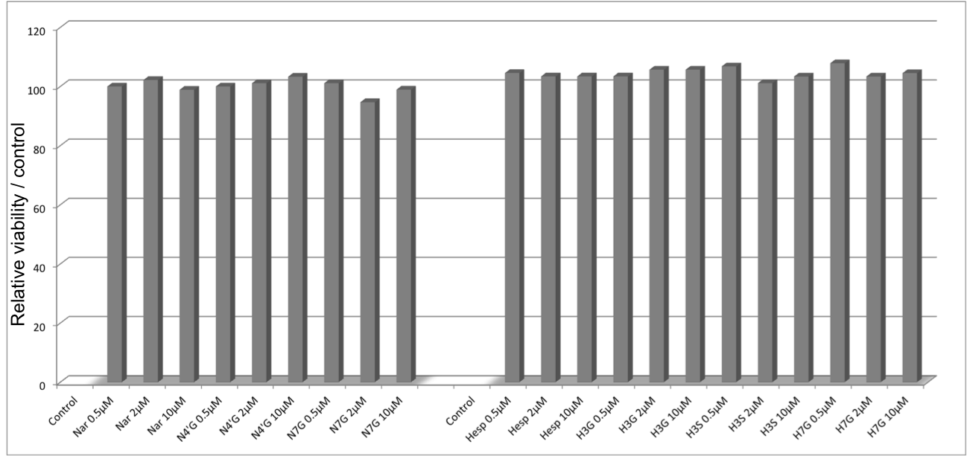
Flavanones and their conjugated metabolites (supplemental figure S1) at 10 µM did not significantly influence cell viability compared to flavanone-free control solution. In subsequent experiments, these compounds were used at 0.5, 2 and 10 µM.
Figure: Viability assays with 0.5, 2 and 10µM of flavanones: naringenin, naringenin-7-glucuronide, hesperetin, hesperetin-3’-glucuronide, hesperetin-3’-sulfate and hesperetin-7-glucuronide.

[1] Trzeciakiewicz A, Habauzit V, Mercier S, Barron D, Urpi-Sarda M, Manach C, Offord E, Horcajada MN: Molecular mechanism of hesperetin-7-O-glucuronide, the main circulating metabolite of hesperidin, involved in osteoblast differentiation. J Agric Food Chem 2010, 58(1):668-675.

