Fig. 1. LC chromatograms of extracts obtained from the quebracho-supplemented diet (a) and the control diet (b) (wavelength: 214 nm)
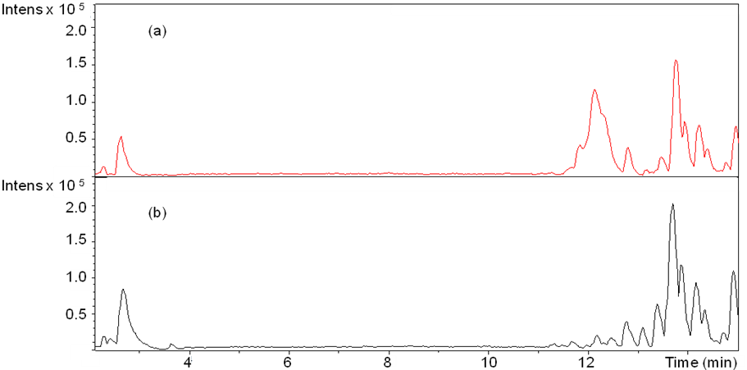

Fig. 2. LC chromatogram (wavelength: 214 nm) (a) and LC-MS extracted ion chromatograms for m/z (M-H⁻) = 561·15 (b), 833·20 (c) and 1105·29 (d) from extracts of the quebracho-enriched diet.
Fig. 3: Possible assignments of profisetinidins that were detected in the LC-MS chromatograms of extracts from the quebracho-enriched diet

Chemical Formula : C₁₅H₁₀O₆
Exact Mass: 285.046 (fisetin)
Chemical Formula : C₃₀H₂₆O₁₁  Exact Mass: 562.150 (profisetinidindimer) | Chemical Formula : C₄₅H₃₈O₁₆  Exact Mass: 834.223 (profisetinidintrimer)
n =2 Chemical Formula : C₆₀H₅₀O₂₁
Exact Mass: 1106·293

Fig. 4. LC-chromatogram (a) and extracted ion chromatogram for m/z (M-H⁻) = 285·046 (b) from quebracho-enriched diet (wavelength: 214 nm)
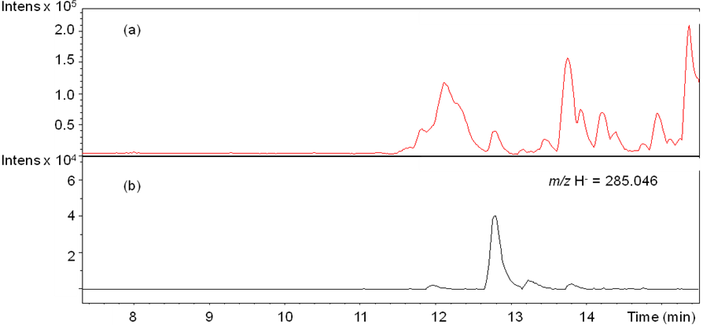

Fig 5. LC-chromatogram (wavelength: 214 nm) of a liver sample from one lamb from the control + quebracho tannin (C+T) group (a) and of a liver sample from one lamb from the control (C) group (b).
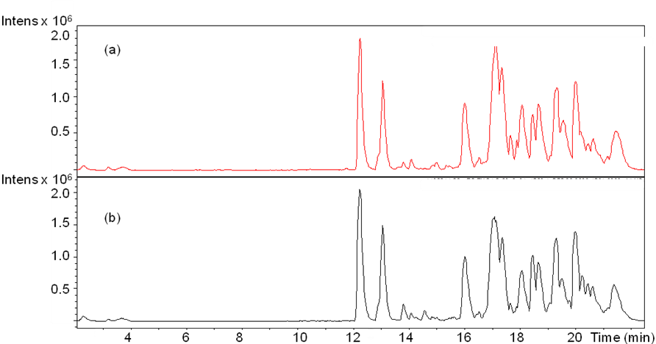

Fig 6. LC-chromatogram (wavelength: 214 nm) of a plasma sample from one lamb from the C+T group (a) and of a plasma sample from one lamb from the C group (b).

