Online Supplemental Material
Supplemental Table 1 Example of experimental meals in the first week
LC group | CR group
Breakfast
Boiled egg 2  Cucumber 200 g  Lactalbumin 15 g  Black sesame 5 g | Boiled egg 1  Cucumber 200 g  Steamed bread 50 g
Lunch
Steamed bream 220 g  Leaf lettuce 250 g  Lettuce stem 100 g  Plant oil 25 g | Steamed bream 100 g  Leaf lettuce 250 g  Lettuce stem 100 g  Rice 65 g  Plant oil 10 g
Super
Duck leg 220 g  Shii-take mushroom 2  Green vegetables 250 g  Eggplant 150 g  Plant oil 20 g | Duck leg 100 g  Shii-take mushroom 2  Green vegetables 250 g  Eggplant 150 g  Rice 60 g  Plant oil 10 g
Snack
Boiled egg, cucumber, tomato ( ad libitum ) | None
CR, calorie-restricted; LC, low-carbohydrate.
∗ Dietary design is similar for the CR group in the remaining 11 week, while in LC group, steam bread or rice was gently increased weekly, and plant oil was reduced accordingly.
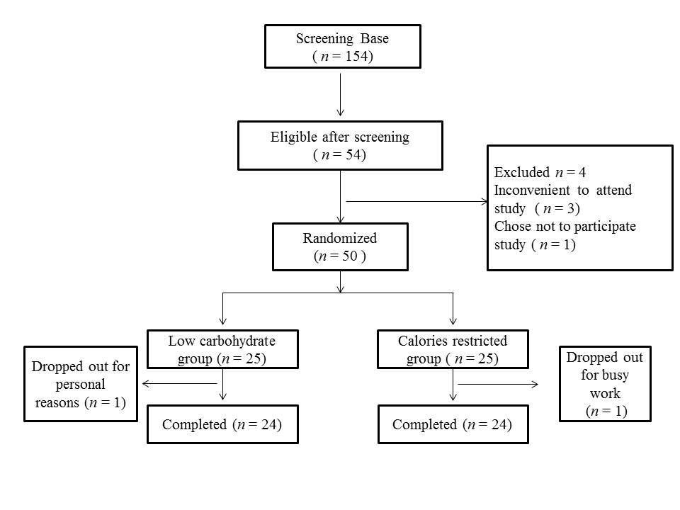
Supplemental Figure 1 Study flow diagram

