Online Supplemental Material

Supplemental Table 1 Ingredients and nutrient composition of the four experimental diets containing high or low concentrations of fermentable carbohydrates (fCHO) or fermentable protein (fCP).
 | low fCP |  |  | high fCP
Item | low  fCHO | high  fCHO |  | low  fCHO | high  fCHO
Ingredients | g/kg as fed
Corn | 402 | 261 |  | 563 | 420
Wheat | 400 | 400 |  | 50 | 50
Soybean meal (44% CP) | 120 | 120 |  | 120 | 120
Heat-treated soybean meal* | - | - |  | 200 | 200
Wheat bran | - | 80 |  | - | 80
Sugar beet pulp | - | 50 |  | - | 50
Monocalcium Phosphate | 20 | 16 |  | 20 | 18
Limestone | 19 | 19 |  | 18 | 18
Soybean oil | 10 | 25 |  | 10 | 25
Vitamin/Mineral premix† | 15 | 15 |  | 15 | 15
Salt | 1∙5 | 1∙5 |  | 1∙5 | 1∙5
L-Lysine HCl | 6∙0 | 5∙8 |  | 0∙2 | -
DL-Methionine | 1∙5 | 1∙5 |  | 0∙5 | 0∙5
L-Threonine | 2∙0 | 2∙0 |  | - | -
L-Tryptophan | 1∙0 | 1∙0 |  | - | -
TiO₂ | 2∙0 | 2∙0 |  | 2∙0 | 2∙0
Nutrient composition | g/kg dry matter
Dry matter | 886 | 889 |  | 885 | 887
Crude Protein | 145 | 148 |  | 198 | 201
SID‡ Lysine | 9∙9 | 9∙9 |  | 9∙8 | 9∙7
SID Methionine | 3∙4 | 3∙4 |  | 3∙3 | 3∙2
SID Threonine | 6∙3 | 6∙2 |  | 6∙9 | 6∙3
SID Tryptophan | 2∙4 | 2∙5 |  | 2∙2 | 2∙3
Calcium | 11∙2 | 11∙1 |  | 11∙5 | 11∙7
P | 7∙5 | 7∙4 |  | 8∙0 | 8∙3
Na | 2∙5 | 2∙7 |  | 2∙6 | 2∙7
Total dietary fiber | 145 | 166 |  | 145 | 180
Insoluble dietary fiber | 101 | 130 |  | 110 | 151
Soluble dietary fiber | 44 | 36 |  | 35 | 29
Starch | 488 | 413 |  | 392 | 315
ME MJ/kg | 13∙0 | 12∙7 |  | 13∙0 | 12∙7
* Steam autoclaved at 124 ˚C for 20 min.
† Mineral and Vitamin Premix (Spezialfutter Neuruppin Ltd., Neuruppin, Germany), containing per kg dry matter: 130 g Sodium (as sodium chloride), 55 g Magnesium (as magnesium oxide), 210 mg Retinol, 3,000 µg, Vitamin D3, 8,000 mg DL-α-Tocopherol, 300 mg Menadione, 250 mg Thiamine, 250 mg Riboflavine, 400 mg Vitamin B6, 2,000 µg Vitamin B12, 2,500 Nicotinic acid, 100 mg Folic acid, 25,000 µg Biotin, 1,000 mg Pantothenate, 80,000 mg Choline chloride, 5,000 mg Iron (as Iron-(II)-carbonate), 1,000 mg Copper (as Copper-(II)- sulfate), 5,000 mg Zinc (as Zinc oxide), 6,000 mg Manganese (as Manganese-(II)-oxide), 45 mg Iodine (as Calcium-iodate), 35 mg Selenium (as Sodium-selenite).
‡ SID = Standardized Ileal Digestible

Online Supplemental Material

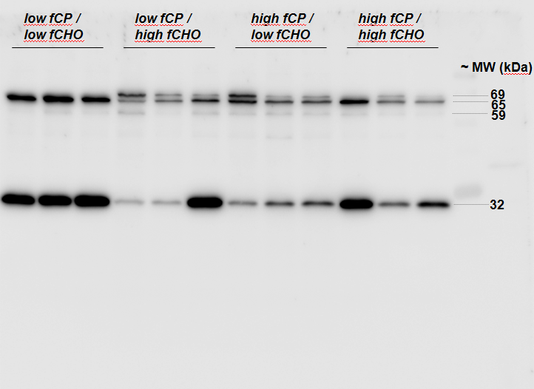
Supplemental Figure 1 Sample Western blot for occludin; samples from distal colon mucosa; membrane fraction

