Supplementary data:
Age dependent effects of cord blood LC-PUFA composition on BMI during the first ten years of life.
Marie Standl, Elisabeth ThieringError: Reference source not found,, Hans Demmelmair², Berthold Koletzko², Joachim HeinrichError: Reference source not found

Correspondence:
Marie Standl
Helmholtz Zentrum München - German Research Centre for Environmental Health
Institute of Epidemiology I
Ingolstädter Landstr. 1
85764 Neuherberg
Germany.
Tel.: +49 89 31872952
Fax: +49 89 31873380
E-mail: marie.standl@helmholtz-muenchen.de

Table S1 Comparison of all investigated variables between study participants and non-participants. Values are mean (sd) for continuous variables or % for categorical variables.
 | Non-participating (N=1077) | Participating (N=388) |  | p-value
 | Mean (sd) or %
Sex [female] | 49% | 44% |  | 0.0859¹
Maternal BMI | 22.3 (3.7) | 22.2 (3.4) |  | 0.8333²
Birth weight [g] | 3430 (441) | 3429 (391) |  | 0.9604³
Excl. Breastfeeding >4m | 49% | 49% |  | 0.8571¹
zBMI
2y | 0.4 (1) | 0.3 (1) |  | 0.2482³
6y | 0 (0.9) | 0 (0.9) |  | 0.6681³
10y | 0 (1) | 0 (1) |  | 0.7349³
n-6 LC-PUFA†
Cord blood | 25.1 (1.5) | 25.2 (1.6) |  | 0.4245³
2y | 13.2 (1.5) | 13.4 (1.6) |  | 0.2697³
6y | 13.6 (1.5) | 13.7 (1.6) |  | 0.5937³
10y | 15 (1.8) | 15 (1.6) |  | 0.9482³
n-3 LC-PUFA†
Cord blood | 8.2 (1.6) | 8.1 (1.6) |  | 0.4389³
2y | 4.6 (1) | 4.6 (0.9) |  | 0.7108³
6y | 4.5 (1) | 4.5 (1) |  | 0.5156³
10y | 5 (1.2) | 4.9 (1.2) |  | 0.6010³
n-6/n-3 ratio†
Cord blood | 3.2 (0.7) | 3.2 (0.7) |  | 0.4125³
2y | 3 (0.5) | 3 (0.6) |  | 0.3294³
6y | 3.1 (0.5) | 3.1 (0.6) |  | 0.7887³
10y | 3.2 (0.6) | 3.2 (0.6) |  | 0.6360³
Differences are tested using (¹) Fisher’s exact test for binary variables, (²) Wilcoxon rank sum test for continuous, not normally distributed variables and (³) two sample t-test for normally distributed variables.
† measured in serum glycerophospholipids
Figure S1 Interaction effect between n-6 LC-PUFA concentrations measured in serum glycerophospholipids in (A) cord blood and (B) at follow-up with time of follow-up (2y, 6y or 10y) on zBMI. Estimates derived from linear mixed models on zBMI (see Table 3). The solid line represents the effect; the dashed lines represent the corresponding 95% confidence interval.
A.
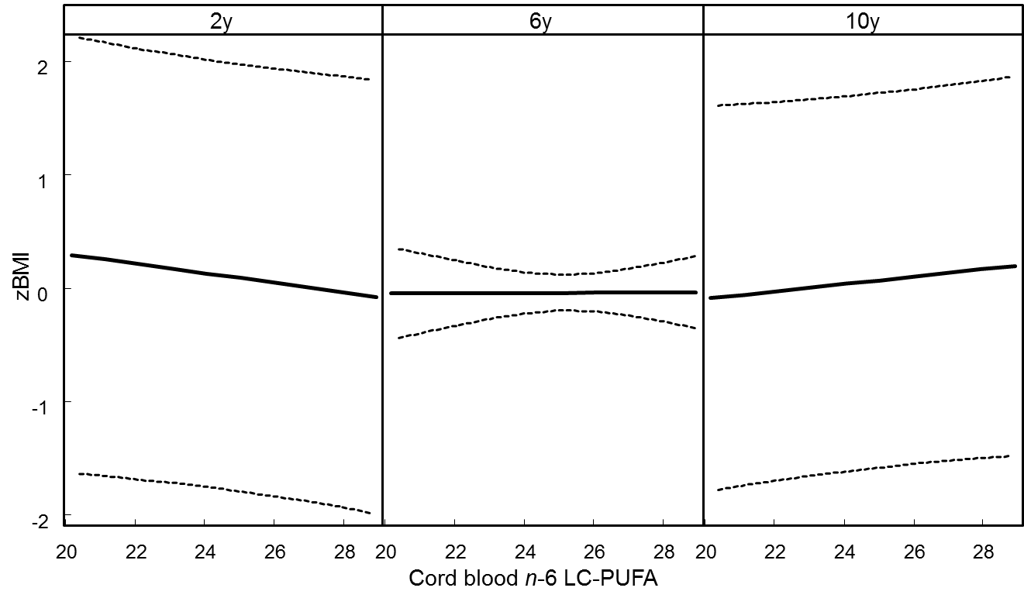
p-value of interaction= 0.1764
B.
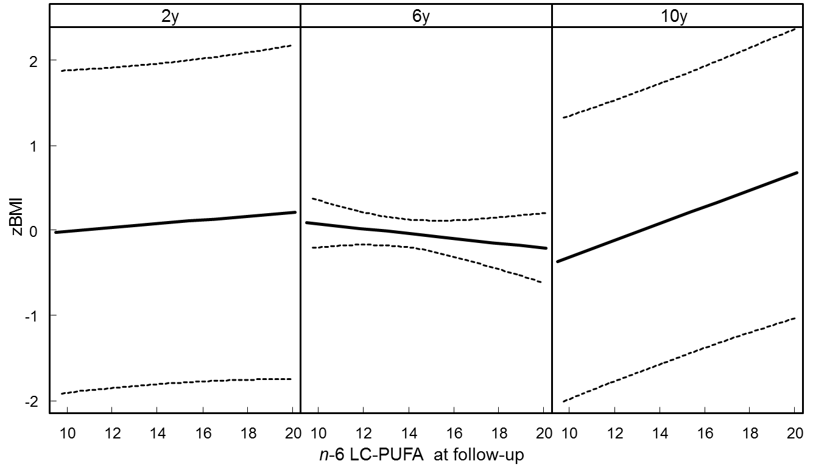
p-value of interaction=0.0009
Figure S2 Interaction effect between n-3 LC-PUFA concentrations measured in serum glycerophospholipids in (A) cord blood and (B) at follow-up with time of follow-up (2y, 6y or 10y) on zBMI. Estimates derived from linear mixed models on zBMI (see Table 3). The solid line represents the effect; the dashed lines represent the corresponding 95% confidence interval.
A.
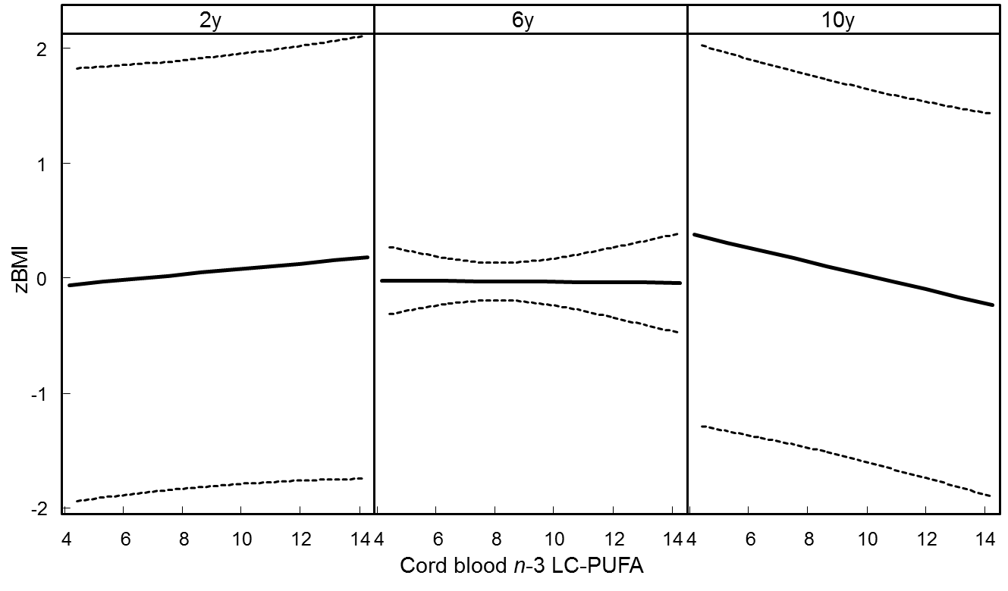
p-value of interaction=0.1870
B.
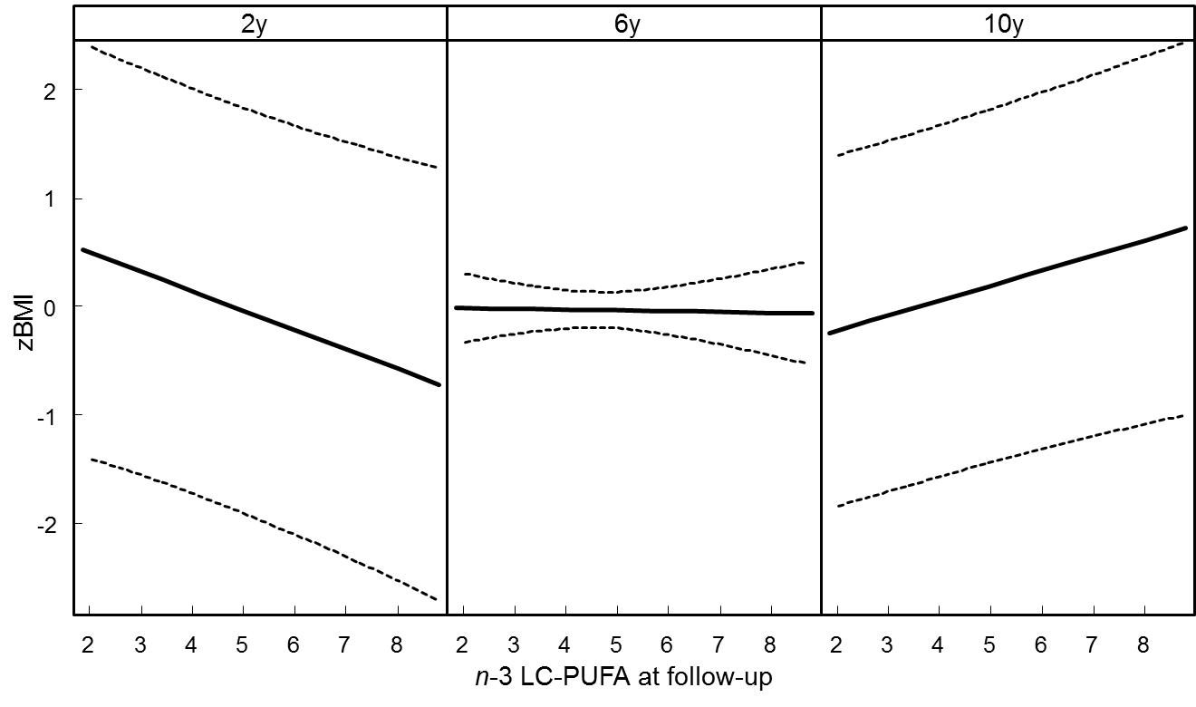
p-value of interaction=0.0028
Figure S3 Interaction effect between n-6/n-3 ratio measured in serum glycerophospholipids at follow-up with time of follow-up (2y, 6y or 10y) on zBMI. Estimates derived from linear mixed models on zBMI (see Table 3). The solid line represents the effect; the dashed lines represent the corresponding 95% confidence interval.
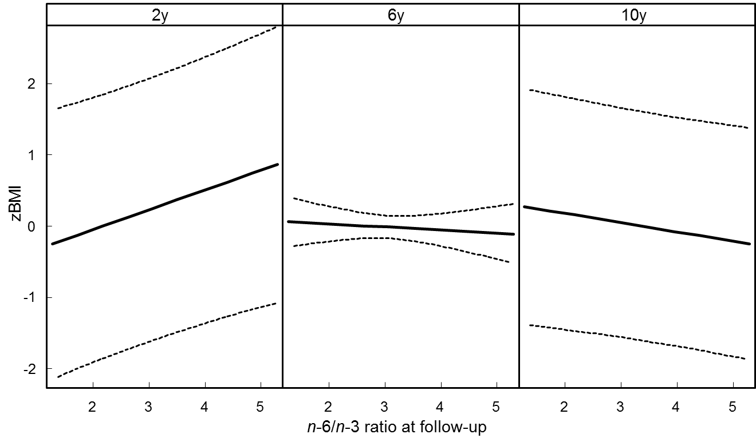
p-value of interaction=0.1356
Table S2 Results of linear regression models stratified for each follow-up in which n-6, n-3 LC-PUFA composition and the n-6/n-3 ratio in cord blood (=PUFA_{CB}) as well as LC-PUFA composition at follow-up (=PUFA_{F}) are regressed on zBMI.
 | 2 years |  |  |  |  |  | 6 years |  |  |  | 10 years
 | N | Beta† | SE | p |  | N | Beta† | SE | p |  | N | Beta† | SE | p
n-6 LC-PUFA_{CB}‡ | 184 | -0.03 | 0.05 | 0.5372 |  | 262 | 0.00 | 0.04 | 0.9855 |  | 228 | 0.02 | 0.04 | 0.5350
n-6 LC-PUFA_{F}‡ | 184 | 0.05 | 0.05 | 0.3775 |  | 262 | -0.01 | 0.04 | 0.7371 |  | 228 | 0.14 | 0.04 | 0.0003
n-3 LC-PUFA_{CB}‡ | 181 | 0.04 | 0.05 | 0.3475 |  | 263 | -0.01 | 0.03 | 0.6891 |  | 227 | -0.05 | 0.04 | 0.1490
n-3 LC-PUFA_{F}‡ | 181 | -0.19 | 0.10 | 0.0591 |  | 263 | 0.06 | 0.06 | 0.3114 |  | 227 | 0.19 | 0.06 | 0.0017
n-6/n-3 ratio_{CB}‡ | 183 | -0.12 | 0.11 | 0.2645 |  | 265 | 0.05 | 0.08 | 0.5403 |  | 230 | 0.14 | 0.08 | 0.0927
n-6/n-3 ratio_{F}‡ | 183 | 0.32 | 0.16 | 0.0434 |  | 265 | -0.11 | 0.10 | 0.2812 |  | 230 | -0.14 | 0.10 | 0.1364
Values with p<0.05 are highlighted in bold; values with p<0.1 are highlighted in italic.
† Estimates are adjusted for birth weight, maternal BMI before pregnancy, exclusive breastfeeding for more than 4 months, as well as age at follow-up, respectively.
‡ measured in serum glycerophospholipids
Table S3 Results of linear mixed models for zBMI vs. n-6 LCPUFA, n-3 LCPUFA and n-6/n-3 ratio in cord blood (PUFA_{CB}) and at follow-up (PUFA_{F}) restricted to children with complete information on all time points.
 |  | n-6 LC-PUFA| (N=74) |  |  |  | n-3 LC-PUFA| (N=74) |  |  |  | n-6/n-3 ratio|  (N=74)
 |  | Beta† | SE | p |  | Beta† | SE | p |  | Beta† | SE | p
PUFA_{CB} |  | 0.00 | 0.06 | 0.3037 |  | 0.09 | 0.07 | 0.5199 |  | -0.19 | 0.14 | 0.9780
PUFA_{F}§ |  | 0.01 | 0.05 | 0.9634 |  | -0.09 | 0.13 | 0.7315 |  | 0.20 | 0.21 | 0.9473
Time_{6y}*PUFA_{CB}‡ |  | 0.04 | 0.06 | 0.6522 |  | -0.02 | 0.07 | 0.5571 |  | 0.11 | 0.15 | 0.3041
Time_{10y}*PUFA_{CB}‡ |  | 0.04 | 0.06 | 0.6522 |  | -0.05 | 0.07 | 0.5571 |  | 0.18 | 0.15 | 0.3041
Time_{6y}*PUFA_{F}‡§ |  | 0.00 | 0.07 | 0.9865 |  | 0.10 | 0.15 | 0.9519 |  | -0.18 | 0.24 | 0.8995
Time_{10y}*PUFA_{F}‡§ |  | -0.01 | 0.07 | 0.9865 |  | 0.11 | 0.14 | 0.9519 |  | -0.27 | 0.23 | 0.8995
† Estimates are adjusted for birth weight, maternal BMI before pregnancy, exclusive breastfeeding for more than 4 months, time of follow-up (=Time: 2y, 6y, or 10y; reference: 2y), as well as age at follow-up, respectively.
‡ Interaction terms between time of follow-up and PUFA in cord blood and PUFA at follow-up.
§ Combined estimate for the LC-PUFA composition at 2, 6 and 10 years.
| measured in serum glycerophospholipids

Institute of Epidemiology I, Helmholtz Zentrum München – German Research Centre for Environmental Health, Neuherberg, Germany.
University of Munich Medical Centre, Dr. von Hauner Children’s Hospital, Munich, Germany.

