Supplement Table S1. Ingredient and nutrient composition of the experimental diets
Item | Diet
Item | Hay |  | High grain
Ingredient composition, % DM
Chinese wildrye | 81.00 | 30.00
Alfalfa | 15.00 | 0
Corn meal | 0 | 45.00
Wheat meal | 0 | 20.00
Soybean | 0 | 1.10
CaCO₃ | 0.50 | 0.95
NaCl, Salt | 0.80 | 0.65
CaHPO₄ | 1.70 | 1.20
Mineral and vitamin supplement | 1.00 | 1.00
NaHCO₃ | 0 | 0.10
Nutrient composition
Dry intake, g | 750 | 750
Metabolizable energy, MJ/kg DM | 8.31 | 11.31
Crude protein, % DM | 10.06 | 10.06
Crude fat, % DM | 3.55 | 3.59
Crude fiber, % DM | 30.17 | 11.18
Neutral detergent fiber, % DM | 57.01 | 25.23
Neutral detergent fiber, % DM | 35.72 | 13.55
Crude ash, % DM | 10.62 | 6.52
Starch, % DM | ND¹ | 58.23
¹Not determined, but considered equal to 0.

Supplement Table S2. The effect of feeding hay or high grain diet on rumen fermentation in goats at the time of slaughter
Item | Hay | High grain | P value
Ruminal parameters
pH | 6.12±0.09 | 5.33±0.09 | <0.001
Total SCFA, mM | 93.90±1.25 | 116.16±4.25 | 0.001
Acetate, mM | 70.24±0.88 | 63.12±1.89 | 0.009
Propionate, mM | 14.57±0.29 | 34.12±2.24 | <0.001
Butyrate, mM | 7.15±0.39 | 15.81±0.94 | <0.001
Isobutyrate, mM | 1.09±0.10 | 1.43±0.15 | 0.089
Valerate, mM | 0.45±0.04 | 0.74±0.05 | 0.002
Isovalerate, mM | 0.41±0.12 | 0.94±0.14 | 0.019
Acetate: Propionate | 4.82±0.05 | 1.88±0.10 | <0.001

Supplemental Table S3. Summary of sequences, phyla and genus for each dietary treatment

 | Cecal lumen |  |  |  | Cecal mucosa
 | Hay | High grain |  |  | Hay |  | High grain
Total Sequences | 35938 | 29430 |  | 28653 |  | 29357
Valid Sequences | 31629 | 25077 |  | 27044 |  | 26070
Phylum | 16 | 16 |  | 19 |  | 22
Genus | 112 | 94 |  | 159 |  | 314

Supplemental Table S4. Relative abundance of bacterial genera in cecal digesta. Only genera which average relative abundance were greater than 0.5% and were significantly affected (P < 0.05) by the high grain feeding ,were listed.
Taxa | Hay | High grain | S.E.Mª | P value
Turicibacter (%) | 1.65 | 19.85 | 3.572 | 0.002
Unclassified Firmicutes (%) | 0.44 | 1.70 | 0.245 | 0.002
Clostridium (%) | 0.44 | 13.44 | 2.454 | 0.009
Treponema (%) | 0.33 | 1.96 | 0.402 | 0.009
Prevotella (%) | 0.00 | 0.76 | 0.328 | 0.005
Unclassified Ruminococcaceae (%) | 37.07 | 22.67 | 2.810 | 0.002
Unclassified Lachnospiraceae (%) | 16.11 | 10.98 | 1.101 | 0.008
Unclassified Clostridiales (%) | 8.04 | 5.14 | 0.600 | 0.005
Unclassified Bacteria (%) | 2.25 | 1.28 | 0.219 | 0.015
Bacteroides (%) | 2.94 | 0.68 | 0.417 | <0.001
Unclassified Prevotellaceae (%) | 2.30 | 0.44 | 0.395 | 0.007
Phascolarctobacterium (%) | 0.93 | 0.30 | 0.135 | 0.008
Phocaeicola (%) | 0.69 | 0.10 | 0.116 | 0.002
Unclassified Peptostreptococcaceae (%) | 7.88 | 2.62 | 1.272 | 0.009
ªS.E.M: standard error of the mean

Supplemental Table S5. Relative abundance of bacterial genera in cecal mucosa. only genera which average relative abundance were greater than 0.5% and were significantly affected (P < 0.05) by the HG feeding ,were listed.
Taxa | Hay | High grain | S.E.Mª | P value
Mucispirillum (%) | 38.46 | 0.53 | 8.191 | 0.009
Turicibacter (%) | 0.21 | 4.22 | 0.742 | 0.009
Clostridium (%) | 0.07 | 3.36 | 0.652 | 0.009
Mogibacterium (%) | 0.25 | 0.55 | 0.074 | 0.031
Bacteroides (%) | 0.20 | 0.53 | 0.062 | 0.001
Ruminococcus (%) | 0.11 | 0.65 | 0.097 | < 0.001
Unclassified Bacteroidales (%) | 0.63 | 1.05 | 0.104 | 0.028
Unclassified Gammaproteobacteria (%) | 0.09 | 2.63 | 0.670 | 0.009
Unclassified Rikenellaceae (%) | 0.54 | 1.91 | 0.380 | 0.028
Unclassified Fibrobacteres (%) | 0.06 | 0.64 | 0.138 | 0.009
Nitrospiraceae_Nitrospira (%) | 0.01 | 0.62 | 0.162 | 0.009
Unclassified Rhodocyclaceae (%) | 0.03 | 0.62 | 0.150 | 0.009
ªS.E.M: standard error of mean

Supplemental Fig. S1. Rarefaction curves of OTUs defined by 3%, 5% and 10% distances for each samples. Hay-L-1, Hay-L-2, Hay-L-3, Hay-L-4, Hay-L-5, the cecal luminal samples from goat on hay diet; HG-L-1, HG-L-2, HG-L-3, HG-L-4, HG-L-5, the cecal luminal samples from goat on high grain diet; Hay-M-1, Hay-M-2, Hay-M-3, Hay-M-4, Hay-M-5, the cecal mucosal samples from goat on hay diet; HG-M-1, HG-M-2, HG-M-3, HG-M-4, HG-M-5, the cecal mucosal samples from goat on high grain diet.
B
α=0.03
α=0.03
A
Lumen
Mucosa
Lumen
Mucosa
Lumen
Mucosa
α=0.05
C
α=0.10
E
α=0.10
F

D
α=0.05

Supplemental Fig. S2. Distribution of all bacterial phyla in lumen and mucosa of cecum observed between dietary treatments. Legend as for supplemental Fig. S1.

Supplemental Fig. S3. Distribution of the top 50 most abundant genera in cecal luminal content observed among dietary treatments. Legend as for supplemental Fig. S1.
Supplemental Fig. S4. Distribution of the top 50 most abundant genera in cecal mucosa observed among dietary treatments. Legend as for supplemental Fig. S1.

Supplemental Fig. S5. Comparisons of cecal epithelial histology between hay-fed goats and high grain-fed goats. Light micrograph of cecum tissue cross section of hay-fed goats (A, scale bar = 100 μm) and high grain-fed goats (B, scale bar = 100 μm). Scanning electron microscopy of cecal surface of hay-fed goats (C, scale bar = 200 μm) and high grain-fed goats (D, scale bar = 200 μm). (Arrow: crypt; White flakes represent mucus in C and D)

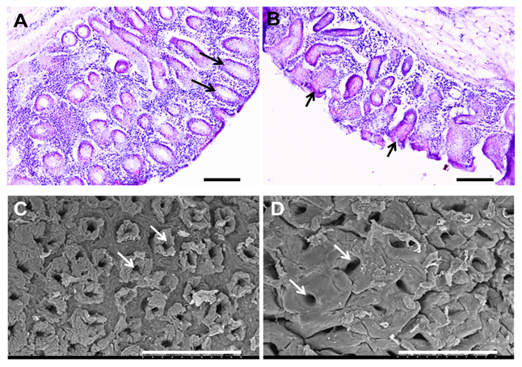

Supplemental Fig. S6. The effects of high grain diet on cecal epithelial ultrastructure. Comparisons of ultrastructure of the cecal epithelia between hay-fed goats (A, scale bar = 1μm) and high grain-fed goats (B, scale bar = 2μm). Cecal epithelial ultrastructural comparisons of junctions complexs between hay-fed goats (C, scale bar = 0.5 μm) and high grain-fed goats (D, scale bar = 1 μm). (V: vacuoles; M: microvillus; Arrow: tight junction)
