SUPPLEMENTARY DATA
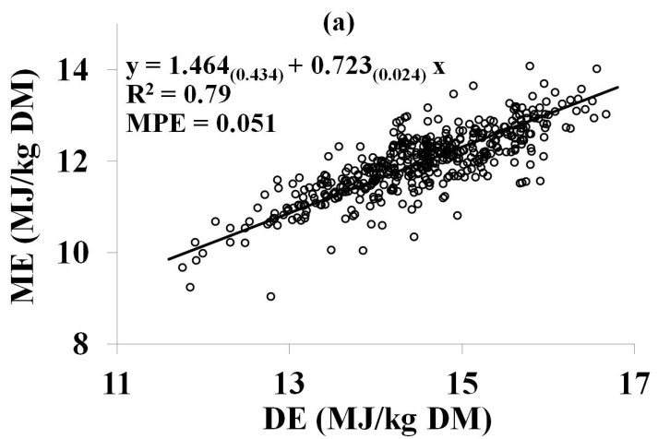 | 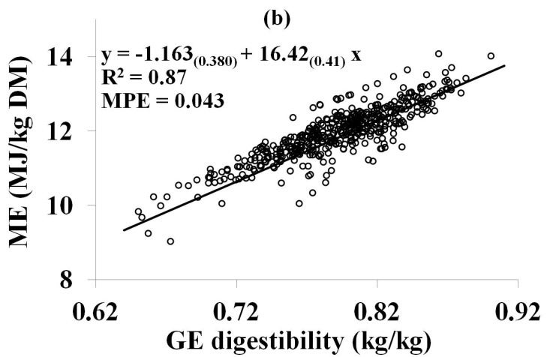
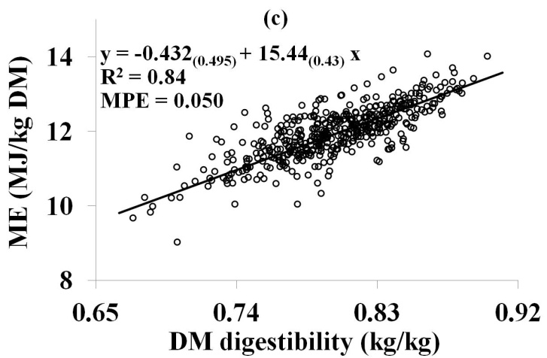 | 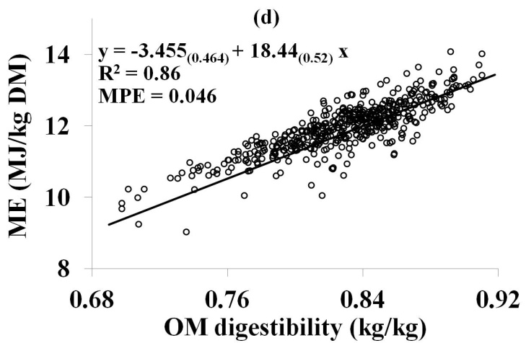
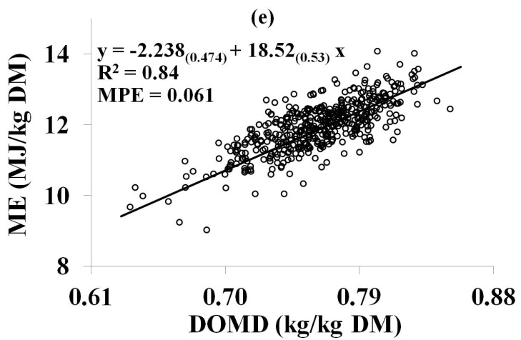 | 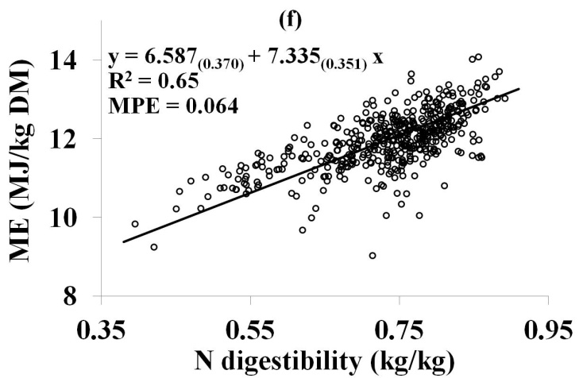
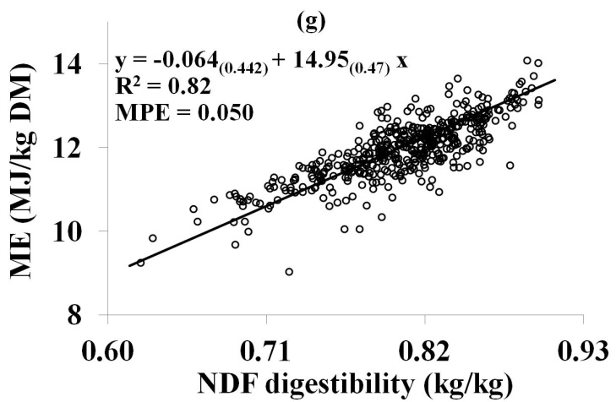 | 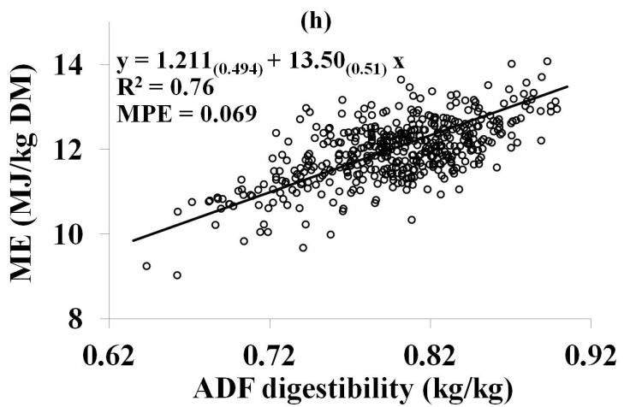
Figure S1. Relationships between metabolisable energy (ME) and (i) digestible energy (DE; panel a), (ii) nutrient digestibility parameters (GE, gross energy; DM, dry matter; OM, organic matter; DOMD, digestible OM in DM; N, nitrogen; NDF, neutral-detergent fibre; ADF, acid-detergent fibre; panels b–h) in fresh grass fed at non-pregnant non–lactating cows at maintenance energy level (n=464). R² and MPE represent pseudo correlation coefficient and mean prediction error, respectively. MPE derived from an internal validation with new equations, developed from the two-thirds of the whole dataset and by using the same random and fixed model as those used to develop equations from the whole dataset; the new equations were validated against the remaining one-third of the whole dataset.

