Supplemental Material
Supplemental Table 1
Bowel function of the volunteers throughout the placebo controlled, double blind crossover intervention study with prebiotic galactooligosaccharides (B-GOS)¹
 | Placebo |  | B-GOS
 | Baseline | Week 10 | Baseline | Week 10
Number of stools | 1.86  +0.85 | 1.87  +1.03 | 1.91  +0.87 | 1.89  +0.87
Stool type | 3.70  +0.77 | 3.62  +0.99 | 3.61  +0.79 | 3.64  +0.88
Abdominal pain | 0.23  +0.51 | 0.20  +0.43 | 0.24  +0.40 | 0.18  +0.35
Bloating | 0.29  +0.52 | 0.31  +0.57 | 0.39  +0.54 | 0.36  +0.55
Flatulence | 0.71  +0.57 | 0.71  +0.68 | 0.84  +0.63 | 0.79  +0.63

Scoring: Stool type (according to Bristol stool chart). Hard (=Type 1) to liquid (=Type 7)
Abdominal pain, bloating and flatulence. None (= 0) to severe (=3)
¹ All values are +SD; n=40.
No significant differences were found between placebo and B-GOS
No significant differences were found from baseline to week 10 in either treatment

Supplemental Figure 1
Plot of the Q² and R²Y in correlation with the PLS design (Figure 1) derived from 1000 random permutations, P - value = 0.013
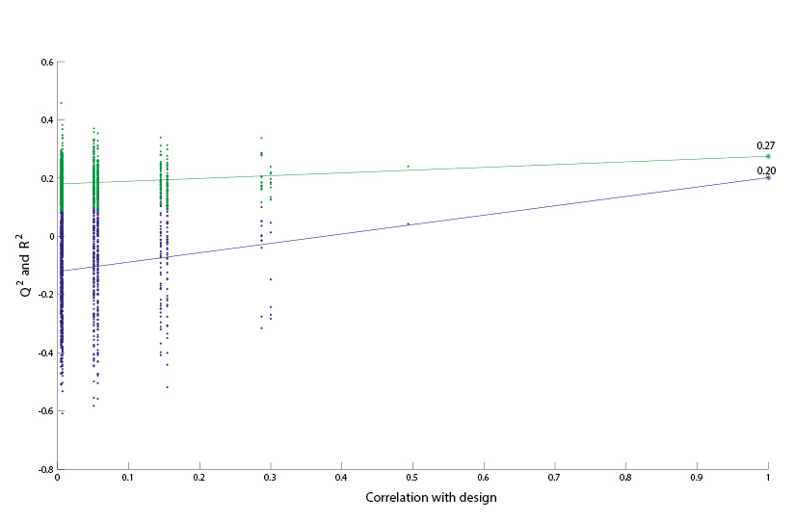

Supplementary Table 2
Mean daily nutrient intake of selected energy and macronutrients of males and females throughout the placebo controlled, double blind crossover intervention study with prebiotic galactooligosaccharide (B- GOS)¹. Total mean nutrient intake of males and females compared to the average U.K intake for individuals of the same age and sex.
 | Placebo |  |  |  |  | B-GOS
 | Week 5 |  | Week 10 |  |  | Week 5 |  | Week 10 |  | Female Total |  | Male Total
 | Female | Male | Female | Male |  | Female | Male | Female | Male | Mean | UK Mean* | Mean | UK Mean*
Energy (kcal) | 1499.53 | 1689.43 | 1486.82 | 1467.87 |  | 1468.69 | 1705.03 | 1488.25 | 1539.98 | 1485.82 | 1522 | 1600.58 | 1976
Energy (kcal) | +406.35 | +490.01 | +513.35 | +382.44 |  | +384.24 | +448.47 | +401.42 | +366.30 | +426.34 |  | +421.80
Total Fat (g) | 55.95 | 64.64 | 56.44 | 54.64 |  | 54.01 | 62.59 | 55.90 | 56.49 | 55.57 | 60.0 | 59.59 | 77.7
Total Fat (g) | +18.27 | +21.11 | +21.94 | +20.58 |  | +18.17 | +18.27 | +16.37 | +12.45 | +18.69 |  | +18.11
Saturated fatty acids (g) | 22.23 | 25.62 | 21.33 | 20.70 |  | 20.08 | 23.95 | 22.10 | 21.41 | 21.43 | 24.0 | 22.92 | 30.4
Saturated fatty acids (g) | +7.16 | +7.95 | +10.00 | +7.31 |  | +6.85 | +9.00 | +6.54 | +6.09 | +7.64 |  | +7.59
Mono-unsaturated fatty acids (g) | 18.21 | 21.16 | 18.27 | 18.29 |  | 17.00 | 21.12 | 17.32 | 18.98 | 17.70 | 19.9 | 19.89 | 26.5
Mono-unsaturated fatty acids (g) | +7.04 | +5.99 | +7.19 | +8.32 |  | +6.60 | +7.06 | +5.37 | +6.16 | +6.55 |  | +6.88
Total n-3 Poly-unsaturated fatty acids (g) | 0.66 | 0.57 | 0.74 | 0.63 |  | 0.60 | 0.64 | 0.59 | 0.71 | 0.65 | 1.9 | 0.64 | 2.4
Total n-3 Poly-unsaturated fatty acids (g) | +0.45 | +0.27 | +0.63 | +0.50 |  | +0.50 | +0.28 | +0.34 | +0.32 | +0.48 |  | +0.34
Total n-6 Poly-unsaturated fatty acids (g) | 4.07 | 2.86 | 3.44 | 3.12 |  | 3.12 | 3.40 | 3.54 | 3.53 | 3.54 | 8.0 | 3.23 | 10.6
Total n-6 Poly-unsaturated fatty acids (g) | +3.90 | +1.07 | +2.37 | +2.27 |  | +2.17 | +1.66 | +3.00 | +1.44 | +2.86 |  | +1.61
Total trans fatty acids (g) | 1.19 | 1.56 | 1.23 | 1.17 |  | 1.15 | 1.45 | 1.27 | 1.29 | 1.21 | 1.4 | 1.37 | 1.9
Total trans fatty acids (g) | +0.43² | +0.58 | +0.86 | +0.57 |  | +0.54 | +0.81 | +0.73 | +0.59 | +0.64 |  | +0.63
Protein (g) | 64.90 | 67.18 | 63.07 | 62.38 |  | 61.76 | 72.93 | 64.07 | 65.05 | 63.45 | 64.2 | 66.88 | 79.7
Protein (g) | +19.48 | +24.07 | +22.83 | +20.47 |  | +17.41 | +17.82 | +21.39 | +20.56 | +20.28 |  | +20.73
Available carbohydrate (g) | 161.51 | 187.11 | 165.43 | 163.45 |  | 163.18 | 188.91 | 159.70 | 168.33 | 162.46 | 184 | 176.95 | 228
Available carbohydrate (g) | +54.36 | +60.75 | +74.25 | +43.58 |  | +54.53 | +64.78 | +56.89 | +46.44 | +60.01 |  | +53.89
Alcohol (g) | 9.59 | 10.30 | 6.34 | 9.08 |  | 8.70 | 10.57 | 10.24 | 9.93 | 8.72 | 4.8 | 9.97 | 14.6
Alcohol (g) | +10.54 | +12.34 | +6.17 | +12.02 |  | +8.96 | +10.98 | +9.70 | +9.68 | +8.84 |  | +11.26
Non-starch polysaccharides (g) | 12.63 | 11.63 | 11.66 | 11.21 |  | 12.89 | 14.57 | 12.58 | 11.63 | 12.44 | 12.3 | 12.26 | 14.8
Non-starch polysaccharides (g) | +3.87 | +3.82 | +4.14 | +4.00 |  | +3.81 | +5.95 | +4.28 | +2.95 | +4.02 |  | +4.18
Total sugars (g) | 78.42 | 73.14 | 82.53 | 70.32 |  | 80.56 | 84.19 | 80.04 | 77.43 | 80.39 | 85.5 | 76.27 | 101.1
Total sugars (g) | +25.07 | +26.07 | +46.08 | +23.95 |  | +29.15 | +42.10 | +32.42 | +31.92 | +33.18 |  | +31.01
Starch (g) | 73.22 | 96.02 | 69.27 | 83.05 |  | 66.23 | 82.34 | 67.87 | 81.65 | 69.15 | 98.9 | 85.76 | 127.2
Starch (g) | +29.36² | +38.66 | +34.46 | +25.19 |  | +32.55 | +26.06 | +28.25 | +24.92 | +31.15³ |  | +28.71
* U.K mean values for men and women aged 65+ yrs. National Diet and Nutrition Survey 2008/09 - 2009/10.
¹ All values are +SD; Females n=25, Males n= 15, ² Significantly different from males, P <0.05 (t-test), ³ Significantly different from males, P <0.01 (t-test)

