Supplemental Figures

(a)

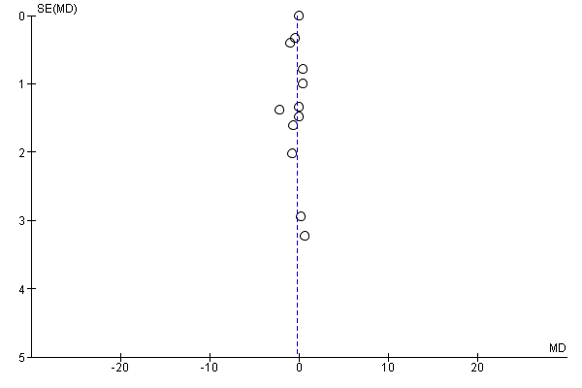

(b)
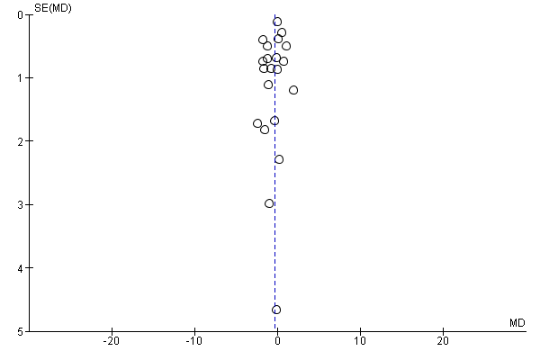

Supplemental Figures.
Publication bias was assessed using a funnel plot depicting the mean difference between the intervention and control groups (treatment effect) against the standard error of the mean difference.
(a) Funnel plot of all RCTs of calcium supplementation reporting change in body fat, Egger’s regression, P = 0.40 indicates no publication bias.
(b) Funnel plot of all RCTs of dairy food supplementation reporting change in body fat, Egger’s regression, P = 0.10 indicates no publication bias.
Mid vertical line represents the zero mean difference or zero effect size.

