Online Supplementary Material (OSM)
Supplemental Figure 1 Flow cytometry gating strategy
Supplemental Table 1
 | Pos | Allele 1 | Allele 2 | Allele 1 Frequency | MAF (%) | Imputation Rsquared* | Genotyped | RSquared
 |  |  |  |  |  | (% exact classified | Genotyped
 |  |  |  |  |  | as 0, 1 or 2) | Genotyped | rs174545 | rs174546 | rs174556 | rs174561
rs174545 | 61325882 | C | G | 0.669 | 31 | 1.001 | Imputed | - | - | - | -
rs174545 | FADS1 intron |  |  |  |  | 99%
rs174546 | 61326406 | C | T | 0.669 | 31 | 1.001 | Genotyped | 0.819 | - | - | -
rs174546 | FADS1 intron
rs174556 | 61337211 | C | T | 0.700 | 30 | 1.001 | Genotyped | 0.969 | 0.778 | - | -
rs174556 | FADS1 intron
rs174561 | 61339284 | T | C | 0.700 | 30 | 1.000 | Imputed | 0.969 | 0.778 | 1.000 | -
rs174561 | FADS1 intron |  |  |  |  | 100%
rs174575 | 61358579 | C | G | 0.756 | 23 | 0.996 | Imputed | 0.998 | 0.819 | 0.972 | 0.972
rs174575 | FADS2 Intron |  |  |  |  | 90%
* Imputation quality measure. Fuchsberger C, Abecasis GR, Hinds DA. minimac2: faster genotype imputation. Bioinformatics 2014

Supplemental Figure 2 Study flow chart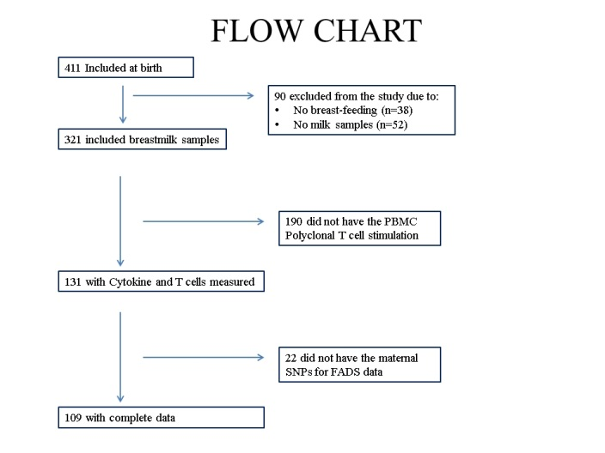

Supplemental figure 3 Heat-map illustrating the pattern of correlations between breast-milk essential fatty acids (LA and ALA, n-3, n-6 and total PUFA content) and maternal and infant FADS SNP rs174546 and ex vivo T-cell cytokines, T-cell counts, and combined cytokine profiles expressed as PC1 and PC2
Results are presented as correlation coefficient with the p-value placed in the brackets below. White boxes represent negative correlations and black boxes positive correlations and the saturation of the colors represent the size of the Spearman correlation coefficients. Bold underlined values indicate that the correlation was statistically significant.
Abbreviations: Tc- Cytotoxic T cell, Th- T helper cell, Treg- regulatory T cell, IFN- γ- Interferon gamma, TNF- α- Tumor Necrosis Factor alpha, IL- Interleukin, PC- Principal Component, LA- Linoleic Acid, ALA- alpha Linolenic Acid, PUFA- Polyunsaturated Fatty Acid.

