Supplementary information: Comparative validity of vitamin C and carotenoids as indicators of fruit and vegetable intake: a systematic review and meta-analysis of randomised controlled trials

Search strategy

Strategy for PubMed
- (fruit[tiab] OR fruits[tiab] OR "fruit"[MeSH Terms] OR fruit'[tiab] OR fruit's[tiab] OR vegetable[tiab] OR vegetables[tiab] OR legumes[tiab] OR pulses[tiab] OR (plant[tiab] AND food[tiab]) OR "Plant food"[tiab])
- (("dietary"[tiab] AND "intervention"[tiab]) OR "dietary intervention"[tiab] OR controlled[tiab] OR randomised[tiab] OR "random allocation"[MeSH Terms] OR ("random"[tiab] AND "allocation"[tiab]) OR "random allocation"[tiab] OR "randomized"[tiab] OR (randomly[tiab] AND assigned[tiab]) OR "patient compliance"[MeSH Terms] OR "compliance"[tiab] OR "compliance"[MeSH Terms] OR (feeding[tiab] AND ("trial"[tiab] OR "study"[tiab])) OR parallel[tiab] OR "cross-over studies"[MeSH Terms] OR ("cross-over"[tiab] AND ("study"[tiab] OR "studies"[tiab])) OR "crossover"[tiab] OR cross-over[tiab])
- ("blood"[tiab] OR "blood"[MeSH Terms] OR "plasma"[MeSH Terms] OR "plasma"[tiab] OR "serum"[MeSH Terms] OR "serum"[tiab] OR circulating[tiab] OR biomarker[tiab] OR biomarkers[tiab] OR biomarker'[tiab] OR biomarker's[tiab] OR antioxidant[tiab] OR antioxidants[tiab] OR antioxidant/nutrients[tiab] OR antioxidant/nutritional[tiab] OR antioxidants/vitamins[tiab] OR antioxidative[tiab] OR "ascorbic acid"[MeSH Terms] OR "ascorbic"[tiab] AND "acid"[tiab] OR "ascorbic acid"[tiab] OR "vitamin c"[tiab] OR carotenoid[tiab] OR carotenoids[tiab] OR carotenoid'[tiab] OR carotenoid's[tiab] OR carotenoide[tiab] OR carotenoides[tiab] OR carotenoids/vitamin[tiab] OR "carotenoids"[MeSH Terms] OR "carotenes"[tiab] OR "xanthophylls"[MeSH Terms] OR "xanthophylls"[tiab] OR "carotene"[tiab] OR "beta-carotene"[tiab] OR "b-carotene"[tiab] OR "alpha-carotene"[tiab] OR "a-carotene"[tiab] OR "carotenes"[tiab] OR cryptoxanthin[tiab] OR beta-cryptoxanthin[tiab] OR b-cryptoxanthin[tiab] OR cryptoxanthine[tiab] OR cryptoxanthins[tiab] OR "lutein"[MeSH Terms] OR "lutein"[tiab] OR "zeaxanthin"[Supplementary Concept] OR "zeaxanthin"[tiab] OR "lycopene"[Supplementary Concept] OR "lycopene"[tiab])
- #1 AND #2 AND #3
Hits on 09/12/2013 = 1521 hits

Strategy for Ovid Embase
- (fruit or fruits or vegetable$ or legume$ or plant food or plant foods).ti,ab.
- Fruit/ or vegetable/ or legume/
- 1 or 2
- (biomarker$ or antioxidant$ or antioxidative or ascorbic acid or vitamin c or carotenoid$ or carotenoide$ or carotene$).ti,ab.
- (xanthophyll$ or beta carotene or b carotene or alpha carotene or a carotene or cryptoxanthin$ or cryptoxanthine$ or lutein or zeaxanthin or lycopene).ti,ab.
- Biological marker/ or antioxidant/ or ascorbic acid/ or carotene alpha/ or carotene, beta/ carotene/ or cryptoxanthin/ or cryptoxanthine/ or xanthophyll/ or zeaxanthin/ or lycopene/
- (1 or 2) AND (3 or 4 or 5 or 6)
- limit 7 to (human and "therapy (best balance of sensitivity and specificity)")
Hits on 09/12/2013 = = 1078
Strategy for CENTRAL
#1 fruit or fruits or fruit' or fruit's or vegetable or vegetables or legumes or pulses or (plant and food) or "Plant food":ti,ab,kw
AND
#2 ("dietary" and "intervention") or "dietary intervention" or controlled or randomised or "random allocation" or ("random" and "allocation") or "random allocation" or "randomized" or (randomly and assigned) or "patient compliance" or "compliance" or "compliance" or (feeding and ("trial" or "study")) or parallel or "cross-over studies" or ("cross-over" and ("study" or "studies")) or "crossover" or cross-over:ti,ab,kw (Word variations have been searched)
AND
#3 "blood" or "plasma" or "serum" or circulating or biomarker or biomarkers or biomarker' or biomarker's or antioxidant or antioxidants or antioxidative or "ascorbic acid" or "ascorbic" and "acid" or "ascorbic acid" or "vitamin c" or carotenoid or carotenoids or carotenoid' or carotenoid's or carotenoide or carotenoides or "carotenoids" or "carotenes" or "xanthophylls" or "xanthophylls" or "carotene" or "beta-carotene" or "b-carotene" or "alpha-carotene" or "a-carotene" or "carotenes" or cryptoxanthin or beta-cryptoxanthin or b-cryptoxanthin or cryptoxanthine or cryptoxanthins or "lutein" or "lutein" or "zeaxanthin" or "lycopene":ti,ab,kw (Word variations have been searched)
AND
2009 onwards
Hits on 09/12/2013 = - 888 hits

Strategy for CINAHL
- (fruit or fruits or vegetable* or legume* or plant food or plant foods) [Text words]
- Fruit or vegetables or legumes or plant,edible. [Index terms]
- 1 or 2
- (biomarker* or antioxidant* or antioxidative or ascorbic acid or vitamin c or carotenoid* or carotenoide* or carotene*).[textwords]
- (xanthophyll* or beta carotene or b carotene or alpha carotene or a carotene or cryptoxanthin* or cryptoxanthine* or lutein or zeaxanthin or lycopene).[textwords]
- Biological markers or antioxidants or ascorbic acid or carotenoids or carotene or beta carotene or xanthophylls or lycopene.[Index terms]
- (control or controlled or random or randomly or randomised or randomized or cross over or parallel).[textwords]

- TI ( fruit or fruits or vegetable* or legume* or plant food or plant foods ) OR AB ( fruit or fruits or vegetable* or legume* or plant food or plant foods )
- MH fruit or fruits or vegetable or legume or plant food or plant foods
- 1 or 2
- TI ( biomarker* or antioxidant* or antioxidative or ascorbic acid or vitamin c or carotenoid* or carotenoide* or carotene* ) OR AB ( biomarker* or antioxidant* or antioxidative or ascorbic acid or vitamin c or carotenoid* or carotenoide* or carotene* )
- TI ( xanthophyll* or beta carotene or b carotene or alpha carotene or a carotene or cryptoxanthin* or cryptoxanthine* or lutein or zeaxanthin or lycopene ) OR AB ( xanthophyll* or beta carotene or b carotene or alpha carotene or a carotene or cryptoxanthin* or cryptoxanthine* or lutein or zeaxanthin or lycopene )
- 4 or 5
- MH Biological markers or antioxidants or ascorbic acid or carotenoids or carotene or beta carotene or xanthophylls or lycopene
- 6 or 7
- 3 AND 8 Limiters – Human
Hits on 09/12/2013 = 601
Strategy for Web of Science
fruit* OR vegetable* OR legume* OR pulses* OR (plant NEAR food)
AND
controlled OR randomised OR randomized OR (random NEAR allocation) OR (randomly NEAR assigned) OR compliance OR (parallel NEAR (trial OR study OR intervention)) OR (crossover NEAR (trial OR study OR intervention)) OR (cross-over NEAR (trial OR study OR intervention))
AND
(Dietary NEAR (trial OR study OR intervention)) OR (feeding NEAR (trial OR study OR intervention))
AND
blood OR plasma OR serum OR circulating OR biomarker*
AND
antioxida* OR (ascorbic NEAR acid) OR (vitamin NEAR c) OR carotenoid* OR carotene* OR xanthophyll* OR beta-carotene OR b-carotene OR alpha-carotene OR a-carotene OR
cryptoxanthin* OR beta-cryptoxanthin* OR b-cryptoxanthin* OR lutein OR zeaxanthin OR lycopene

Refined by: [excluding] Research Areas=( FOOD SCIENCE TECHNOLOGY OR PLANT SCIENCES OR VIROLOGY OR BIODIVERSITY CONSERVATION OR AGRICULTURE OR ZOOLOGY OR MARINE FRESHWATER BIOLOGY OR MICROBIOLOGY OR VETERINARY SCIENCES OR FORESTRY OR ETHNIC STUDIES OR CHEMISTRY OR MYCOLOGY OR PHYSICS OR CELL BIOLOGY OR FISHERIES OR REPRODUCTIVE BIOLOGY OR METEOROLOGY ATMOSPHERIC SCIENCES )
AND [excluding] Document Types=( OTHER OR REFERENCE MATERIAL OR BOOK OR REVIEW OR PATENT OR EDITORIAL )

Hits on 09/12/2013 = 1402


Supplementary table S1: PRISMA 2009 Checklist
Section/topic | # | Checklist item | Reported on page #
TITLE
Title | 1 | Identify the report as a systematic review, meta-analysis, or both. | 1
ABSTRACT
Structured summary | 2 | Provide a structured summary including, as applicable: background; objectives; data sources; study eligibility criteria, participants, and interventions; study appraisal and synthesis methods; results; limitations; conclusions and implications of key findings; systematic review registration number. | 2
INTRODUCTION
Rationale | 3 | Describe the rationale for the review in the context of what is already known. | 3
Objectives | 4 | Provide an explicit statement of questions being addressed with reference to participants, interventions, comparisons, outcomes, and study design (PICOS). | 4
METHODS
Protocol and registration | 5 | Indicate if a review protocol exists, if and where it can be accessed (e.g., Web address), and, if available, provide registration information including registration number. | Protocol not registered
Eligibility criteria | 6 | Specify study characteristics (e.g., PICOS, length of follow-up) and report characteristics (e.g., years considered, language, publication status) used as criteria for eligibility, giving rationale. | 7-8
Information sources | 7 | Describe all information sources (e.g., databases with dates of coverage, contact with study authors to identify additional studies) in the search and date last searched. | 7 and 9
Search | 8 | Present full electronic search strategy for at least one database, including any limits used, such that it could be repeated. | Supplementary information
Study selection | 9 | State the process for selecting studies (i.e., screening, eligibility, included in systematic review, and, if applicable, included in the meta-analysis). | 7
Data collection process | 10 | Describe method of data extraction from reports (e.g., piloted forms, independently, in duplicate) and any processes for obtaining and confirming data from investigators. | 8-7
Data items | 11 | List and define all variables for which data were sought (e.g., PICOS, funding sources) and any assumptions and simplifications made. | 8-9
Risk of bias in individual studies | 12 | Describe methods used for assessing risk of bias of individual studies (including specification of whether this was done at the study or outcome level), and how this information is to be used in any data synthesis. | 9
Summary measures | 13 | State the principal summary measures (e.g., risk ratio, difference in means). | 10
Synthesis of results | 14 | Describe the methods of handling data and combining results of studies, if done, including measures of consistency (e.g., I²) for each meta-analysis. | 10-11
Section/topic | # | Checklist item | Reported on page #
Risk of bias across studies | 15 | Specify any assessment of risk of bias that may affect the cumulative evidence (e.g., publication bias, selective reporting within studies). | 9
Additional analyses | 16 | Describe methods of additional analyses (e.g., sensitivity or subgroup analyses, meta-regression), if done, indicating which were pre-specified. | 11-12
RESULTS
Study selection | 17 | Give numbers of studies screened, assessed for eligibility, and included in the review, with reasons for exclusions at each stage, ideally with a flow diagram. | 12  Figure 1
Study characteristics | 18 | For each study, present characteristics for which data were extracted (e.g., study size, PICOS, follow-up period) and provide the citations. | 12-13  Table 1
Risk of bias within studies | 19 | Present data on risk of bias of each study and, if available, any outcome level assessment (see item 12). | 13-14  Table 2
Results of individual studies | 20 | For all outcomes considered (benefits or harms), present, for each study: (a) simple summary data for each intervention group (b) effect estimates and confidence intervals, ideally with a forest plot. | Supplementary figures S3-10
Synthesis of results | 21 | Present results of each meta-analysis done, including confidence intervals and measures of consistency. | Figures 2-3
Risk of bias across studies | 22 | Present results of any assessment of risk of bias across studies (see Item 15). | 14
Additional analysis | 23 | Give results of additional analyses, if done (e.g., sensitivity or subgroup analyses, meta-regression [see Item 16]). | 15-17
DISCUSSION
Summary of evidence | 24 | Summarize the main findings including the strength of evidence for each main outcome; consider their relevance to key groups (e.g., healthcare providers, users, and policy makers). | 18, 21
Limitations | 25 | Discuss limitations at study and outcome level (e.g., risk of bias), and at review-level (e.g., incomplete retrieval of identified research, reporting bias). | 21-22
Conclusions | 26 | Provide a general interpretation of the results in the context of other evidence, and implications for future research. | 22
FUNDING
Funding | 27 | Describe sources of funding for the systematic review and other support (e.g., supply of data); role of funders for the systematic review. | 1

From: Moher D, Liberati A, Tetzlaff J, Altman DG, The PRISMA Group (2009). Preferred Reporting Items for Systematic Reviews and Meta-Analyses: The PRISMA Statement. PLoS Med 6(6): e1000097. doi:10.1371/journal.pmed1000097
For more information, visit: www.prisma-statement.org.

Supplementary table 2: Range of biomarkers measured in randomised controlled trials of fruit and vegetable intake on biomarker concentrations
Author | Year | α-carotene | β-carotene | β-crytoxanthin | Lutein | Lycopene | Vitamin C | Zeaxanthin | Total Carotenoids | Complete 5 common carotenoids and vitamin C | Types of Fruit and vegetable provided
Baldrick | 2012 | X | X | X | X | X | X | X |  | X | NR
Berry | 2010 | X | X |  |  |  | X |  |  |  | Potassium rich¹
Brevik | 2004 | X | X | X | X | X |  | X | X |  | Mixed²
Briviba | 2008 | X | X | X | X | X | X | X | X | X | NR
Broekmans | 2000 | X | X | X | X | X | X | X |  | X | Mixed³
Chong | 2013 | X | X | X | X | X | X |  | X | X | High or low flavanoid⁴
Crane | 2011 | X | X | X |  | X |  |  | X |  | Vegetables only⁵
Dragsted | 2004 |  |  |  |  | X |  |  |  |  | Limited variety⁶
Gill | 2004 | X | X | X | X | X | X |  |  | X | Cruciferous and Leguminous Sprouts⁷
Howe | 2009 | X | X |  |  |  |  |  |  |  | NR
Martini | 1995 | X | X | X | X | X |  |  |  |  | Carotenoid rich or cruciferous⁸
McCall | 2009 | X | X | X | X | X | X | X |  | X | NR
Moller | 2003 |  | X |  |  |  | X |  |  |  | Antioxidant rich⁹
Neville | 2013 | X | X | X | X | X | X | X | X | X | NR
Rantala | 2002 | X | X | X |  | X | X |  |  |  | Antioxidant rich¹⁰
Thompson | 2005 | X | X | X | X | X |  |  |  |  | Mixed¹¹
Thompson | 2005b | X | X | X | X | X |  |  |  |  | Mixed
Van het Hof | 1999 | X | X | X | X | X | X | X |  | X | Mainly vegetable¹²
Wallace | 2013 | X | X | X | X | X | X | X |  | X | NR
NR=Not reported
¹Berry 2010:apples, bananas, cabbage, carrots, green beans, lettuce, nectarines, citrus fruits, pears, peppers, plums, peaches, dried fruit, berries, spinach, tomatoes, mixed vegetables
²Brevik 2004: apples, blueberries, broccoli, carrots, cauliflower, onion, oranges, pears, peppers (red), rasberries, strawberry jam, tomatoes
³Broekmans 2000: apples, bananas, cabbage (red and white), carrots, cauliflower, chicory, cucumber, grapes, green beans, kiwi, lettuce, melon, mushrooms, onion, oranges/tangerines, pears, peppers (red), sprouts, sweetcorn, tomatoes
⁴Chong 2013 high flavanoid: aubergine, apples, asparagus, blueberries, blackberries, cabbage (red), cherries, grapefruit, grapes (black), kale, lettuce (red), onion, oranges/tangeriens, peppers (green or yellow), plums, radishes, rasberries, strawberries, spinach, cherry tomatoes, watercress
Chong 2013 low flavanoid: apricot, avacodo, broccoli, brussle sprouts, cabbage, carrots, cauliflower, cucumber, grapes (white/green), green beans, kiwi, leeks, mange tout, mangoes, mushrooms, parsnips, peaches, pears, peas, pineapple, ruhbarb, sweetcorn, plum tomatoes
⁵Crane 2011: carrots, lettuce green mix, peppers (red), tomatoes
⁶Dragsted 2004: apples, broccoli, carrots, onion, oranges, pears, tomatoes
⁷Gill 2004: cruciferous sprouts, legume sprouts
⁸Martini 1995 carotenoid rich: carrots, spinach, cruciferous: broccoli, cauliflower
⁹Moller 2003: apples, broccoli, carrots, onion, orange juice, pears, tomatoes
¹⁰Rantala 2002: fresh vegetables, citrus fruits, berries
¹¹Thompson 2005: aubergine, apples, artichoke, banboo shoots, bannans, broccoli, cabbage, carrots, caugette, celery, cucumber, endive, garlic, grapefruit, grapes, lemon, lettuce, lime, melon, onion, oranges, parsnips, peaches, peppers, radishes, strawberries, spinach, spring onion,sweetcorn, tomatoes
¹²Van het Hof 1999: broccoli, green beans, lettuce, oranges/tangerines, peas, spinach, sprouts, mixed vegetables
Supplementary figure 1: Summary of pooled difference between arms consuming higher vs. lower amounts of fruit and vegetables in standardised mean change of biomarkers from pre- to post-intervention in trials with the same set of 6 biomarkers measured excluding outlying results (>2 SD change). I² is an indicator of between-trial heterogeneity. Random effects meta-analysis was used to pool mean differences.
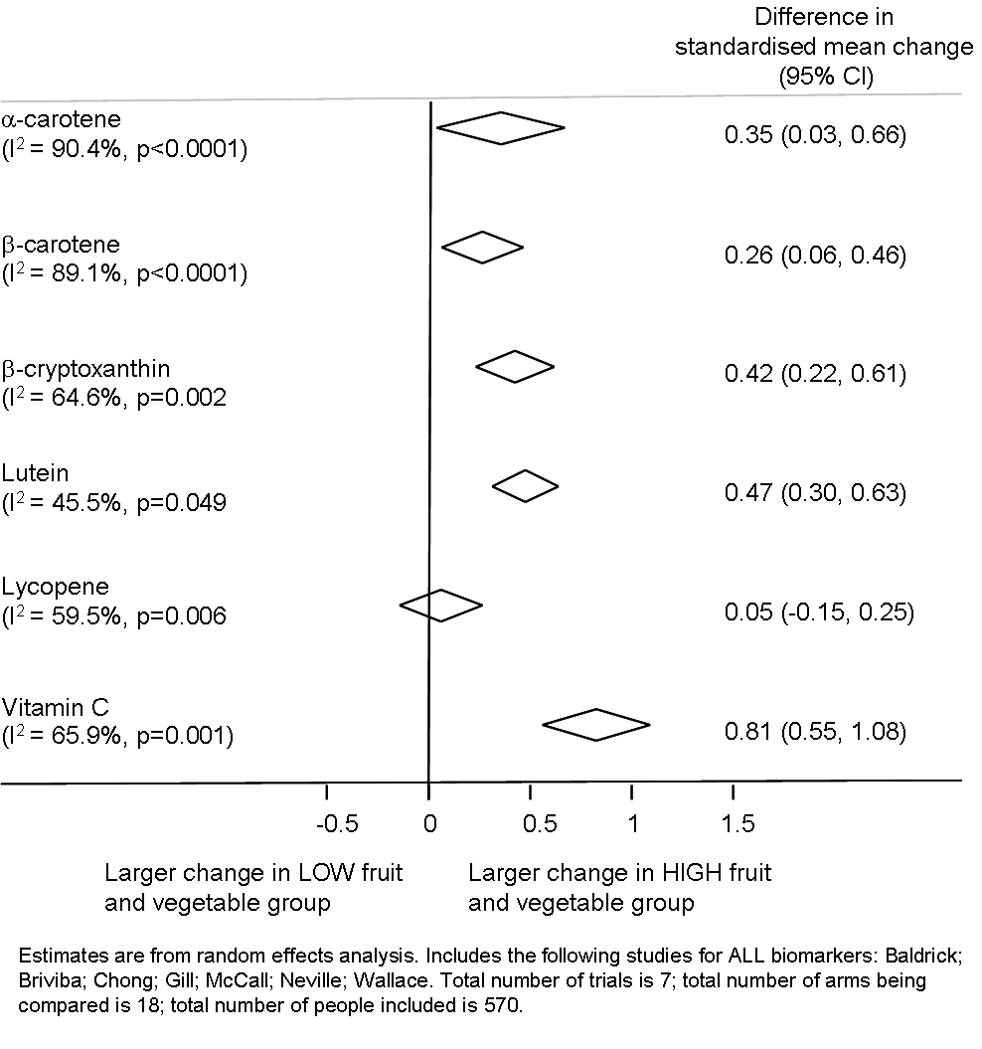
Supplementary figure 2: Summary of pooled difference between arms consuming higher vs. lower amounts of fruit and vegetables in standardised mean change of biomarkers from pre- to post-intervention in all studies with available data on each biomarker. I² is an indicator of between-trial heterogeneity. Random effects meta-analysis was used to pool mean differences.
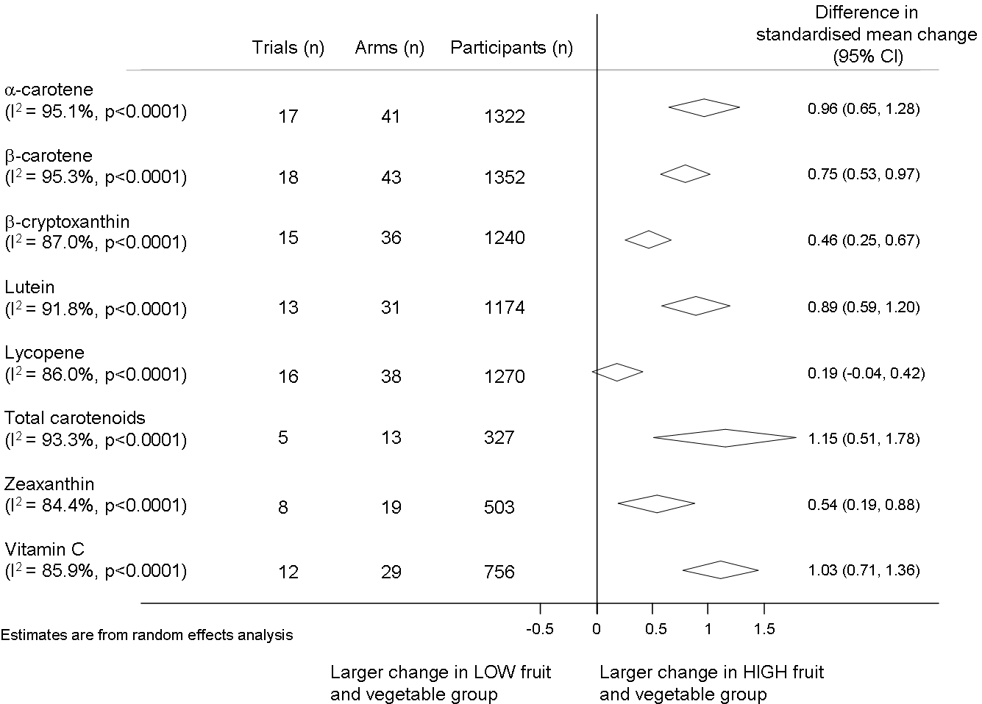

Supplementary figure 3: Summary of pooled difference between arms consuming higher vs. lower amounts of fruit and vegetables in standardised mean change of biomarkers from pre- to post-intervention in all studies with available data on each biomarker (excluding studies with non-normally distributed data). I² is an indicator of between-trial heterogeneity. Random effects meta-analysis was used to pool mean differences.
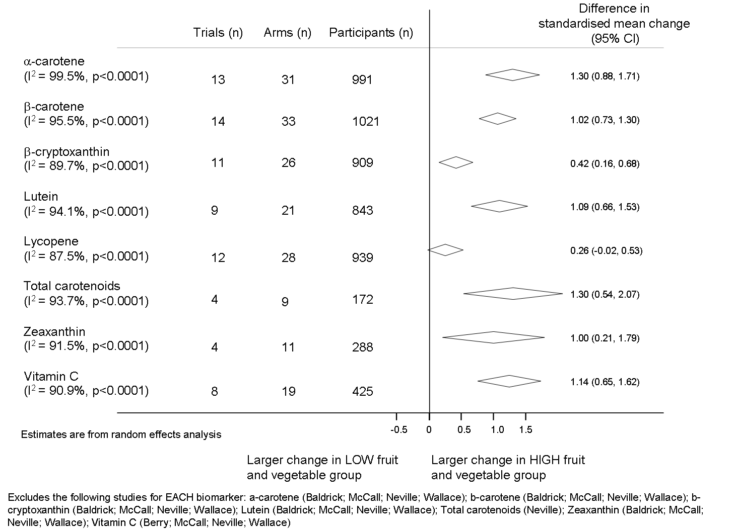
Supplementary figure 4: Pooled differences between arms consuming higher vs. lower amounts of fruit and vegetables in standardised mean change of a-carotene from pre- to post-intervention in all studies with available data. I² is an indicator of between-trial heterogeneity. Random effects meta-analysis was used to pool mean differences.
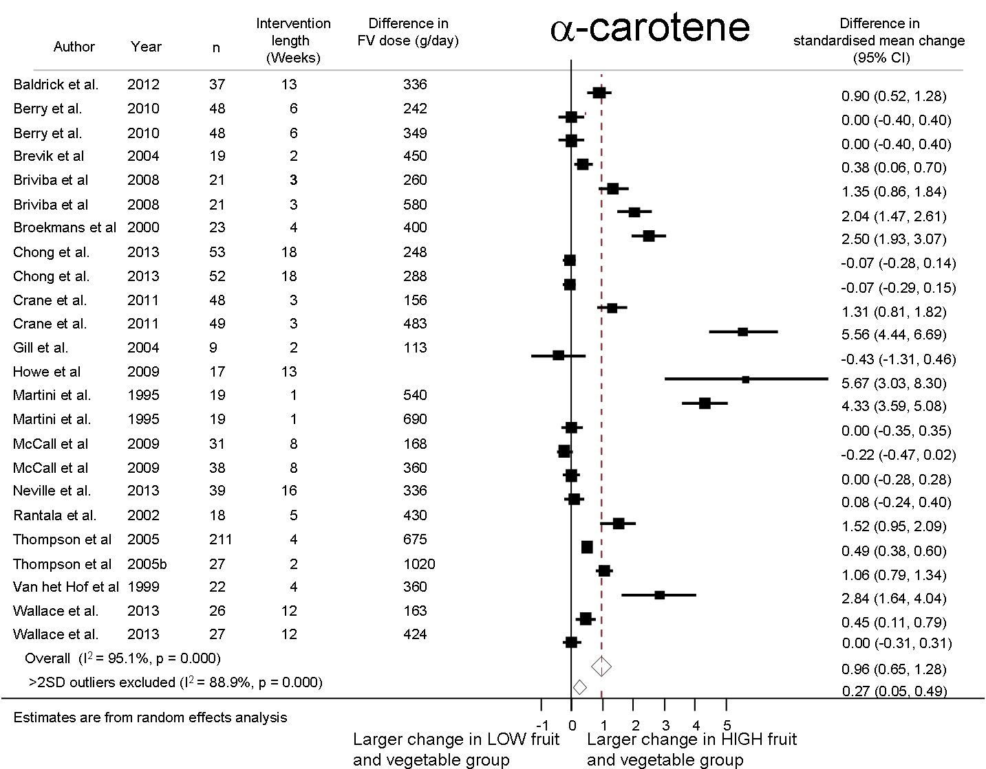
Supplementary figure 5: Pooled differences between arms consuming higher vs. lower amounts of fruit and vegetables in standardised mean change of b-carotene from pre- to post-intervention in all studies with available data. I² is an indicator of between-trial heterogeneity. Random effects meta-analysis was used to pool mean differences.
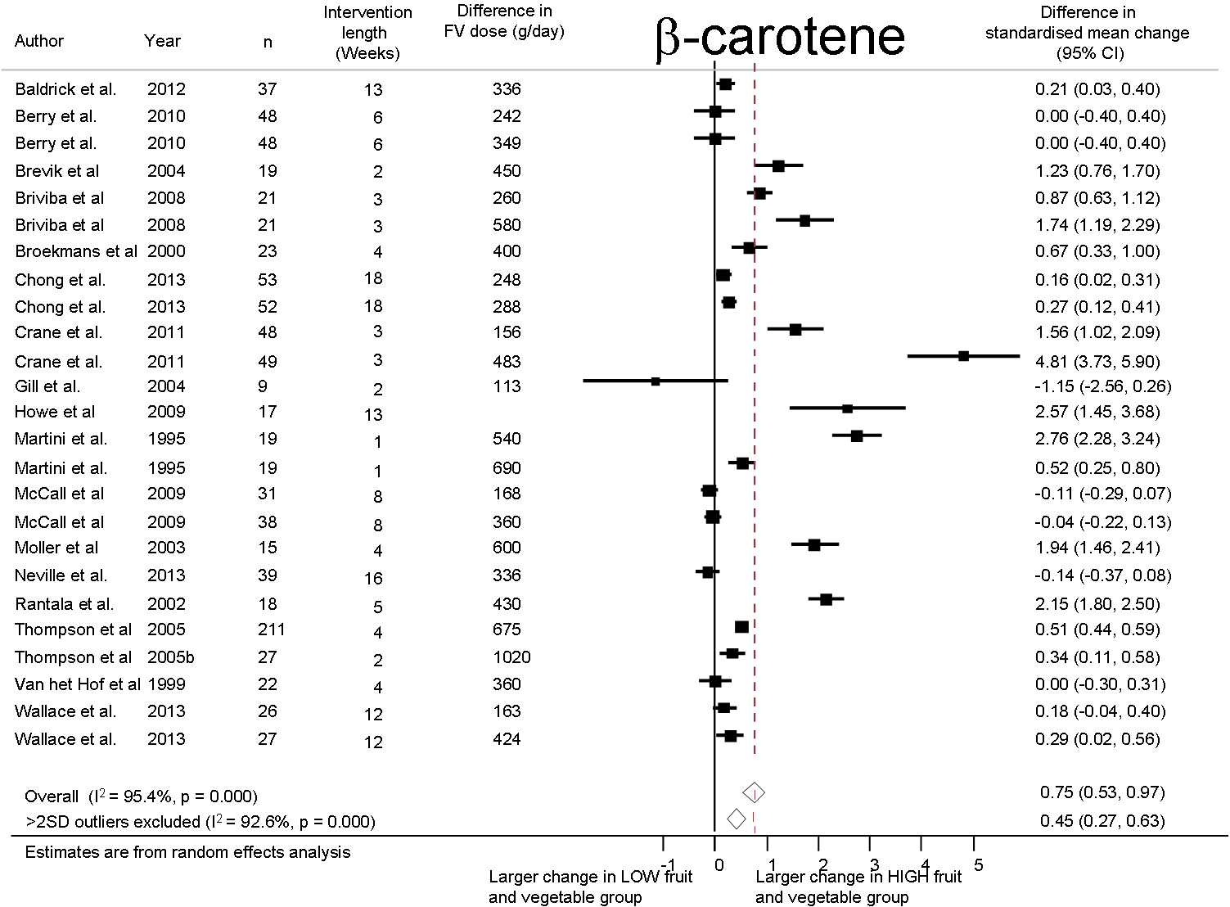
Supplementary figure 6: Pooled differences between arms consuming higher vs. lower amounts of fruit and vegetables in standardised mean change of b-cryptoxanthin from pre- to post-intervention in all studies with available data. I² is an indicator of between-trial heterogeneity. Random effects meta-analysis was used to pool mean differences.

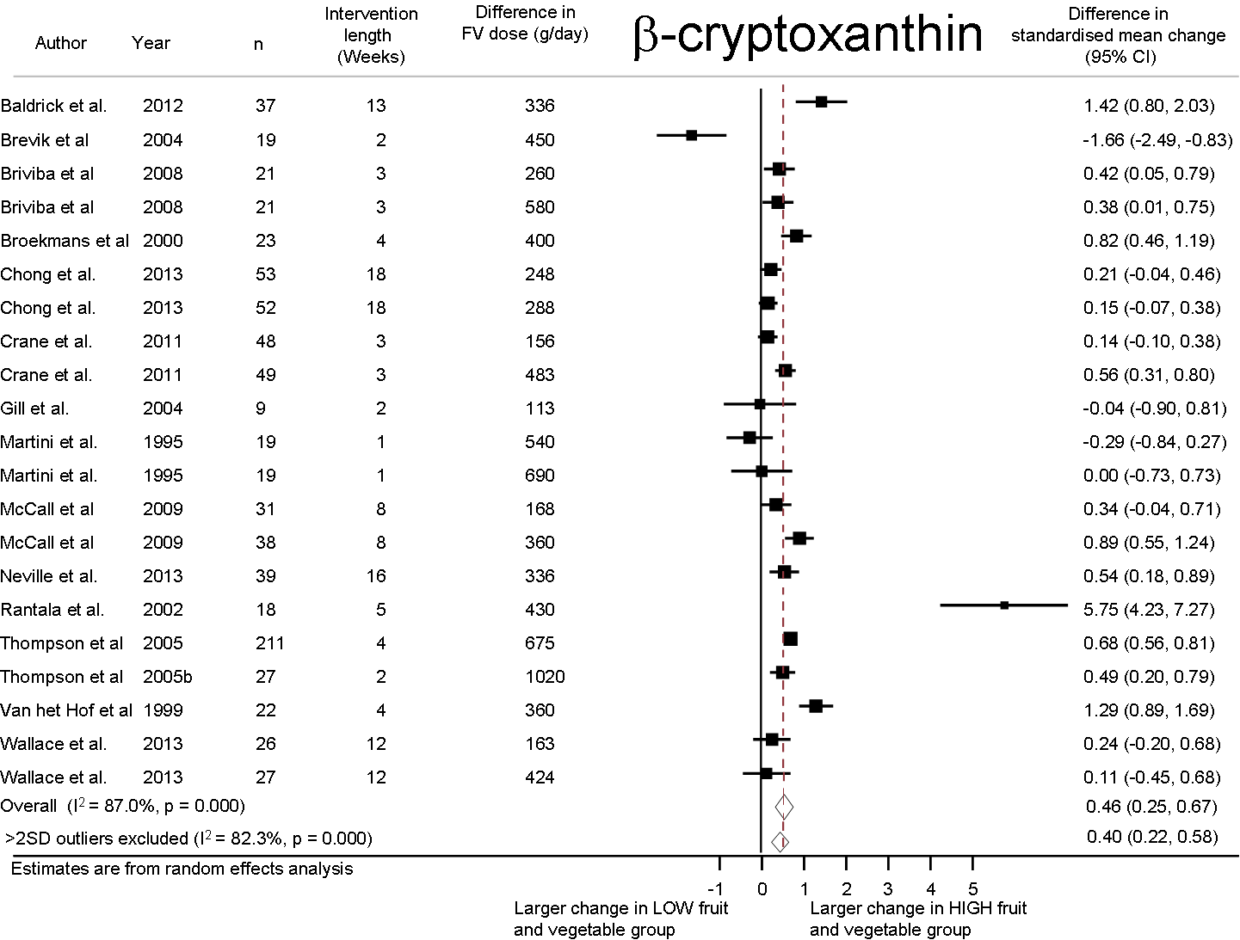
Supplementary figure 7: Pooled differences between arms consuming higher vs. lower amounts of fruit and vegetables in standardised mean change of lutein from pre- to post-intervention in all studies with available data. I² is an indicator of between-trial heterogeneity. Random effects meta-analysis was used to pool mean differences.
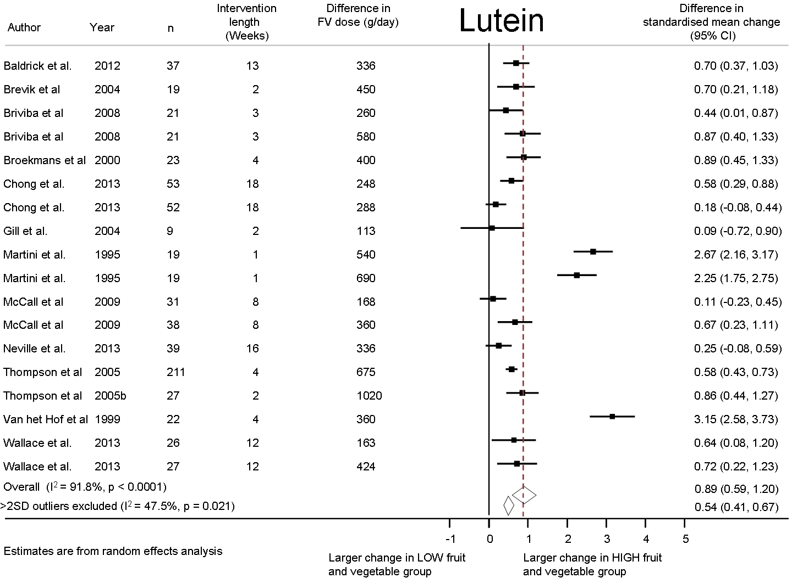
Supplementary figure 8: Pooled differences between arms consuming higher vs. lower amounts of fruit and vegetables in standardised mean change of lycopene from pre- to post-intervention in all studies with available data. I² is an indicator of between-trial heterogeneity. Random effects meta-analysis was used to pool mean differences.
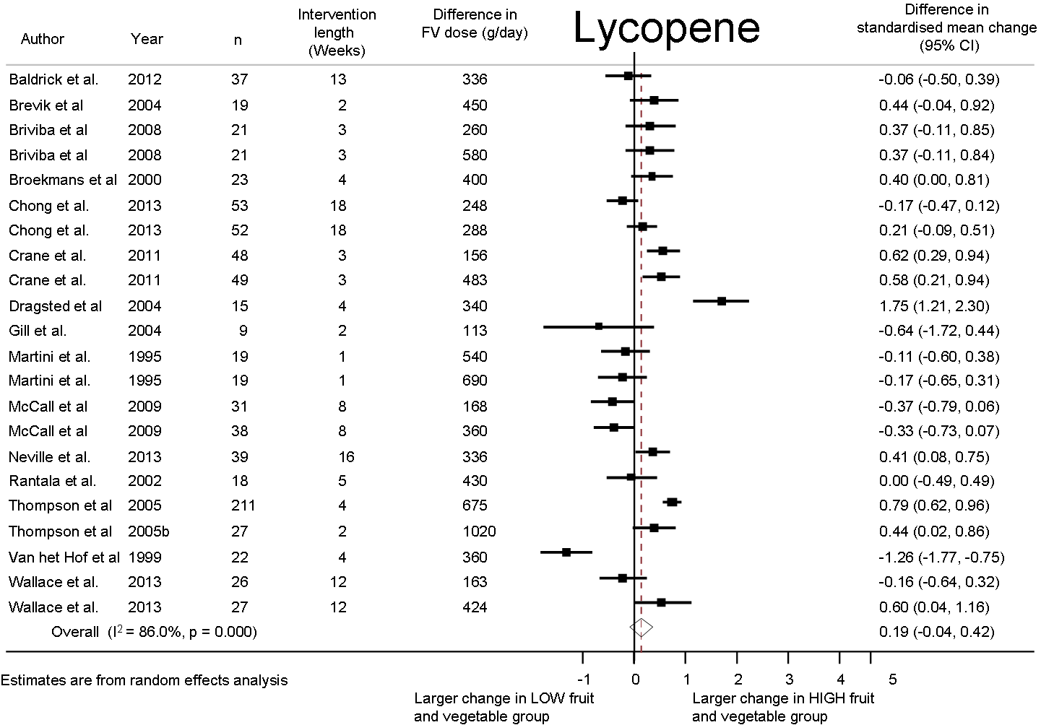
Supplementary figure 9: Pooled differences between arms consuming higher vs. lower amounts of fruit and vegetables in standardised mean change of vitamin C from pre- to post-intervention in all studies with available data. I² is an indicator of between-trial heterogeneity. Random effects meta-analysis was used to pool mean differences.
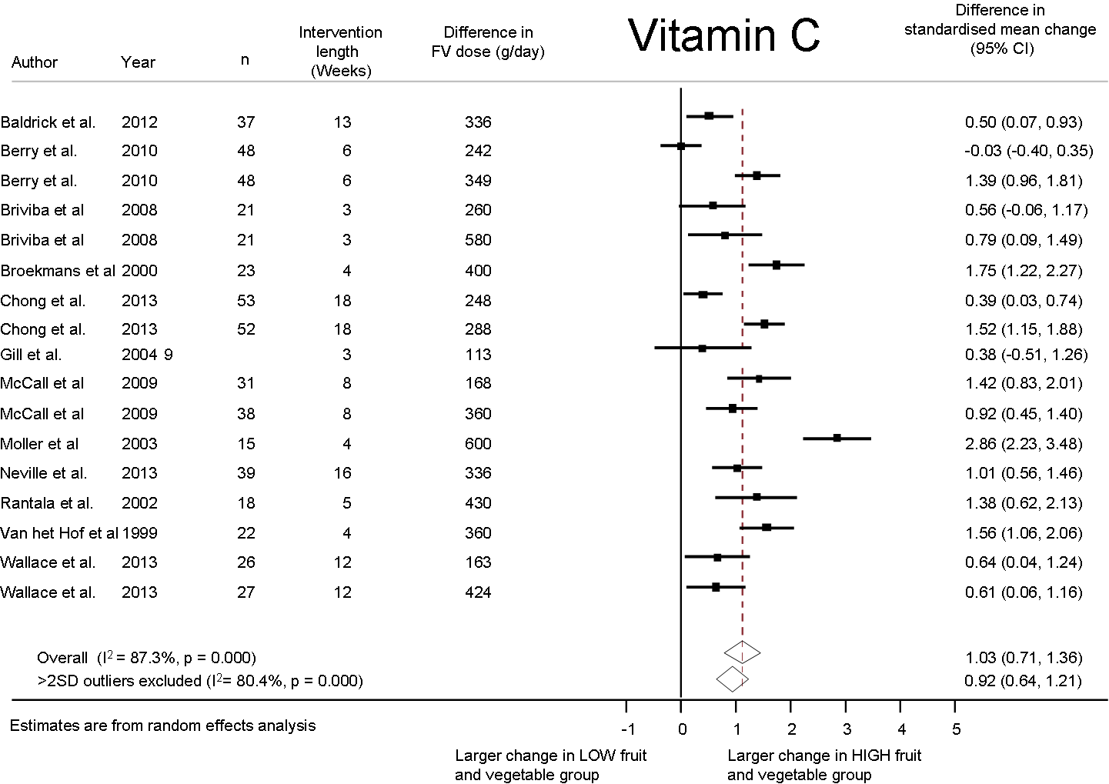
Supplementary figure 10: Pooled differences between arms consuming higher vs. lower amounts of fruit and vegetables in standardised mean change of zeaxanthin from pre- to post-intervention in all studies with available data. I² is an indicator of between-trial heterogeneity. Random effects meta-analysis was used to pool mean differences.
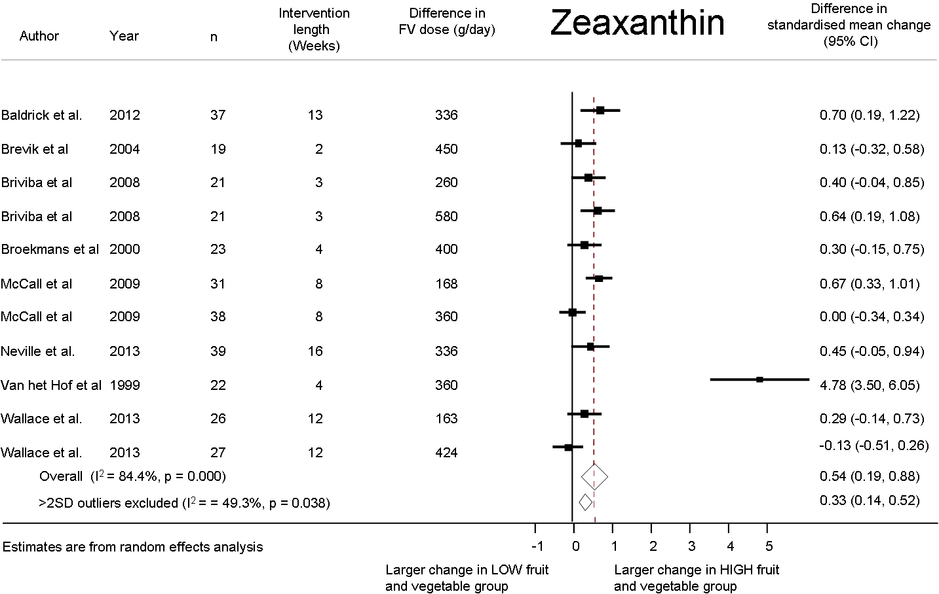
Supplementary figure 11: Pooled differences between arms consuming higher vs. lower amounts of fruit and vegetables in standardised mean change of total carotenoids from pre- to post-intervention in all studies with available data. I² is an indicator of between-trial heterogeneity. Random effects meta-analysis was used to pool mean differences.
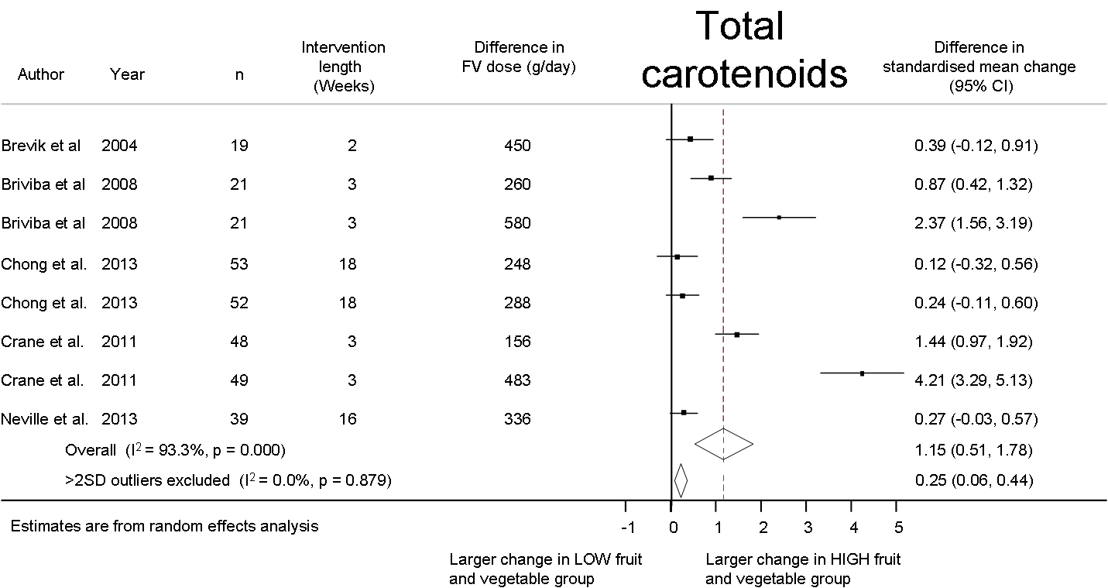
Supplementary figure 12: Summary of pooled differences between arms consuming higher vs. lower amounts of fruit and vegetables in standardised mean change of biomarkers from pre- to post-intervention in all studies with available data grouped by intervention delivery. I² is an indicator of between-trial heterogeneity. Random effects meta-analysis was used to pool mean differences.
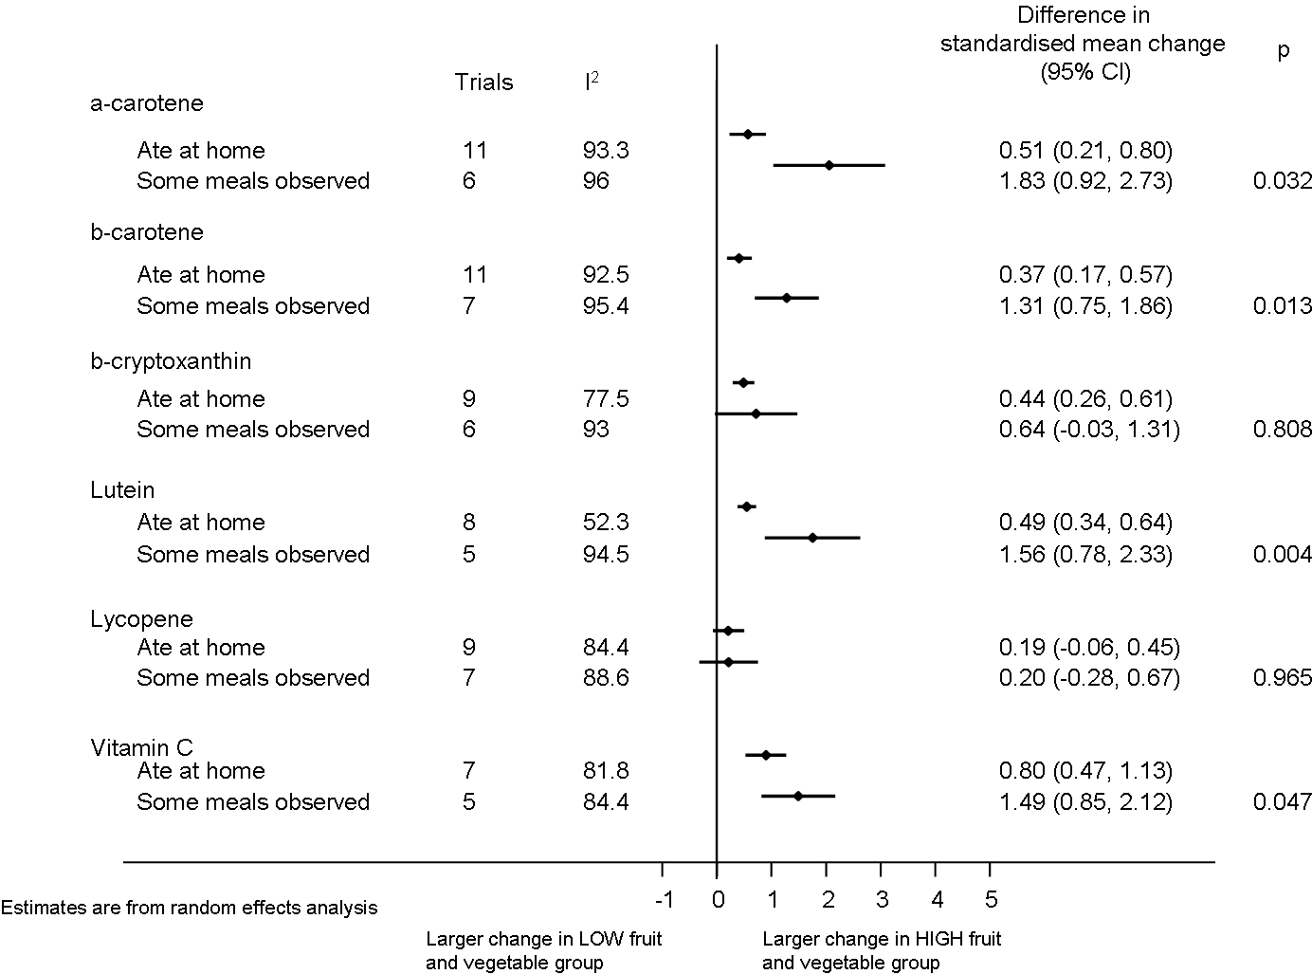
Supplementary figure 13: Summary of pooled differences between arms consuming higher vs. lower amounts of fruit and vegetables in standardised mean change of biomarkers from pre- to post-intervention in all studies with available data grouped by intervention duration. I² is an indicator of between-trial heterogeneity. Random effects meta-analysis was used to pool mean differences.
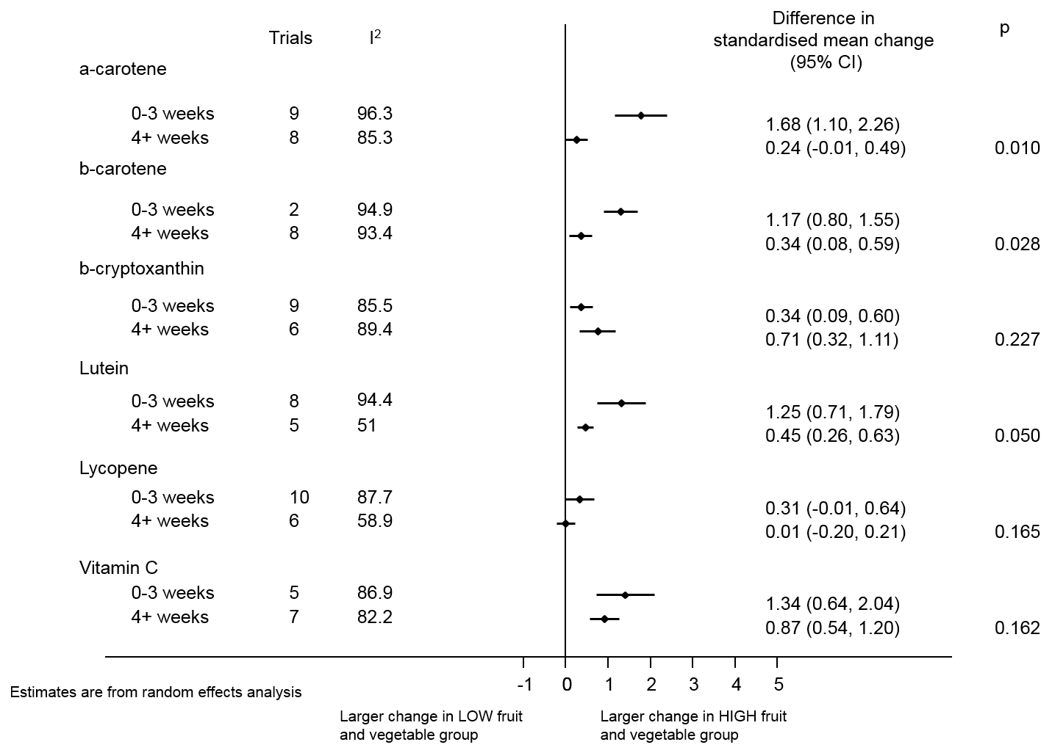
Supplementary figure 14: Summary of pooled differences between arms consuming higher vs. lower amounts of fruit and vegetables in standardised mean change of biomarkers from pre- to post-intervention in all studies with available data grouped by health status of the samples. I² is an indicator of between-trial heterogeneity. Random effects meta-analysis was used to pool mean differences.
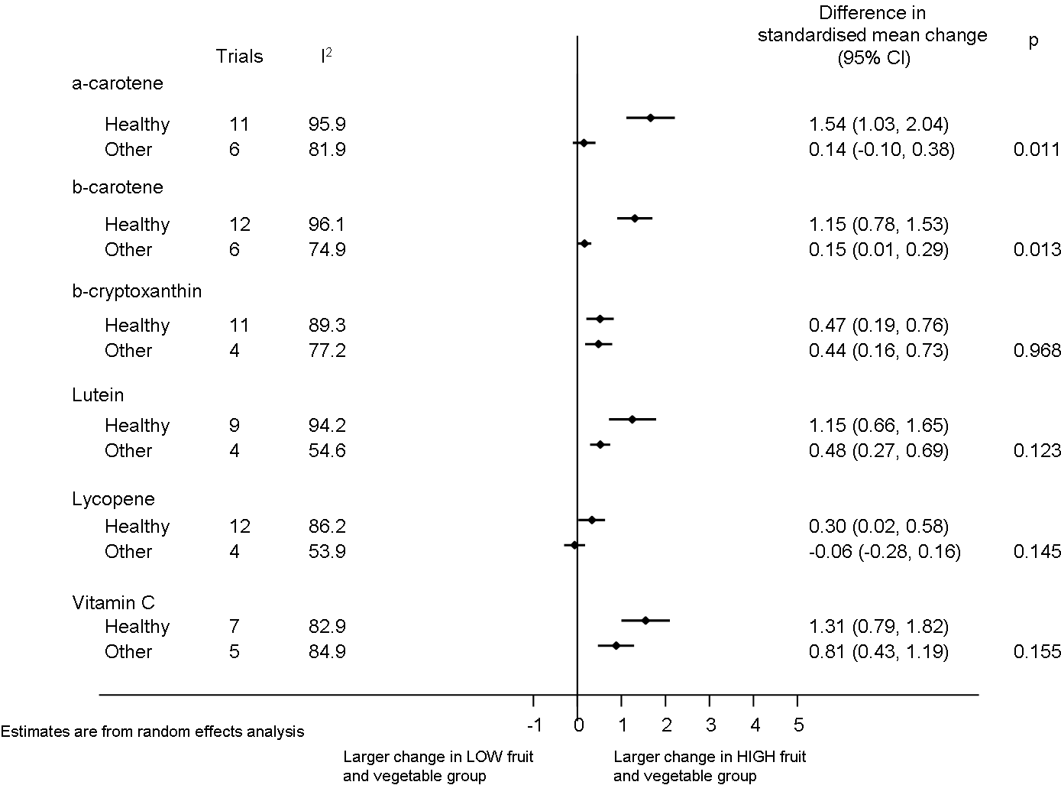
Supplementary figure 15: Summary of pooled differences between arms consuming higher vs. lower amounts of fruit and vegetables in standardised mean change of biomarkers from pre- to post-intervention in all studies with available data grouped by location of trial. I² is an indicator of between-trial heterogeneity. Random effects meta-analysis was used to pool mean differences.
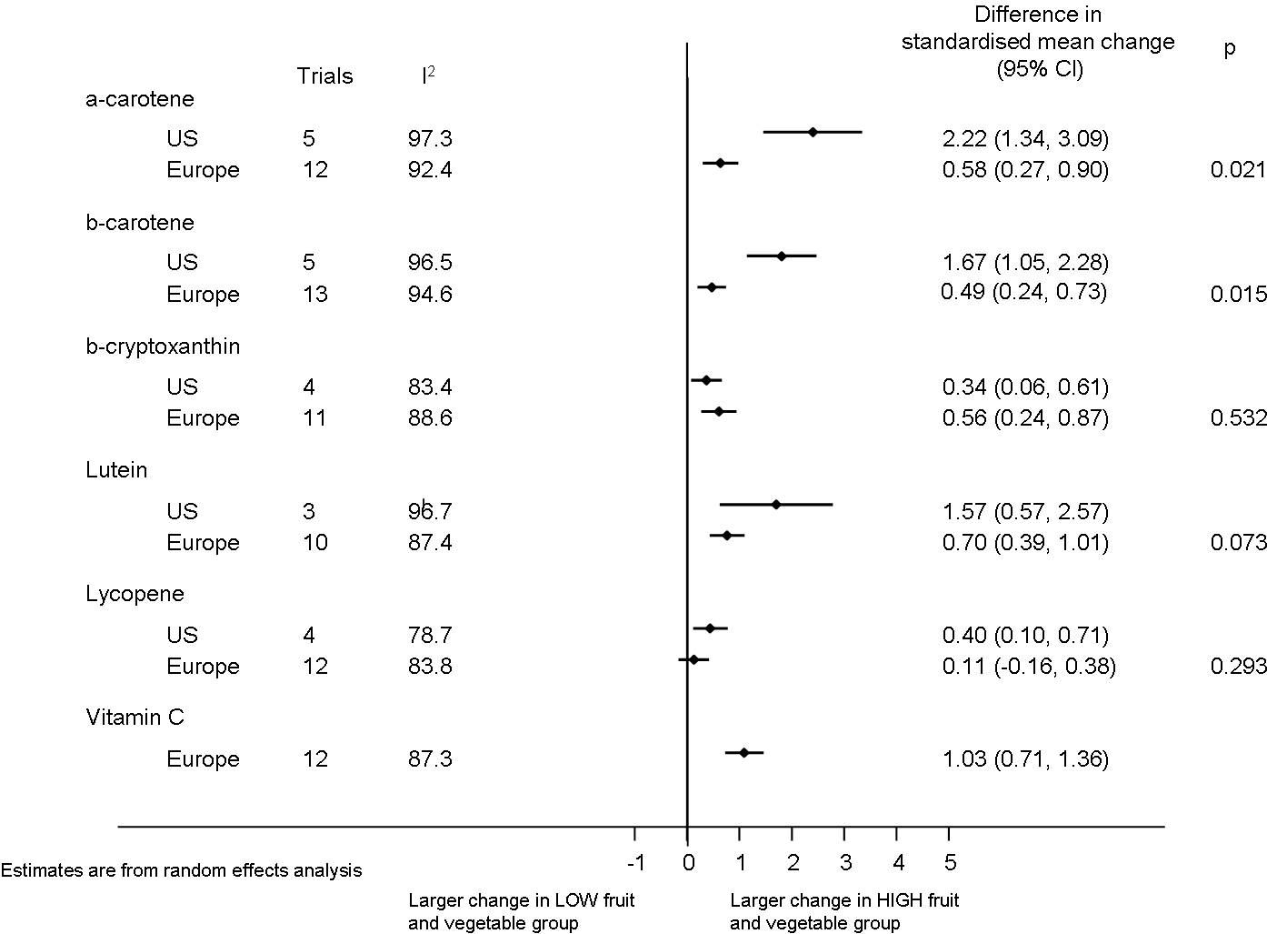
Supplementary figure 16: Summary of pooled differences between arms consuming higher vs. lower amounts of fruit and vegetables in standardised mean change of biomarkers from pre- to post-intervention in all studies with available data grouped by design of trial. I² is an indicator of between-trial heterogeneity. Random effects meta-analysis was used to pool mean differences.
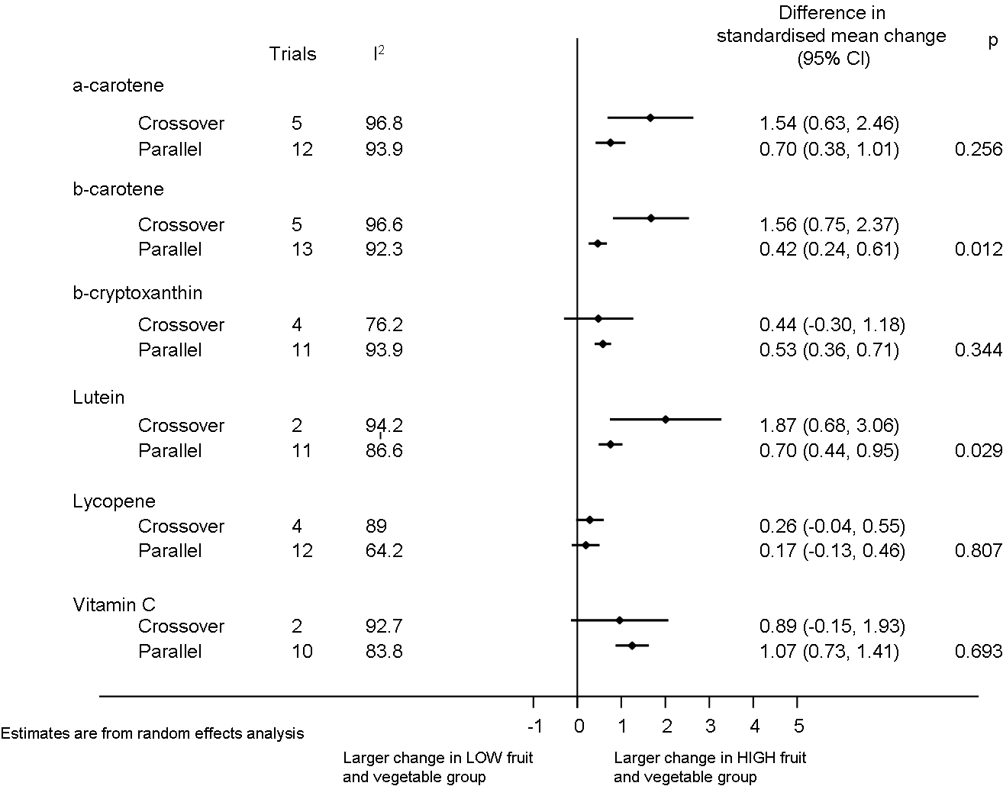
Supplementary figure 17: Summary of pooled differences between arms consuming higher vs. lower amounts of fruit and vegetables in standardised mean change of biomarkers from pre- to post-intervention in all studies with available data grouped by intervention foods. I² is an indicator of between-trial heterogeneity. Random effects meta-analysis was used to pool mean differences.
