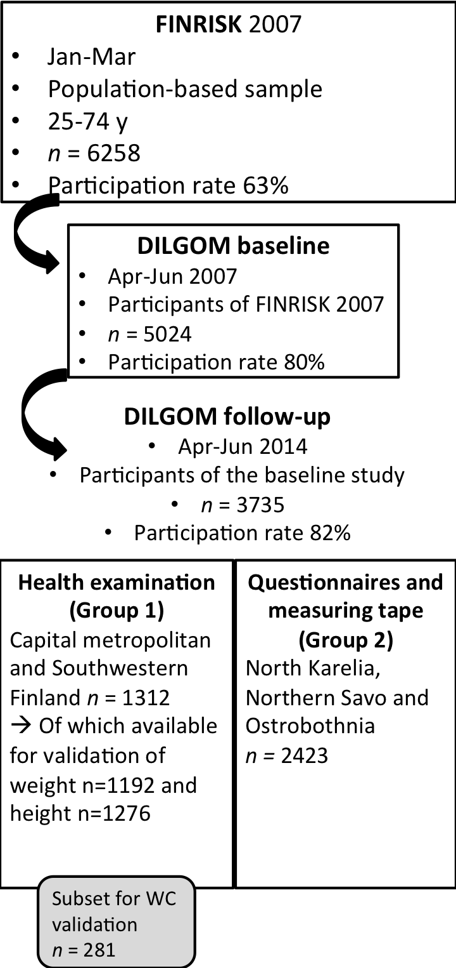
Supplementary Figure 1. Flowchart of the DILGOM 2014 Study population.

