Supplementary Appendix 1. International Classification of Diseases (ICD), 9th version.

Diseases of the Circulatory System 390-459
390-392 Acute Rheumatic Fever
- 390 Rheumatic fever without mention of heart involvement
- 391 Rheumatic fever with heart involvement
- 392 Rheumatic chorea
393-398 Chronic Rheumatic Heart Disease
- 393 Chronic rheumatic pericarditis
- 394 Diseases of mitral valve
- 395 Diseases of aortic valve
- 396 Diseases of mitral and aortic valves
- 397 Diseases of other endocardial structures
- 398 Other rheumatic heart disease
401-405 Hypertensive Disease
- 401 Essential hypertension
- 402 Hypertensive heart disease
- 403 Hypertensive chronic kidney disease
- 404 Hypertensive heart and chronic kidney disease
- 405 Secondary hypertension
410-414 Ischemic Heart Disease
- 410 Acute myocardial infarction
- 411 Other acute and subacute forms of ischemic heart disease
- 412 Old myocardial infarction
- 413 Angina pectoris
- 414 Other forms of chronic ischemic heart disease
415-417 Diseases of Pulmonary Circulation
- 415 Acute pulmonary heart disease
- 416 Chronic pulmonary heart disease
- 417 Other diseases of pulmonary circulation
420-429 Other Forms of Heart Disease
- 420 Acute pericarditis
- 421 Acute and subacute endocarditis
- 422 Acute myocarditis
- 423 Other diseases of pericardium
- 424 Other diseases of endocardium
- 425 Cardiomyopathy
- 426 Conduction disorders
- 427 Cardiac dysrhythmias
- 428 Heart failure
- 429 Ill-defined descriptions and complications of heart disease
430-438 Cerebrovascular Disease
- 430 Subarachnoid hemorrhage
- 431 Intracerebral hemorrhage
- 432 Other and unspecified intracranial hemorrhage
- 433 Occlusion and stenosis of precerebral arteries
- 434 Occlusion of cerebral arteries
- 435 Transient cerebral ischemia
- 436 Acute, but ill-defined, cerebrovascular disease
- 437 Other and ill-defined cerebrovascular disease
- 438 Late effects of cerebrovascular disease
440-449 Diseases of Arteries, Arterioles, And Capillaries
- 440 Atherosclerosis
- 441 Aortic aneurysm and dissection
- 442 Other aneurysm
- 443 Other peripheral vascular disease
- 444 Arterial embolism and thrombosis
- 445 Atheroembolism
- 446 Polyarteritis nodosa and allied conditions
- 447 Other disorders of arteries and arterioles
- 448 Disease of capillaries
- 449 Septic arterial embolism
451-459 Diseases of Veins and Lymphatics, And Other Diseases of Circulatory System
- 451 Phlebitis and thrombophlebitis
- 452 Portal vein thrombosis
- 453 Other venous embolism and thrombosis
- 454 Varicose veins of lower extremities
- 455 Hemorrhoids
- 456 Varicose veins of other sites
- 457 Noninfectious disorders of lymphatic channels
- 458 Hypotension
- 459 Other disorders of circulatory system

Neoplasms 140-239
140-149 Malignant Neoplasm of Lip, Oral Cavity, And Pharynx
150-159 Malignant Neoplasm of Digestive Organs and Peritoneum
160-165 Malignant Neoplasm of Respiratory and Intrathoracic Organs
170-176 Malignant Neoplasm of Bone, Connective Tissue, Skin, And Breast
179-189 Malignant Neoplasm of Genitourinary Organs
190-199 Malignant Neoplasm of Other and Unspecified Sites
200-209 Malignant Neoplasm of Lymphatic and Hematopoietic Tissue
Supplementary Appendix 2. Search strings for retrieval of records from PubMed and EMBASE databases.
PubMed
((Mediterranean[All Fields] AND ("diet"[MeSH Terms] OR "diet"[All Fields])) OR (("diet"[MeSH Terms] OR "diet"[All Fields] OR "dietary"[All Fields]) AND pattern[All Fields])) AND (("mortality"[Subheading] OR "mortality"[All Fields] OR "mortality"[MeSH Terms]) OR ("death"[MeSH Terms] OR "death"[All Fields])) AND English[lang]

EMBASE
(('mediterranean'/exp OR mediterranean) AND ('diet'/exp OR diet) OR (dietary AND pattern)) AND ('mortality'/exp OR mortality OR 'death'/exp OR death)
Supplementary Appendix 3. Plot of the directed acyclic graphs (DAG) for the association of Mediterranean diet and mortality. The graphical model is available at dagitty.net/mnIVR8A
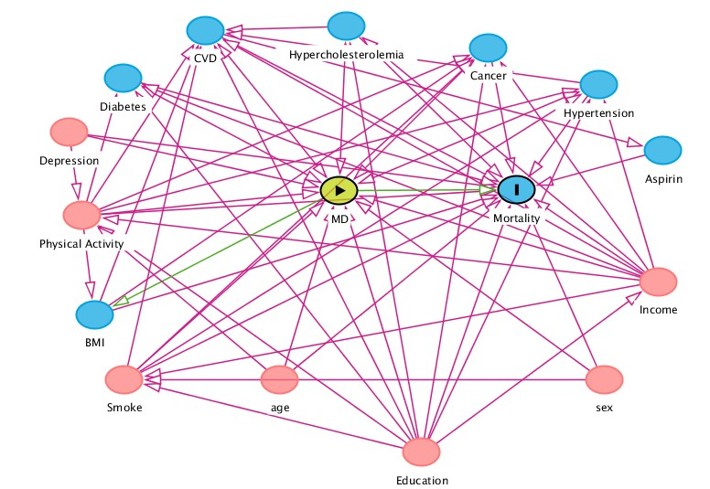
Supplementary Table 1. Median intake (g/d) of food groups included in the Mediterranean diet score (MDS) in the elderly sample of the Moli-sani cohort study.

 | Whole sample | Men | Women
N of subjects | 5,200 | 2,645 | 2,555
Fruits and nuts | 328 (199) | 344 (206) | 310 (188)
Vegetables | 137 (67) | 148 (68) | 130 (66)
Fish | 38 (26) | 39 (27) | 37 (26)
Cereals | 182 (85) | 199 (92) | 164 (70)
Legumes | 23 (22) | 24 (22) | 23 (22)
Monounsaturated/saturated fatty acids | 1.38 (0.31) | 1.42 (0.30) | 1.34 (0.32)
Meat and meat products | 86 (41) | 95 (43) | 77 (36)
Dairy products | 182 (116) | 166 (109) | 194 (121)
Moderate alcohol intake (%)* | 44.4 | 56.7 | 31.7

Values are reported as medians and standard deviation.
*Moderate alcohol intake is defined as ethanol consumption of 10–50 g/d and 5–25 g/d, for men and women, respectively.
Supplementary Figure 1. Adjusted dose-response association between Mediterranean diet score and risk of all-cause death in the elderly sample of the Moli-sani cohort study (n of subjects=5,200; n of all-cause deaths = 900). Risk estimates were obtained from the multivariable model adjusted for sex, age (continuous), education, household income, leisure-time physical activity, smoking status, BMI, cancer, CVD, diabetes, hypertension, hypercholesterolemia, use of antidepressants and energy intake. The Mediterranean diet score was considered as a continuous exposure and the reference value for hazard ratios was Mediterranean diet score=0. The dotted lines indicate 95% confidence bands. 3 knots were used, located at the 5th, 50th, and 95th percentiles of the Mediterranean diet score (2.0, 4.0, 7.0).

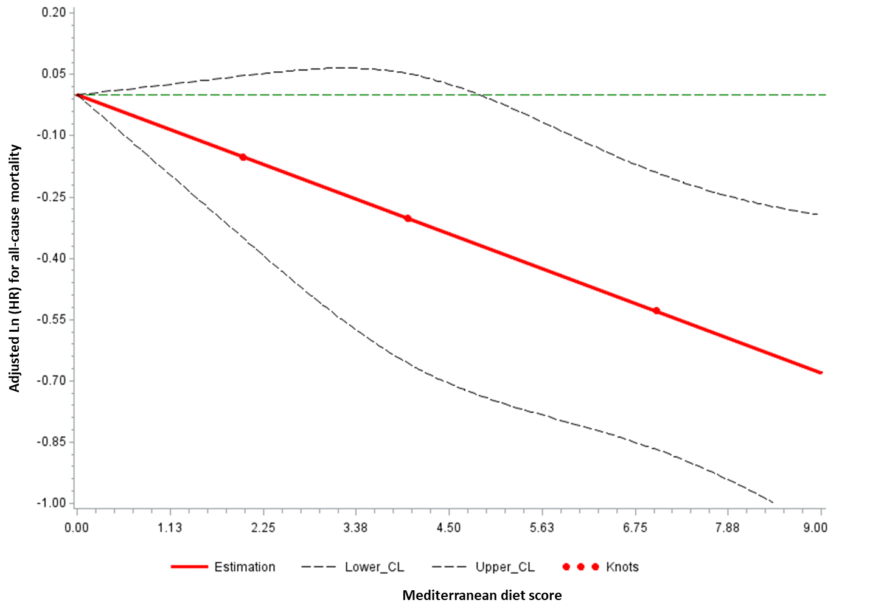

Supplementary Table 2 Hazard ratios (95% confidence intervals) for all-cause mortality at different levels of adherence to the Mediterranean diet in prospective cohort studies included in the dose-repose meta-analysis

 | All-cause mortality
First Author, year | HR (95%CI)
Sjögren, 2010
Total n=924 men
Low MD (0-2) | -1-
3-5 | 0.73 (0.52-1.00)
6-8 | 0.56 (0.33-0.96)
Tognon, 2011
Total n=1,037 men and women
Low MD (0-1) | -1-
2 | 1.04 (0.66-1.63)
3 | 0.90 (0.60-1.36)
4 | 0.87 (0.58-1.30)
5 | 0.77 (0.52-1.16)
6 | 0.76 (0.49-1.16)
7 | 0.61 (0.37-1.03)
8-9 | 0.54 (0.26-1.12)
Bonaccio, 2018 (Current study)
Total n =5,200 men and women
Low MD (0-1) | -1-
2 | 1.10 (0.72-1.69)
3 | 0.94 (0.63-1.41)
4 | 0.88 (0.59-1.31)
5 | 0.88 (0.59-1.32)
6 | 0.81 (0.53-1.22)
7 | 0.80 (0.51-1.26)
8-9 | 0.60 (0.33-1.10)

In study by Sjögren multivariable hazard ratios obtained from the model adjusted for energy intake, smoking, social class, type 2 diabetes, metabolic syndrome, lipid-lowering treatment, blood pressure–lowering treatment, waist circumference, diastolic blood pressure, insulin, and C-reactive protein.
In the study by Tognon multivariable hazard ratios obtained from the model adjusted for gender, baseline BMI, waist circumference, physical activity, marital status, smoking status, birth cohort, and education.
In the study by Bonaccio multivariable hazard ratios obtained from the model adjusted for sex, age, education, household income, leisure-time physical activity, smoking status, BMI, cancer, CVD, diabetes, hypertension, hypercholesterolemia, use of antidepressants and energy intake.
Supplementary Appendix 4. Moli-sani Study Investigators

The enrolment phase of the Moli-sani Study was conducted at the Research Laboratories of the Catholic University in Campobasso (Italy), the follow up of the Moli-sani cohort is being conducted at the Department of Epidemiology and Prevention of the IRCCS Neuromed, Pozzilli, Italy.

Steering Committee: Licia Iacoviello*°(Chairperson), Giovanni de Gaetano* and Maria Benedetta Donati*.
Scientific secretariat: Licia Iacoviello*° (Coordinator), Marialaura Bonaccio*, Americo Bonanni*, Chiara Cerletti*, Simona Costanzo*, Amalia De Curtis*, Giovanni de Gaetano*, Augusto Di Castelnuovo*, Maria Benedetta Donati*, Francesco Gianfagna*°, Mariarosaria Persichillo*, Teresa Di Prospero* (Secretary).
Safety and Ethycal Committee: Jos Vermylen (Catholic Univesity, Leuven, Belgio) (Chairperson), Ignacio De Paula Carrasco (Accademia Pontificia Pro Vita, Roma, Italy), Simona Giampaoli (Istituto Superiore di Sanità, Roma, Italy), Antonio Spagnuolo (Catholic University, Roma, Italy).
External Event adjudicating Committee: Deodato Assanelli (Brescia, Italy), Vincenzo Centritto (Campobasso, Italy).
Baseline and Follow-up data management: Simona Costanzo* (Coordinator), Marco Olivieri (Università del Molise, Campobasso, Italy).
Informatics: Marco Olivieri (Università del Molise, Campobasso, Italy).
Data Analysis: Augusto Di Castelnuovo* (Coordinator), Marialaura Bonaccio*, Simona Costanzo*, Alessandro Gialluisi*, Francesco Gianfagna*°, Emilia Ruggiero*.
Biobank and biomedical analyses: Amalia De Curtis* (Coordinator), Sara Magnacca*.
Genetic analyses: Benedetta Izzi* (Coordinator), Francesco Gianfagna*°, Claudio Grippi*, Annalisa Marotta*, Fabrizia Noro*.
Communication and Press Office: Americo Bonanni* (Coordinator), Francesca De Lucia (Associazione Cuore Sano, Campobasso, Italy).
Recruitment staff: Mariarosaria Persichillo* (Coordinator), Francesca Bracone*, Francesca De Lucia (Associazione Cuore Sano, Campobasso, Italy), Salvatore Dudiez*, Livia Rago*.
Follow-up Event adjudication: Livia Rago* (Coordinator), Simona Costanzo*, Amalia De Curtis*, Licia Iacoviello*°, Teresa Panzera*, Mariarosaria Persichillo*.
Regional Health Institutions: Direzione Generale per la Salute - Regione Molise; Azienda Sanitaria Regionale del Molise (ASReM, Italy); Molise Dati Spa (Campobasso, Italy); Offices of vital statistics of the Molise region.
Hospitals: Presidi Ospedalieri ASReM: Ospedale A. Cardarelli – Campobasso, Ospedale F. Veneziale – Isernia, Ospedale San Timoteo - Termoli (CB), Ospedale Ss. Rosario - Venafro (IS), Ospedale Vietri – Larino (CB), Ospedale San Francesco Caracciolo - Agnone (IS); Casa di Cura Villa Maria - Campobasso; Fondazione di Ricerca e Cura Giovanni Paolo II - Campobasso; IRCCS Neuromed - Pozzilli (IS).

* Department of Epidemiology and Prevention, IRCCS Neuromed, Pozzilli, Italy
°Department of Medicine and Surgery, University of Insubria, Varese, Italy

Baseline Recruitment staff is available at
http://www.moli-sani.org/index.php?option=com_content&task=view&id=21128&Itemid=118

