Supplementary Figure 1: Bland-Altman plots of difference in (a) resting metabolic rate (RMR) versus average RMR; (b) oxygen consumption (VO₂) versus average VO₂.
The solid line represents the expected difference in (a) RMR and (b) VO₂ measured by QUARK RMR and Fitmate GS, while the dashed lines represent the regression-based upper and lower 95% limits of agreement (expected difference derived from the line of best agreement ± 1.96 * residual SD from the regression). Grey dots represent males and black dots represent females.
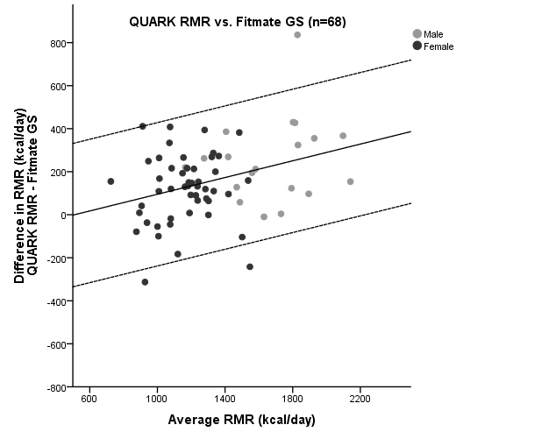
a.

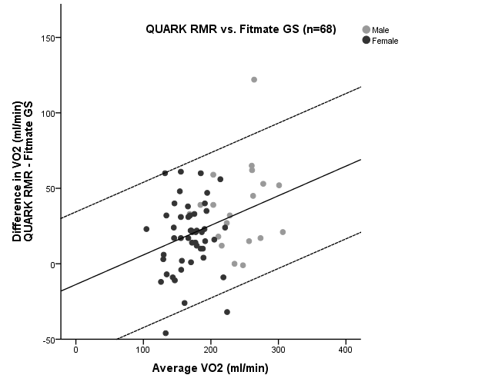
b.

