Supporting information
Figure S1.
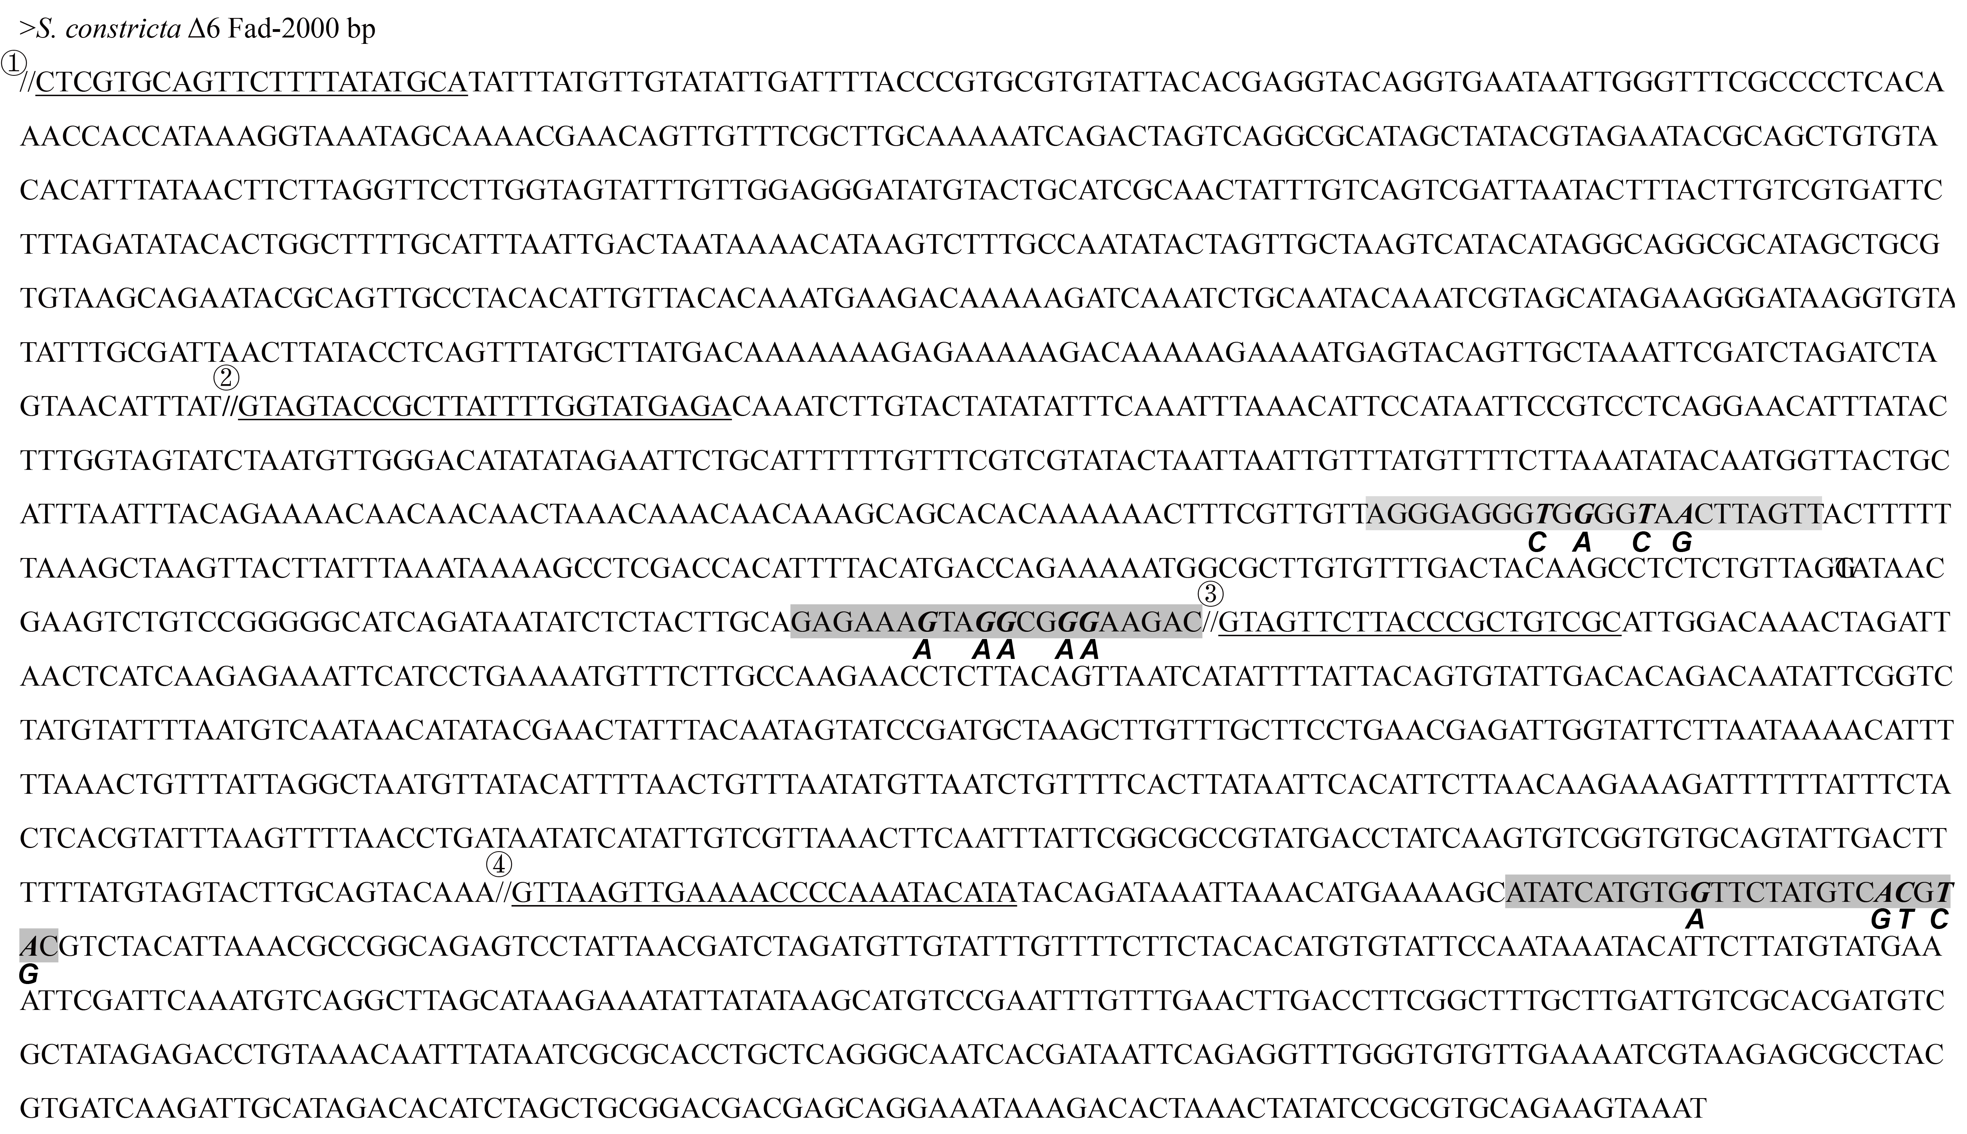
Figure S1. Potential binding sites for S. constricta SREBP on Δ6 Fad promoter by bioinformatic analysis. The numbers indicate the site at which the S. constricta Δ6 Fad promoter is segmented. The grey sequences are the software-predicted SREBP binding sites. The bolded and slanted bases are the designed mutation sites, below which are the corresponding mutated bases.

