Supplementary Information
Long-term vitamin D deficiency promotes renal fibrosis and functional impairment in middle-aged male mice
Zhi-Hui Zhang^{1,2, ♯}, Biao Luo^{2, ♯}, Shen Xu¹, Zhi-Cheng Zhang², Wei-Yang Xing¹, Yuan-Hua Chen², Cheng Zhang^{2,3}, Hua Wang^{2,3}, Dong-Dong Xie^{1,}*, De-Xiang Xu^{2,3,}*
¹Second Affiliated Hospital, Anhui Medical University, Hefei 230601, China
²Department of Toxicology, Anhui Medical University, Hefei 230032, China
³Laboratory of Environmental Toxicology, Anhui Medical University, Hefei 230032, China
♯These authors contributed equally to this work.
Abbreviations: CKD, chronic kidney disease; EMT, epithelial-mesenchymal transition; PNW, postnatal week; RIA, radioimmunoassay; RT-PCR, reverse transcription-polymerase chain reaction; TGF-β, transforming growth factor beta; VDD, vitamin D deficiency; VDR, vitamin D receptor.
Keywords:Vitamin D deficiency; Renal fibrosis; Epithelial-mesenchymal transition
* Corresponding authors
Correspondence should be addressed to: Prof. De-Xiang Xu, Department of Toxicology, Anhui Medical University, Hefei 230032, China. E-mail address: xudex@126.com; Dr. Dong-Dong Xie, Department of Urology, Second Affiliated Hospital, Anhui Medical University, Hefei 230032, China. E-mail: xiedd_urology@163.com.
Running Head: Vitamin D deficiency promotes renal fibrosis

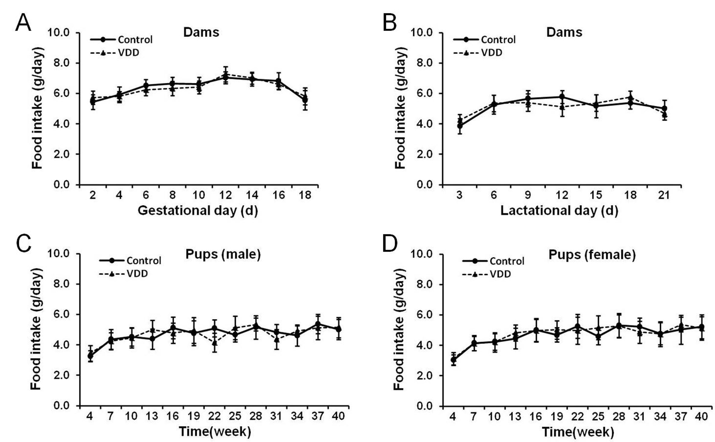
Fig. S1. Daily food intake of dams and pups. (A) Daily food intake of dams during pregnancy (N=8). (A) Daily food intake of dams during lactation (N=10). (C). Daily food intake of male pups (N=10~15). (D) Daily food intake of female pups (N=10~14). Data were expressed as means ± S.E.M.

