Appendix

Table A1. Subgroup analysis to assess the effects of resistant starch supplementation on fasting plasma insulin
 | No. of trials | I² | Effect size | 95% CI |  | P
(1) Intervention duration
< 8 weeks | 9 | 5.3% | 0.98 | (-2.54, 4.50) |  | 0.59
≥ 8 weeks | 6 | 70.8% | -8.64 | (-15.83, -1.44) |  | 0.02
(2) Dosage of resistant starch
< 28 g/d | 10 | 53.3% | -1.62 | (-6.27, 3.02) |  | 0.49
≥ 28 g/d | 5 | 65.6% | -0.23 | (-4.54, 4.08) |  | 0.92
(3) Mean age of subjects
< 50 | 10 | 54.9% | -0.20 | (-3.62, 3.23) |  | 0.91
≥ 50 | 5 | 60.6% | -4.72 | (-12.87, 3.43) |  | 0.26
(4) Health status
Healthy | 7 | 26.2% | -1.27 | (-6.49, 3.94) |  | 0.63
Overweight or high risk of having diabetes | 7 | 73.8% | -0.57 | (-4.65, 3.52) |  | 0.79
Diabetes | 1 | - | -1.90 | (-18.83, 15.03) |  | 0.83
(5) Study Design
Crossover design | 12 | 61.2% | -1.35 | (-4.64, 1.94) |  | 0.42
Parallel design | 3 | 0 | 4.63 | (-6.57, 15.82) |  | 0.42
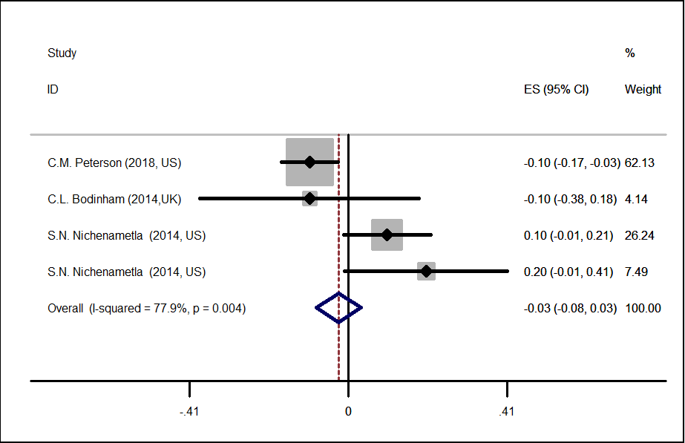

Figure A1. Forest plot of the effect of resistant starch supplementation on glycated hemoglobin by a random effects model. The p value for the overall effect was 0.39. The diamond denotes the overall estimated effect, and the horizontal lines denote the 95% CI. The grey bar denotes the weight percentage.

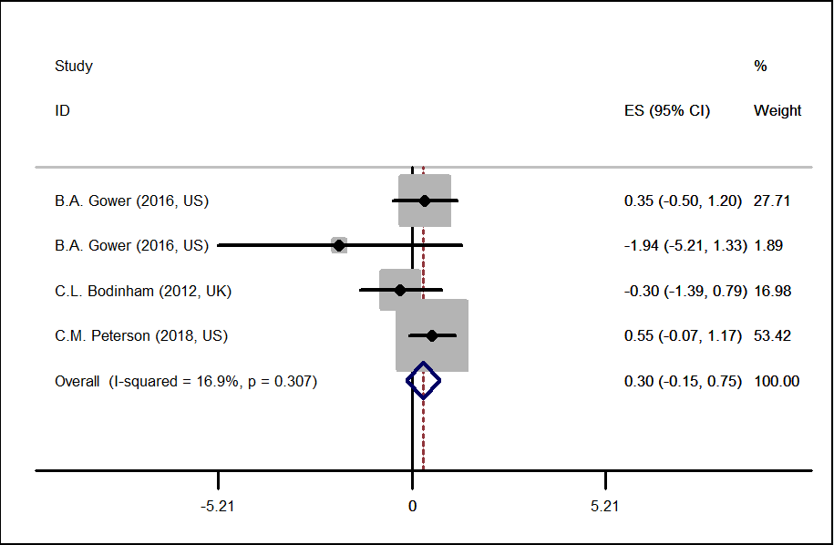

Figure A2. Forest plot of the effect of resistant starch supplementation on the insulin sensitivity index by a random effects model. The p value for the overall effect was 0.19. The diamond denotes the overall estimated effect, and the horizontal lines denote the 95% CI. The grey bar denotes the weight percentage.

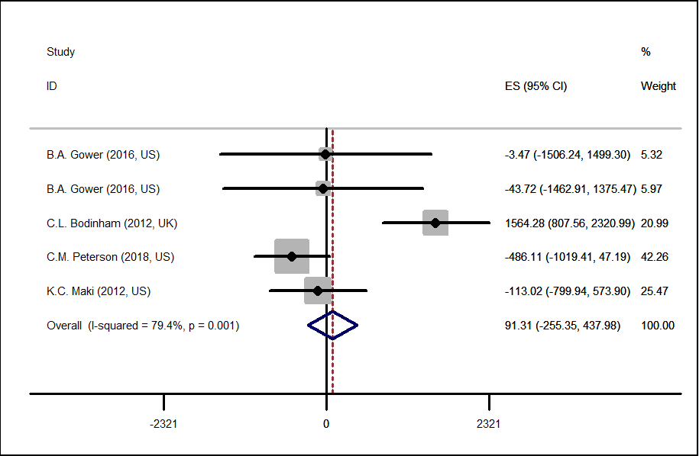

Figure A3. Forest plot of the effect of resistant starch supplementation on the acute insulin response by a random effects model. The p value for the overall effect was 0.61. The diamond denotes the overall estimated effect, and the horizontal lines denote the 95% CI. The grey bar denotes the weight percentage.

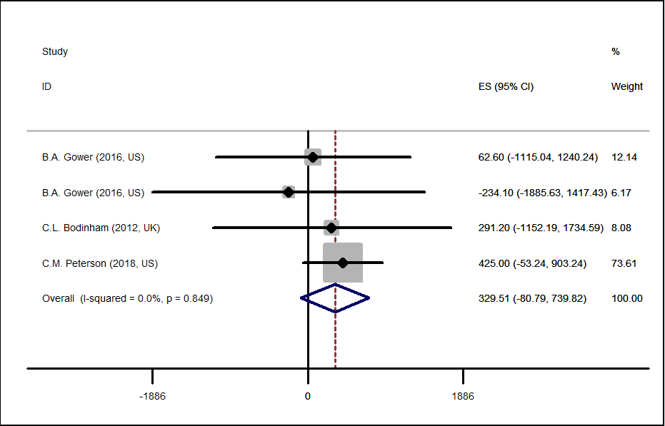

Figure A4. Forest plot of the effect of resistant starch supplementation on the disposition index by a random effects model. The p value for the overall effect was 0.12. The diamond denotes the overall estimated effect, and the horizontal lines denote the 95% CI. The grey bar denotes the weight percentage.

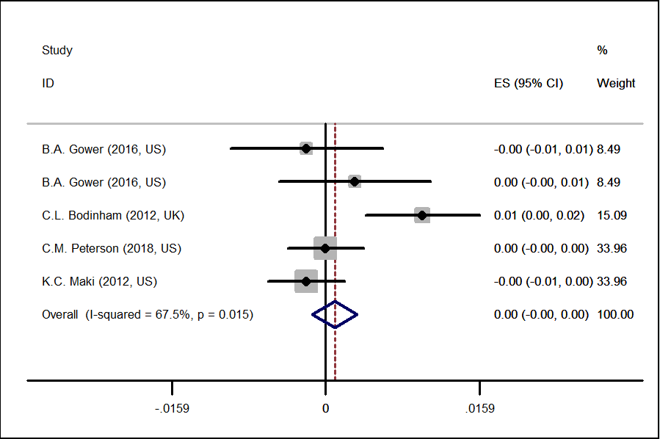

Figure A5. Forest plot of the effect of resistant starch supplementation on the glucose effectiveness by a random effects model. The p value for the overall effect was 0.43. The diamond denotes the overall estimated effect, and the horizontal lines denote the 95% CI. The grey bar denotes the weight percentage.

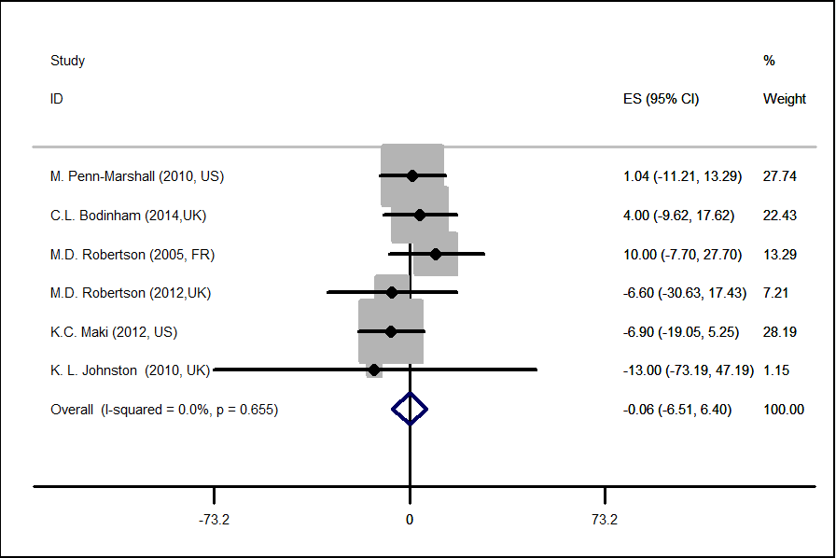

Figure A6. Forest plot of the effect of resistant starch supplementation on HOMA-β by a random effects model. The p value for the overall effect was 0.99. The diamond denotes the overall estimated effect, and the horizontal lines denote the 95% CI. The grey bar denotes the weight percentage.

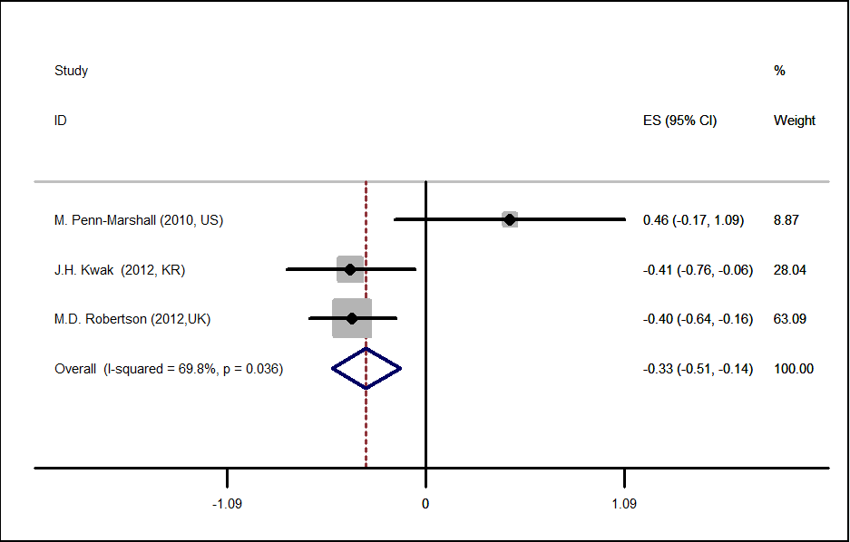

Figure A7. Forest plot of the effect of resistant starch supplementation on HOMA-IR by a random effects model. The p value for the overall effect was 0.001.The diamond denotes the overall estimated effect, and the horizontal lines denote the 95% CI. The grey bar denotes the weight percentage.

