SUPPLEMENTARY DATA

Table S1 Full search strategy performed on PubMed

Table S2 Characteristics of excluded studies [ordered by study ID]

Table S3 Characteristics of the interventions according to oral nutrition therapy, assessment of adherence to the planned trials’ protocol, and authors’ conflict of interests disclosures from primary studies

Table S4 Reasons for classification of risk of bias in primary studies according to RoB 2

Table S5 Univariate meta-regression analysis of the effect of nutritional intervention on body weight

Table S6 Univariate meta-regression analysis of the effect of nutritional intervention on handgrip and quadriceps strength

Figure S1 Risk of bias summary: review authors’ judgements for individual studies included

Figure S2 Funnel plot for body weight

Figure S3 Funnel plot for lean body mass

Figure S4 Funnel plot for handgrip strength

Figure S5 Funnel plot for quadriceps strength

Table S1 Full search strategy performed on PubMed, lasted performed in May 18th, 2021.
PICO Component |  | Search strategy in PubMed
#1 | Population | (((((((((((((((((((((((((((Pulmonary Disease, Chronic Obstructive [Title/Abstract]) OR (COPD[Title/Abstract])) OR (Chronic Obstructive Pulmonary Disease[Title/Abstract])) OR (COAD[Title/Abstract])) OR (Chronic Obstructive Airway Disease[Title/Abstract])) OR (Chronic Obstructive Lung Disease[Title/Abstract])) OR (Airflow Obstruction, Chronic[Title/Abstract])) OR (Airflow Obstructions, Chronic[Title/Abstract])) OR (Chronic Airflow Obstructions[Title/Abstract])) OR (Chronic Airflow Obstruction[Title/Abstract])) OR (Bronchitis, Chronic[Title/Abstract])) OR (Pulmonary Emphysema[Title/Abstract])) OR (Lung Diseases, Obstructive[Title/Abstract])) OR (Lung Disease, Obstructive[Title/Abstract])) OR (Obstructive Lung Disease[Title/Abstract])) OR (Obstructive Lung Diseases[Title/Abstract])) OR (Obstructive Pulmonary Diseases[Title/Abstract])) OR (Obstructive Pulmonary Disease[Title/Abstract])) OR (Pulmonary Disease, Obstructive[Title/Abstract])) OR (Pulmonary Diseases, Obstructive[Title/Abstract])) OR (alpha 1-Antitrypsin Deficiency[Title/Abstract])) OR (COPD, Severe Early-Onset[Title/Abstract]))) OR (Pulmonary Disease, Chronic Obstructive[Title/Abstract])) OR (Bronchitis, Chronic[Title/Abstract])))
#2 | Intervention | ((((((((((((((((((((((((((((((((((((((((((((Diet[Title/Abstract]) OR (Diets[Title/Abstract])) OR (Nutrition Therapy[Title/Abstract])) OR (Therapy, Nutrition[Title/Abstract])) OR (Medical Nutrition Therapy[Title/Abstract])) OR (Nutrition Therapy, Medical[Title/Abstract])) OR (Therapy, Medical Nutrition[Title/Abstract])) OR (Diet Therapy[Title/Abstract])) OR (Nutritional Support[Title/Abstract])) OR (Support, Nutritional[Title/Abstract])) OR (Dietary Supplements[Title/Abstract])) OR (Dietary Supplement[Title/Abstract])) OR (Supplements, Dietary[Title/Abstract])) OR (Dietary Supplementations[Title/Abstract])) OR (Supplementations, Dietary[Title/Abstract])) OR (Food Supplementations[Title/Abstract])) OR (Food Supplements[Title/Abstract])) OR (Food Supplement[Title/Abstract])) OR (Supplement, Food[Title/Abstract])) OR (Supplements, Food[Title/Abstract])) OR (Food, fortificated[Title/Abstract])) OR (Food, fortification[Title/Abstract])) OR (Energy intake[Title/Abstract])) OR (Protein intake[Title/Abstract])) OR (Energy drinks[Title/Abstract])) OR (Energy drink[Title/Abstract])) OR (Drink, energy[Title/Abstract])) OR (Drinks, energy[Title/Abstract])) OR (Energy supplements[Title/Abstract])) OR (Protein supplements[Title/Abstract])) OR (Calorie supplement[Title/Abstract])) OR (Protein, Whey[Title/Abstract])) OR (Proteins, Whey[Title/Abstract])) OR (Whey protein[Title/Abstract])) OR (Creatine[Title/Abstract])) OR (Amino acids[Title/Abstract])) OR (Amino Acids, Peptides,[Title/Abstract] AND Proteins[Title/Abstract])) OR (BCAA[Title/Abstract])) OR (Nutritional intervention[Title/Abstract])) OR (Enteral nutrition support[Title/Abstract])) OR (Whey peptide[Title/Abstract])) OR (Nutritional supplement therapy[Title/Abstract])) OR (Essential amino acids supplementation[Title/Abstract])) OR (Nutrient Supplementation[Title/Abstract]))
#3 | Study design | ((randomized controlled trial[pt] OR controlled clinical trial[pt] OR randomized[tiab] OR placebo[tiab] OR drug therapy[sh] OR randomly[tiab] OR trial[tiab] OR groups[tiab] NOT (animals [mh] NOT humans [mh]))))
Combined search |  | #1 AND #2 AND #3

Table S2 Characteristics of excluded studies [ordered by study ID]

Study | Reason for exclusion
Angelillo, 1985 ⁽⁷¹⁾ | Supplementation given only for five days.
Benito-Martinez, 2017 ⁽⁷²⁾ | Study population with diverse lung diseases.
Cai, 2003 ⁽⁷³⁾ | Herbal intervention.
Calder, 2018 ⁽⁷⁴⁾ | Provision of similar amounts of protein and calories in both groups.
Camere, 2016 ⁽⁷⁵⁾ | Only abstract available.
Collins, 2014 ⁽⁷⁶⁾ | Only abstract available.
Gurgun, 2011 ⁽⁷⁷⁾ | Only abstract available.
Ingadottir, 2020 ⁽⁷⁸⁾ | Outcome not relevant to this review.
Laviolette, 2010 ⁽⁷⁹⁾ | Provision of similar amounts of protein and calories in both groups.
Matsuyama, 2005 ⁽⁸⁰⁾ | Publication retracted (fraudulent).
Ogasawara, 2018 ⁽⁸¹⁾ | Outcome not relevant to this review.
Planas, 2005 ⁽⁸²⁾ | Comparison between two active supplementations
Raizada, 2014 ⁽⁸³⁾ | Non-randomized prospective study.
Sugawara, 2011 ⁽⁸⁴⁾ | Only abstract available.
Tümer, 2009 ⁽⁸⁵⁾ | No placebo/control intervention.
Zongxing, 2005 ⁽⁸⁶⁾ | Outcome not relevant to this review.

Table S3 Characteristics of the interventions according to oral nutrition therapy, assessment of adherence to the planned trials’ protocol, and authors’ conflict of interests disclosures from primary studies
Author, year | Oral nutrition therapy characteristics |  | Intervention time  (weeks) | Mean difference energy and protein intake between intervention and control group | Method of adherence measure | Funding, including role in study and authors’ COI disclosures
Author, year | Intervention group (IG) | Control group (CG)
Lewis/1987 ⁽³⁹⁾ | ONS: Isocal HCN®, 2 kcal/mL (40% CHO, 45% fat, and 15% prot), 240 – 480mL/day  ONS goal: provide 500–1000 kcal/day and 19–38 g prot/day  + usual diet | Usual diet | 8 | 208 kcal/day  15.4g/day | NR | No information given
Efthimiou/1988 ⁽⁴⁰⁾ | ONS: Build-up® (Carnation), each ONS sachet mixed with 237 mL of whole milk: 320 kcal and 18 g prot, two to four times/day  ONS goal: months four to six, to reach  2,500 kcal/day and 90g prot/day (men) or  2,300 kcal/day and 80g prot/day (women)  Normal diet: months one to three, and seven to nine | Normal diet | 12 | 681 kcal/day  25.9g/day | NR | No information given
Knowles/1988 ⁽⁵¹⁾ | ONS: Sustacal® (54% CHO, 22% fat, and 24% prot)  ONS goal: increase caloric intake about 50% above normal level | Usual diet | 8 | 458.9 kcal/day  Protein NR | Daily food diary | No information given

(continued on next page)

Table S3 Continued
Author, year | Oral nutrition therapy characteristics |  | Intervention time  (weeks) | Mean difference energy and protein intake between intervention and control group | Method of adherence measure |  | Funding, including role in study and authors’ COI disclosures
Author, year | Intervention group (IG) | Control group (CG)
Otte/1989 ⁽⁶²⁾ | ONS: Novo® (1 kcal/mL, 50% CHO, 30% fat, and 20% prot)  ONS goal: 400 kcal/day and 20 g prot/day | Placebo: same consistency and taste than ONS, but 0.1 Kcal/mL, and 0.005g prot/mL | 13 | NR | A nurse connected to the study visited the patients every 14th day, she ensured correct administration |  | NOVO (Bagsvaerd, Denmark) provided the nutritional formula and reference product to the study.
Fuenzalida/1990 ⁽⁶⁵⁾ | ONS: Sustacal HC® (1.5 kcal/mL, 50% CHO, 29% fat, and 16% prot)  ONS goal: from 360 kcal to 1,080kcal/day + Hospital Diet | Hospital Diet | 6 | 67.1 kcal/day  Protein NR | NR |  | No information given
Entrenas Costa/1991 ⁽⁶⁶⁾ | ONS: Pulmocare® (1.5 Kcal/mL, 28% CHO, 55.2% fat, and 16.7% prot)  ONS goal: increase caloric intake with ONS by up to 1.5 times BEE | Hospital Diet | 2.25 | NR | NR |  | No information given
Rogers/1992 ⁽⁶⁷⁾ | Varied ONS (with eating plan: 1.7 x REE and 1.5g prot /kg) | Usual diet (hospitalized at week 1 and 4 of the study) | 3 | NR | NR |  | No information given
Ganzoni/1994 ⁽⁶⁸⁾ | ONS: Fresubin OP® 200 mL, one to two times/day  Fats and carbohydrates addition in all meals (small and frequents) | Normocaloric diet | 48 | -25.5 kcal/day  Protein NR | Caloric intake at three-month intervals was monitored, but NR the assessment method used |  | No information given

(continued on next page)

Table S3 Continued
Author, year | Oral nutrition therapy characteristics |  | Intervention time  (weeks) | Mean difference energy and protein intake between intervention and control group | Method of adherence measure | Funding, including role in study and authors’ COI disclosures
Author, year | Intervention group (IG) | Control group (CG)
Schols/1995 ⁽⁶⁹⁾ | ONS: high-caloric drink mix (Nutridrink®, Protifar®, Fantomalt®, and oil), 200 mL (35% CHO, 51% fat, and 14% prot) daily high caloric liquid supplement (420 kcal/200 ml:  ONS goal: 420 kcal/day | No ONS | 8 | 531.9 kcal/day  Protein NR | Supplement intake was recorded daily | No information given
Saudny-Unterberger/1997 ⁽⁷⁰⁾ | ONS: Ensure®, Ensure Plus®, or  A variety of puddings, or extra snacks  ONT goal: to assure a caloric intake ≥1.5x REE, if normal BMI and at ≥ 1.7x REE, if low BMI | Hospital diet | 2 | 355 kcal/day  10g/day | NR | Supplements were provided by Abbott Laboratories, Montreal, Canada.
Goris/2003 ⁽⁴¹⁾ | ONS: Respifor® (1.5 kcal/mL, 60% CHO, 20% fat, and 20% prot), three times/day  ONT goal: 560 kcal/day  + nutritional advices from a dietitian on how to increase their energy intake. | Nutritional advices from a dietitian on how to increase their energy intake | 12 | 143.3 kcal/day  Protein NR | NR | No information given
Steiner/2003 ⁽⁴²⁾ | ONS: Respifor® (1.5 kcal/mL, 60% CHO, 20% fat, and 20% prot), three times/day  ONS goal: 570 kcal/day | Placebo: packed and flavored identically from ONS (non-nutritive) | 7 | 407 kcal/day  24.1g/day | Self-reported compliance with the supplement (% cartons  taken/cartons prescribed) | No information given

(continued on next page)

Table S3 Continued
Author, year | Oral nutrition therapy characteristics |  | Intervention time  (weeks) | Mean difference energy and protein intake between intervention and control group | Method of adherence measure | Funding, including role in study and authors’ COI disclosures
Author, year | Intervention group (IG) | Control group (CG)
Vermeeren/2004 ⁽⁴³⁾ | ONS: Respifor® (1.5 kcal/mL, 60% CHO, 20% fat, and 20% prot), three times/day  ONS goal: 570 kcal/day | Placebo: vanilla flavored  water with 0 kcal/day | 1.29 | 355.9 kcal/day  30 g/day | Monitored by the nurses | The study was supported by Numico Research BV, The Netherlands
Fuld/2005 ⁽⁴⁴⁾ | ONS: Creatine (Cr) + glucose polymer (5 g Cr and 35 g glucose/dose).  A. Loading phase: three times/day (14 days)  B. Maintenance phase: one time/day (10 wk) | Placebo: glucose polymer 40.7 g | 12 | NR | NR | Authors declared no COI
Faager/2006 ⁽⁴⁵⁾ | ONS: Creatine (0.3 g/kg BW/d) first 7 d, and 0.07 g/kg BW/d next 7 wk | Placebo: glucose | 8 | NR | Urine 24 h  1 wk from trial start and at 8 wk, and 2 mo after the end of ONS intake | No information given
Deacon/2008 ⁽⁴⁴⁾ | ONS: Creatine monohydrate (Cr) loaded for 5 days (22 g, divided in four doses/day), followed by maintenance during PR (3.76 g/d). | Placebo: Similar texture and appearance powder: Lactose for 5 days(24 g divided in four doses/day), followed by 4 g/day during PR | 1.71 | NR | Self-reported and ONS empty tub return | Authors declared no COI
Weekes/2009 ⁽⁴⁷⁾ | Tailored dietary advice and counseling and  Food Fortification (FF): whole milk powder, to “fortify” 1 pint of full-cream milk. FF goal: provide 200 to 300 kcal and 7 to 11 g of prot/day | Leaflet providing advice on nourishing snacks and drinks and encouraging FF during baseline assessment (content was never discussed) | 24 | 194 kcal/day  11.8 g/day | 5-day dietary diaries (months 1, 3, 6, 7, 9 and 12) | None declared.

(continued on next page)

Table S3 Continued
Author, year | Oral nutrition therapy characteristics |  | Intervention time  (weeks) | Mean difference energy and protein intake between intervention and control group | Method of adherence measure | Funding, including role in study and authors’ COI disclosures
Author, year | Intervention group (IG) | Control group (CG)
Baldi/2010 ⁽⁴⁸⁾ | ONS: liquid supplements of 200 mL each, Aminotrofic® (EAAs mixture 4 g), two times/day | No ONS | 12 | -90 kcal/day  Protein NR | Assessed but NR how | Authors declared no COI
Dal Negro/2010 ⁽⁴⁹⁾ | ONS: Aminotrofic® (EAAs mixture 4g) , two times/day | Placebo: indistinguishable from ONS | 12 | NR | NR | No information given
Sugawara/2010 ⁽⁵⁰⁾ | ONS: Nutritional drink 200 mL (60% CHO, 25% fat, and 15% prot, enriched with w-3 PUFA, and vitamin A), two times/day  ONS goal: 400 kcal/day  + Encouraged to consume regular meal portions | Monthly 45-min education program (COPD and dyspnea control, medication and equipment use, nutrition, stress management, and relaxation techniques) | 12 | NR | NR | Authors declared no COI
Dal Negro/2012 ⁽⁵²⁾ | ONS: Aminotrofic® (EAAs mixture 4g) , two times/day | Placebo | 12 | -75.5 kcal/day  -5.8 g/day | NR | No information given
Sugawara/2012 ⁽⁵³⁾ | ONS: Meint® 200 mL (1.0 kcal/mL, 53% CHO, 25% fat, and 20% whey protein), two times/day | Normal meals alone with dietary instruction | 12 | -2.5 kcal/day  -1.5 g/day | Daily intake of ONS was confirmed in a diary. | Authors declared no COI
Constantin/2013 ⁽⁵⁴⁾ | ONS: 19g prot and 49g glucose polymer in 500 mL of water. | Placebo: identical volume, noncaloric drink | 8 | NR | ONS intake was supervised and took place immediately after each training session (three times/wk) | None declared

(continued on next page)

Table S3 Continued
Author, year | Oral nutrition therapy characteristics |  | Intervention time  (weeks) | Mean difference energy and protein intake between intervention and control group | Method of adherence measure | Funding, including role in study and authors’ COI disclosures
Author, year | Intervention group (IG) | Control group (CG)
Gurgun/2013 ⁽⁵⁵⁾ | ONS: nutritional drink 250 mL (53.3% CHO, 30% fat, and 16.7% prot), three times/day  + encouragement to continue the consumption of their own meal portions. | Usual medical standard of care | 8 | NR | Patient’s daily intake was checked by controlling their food diary. | No information given
Marinari/2013 ⁽⁵⁶⁾ | ONS: EufortynLios® (Creatine 170 mg + 160 mg Coenzyme Q-Ter), two times/day | Placebo: bags apparently identical to ONS | 8 | NR | NR | Authors declared no COI
Ahnfeldt-Mollerup/2015 ⁽⁵⁷⁾ | ONS: Protein bar (134.8 kcal, 14.6g CHO, 4.2g fat, and 9.3 prot), two times/day | Exercise only | 9 | -89.6 kcal/day  -2.50 g/day | Staff at the PRP distributed the protein bars to the participants and followed up on compliance regarding their intake. | Authors declared no COI
Khan/2016 ⁽⁵⁸⁾ | ONS: protein powder PROTENIX® (2 servings: 90 Kcal, 55% CHO, 0% fat, and 45% prot), 30 g/day | Usual diet | 12 | NR | Based on drink consumption diaries and changes | No information given
 |  |  |  |  |  | (continued on next page)

Table S3 Continued
Author, year | Oral nutrition therapy characteristics |  | Intervention time  (weeks) | Mean difference energy and protein intake between intervention and control group | Method of adherence measure | Funding, including role in study and authors’ COI disclosures
Author, year | Intervention group (IG) | Control group (CG)
van de Bool/2017 ⁽⁵⁹⁾ | ONS: 1.5 kcal/mL, 125 mL (60% CHO, 20% fat, 20% prot, enriched with leucine, w-3 PUFA, and vitamin D), two to three times/day | Placebo: Non active constituents and flavored non-caloric aqueous solution. | 16 | -134.4 kcal/day  -3.3 g/day | Tracked on a calendar, but also calculated from the amount of supplements provided and turned in after the ONS period. | One author employed by Nutricia Research. Two authors report grants from Netherlands Lung Foundation and Nutricia Research, during the conduct of the study. One author member of International Scientific Advisory Board of Nutricia Advanced Medical Nutrition.
De Benedetto/2018 ⁽⁶⁰⁾ | 160 mg Coenzyme QTer® + 170 mg Creatine, twice daily | Placebo | 8 | NR | NR | Interdisciplinary Association for Research in Lung Disease (AIMAR) Study Group and by an unrestricted grant of Scharper S.p.A None of the sponsors had an influence on the design, conduct, analysis and interpretation of the study.
Degirmenci/2018 ⁽⁶¹⁾ | ONS: Nutrivigor®, 220 mL (39g CHO, 11g fat, 18g prot, enriched with HMB, FOS, calcium, and vitamin D), two times/day + usual diet | No nutritional support. | 12 | NR | NR | No information given
 |  |  |  |  |  | (continued on next page)

Table S3 Continued
Author, year | Oral nutrition therapy characteristics |  | Intervention time  (weeks) | Mean difference energy and protein intake between intervention and control group | Method of adherence measure | Funding, including role in study and authors’ COI disclosures
Author, year | Intervention group (IG) | Control group (CG)
van Beers/2020 ⁽⁶³⁾ | ONS: 1.5 kcal/mL, 125 mL (60% CHO, 20% fat, 20% prot, enriched with leucine, w-3 PUFA, and vitamin D)  Phase 1: First 4 months, ONS three times/day  Phase 2: Next 8 months, ONS one time/day (non-blinded) | Placebo: Non active constituents and flavored non-caloric aqueous solution.  Phase 1: Only at first 4 months | 48 | -178.2 kcal/day  -10.5 g/day | Tracked on a calendar, but also calculated from the number of supplements provided and turned in after the ONS period. | One author reports grants from the Lung Foundation Netherlands and Nutricia Research during the study. One author reports personal fees from AstraZeneca, Boehringer Ingelheim, Chiesi, Novartis, GlaxoSmithKline and TEVA outside the submitted work. One author reports a grant for this study as it was financially supported by a public-private consortium of Maastricht University/NUTRIM, CIRO+ BV Horn, Nutricia Research and the Lung Foundation Netherlands, personal fees as employee at Nutricia Research during the study and personal fees as employee at Nutricia Research outside the submitted work. One author has a patent issued covering the product.
 |  |  |  |  |  | (continued on next page)

Table S3 Continued
Author, year | Oral nutrition therapy characteristics |  | Intervention time  (weeks) | Mean difference energy and protein intake between intervention and control group | Method of adherence measure | Funding, including role in study and authors’ COI disclosures
Author, year | Intervention group (IG) | Control group (CG)
van Beers/2020 ⁽⁶³⁾ (continued) |  |  |  |  |  | One author reports personal fees from Nycomed, Boehringer, AstraZeneca, GSK, Novartis and Chiesi. Prof. Schols reports grants from Nutricia Advanced Medical Nutrition.
Ahmadi/2020 ⁽⁶⁴⁾ | ONS: Whey beverage fortified with magnesium and vitamin C (15.9 g whey protein) + dietary advice and routine care | Dietary advice and routine care | 8 | 217.2 kcal/day  13.9 g/day | Checked based on the amount consumed by each of them | Authors declared no COI

Abbreviations: ONS, Oral nutritional supplement; %CHO, % of total energy from carbohydrate ;%fat, % of total energy from fat; %prot, % of total energy from protein; prot, protein; NR, Not reported; COI, Conflict of interests; BEE, Basal Energy Expenditure; REE, Resting Energy Expenditure; BMI, Body mass index; ONT, Oral nutrition therapy; BW, Body weight: PR,Pulmonary rehabilitation; EAAs, Essential amino acids; w-3 PUFA, omega-3 polyunsaturated fatty acids; DHA + EPA, Docosahexaenoic acid + Eicosapentaenoic acid; HMB,Hydroxymethyl Butyrate; FOS, Fructooligosaccharides.

Table S4 Reasons for classification of risk of bias in primary studies according to RoB 2
Study | D1 | D2 | D3 | D4 | D5 | Overall | Reasons
Lewis /1987 ⁽³⁹⁾ | Some concerns | Some concerns | Low | Low | Low | Some concerns | It is not clearly described if participants, careers and people delivering the interventions aware of the assigned intervention during the trial. There is no information about the allocation sequence concealment. It is not clear if patients differed regarding baseline features.
Efthimiou/1988 ⁽⁴⁰⁾ | Some concerns | High | Some concerns | Low | Low | High | There is no information about the allocation sequence concealment. It is not clear if patients differed regarding baseline features. There is no information about losses of follow-up.
Knowles/1988 ⁽⁵¹⁾ | Some concerns | High | Some concerns | Low | Some concerns | High | It is not clear if patients differed regarding baseline features. There is no information about losses of follow-up and about the washout period.
Otte/1989 ⁽⁶²⁾ | Some concerns | High | Low | Low | Low | High | There is no information about the allocation sequence concealment. Between groups comparisons of outcomes were not performed.
Fuenzalida/1990 ⁽⁶⁵⁾ | Some concerns | High | Some concerns | Low | Low | High | There is no information about the allocation sequence concealment. Between groups comparisons of outcomes were not performed. There is no information about losses of follow-up.
 |  |  |  |  |  |  | (continued on next page)

Table S4 Continued
Study | D1 | D2 | D3 | D4 | D5 | Overall | Reasons
Entrenas Costa/1991 ⁽⁶⁶⁾ | High | High | Some concerns | Low | Low | High | There is no information about the allocation sequence concealment. There are some differences between groups at baseline. There is no information about losses of follow-up. Between groups comparisons of outcomes were not performed.
Rogers/1992 ⁽⁶⁷⁾ | Some concerns | Some concerns | Some concerns | Low | Low | High | It is not clearly described if participants, careers and people delivering the interventions aware of the assigned intervention during the trial. There is no information about the allocation sequence concealment and the losses of follow-up.
Ganzoni/1994 ⁽⁶⁸⁾ | Some concerns | Some concerns | High | Low | Some concerns | High | It is not clearly described if participants, careers and people delivering the interventions aware of the assigned intervention during the trial. There is no information about the allocation sequence concealment and patient’s baseline features. Losses of follow-up were > 20%.
Schols/1995 ⁽⁶⁹⁾ | Some concerns | Some concerns | Low | Low | Low | Some concerns | There is no information about the allocation sequence concealment. It is not clearly described if careers and people delivering the interventions aware of the assigned intervention during the trial
 |  |  |  |  |  |  | (continued on next page)

Table S4 Continued
Study | D1 | D2 | D3 | D4 | D5 | Overall | Reasons
Saudny-Unterberger/1997 ⁽⁷⁰⁾ | Some concerns | Some concerns | High | Low | Low | High | It is not clearly described if participants, careers and people delivering the interventions aware of the assigned intervention during the trial. There is no information about the allocation sequence concealment. Losses of follow-up were > 20%.
Goris/2003 ⁽⁴¹⁾ | Some concerns | Some concerns | Low | Low | Low | Some concerns | It is not clearly described if participants, careers and people delivering the interventions aware of the assigned intervention during the trial. There is no information about the allocation sequence concealment.
Steiner/2003 ⁽⁴²⁾ | Some concerns | Low | Some concerns | Low | Low | Some concerns | There is no information about the allocation sequence concealment. Losses of follow-up were > 20%.
Vermeeren/2004 ⁽⁴³⁾ | Some concerns | Low | Low | Low | Low | Some concerns | There is no information about the allocation sequence concealment.
Fuld/2005 ⁽⁴⁴⁾ | Some concerns | Low | High | Low | Low | High | There is no information about the allocation sequence concealment. Losses of follow-up were > 20%.
Faager/2006 ⁽⁴⁵⁾ | Some concerns | Low | High | Low | Low | High | There is no information about the allocation sequence concealment. Losses of follow-up were > 20%.
Deacon/2008 ⁽⁴⁶⁾ | Some concerns | Low | High | Low | Low | High | There is no information about the allocation sequence concealment. Losses of follow-up were > 20%.
 |  |  |  |  |  |  | (continued on next page)

Table S4 Continued
Study | D1 | D2 | D3 | D4 | D5 | Overall | Reasons
Weekes/2009 ⁽⁴⁷⁾ | Some concerns | Low | High | Low | Low | High | There is no information about the allocation sequence concealment. Losses of follow-up were > 20%.
Baldi/2010 ⁽⁴⁸⁾ | Some concerns | Some concerns | Low | Low | Low | Some concerns | There is no information about the allocation sequence concealment. It is not clearly described if participants aware of the assigned intervention during the trial while career and people delivering the interventions aware about this.
Dal Negro/2010 ⁽⁴⁹⁾ | Some concerns | Low | Some concerns | Low | Low | Some concerns | There is no information about the allocation sequence concealment and losses of follow-up.
Sugawara/2010 ⁽⁵⁰⁾ | Some concerns | Some concerns | Low | Low | Low | Some concerns | It is not clearly described if participants, careers and people delivering the interventions aware of the assigned intervention during the trial. There is no information about the allocation sequence concealment.
Dal Negro/2012 ⁽⁵²⁾ | Some concerns | Low | Some concerns | Low | Low | Some concerns | There is no information about the allocation sequence concealment and losses of follow-up.
Sugawara/2012 ⁽⁵³⁾ | Some concerns | Some concerns | Some concerns | Low | Some concerns | High | It is not clearly described if participants, careers and people delivering the interventions aware of the assigned intervention during the trial. There is no information about the allocation sequence concealment. Loss of follow-up equal to 14%. Results of some outcomes of interest were not reported.
 |  |  |  |  |  |  | (continued on next page)

Table S4 Continued
Study | D1 | D2 | D3 | D4 | D5 | Overall | Reasons
Constantin/2013 ⁽⁵⁴⁾ | Some concerns | Low | Some concerns | Low | Some concerns | High | There is no information about the allocation sequence concealment. Loss of follow-up equal to 15%. Results of some outcomes of interest were not reported.
Gurgun/2013 ⁽⁵⁵⁾ | Some concerns | Some concerns | Some concerns | Low | Low | High | It is not clearly described if participants, careers and people delivering the interventions aware of the assigned intervention during the trial. There is no information about the allocation sequence concealment and losses of follow-up. Groups had different body weight at baseline.
Marinari/2013 ⁽⁵⁶⁾ | Some concerns | Low | Some concerns | Low | Low | Some concerns | There is no information about the allocation sequence concealment and the losses of follow-up.
Ahnfeldt-Mollerup/2015 ⁽⁵⁷⁾ | Some concerns | Some concerns | Some concerns | Low | Low | High | There is no information about the allocation sequence concealment. It is not clearly described if participants aware of the assigned intervention during the trial while career and people delivering the interventions aware about this. Loss of follow-up > 20%.
Khan/2016 ⁽⁵⁸⁾ | Some concerns | Some concerns | Low | Low | Low | Some concerns | There is no information about the allocation sequence concealment. It is not clearly described if career and people delivering the interventions aware about this while participants aware of the assigned intervention during the trial.
 |  |  |  |  |  |  | (continued on next page)

Table S4 Continued
Study | D1 | D2 | D3 | D4 | D5 | Overall | Reasons
van de Bool/2017 ⁽⁵⁹⁾ | Some concerns | Low | Some concerns | Low | Low | Some concerns | There is no information about the allocation sequence concealment. Loss of follow-up equal to 15%.
De Benedetto/2018 ⁽⁶⁰⁾ | Some concerns | Low | Some concerns | Low | Low | Some concerns | There is no information about the allocation sequence concealment. Loss of follow-up equal to 15%.
Degirmenci/2018 ⁽⁶¹⁾ | Some concerns | Some concerns | High | Low | Low | High | It is not clearly described if participants, careers and people delivering the interventions aware of the assigned intervention during the trial. There is no information about the allocation sequence concealment. Losses of follow-up were > 20%.
van Beers/2020 ⁽⁶³⁾ | Some concerns | Some concerns | High | Low | Low | High | It is not clearly described if participants, careers and people delivering the interventions aware of the assigned intervention during the trial. There is no information about the allocation sequence concealment. Losses of follow-up were > 20%.
Ahmadi/2020 ⁽⁶⁴⁾ | Some concerns | Some concerns | Low | Low | Low | Some concerns | Careers and people delivering the interventions aware of the assigned intervention during the trial. Groups were different in baseline regarding some outcomes as lean mass and quality of life.

Table S5 Univariate meta-regression analysis of the effect of nutritional intervention on body weight and lean body mass
Covariate | Body weight (kg) |  |  |  | Lean body mass*
Covariate | Adjusted  R² (%) | Estimate | Confidence interval 95% | p-value | Adjusted  R² (%) | Estimate | Confidence interval 95% | p-value
Amount of energy prescribed (kcal) | 36.50 | -0.0034 | -0.0069 to 0.0000 | 0.0514 | Zero | -0.0007 | -0.0021 to 0.0008 | 0.3082
Amount of protein prescribed (g) | 16.66 | -0.0620 | -0.1386 to 0.0147 | 0.1072 | Zero | -0.0124 | -0.0453 to 0.0206 | 0.4121
Duration of intervention (wk) | 45.95 | 0.0454 | -0.0089 to 0.0997 | 0.0974 | Zero | 0.0010 | -0.0199 to 0.0218 | 0.9203
BMI (kg/m²) | zero | -0.1783 | -0.5743 to 0.2176 | 0.3505 | Zero | -0.0046 | -0.0717 to 0.0625 | 0.8821

Abbreviation: BMI, body mass index

* Analyzes did not perform due to the number of studies with this information available.

Table S6 Univariate meta-regression analysis of the effect of nutritional intervention on handgrip and quadriceps strength

Covariate | Handgrip strength |  |  |  | Quadriceps strength
Covariate | Adjusted  R² (%) | Estimate | Confidence interval 95% | p-value | Adjusted  R² (%) | Estimate | Confidence interval 95% | p-value
BMI (kg/m²) | Zero | -0.0115 | -0.1897 to 0.1666 | 0.8990 | 25.93 | -0.0517 | -0.1377 to 0.0344 | 0.2391
Duration of  intervention (wk) | Zero | 0.0106 | -0.0450 to 0.0661 | 0.7094 | Zero | -0.0015 | -0.0156 to 0.0125 | 0.8311
Amount of protein prescribed (g)* | - | - | - | - | Zero | -0.0026 | -0.0272 to 0.0220 | 0.8368

Abbreviation: BMI, body mass index

* Analyzes did not perform due to the number of studies with this information available.

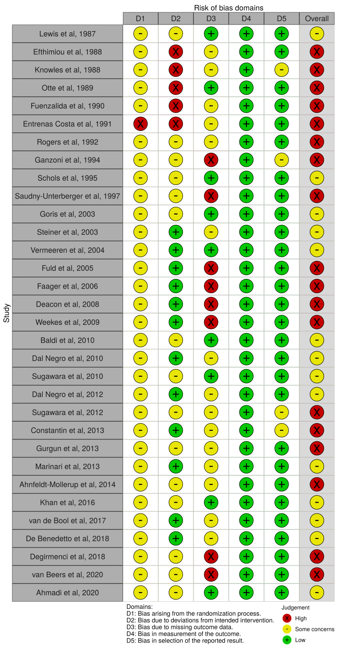.

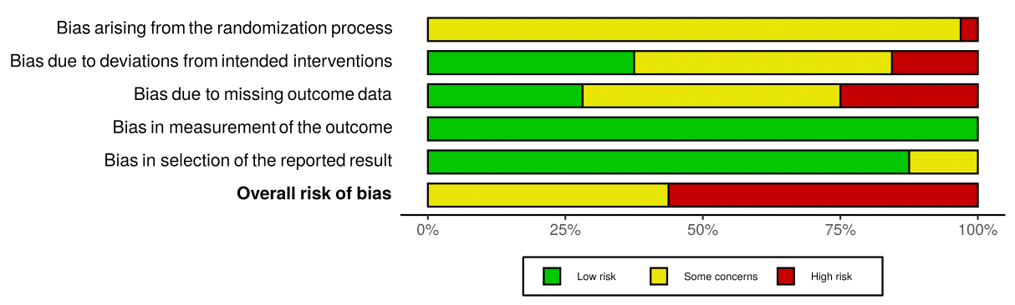

Figure S1 Risk of bias summary: review authors’ judgements for individual studies included

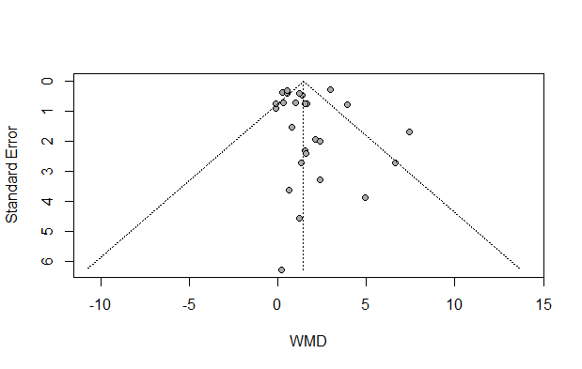

Egger’s test (P=0.57)

Figure S2 Funnel plot for body weight

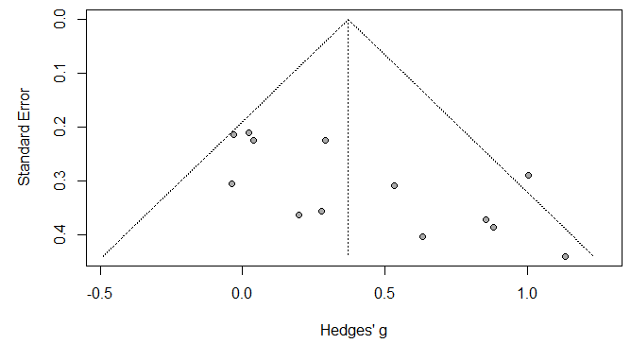

Egger’s test (P=0.0087)

Figure S3 Funnel plot for lean body mass

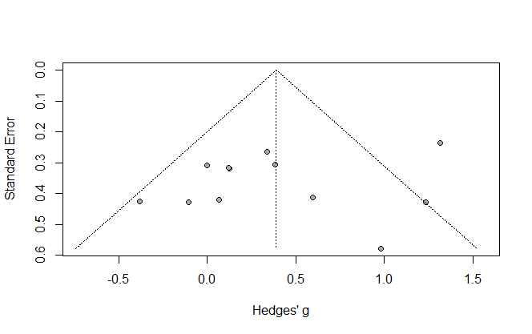

Egger’s test (P=0.39)

Figure S4 Funnel plot for handgrip strength

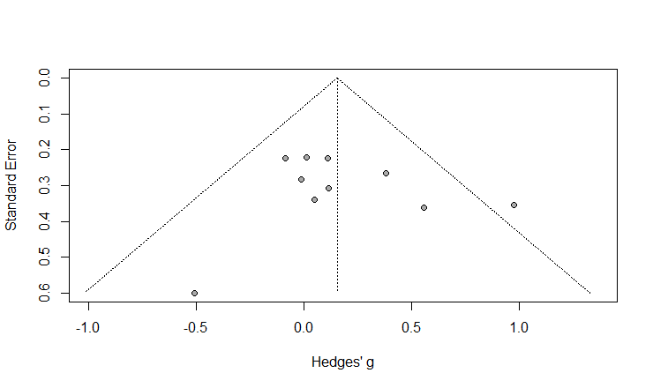

Egger’s test (P=0.58)

Figure S5 Funnel plot for quadriceps strength

