SUPPLEMENTARY MATERIAL
Prognostic value of different cut-off points of the NRS-2002 tool to identify nutritional risk in critically ill patients: a longitudinal study
Bruna Barbosa Stello, Aline Cattani, Danielle Silla Jobim Milanez, Elisa Loch Razzera, Júlia Lima³ and Flávia Moraes Silva

Supplementary Table 1. Characteristics and outcomes in critically ill patients according to the new defined cut-off points of Nutritional Risk Screening (NRS-2002
Variables | NRS-2002 < 4  (n=156) | NRS-2002 > 4  (n=216) | P
Sex, Male | 84 (53.5) | 106 (49.1) | 0.504 ª
Age, years | 56.45 + 11.69 | 65.88 + 14.62 | <0.001 ^{b}
Current weight, kg | 75.63 + 16.41 | 68.61 + 16.97 | <0.001 ^{b}
BMI, kg/m² | 26.78 + 4.66 | 24.99 + 5.52 | <0.001 ^{b}
APACHE II | 13 (8 - 19.5) | 20 (14 - 25) | <0.001 ^{c}
SOFA | 5 (2 - 9) | 7 (4 - 10) | 0.004 ^{c}
Surgical procedure | 122 (78.2) | 121 (56.0) | <0.001 ª
Cancer diagnosis | 77 (49.0) | 114 (52.8) | 0.544 ª
Sepsis | 25 (16.1) | 61 (28.2) | 0.009 ª
Transplant | 28 (17.8) | 15 (6.9) | 0.002 ª
MV at admission | 73 (46.5) | 124 (57.7) | 0.043 ª
HD at admission | 11 (7.1) | 19 (9.0) | 0.639 ª
Hospital LOS, days | 16 (9 - 26) | 22 (12 - 37) | <0.001 ^{c}
ICU LOS, days | 4 (2 - 8) | 6.0 (3.0-10) | 0.034 ^{c}
ICU readmission | 10 (6.4) | 30 (14.0) | 0.029 ª
ICU death | 10 (7.1) | 54 (26.7) | <0.001 ª
Hospital death | 22 (14.0) | 86 (39.8) | <0.001 ª
a Chi-square test, b Student T test, c Mann-Whitney test. P values < 0.05 were considered statistically significant.

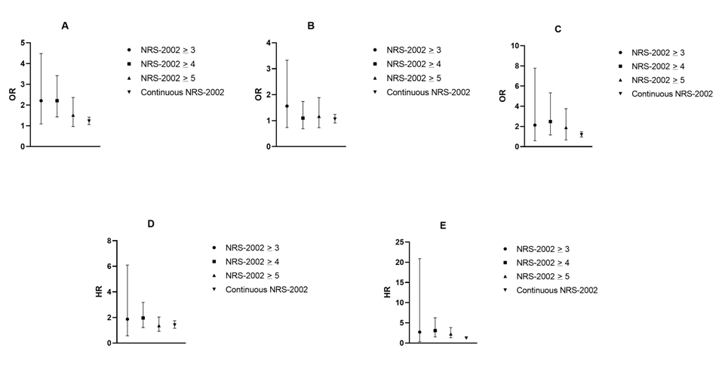Supplementary Figure 1: a summary of the association between NRS-2002 and clinical outcomes, considering its different cut-off points.
A. Prolonged Hospital LOS; B. Prolonged ICU LOS; C. ICU Readmission; D. Hospital Mortality; E. ICU Mortality (OR = odd ratio, HR= hazard ratio).
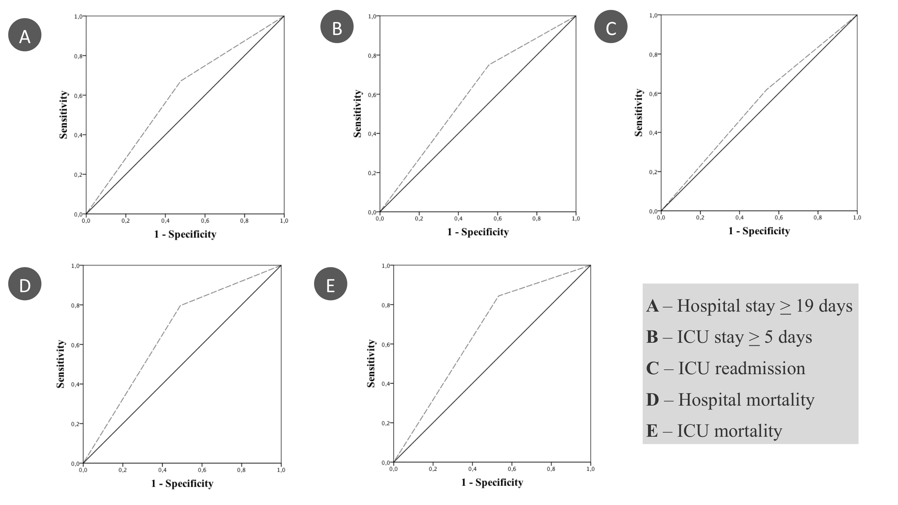
Supplementary Figure 2: Accuracy of the new cut-off point of NRS-2002 (> 4 points) in predicting clinical outcomes (AUC ROC curve).

