**Online Appendix for**

**“State First? A Disaggregation and Empirical Interrogation”**

**Contents**

Data 3

Controls 6

Main robustness checks 9

Breakdown results 9

Democratic deepening results 13

IV 15

Alternative specifications 16

Literature 20

# **Data**

We probe the validity of our state capacity measure by comparing it to the ‘Monopoly on violence’ indicator from the Bertelsmann Transformation Index (BTI 2018), which measures the extent to which a state has monopoly on the use of force over its entire territory. For example, if a state has no competitors within its territory, it has a score of 10; if it has in principle established nationwide monopoly but is challenged by guerrillas or clans in territorial enclaves, it scores 7; if the state only has monopoly in key parts of the country, it scores 4. While this may also correlate with bureaucratic quality, it is a much more minimalistic measure of state strength that certainly concerns the ability of the state to penetrate the whole of its territory. The Pearson’s R correlation between the BTI measure and our primary V-Dem measure is 0.78 (in 2016), suggesting that they reasonably tap into the same overarching concept. Due to its limited spatial and temporal coverage, we do not use the BTI indicator in our analysis.

To ensure the validity of our measure of bureaucratic quality, we compare it to two other indicators of bureaucratic quality, which we do not use in our analysis due to their limited spatial and temporal coverage. These are the World Bank’s ‘Control of corruption’ and ‘Government effectiveness’ indicators (WB 2018) and the Transparency International perception of corruption index (TI 2018). All three Pearson’s R correlations are above 0.8, again suggesting that they tap into the same overarching concept.

As an additional robustness check, we rerun our baseline models[1] using alternative indicators from the V-Dem dataset (Coppedge et al. 2019). To measure state capacity, we use the *v2stfisccap* variable, which measures the extent to which the government finances its activities via taxes. A high score indicates that it primarily relies on income from taxes on property, economic transactions, corporate profits, and capital. A low score indicates that it relies on revenues from external sources, such as foreign aid or loans. The coefficients for the models that predict democratic breakdowns are -0.003 for the LT model, and -0.008 for the RI model. The coefficients for the models predicting democratic deepening are -0.02 for the LT model, and 0.015 for the RI model. All coefficients are insignificant at the 0.1 level. To measure bureaucratic quality, we use the ‘Public sector corruption index*,*’which measures the extent to which public sector employees take bribes or kickbacks, and the frequency of embezzlement and misappropriation of public funds for personal use. It has been rescaled so that higher values indicate less corruption. The coefficients for the models that predict democratic breakdowns are -0.074 for the LT model, and -0.189 for the RI model. The coefficients for the models predicting democratic deepening are 0.166 for the LT model, and 0.203 for the RI model. All coefficients are significant at the 0.01 level. This suggests that our main findings are not measure-dependent.

Figure A1 presents country-year distributions across the scales of bureaucratic quality and state capacity for the LT and RI models, respectively. Figure A2 presents the development in average levels of our two state measures in democracies over time. Looking at the development of state capacity, we see that it generally increased until World War II. Afterwards, there are no clear trends in capacity. Moreover, the average level of bureaucratic quality seems to remain generally stable, except for a large dip immediately before and during World War II. However, as the number of countries is not stable over time, these trends may also reflect variation in state capacity and bureaucratic quality in late-coming democracies.

Figure A1: Distributions of the main explanatory variables

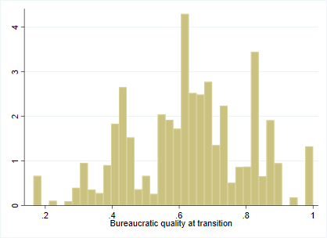 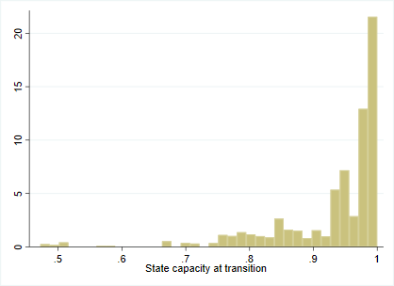

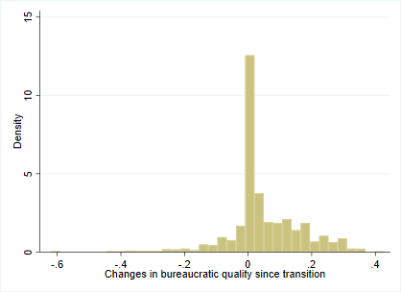 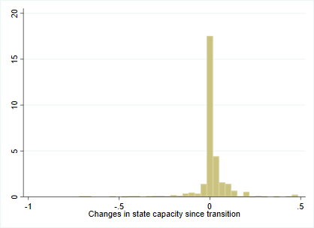

Figure A2: The development of state aspects in democracies over time

|  |
| --- |
|  |
| C:\Users\au446231\Desktop\MG\david\overtid.png |

# **Controls**

Besides region fixed effects and year fixed effects, our baseline LT models control for colonial legacies by including two dummy variables indicating whether a country was ‘ever colonized’ and whether it was a ‘British colony’ from Miller (2015), based on the expectation that a British colonial legacy raised the likelihood of democracy.

As indicated, we also run robustness checks in models with potential post-treatment controls that could plausibly affect state development and democratic survival and deepening. In these models, we account for previous regime experience using a stockmeasure, which sums previous years of being a democracy with a score of one per previous democratic year, and sums previous years of being autocratic with a score of minus one per year. Economic development is measured using logged GDP per capita.Another predictor of regime strength is oil dependence,measured as the revenue from oil as a proportion of GDP. We also control for GDP growthby the annual change in GDP per capita (oil data from Miller 2015; GDP data from Maddison 2018). To account for democratic diffusion, we use the average number of democracies in the region (excluding the country in question). Finally, we control for war and civil warusing two dummies from Clio-infra (2018). In the LT models, we use the value in the year of the first democratic transition, while we lag the controls two years in the RI models to minimize the risk of post-treatment bias. Descriptive statistics for all variables are presented in Table A1.

|  |  |  |  |  |
| --- | --- | --- | --- | --- |
| Table A1: Descriptive Statistics | | | | |
| Variable | Mean | Std. Dev. | Min | Max |
| *Outcome* |  |  |  |  |
| Breakdown (BMR) | 0.017 | 0.129 | 0 | 1 |
| **Δ** Electoral democracy index | 0.092 | 0.139 | -0.579 | 0.571 |
| *Main variables* |  |  |  |  |
| State capacity (LT) | 0.932 | 0.091 | 0.472 | 1 |
| State capacity (RI) | 0.008 | 0.091 | -0.720 | 0.485 |
| Bureaucratic quality (LT) | 0.631 | 0.177 | 0.165 | 1 |
| Bureaucratic quality (RI) | 0.047 | 0.112 | -0.620 | 0.427 |
| *Controls* |  |  |  |  |
| Electoral democracy indextransition | 0.563 | 0.152 | 0.176 | 0.896 |
| Ever colonized | 0.466 | 0.499 | 0 | 1 |
| British colony | 0.253 | 0.435 | 0 | 1 |
| Ln(GDP/cap) | 8.892 | 0.970 | 6.094 | 11.314 |
| GDP growth | 0.026 | 0.064 | -0.571 | 0.923 |
| Ln(GDP/cap)transition | 8.040 | 0.696 | 6.221 | 10.147 |
| Oil dependence | 0.008 | 0.034 | 0 | 0.395 |
| Oil dependencetransition | 0.006 | 0.037 | 0 | 0.352 |
| Regional Democracy level | 0.218 | 0.210 | 0 | 0.952 |
| Democratic stock | -47.1 | 72.81 | -210 | 200 |
| Civil War | 0.084 | 0.278 | 0 | 1 |
| War | 0.077 | 0.266 | 0 | 1 |
|  | | | | |

# **Main robustness checks**

## *Breakdown results*

|  |  |  |  |  |
| --- | --- | --- | --- | --- |
| Table A2: Determining democratic breakdown using logit models | | | | |
|  | (1) | (2) | (3) | (4) |
|  |  |  |  |  |
| State capacityt=transition | -2.96** |  |  |  |
| (0.907) |  |  |  |
|  |  |  |  |  |
| Bureaucratic qualityt=transition |  |  | -3.82*** |  |
|  |  | (0.629) |  |
|  |  |  |  |  |
| ΔState capacity t-1 |  | -1.56 |  |  |
|  | (1.382) |  |  |
|  |  |  |  |  |
| ΔBureaucratic quality.t-1 |  |  |  | -6.88*** |
|  |  |  | (1.57) |
| Baseline | Yes | Yes | Yes | Yes |
| N | 5005 | 1965 | 5005 | 1978 |
| Countries | 119 | 57 | 119 | 57 |

Models 1 and 3 estimated using logit. Models 2 and 4 estimated using conditional

logit. To avoid bias year polynomials (y y2) were used instead of year fixed effects.

Standard errors clustered by country in parentheses.

* *p* < 0.05, ** *p* < 0.01, *** *p* < 0.001

Figure A3: Sensitivity tests for regional impacts (breakdown, level at transition models)

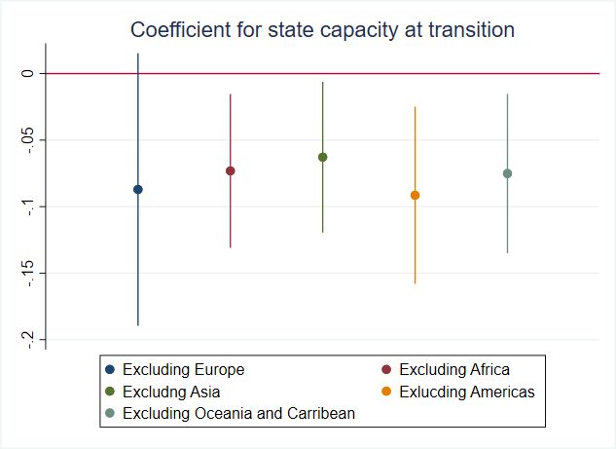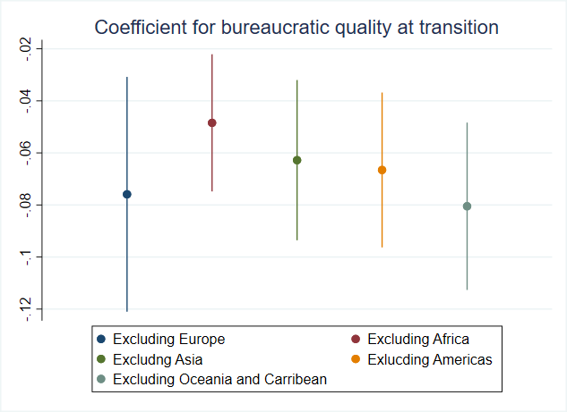

95 % confidence intervals

Figure A4: Sensitivity tests for regional impacts (breakdown, running impact models)

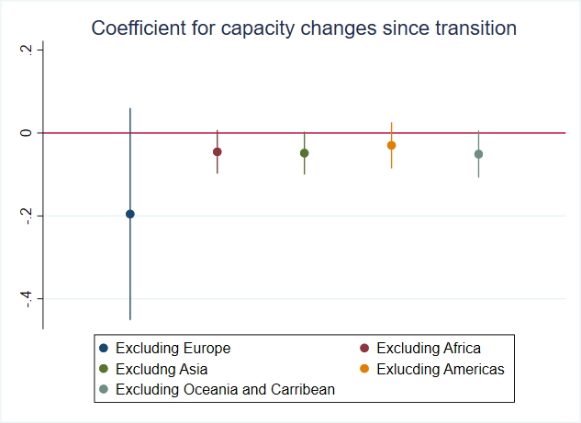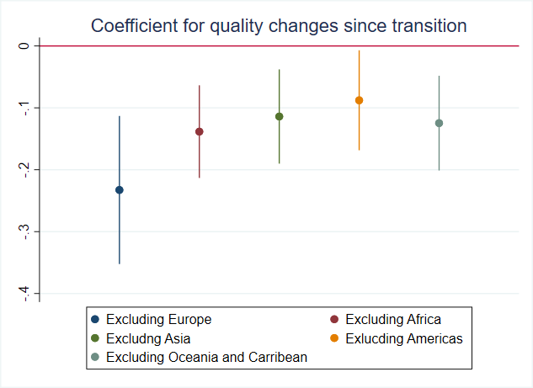

95% confidence intervals

|  |  |  |  |  |  |  |  |
| --- | --- | --- | --- | --- | --- | --- | --- |
| Table A3: Determining democratic breakdown, including interaction terms | | | | | | | |
|  | (1) | (2) | (3) | (4) | (5) | (6) |
| State capacityt=transition | -0.068 | -0.049 | -0.010 |  |  |  |
| (0.125) | (0.091) | (0.079) |  |  |  |
|  |  |  |  |  |  |  |
| Bureaucratic qualityt=transition | -0.056 | -0.054 | -0.027 |  |  |  |
| (0.181) | (0.137) | (0.119) |  |  |  |
|  |  |  |  |  |  |  |
| Capacity x Qualityt=transition | -0.005 | -0.005 | -0.034 |  |  |  |
| (0.190) | (0.142) | (0.125) |  |  |  |
|  |  |  |  |  |  |  |
| ΔState capacity-1 |  |  |  | 0.024 | -0.007 | -0.015 |
|  |  |  | (0.018) | (0.042) | (0.051) |
|  |  |  |  |  |  |
| ΔBureaucratic qualityt-1 |  |  |  | -0.107*** | -0.145** | -0.182** |
|  |  |  | (0.019) | (0.044) | (0.052) |
|  |  |  |  |  |  |  |
| Capacity x Qualityt-1 |  |  |  | -0.139* | -0.112 | -0.162 |
|  |  |  | (0.070) | (0.188) | (0.213) |
|  |  |  |  |  |  |  |
| Baseline | No | Yes | Yes | No | Yes | Yes |
| Add. controls | No | No | Yes | No | No | Yes |
| N | 5005 | 5005 | 4510 | 4865 | 4865 | 4118 |
| Countries | 119 | 119 | 104 | 119 | 119 | 104 |

Estimated using OLS. Standard errors clustered by country in parentheses.

* *p* < 0.05, ** *p* < 0.01, *** *p* < 0.001

|  |
| --- |
| Figure A5: Determining democratic breakdown using the LIED dataset |
| **C:\Users\au446231\Documents\lied.png** |
| From left to right, the coefficients are based on Models 2 and 5 from Table 3, and Models 2 and 5 from Table 4. 95% confidence intervals. |

Figure A6: Predicted probabilities of a democratic breakdown

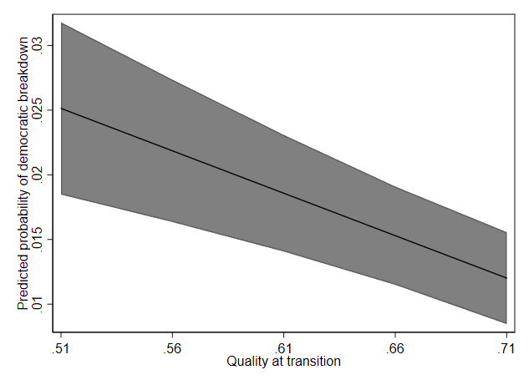 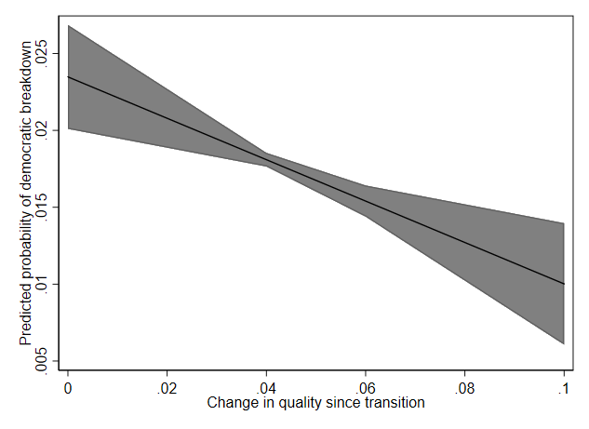

Left panel is based on Model 5, Table 3; right panel is based on Model 5, Table 4.

Comment for Figure A6: To determine whether the relationship between bureaucratic quality and democratic survival is substantially important, we plot predicted probabilities of democratic breakdown from the 25th to the 75th percentile of bureaucratic quality in the year of the first democratic transition (left panel) and at post-transition levels (right panel). Based on transition levels, the risk of breakdown is reduced from approximately 2.5 (25th percentile) to 1.25 (75th percentile) percentage points. We see a similar, if not slightly stronger, decrease in risk of breakdown based on post-transition changes. Overall, this suggests that bureaucratic quality substantially decreases the risk of democratic breakdown.

## *Democratic deepening results*

Figure A7: Sensitivity tests for regional impacts (deepening, level at transition models)

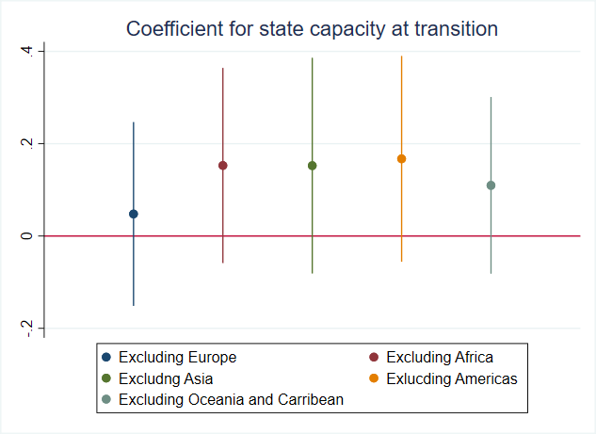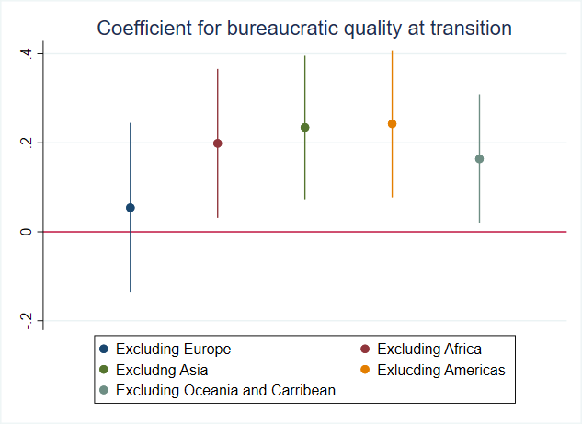

95% confidence intervals

Figure A8: Sensitivity tests for regional impacts (deepening, running impact models)

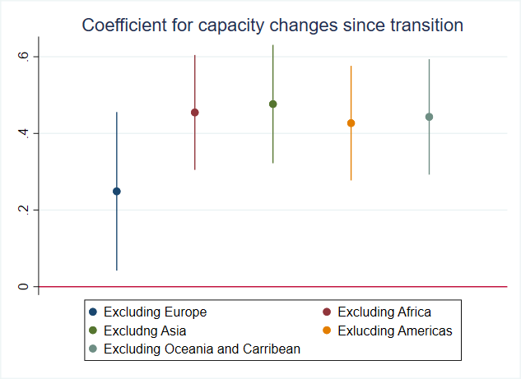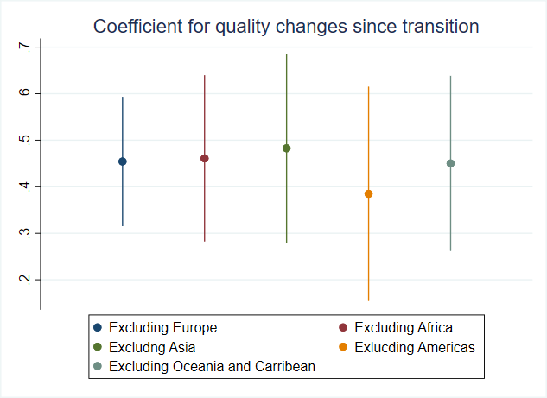

95% confidence intervals

|  |  |  |  |  |  |  |  |
| --- | --- | --- | --- | --- | --- | --- | --- |
| Table A4: Determining democratic deepening | | | | | | | |
|  | (1) | (2) | (3) | (4) | (5) | (6) |
| State capacityt=transition | -0.634** | -0.663* | -0.215 |  |  |  |
| (0.216) | (0.276) | (0.209) |  |  |  |
|  |  |  |  |  |  |  |
| Bureaucratic qualityt=transition | -0.950* | -1.046* | -0.212 |  |  |  |
| (0.380) | (0.434) | (0.332) |  |  |  |
|  |  |  |  |  |  |  |
| Capacity x Qualityt=transition | 1.232** | 1.309** | 0.549 |  |  |  |
| (0.427) | (0.491) | (0.343) |  |  |  |
|  |  |  |  |  |  |  |
| ΔState capacity-1 |  |  |  | 0.175** | 0.280** | 0.098 |
|  |  |  | (0.063) | (0.094) | (0.074) |
|  |  |  |  |  |  |
| ΔBureaucratic qualityt-1 |  |  |  | 0.399*** | 0.369*** | 0.154** |
|  |  |  | (0.104) | (0.101) | (0.056) |
|  |  |  |  |  |  |  |
| Capacity x Qualityt-1 |  |  |  | 0.144 | -0.133 | -0.167 |
|  |  |  | (0.013) | (0.411) | (0.286) |
|  |  |  |  |  |  |  |
| Baseline | No | Yes | Yes | No | Yes | Yes |
| Add. controls | No | No | Yes | No | No | Yes |
| N | 4645 | 4645 | 4309 | 4645 | 4645 | 3873 |
| Countries | 117 | 117 | 103 | 117 | 117 | 102 |

Standard errors clustered by country in parentheses

* *p* < 0.05, ** *p* < 0.01, *** *p* < 0.001

|  |  |  |  |  |  |  |  |  |
| --- | --- | --- | --- | --- | --- | --- | --- | --- |
| Table A5: LT models and positive and negative changes in democracy score | | | | | | | | |
|  | (1) | (2) | (3) | (4) | (5) | (6) | (7) | (8) |
| Direction of changes | +Δ | +Δ | +Δ | +Δ | -Δ | -Δ | -Δ | -Δ |
| State capacityt=transition | 0.131 | 0.207* |  |  | -0.00850 | -0.00580 |  |  |
| (0.0955) | (0.0844) |  |  | (0.0121) | (0.0134) |  |  |
|  |  |  |  |  |  |  |  |  |
| Bureaucratic qualityt=transition |  |  | 0.173* | 0.303*** |  |  | -0.0112 | -0.0136 |
|  |  | (0.0721) | (0.0576) |  |  | (0.00585) | (0.00703) |
| Baseline | Yes | Yes | Yes | Yes | Yes | Yes | Yes | Yes |
| Add. controls | No | Yes | No | Yes | No | Yes | No | Yes |
| N | 4654 | 4309 | 4654 | 4309 | 4654 | 4309 | 4654 | 4309 |
| Countries | 117 | 103 | 117 | 103 | 117 | 103 | 117 | 103 |

Positive values in Models 1-4 indicate democratic deepening. Higher values in Models 5-8 indicate more democratic erosion. Standard errors clustered by country in parentheses

* *p* < 0.05, ** *p* < 0.01, *** *p* < 0.001

|  |  |  |  |  |  |  |  |  |  |
| --- | --- | --- | --- | --- | --- | --- | --- | --- | --- |
| Table A6: RI models and positive and negative changes in democracy score | | | | | | | | | |
|  | (1) | (2) | (3) | (4) | (5) | (6) | (7) | (8) |
| Direction of changes | +Δ | +Δ | +Δ | +Δ | -Δ | -Δ | -Δ | -Δ |
| ΔState capacity-1 | 0.254*** | 0.0181 |  |  | -0.194*** | -0.151*** |  |  |
| (0.0513) | (0.0416) |  |  | (0.0452) | (0.0440) |  |  |
|  |  |  |  |  |  |  |  |
| ΔBureaucratic qualityt-1 |  |  | 0.242*** | 0.227*** |  |  | -0.213*** | -0.222*** |
|  |  | (0.0694) | (0.0651) |  |  | (0.0403) | (0.0420) |
| Baseline | Yes | Yes | Yes | Yes | Yes | Yes | Yes | Yes |
| Add. controls | No | Yes | No | Yes | No | Yes | No | Yes |
| N | 4645 | 3873 | 4645 | 4010 | 4645 | 3873 | 4645 | 4010 |
| Countries | 117 | 102 | 117 | 103 | 117 | 102 | 117 | 103 |

Positive values in Models 1-4 indicate democratic deepening. Higher values in Models 5-8 indicate more democratic erosion. Standard errors clustered by country in parentheses

* *p* < 0.05, ** *p* < 0.01, *** *p* < 0.001

# **IV-estimations**

Despite our use of transition levels values of state capacity and bureaucratic quality, one might still object that our results are driven by either omitted variables or reverse causality. To mitigate such worries, we instrument state capacity and bureaucratic quality using two historical measures that are more credibly exogenous to nineteenth and twentieth century political development: the type of terrain in a country during pre-industrial times, and the traditional inheritance rule (of land) in place among the ancestors living in these times (data from Giuliano & Nunn 2018). As it is harder to establish monopoly on violence in less accessible terrain, we use the percentage of different types of terrain as an instrument for state capacity (e.g. desert, rainforest, and temperate woodland). Areas with less communal inheritance traditions developed weaker kinship ties. As a result, later state building was characterized by contractual ties rather than kin, which promoted the establishment of an impartial administration (Fukuyama 2011, 239-240; Broms and Kokkonen 2019, 620-622). To account for possible violations of the exclusion restriction, we employ both baseline and additional controls models (all using time polynomials, t and t2, instead of year fixed effects). The models, which are shown in Table A7, corroborate our main findings.

|  |  |  |  |  |  |  |  |  |
| --- | --- | --- | --- | --- | --- | --- | --- | --- |
| Table A7: IV results | | | | |  |  |  |  |
|  | (1) | (2) | (3) | (4) | (5) | (6) | (7) | (8) |
| Dep. variable | Breakdown | Breakdown | Dem. deepening | Dem. deepening | Breakdown | Breakdown | Dem. deepening | Dem. deepening |
| State capacityt=transition | -0.238** |  | -0.439 |  | -0.069 |  | 0.146 |  |
| (0.082) |  | (0.371) |  | (0.113) |  | (0.378) |  |
|  |  |  |  |  |  |  |  |  |
| Bureaucratic qualityt=transition |  | -0.159* |  | 0.595* |  | -0.171* |  | 0.520* |
|  | (0.077) |  | (0.267) |  | (0.078) |  | (0.232) |
|  |  |  |  |  |  |  |  |  |
| F statistic for first stage | 27.4 | 8.5 | 24.3 | 7.3 | 10.6 | 6.4 | 9.9 | 6.1 |
| Baseline controls | Yes | Yes | Yes | Yes | Yes | Yes | Yes | Yes |
| Add. controls | No | No | No | No | Yes | Yes | Yes | Yes |
| N | 4774 | 4774 | 4536 | 4536 | 4335 | 4335 | 4218 | 4218 |
| Countries | 113 | 113 | 111 | 111 | 100 | 100 | 99 | 99 |

Standard errors clustered by country in parentheses.

* *p* < 0.1, ** *p* < 0.05, *** *p* < 0.01

# 

# **Alternative specifications**

Our breakdown models may be thought of as using grouped duration data. Following Carter and Signorino (2010), we therefore rerun our breakdown models this time including cubic polynomials (t, t2, and t3) of the time since a country became democratic. These results are shown in Tables A8 and A9 below. The results are substantively similar, thus eliminating worries that our results are driven by time dependence.

|  |  |  |  |  |  |  |  |
| --- | --- | --- | --- | --- | --- | --- | --- |
| Table A8: LT models of democratic breakdown | | | | | | | |
|  | (1) | (2) | (3) | (4) | (5) | (6) | (7) |
|  |  |  |  |  |  |  |  |
| State capacityt=transition | -0.082** | -0.062* | -0.039 |  |  |  | -0.024 |
| (0.031) | (0.028) | (0.028) |  |  |  | (0.031) |
|  |  |  |  |  |  |  |  |
| Bureaucratic qualityt=transition |  |  |  | -0.055*** | -0.055*** | -0.053** | -0.051** |
|  |  |  | (0.011) | (0.014) | (0.015) | (0.016) |
| t, t2, t3 | Yes | Yes | Yes | Yes | Yes | Yes | Yes |
| Baseline | No | Yes | Yes | No | Yes | Yes | Yes |
| Add. controls | No | No | Yes | No | No | Yes | Yes |
| N | 5005 | 5005 | 4510 | 5005 | 5005 | 4510 | 4510 |
| Countries | 119 | 119 | 104 | 119 | 119 | 104 | 104 |

Standard errors clustered by country in parentheses.

* *p* < 0.05, ** *p* < 0.01, *** *p* < 0.001

|  |  |  |  |  |  |  |  |  |
| --- | --- | --- | --- | --- | --- | --- | --- | --- |
| Table A9: RI models of democratic breakdown | | | | | | | | |
|  | (1) | (2) | (3) | (4) | (5) | (6) | (7) |
|  |  |  |  |  |  |  |  |
| ΔState capacity-1 | -0.0151 | -0.0497 | -0.0539 |  |  |  | 0.0167 |
| (0.0169) | (0.0276) | (0.0353) |  |  |  | (0.0371) |
|  |  |  |  |  |  |  |  |
| ΔBureaucratic qualityt-1 |  |  |  | -0.0723*** | -0.139*** | -0.209*** | -0.214*** |
|  |  |  | (0.0170) | (0.0382) | (0.0487) | (0.0522) |
| t, t2, t3 | Yes | Yes | Yes | Yes | Yes | Yes | Yes |
| Baseline | No | Yes | Yes | No | Yes | Yes | Yes |
| Add. controls | No | No | Yes | No | No | Yes | Yes |
| N | 4865 | 4865 | 4118 | 4895 | 4895 | 4124 | 4118 |
| Countries | 119 | 119 | 104 | 119 | 119 | 104 | 104 |

Standard errors clustered by country in parentheses.

* *p* < 0.1, ** *p* < 0.05, *** *p* < 0.01

We also conduct survival analysis to estimate breakdown in the level at transition models. Survival time is measured as the time democracy has been in place without a breakdown. We code failure as 1 if a democratic spell ends in a breakdown. All four models in Table A10 use cox proportional hazard estimation. To account for within country dependence, the models also use shared frailty estimation.[2] As before, we find a robust, positive impact of bureaucratic quality on survival, and a non-robust impact of state capacity. These results are shown in Table A10. Figure A9 shows the estimated time of democratic survival based on state capacity (Model 2) and bureaucratic quality (Model 4) levels, respectively. This supports that the effect of bureaucratic quality (the difference between survival effects for bureaucratic quality at the 25th and 75th percentiles) is substantial.

|  |  |  |  |  |
| --- | --- | --- | --- | --- |
| Table A10: Democratic survival | | | | |
|  | (1) | (2) | (3) | (4) |
|  |  |  |  |  |
| State capacityt=transition | 0.125* | 0.302 |  |  |
| (-2.21) | (-1.17) |  |  |
|  |  |  |  |  |
| Bureaucratic qualityt=transition |  |  | 0.080*** | 0.094** |
|  |  | (-3.63) | (-3.06) |
|  |  |  |  |  |
| Baseline | Yes | Yes | Yes | Yes |
| Add. Controls | No | Yes | No | Yes |
| N | 184 | 164 | 184 | 164 |
| Countries | 119 | 104 | 119 | 104 |

t statistics in parentheses.

* *p* < 0.05, ** *p* < 0.01, *** *p* < 0.001

Figure A9: Estimated survival function based on Table A10, Models 2 and 4

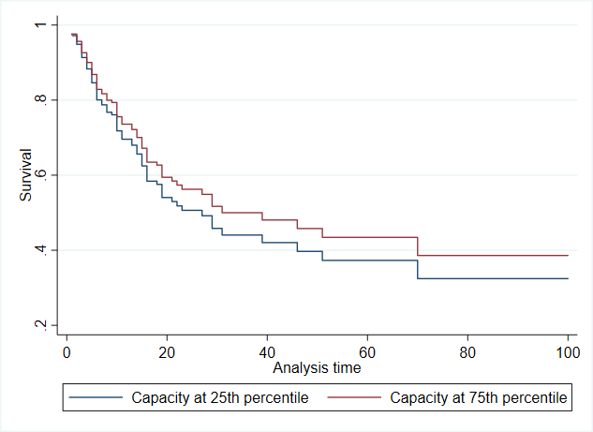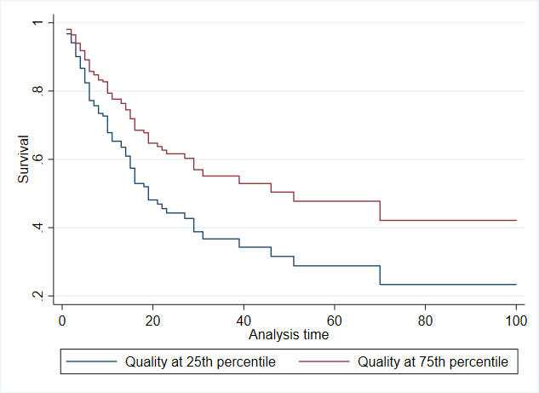

Next, we also run the RI models estimating breakdown and deepening, respectively, using the lagged levels of the state measures to mitigate worries that lagged changes would provide too little variation. We run these models with both baseline and additional controls. The results are presented in Table A11, and they corroborate the main results.

|  |  |  |  |  |  |  |  |  |
| --- | --- | --- | --- | --- | --- | --- | --- | --- |
| Table A11: RI models with alternative explanatory variable | | | | | | | | |
|  | (1) | (2) | (3) | (4) | (5) | (6) | (7) | (8) |
| Dependent var. | Breakdown | Breakdown | Breakdown | Breakdown | Dem. deepening | Dem. deepening | Dem. deepening | Dem deepening |
| State capacity-1 | -0.001 | -0.001 |  |  | 0.004** | 0.002** |  |  |
| (0.000) | (0.000) |  |  | (0.001) | (0.001) |  |  |
|  |  |  |  |  |  |  |  |
| Bureaucratic qualityt-1 |  |  | -0.017*** | -0.021** |  |  | 0.055** | 0.022*** |
|  |  | (0.005) | (0.006) |  |  | (0.011) | (0.007) |
| Baseline | Yes | Yes | Yes | Yes | Yes | Yes | Yes | Yes |
| Add. controls | No | Yes | No | Yes | No | Yes | No | Yes |
| N | 4863 | 4118 | 4979 | 4163 | 4643 | 3873 | 4675 | 3875 |
| Countries | 119 | 104 | 119 | 104 | 117 | 102 | 117 | 102 |

Standard errors clustered by country in parentheses.

* *p* < 0.1, ** *p* < 0.05, *** *p* < 0.01

We also consider a more complex dynamic panel model for the models that predict democratic deepening – system generalized method of moments (GMM) (Blundell and Bond 1998).[3] This method is often employed with slow-moving variables (see e.g. Bizzarro et al. 2018). To reduce the number of instruments, we use ten-year intervals instead of annual data. Our dependent variable is the average change in the polyarchy index in a 10-year interval. One lag (the second) is used for instrumentation. This results in 105 instruments, which is below the rule-of-thumb threshold (the number of cross-sectional units – 117 in this case) (Roodman 2009). The AR(2) test p-value for state capacity is 0.29, and the value for bureaucratic quality is 0.25. The Hanson J-test p-values are 0.82 and 0.88, respectively, suggesting that the models return consistent estimates. We also rerun our baseline models on the ten-year panel to ensure that the results are not specific to the GMM estimator. These models, which corroborate the main findings, are reported in Table A12 below.

|  |  |  |  |  |
| --- | --- | --- | --- | --- |
| Table A12: Alternative specifications of the democratic deepening models | | | | |
|  | (1) | (2) | (3) | (4) |
| Estimator | OLS | OLS | Sys. GMM | Sys. GMM |
| State capacity t-1 | -0.000 |  | 0.001 |  |
| (0.001) |  | (0.002) |  |
|  |  |  |  |  |
| Bureaucratic qualityt-1 |  | 0.035*** |  | 0.029** |
|  | (0.008) |  | (0.010) |
| Baseline | Yes | Yes | Yes | Yes |
| N | 605 | 637 | 549 | 549 |
| Countries | 113 | 116 | 117 | 117 |

Standard errors clustered by country in parentheses.

* *p* < 0.05, ** *p* < 0.01, *** *p* < 0.001

# 

# **Literature**

Bizzarro, Fernando, John Gerring, Carl Henrik Knutsen, Allen Hicken, Michael Bernhard, Svend-Erik Skaaning, Michael Coppedge, and Staffan Lindberg. 2018. “Party Strength and Economic Growth.” *World Politics* 70(2): 275-320.

Blundell, Richard, Stephen Bond. 1998. “Initial Conditions and Moment Restrictions in Dynamic Panel Models.” *Journal of Econometrics* 87(1): 115-143.

Broms, Rasmus, Andrej Kokkonen. 2019. ”Inheritance Regimes: Medieval Family Structures and Current Institutional Quality.” *Governance* 32(1): 619-637.

BTI. 2018. “Bertelmanns Transformation Index” <https://www.bti-project.org/en/index/methodology/>

Carter, David, Curtis Signorino. 2010. “Back to the Future: Modeling Time Dependence in Binary Data.” *Political Analysis* 18(3): 271-292.

Clio-infra. 2018. “Historical Datasets”. <https://www.clio-infra.eu/index.html#about>

Coppedge, Michael, John Gerring, Carl Henrik Knutsen, Staffan I. Lindberg,

Jan Teorell, David Altman, Michael Bernhard, M. Steven Fish, Adam Glynn, Allen Hicken, Anna Lührmann, Kyle L. Marquardt, Kelly McMann, Pamela Paxton, Daniel Pemstein, Brigitte Seim, Rachel Sigman, Svend-Erik Skaaning, Jeffrey Staton, Agnes Cornell, Lisa Gastaldi, Haakon Gjerløw, Valeriya Mechkova, Johannes von Römer, Aksel Sundtröm, Eitan Tzelgov, Luca Uberti, Yi-tingWang, Tore Wig, and Daniel Ziblatt (2019). "V-Dem Codebook v9", Varieties of Democracy (V-Dem) Project.

Fukuyama, Francis. 2011. *The Origins of Political Order.* Bevin Way: Profile Books.

Giuliano, Paola, Nathan Nunn. 2018. “Ancestral Characteristics of Modern Populations.” *Economic History of Developing Regions* 33(1): 1-17.

Maddison Project Database. 2018. Bolt, Jutta, Robert Inklaar, Herman de Jong and Jan Luiten van Zanden (2018), “Rebasing ‘Maddison’: new income comparisons and the shape of long-run economic development”, [Maddison Project Working paper 10](https://www.rug.nl/ggdc/historicaldevelopment/maddison/research)

Miller, Michael K. 2015. “Democratic Pieces: Autocratic Elections and Democratic Development since 1815” *British Journal of Political Science* 45(3): 501-530.

Roodman, David. 2009. “A Note on the Theme of too Many Instruments.” *Oxford Bulletin of Economics and Statistics* 71(1): 135-158.

World Bank (WB). 2018. The Worldwide Governance Indicators project. Retrieved from: <http://info.worldbank.org/governance/wgi/#home>

Transparency International (TI). 2018. Corruption Perceptions Index. Retrieved from: <https://www.transparency.org/research/cpi>

1. Based on the setup in Models 2 and 5 from Tables 3 and 4 for democratic breakdown, and Models 2 and 5 from Tables 5 and 6 for democratic deepening.
2. However, as Models 2 and 4 did not converge when including controls for GDP/cap and oil dependence we did not use shared frailty estimation in these models. Also, controls for year (including dummies and polynomials) were not included because, otherwise, the models did not converge with any type of estimation.
3. Specifically, we use the *xtabond2* command in Stata.