Supplementary Information

Allelic variation in 5-HTTLPR and the effects of citalopram on the emotional neural network

Yina Ma^{1,4}, Bingfeng Li^{2,3}, Chenbo Wang^{1,3}, Wenxia Zhang^{2,3}, Yi Rao^{2,3}, Shihui Han^{1,3}

¹Department of Psychology,
²Peking-Tsinghua Center for Life Sciences at School of Life Sciences,
³PKU-IDG/McGovern Institute for Brain Research,
Peking University, Beijing 100871, China
⁴Lieber Institute for Brain Development, Johns Hopkins University School of Medicine, 855 North Wolfe Street, Baltimore, MD 21205, USA

Table S1
Figure S1

Correspondence:

Yina Ma
Lieber Institute for Brain Development
Johns Hopkins University School of Medicine
855 North Wolfe Street
Baltimore, MD 21205, USA
603-443-2062
yina.ma@libd.org
or
Shihui Han
Department of Psychology
Peking University
Beijing 100871, China
Phone: 8610-6275-9138
Fax: 8610-6276-1081
email: shan@pku.edu.cn

Supplementary Methods

Genotyping

We used a PCR method^{s1} to determine the genotypes of 5-HTTLPR. In a total volume of 50 µl, about 25ng of genomic DNA were amplified in the presence of 1 x TransStart FastPfu DNA Polymerase (TransGen Biotech) reaction system and oligonucleotide primers (forward 5’-GCATCCCCCATTATCCCCCCCT-3’ and reverse 5’-AGGCTTGGAGGCCGGGATGC-3’) at a final concentration of 200 nM. Thermal cycling consisted of a 15 min of initial denaturation at 95° followed by 35 cycles of 95° (20 s), 69° (20 s) and 72° (15 s), each with a final extension step of 10 min at 72°. Subsequently, the PCR product was loaded onto a 3% agarose gel (BioWest G-10) to perform electrophoresis to distinguish genotypes of s/s, s/l and l/l. All genotyping was performed in duplicate.

The analysis of effect size

To estimate the power of our results, we conducted power analyses, calculated the effect size and reviewed published genetic fMRI studies exploring 5-HTTLPR genotype effects and pharmacological fMRI studies exploring SSRI effects. These analyses confirmed a large effect size and appropriate sample size of the current study.

Effect size calculation

We calculated the effect size of differential citalopram effects on amygdala activity between s/s and l/l genotype groups in the current study. According to Cohen's recommendation^{s2}, the effect size of the current study was large, i.e., Cohen’s d= 1 for left amygdala and Cohen’s d= 0.8 for the right amygdala activity.

Power analysis

We further conducted post-hoc power analyses to estimate the appropriateness of our sample size. It is generally accepted that statistic power of 0.8 or greater reveals reliable empirical findings.^{s2-4} The effect size estimated from our current data (Cohen’s d= 1 for left amygdala and Cohen’s d= 0.8 for right amygdala) indicated that a sample size of N= 26 (n=13/genotype, left amygdala) or of N=40 (n=20/genotype for right amygdala) is required to achieve 80% power at an alpha level of 0.05 to reveal stronger citalopram effects on l/l than s/s genotype of 5-HTTLPR. Thus the sample size of 46 subjects in the current study is an appropriate sample (from G*Power analysis). In other words, our sample size (N=46, n=23/genotype) achieved 95% (left amygdala) and 84% (right amygdala) power to detect stronger citalopram effects on l/l than s/s genotype of 5-HTTLPR at an alpha level of 0.05, which is higher than the conventionally accepted statistic power (G*Power analysis).

Comparison with the previous studies in the field

According to the recent meta-analysis^{s5} of 5-HTTLPR genotype differences in amygdala reactivity, there are 26 fMRI studies that examined 5-HTTLPR genotype differences in amygdala reactivity. The sample size of these studies varied, from 10/genotype~46/genotype, with a Mean of 19/genotype, and Mode of 14/genotype. The current study including 46 subjects (23/genotype), this sample size is larger than those in most of the published papers.

According to our recent meta-analysis^{s6} on antidepressant effects on emotional response, there are 34 fMRI studies that examined antidepressant effects on neural responses to emotions in healthy participants. 21 studies used within-subjects treatment (same design as the current study) and the average sample size is 15 subjects. Our sample size of 23/genotype is larger than all the previous studies of antidepressant effects on neural responses to emotions.

Replication of previous findings

Our study was a hypothesis-driven work and replicated the basic findings of previous studies. These include stronger amygdala activity to emotional faces than to neutral faces,^{S7-9} stronger amygdala activity in s/s than l/l genotype individuals under placebo,^{S10-12} and a significant main effect of acute SSRI administration (i.e., increased amygdala activity).^{S13,14} In addition, the pattern of 5-HTTLPR genotype modulations of SSRI effects on amygdala activity (i.e., stronger citalopram effect in l/l than s/s genotype) is also consistent with the previous biological findings^{S15-18} and behavioral clinical observations. ^{S19,20}

Taken together, considering the effect size of the current work and the sample size of published studies, the sample size of our study allowed us to make a conclusion (though with caution) on the 5-HTTLPR genotype differences in SSRI effects on emotional neural activity.

Table S1. Mean (SD) ratings of mood at the beginning and end of each session

 | s/s genotype |  | l/l genotype
 | Placebo | Citalopram | Placebo | Citalopram
Pre-scan Positive | 2.82 (0.70) | 2.73 (0.73) | 2.74 (0.60) | 2.59 (0.74)
Post-scan Positive | 2.79 (0.73) | 2.66 (0.68) | 2.56 (0.69) | 2.49 (0.85)
Pre-scan Negative | 1.59 (0.60) | 1.54 (0.74) | 1.44 (0.54) | 1.46 (0.73)
Post-scan Negative | 1.60 (0.62) | 1.56 (0.75) | 1.40 (0.64) | 1.40 (0.56)

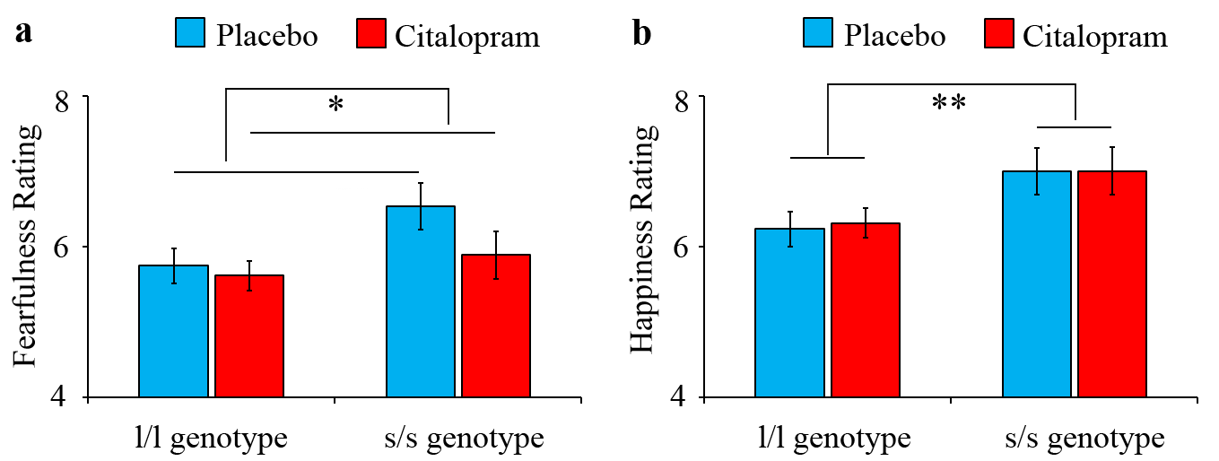

Figure S1. Post-scan ratings of emotional intensity of fearful and happy faces. Emotional intensity rating scores of fearful and happy faces were subjected to a 2 (Treatment: citalopram vs. placebo) × 2 (Genotype: s/s vs. l/l genotype) ANOVA. Subjects rated fearful faces less fearful after citalopram than after placebo administration (F(1,43)=5.44, p=0.024). However, this effect did not differ significantly between s/s and l/l genotype groups (F(1,43)=2.44, p=0.126). s/s genotype rated greater emotional intensity of happy faces compared to l/l genotype (F(1,43)=7.30, p=0.010), but neither the main effect of Treatment nor its interaction with Genotype was significant (ps>0.35). (*p<0.05, **p<0.01).
Reference

S1. Ota M, Fukushima H, Kulski JK, Inoko H. Single nucleotide polymorphism detection by polymerase chain reaction-restriction fragment length polymorphism. Nat Protoc 2007; 2: 2857-2864.

S2. Cohen, J. 1988. Statistical Power Analysis for the Behavioral Sciences. 2nd edn. Hillsdale, New Jersey: Lawrence Erlbaum

S3. Peterman, RM. 1990. Statistical power analysis can improve ﬁsheries research and management. Can. J. Fish. Aquat. Sci., 47, 2–15.

S4. Ellis, PD. (2010). The Essential Guide to Effect Sizes: An Introduction to Statistical Power, Meta-Analysis and the Interpretation of Research Results. United Kingdom: Cambridge University Press.

S5. Murphy SE, Norbury R, Godlewska BR, Cowen PJ, Mannie ZM, Harmer CJ, Munafò MR. The effect of the serotonin transporter polymorphism (5-HTTLPR) on amygdala function: a meta-analysis. Mol Psychiatry 2013; 18: 512-520.

S6. 21. Ma Y. Neuropsychological mechanism underlying antidepressant effect: a systematic meta-analysis. Mol Psychiatry 2015; 20:311-319.

S7. Breiter H, Etcoff N, Whalen P, Kennedy W, Rauch S, Buckner R et al. Response and habituation of the human amygdala during visual processing of facial expression. Neuron 1996; 17: 875-887.

S8. Morris JS, Frith CD, Perrett DI, Rowland D, Young AW, Calder AJ et al. A differential neural response in the human amygdala to fearful and happy facial expressions. Nature 1996; 383: 812-815.

S9. Morris JS, Friston KJ, Buchel C, Frith CD, Young AW, Calder AJ et al. A neuromodulatory role for the human amygdala in processing emotional facial expressions. Brain 1998; 121: 47-57.

S10. Hariri AR, Mattay VS, Tessitore A, Kolachana B, Fera F, Goldman D et al. Serotonin transporter genetic variation and the response of the human amygdala. Science 2002; 297: 400–403.

S11. Hariri AR, Drabant EM, Munoz KE, Kolachana BS, Mattay VS, Egan MF et al. A susceptibility gene for affective disorders and the response of the human amygdala. Arch Gen Psychiatry 2005; 62:146–152.

S12. Dannlowski U, Ohrmann P, Bauer J, Deckert J, Hohoff C, Kugel H et al. 5-HTTLPR biases amygdala activity in gesponse to masked facial expressions in major depression. Neuropsychopharmacology 2008; 33: 418–424.

S13. Bigos KL, Pollock BG, Aizenstein HJ, Fisher PM, Bies RR, Hariri AR. Acute 5-HT reuptake blockade potentiates human amygdala reactivity. Neuropsychopharmacology 2008; 33: 3221-3225.

S14. Grady CL, Siebner HR, Hornboll B, Macoveanu J, Paulson OB, Knudsen GM. Acute pharmacologically induced shifts in serotonin availability abolish emotion-selective responses to negative face emotions in distinct brain networks. Eur Neuropsychopharmacol 2013; 23: 368-378.

S15. Heils A, Teufel A, Petri S, Stober G, Riederer P, Bengel D, Lesch KP. Allelic variation of human serotonin transporter gene expression. J Neurochem 1996; 66: 2621–2624.

S16. Canli T, Lesch KP. Long story short: the serotonin transporter in emotion regulation and social cognition. Nat Neurosci 2007; 10: 1103-1109.

S17. Lesch KP, Bengel D, Heils A, Sabol SZ, Greenberg BD, Petri S et al. Association of anxiety-related traits with a polymorphism in the serotonin transportergene regulatory region. Science 1996; 274:1527-1531.

S18. Whale R, Quested DJ, Laver D, Harrison PJ, Cowen PJ. Serotonin transporter (5-HTT) promoter genotype may influence the prolactin response to clomipramine. Psychopharmacology 2000; 150:120-122.

S19. Smeraldi E, Zanardi R, Benedetti F, Dibella D, Perez J, Catalano M. Polymorphism within the promoter of the serotonin transporter gene and antidepressant efficacy of fluvoxamine. Mol Psychiatry 1998; 3: 508-511.

S20. Serretti A, Kato M, De Ronchi D, Kinoshita T. Meta-analysis of serotonin transporter gene promoter polymorphism (5-HTTLPR) association with selective serotonin reuptake inhibitor efficacy in depressed patients. Mol Psychiatry 2007; 12: 247-257.

