Data supplement to Williams et al Community-based group guided self-help intervention for low mood and stress: randomised controlled trial. Br J Psychiatry doi: 10.1192/bjp.bp.115.170936

Table DS1 Ethnicity and education of participants at randomisation
[AQ3 Please explain Higher and standard grade as used in your Table.]

Characteristic | Overall %  (n=142) | Immediate access (IA) group  (n=71) | Delayed access control (DAC) group  (n=71)
Ethnicity, % (n)
White | 91.5 (130) | 93.0 (66) | 90.1 (64)
Mixed | 3.5 (5) | 2.8 (2) | 4.2 (3)
Asian/Asian British | 2.1 (3) | 1.4 (1) | 2.8 (2)
Black/Black British | 1.4 (2) | 2.8 (2) | 0.0 (0)
Chinese | 0.7 (1) | 0.0 (0) | 1.4 (1)
Other | 0.7 (1) | 0.0 (0) | 1.4 (1)
Education, % (n)^{b}
Postgraduate degree | 15.6 (22) | 12.9 (9) | 18.3 (13)
Undergraduate degree | 24.8 (35) | 27.1 (19) | 22.5 (16)
HNC, HND, SVQ or RSA | 22.0 (31) | 22.9 (16) | 21.1 (15)
Higher grade or equivalent | 12.1 (17) | 14.3 (10) | 9.9 (7)
Standard grade or equivalent | 16.3 (23) | 12.9 (9) | 19.7 (14)
No formal qualifications | 9.2 (13) | 10.0 (7) | 8.5 (6)
HNC, higher national certificate; HND, higher national diploma; SVQ, Scottish vocational qualification; RSA, Royal Society of Arts (typing and word processing qualification).
a. Data for the MINI diagnostic interview was only available as follows: overall n=93; IA group, n=41; DAC group, n=52.
b. For Education there is missing data for one individual in the IA group. [AQ4 I have added footnote b. to fit with the data presented; I hope it is appropriate, if not the figures need checking.]

Figure DS2 Cost and QALY - bootstrapped using stratified sampling and recycled predictions

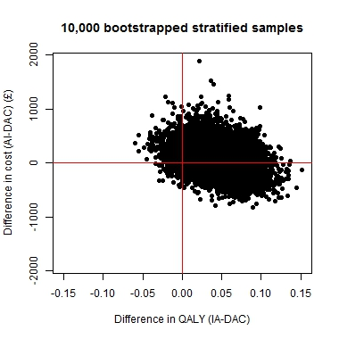

Figure DS3 Attendance survival curve.

