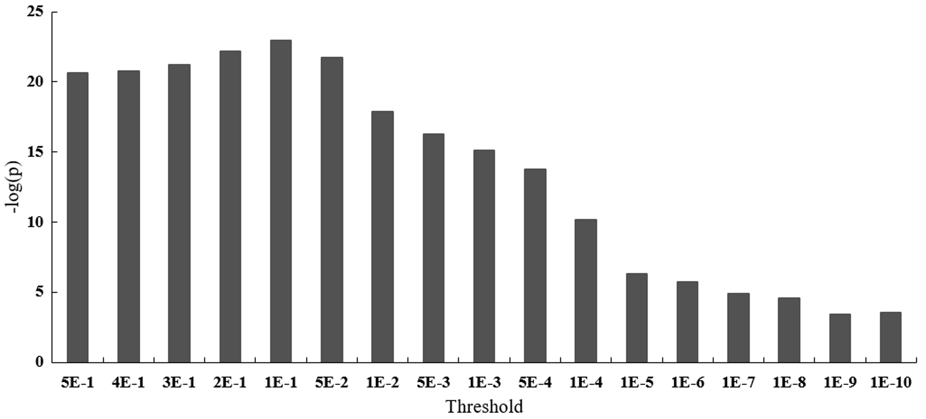
Fig. 1. Comparison of the PGRS between schizophrenia patients and normal controls. Specifically, when the value of –log(p) was greater, the difference between the SZ and HC was more significant. The most significant difference was observed when the threshold was equal to 0.1.
Table 1: The PGRS under different thresholds
ID | P_{T} | PGRS(SZ) |  | PGRS(NC) |  | t-test: SZ vs NC
ID | P_{T} | Mean(10⁻²) | SD(10⁻⁴) | Mean(10⁻²) | SD(10⁻⁴) | T | p | -log(p)
1 | 0.5 | 1.083 | 0.412 | 1.080 | 0.447 | 9.702 | 2.44E-21 | 20.613
2 | 0.4 | 1.156 | 0.472 | 1.153 | 0.511 | 9.740 | 1.73E-21 | 20.762
3 | 0.3 | 1.239 | 0.554 | 1.235 | 0.593 | 9.854 | 6.22E-22 | 21.206
4 | 0.2 | 1.350 | 0.686 | 1.346 | 0.732 | 10.103 | 6.32E-23 | 22.199
5 | 0.1 | 1.520 | 0.952 | 1.514 | 1.023 | 10.290 | 1.10E-23 | 22.959
6 | 0.05 | 1.671 | 1.305 | 1.663 | 1.380 | 9.990 | 1.79E-22 | 21.747
7 | 0.01 | 1.982 | 2.580 | 1.968 | 2.606 | 8.971 | 1.40E-18 | 17.854
8 | 0.005 | 2.096 | 3.290 | 2.078 | 3.289 | 8.527 | 5.44E-17 | 16.264
9 | 0.001 | 2.358 | 5.592 | 2.330 | 5.303 | 8.185 | 8.15E-16 | 15.089
10 | 5E-04 | 2.459 | 6.770 | 2.427 | 6.317 | 7.791 | 1.65E-14 | 13.783
11 | 1E-04 | 2.705 | 10.241 | 2.664 | 9.435 | 6.582 | 7.43E-11 | 10.129
12 | 1E-05 | 3.118 | 16.531 | 3.068 | 14.897 | 5.059 | 5.02E-07 | 6.299
13 | 1E-06 | 3.574 | 21.875 | 3.510 | 20.611 | 4.806 | 1.77E-06 | 5.752
14 | 1E-07 | 4.127 | 30.251 | 4.046 | 28.697 | 4.369 | 1.38E-05 | 4.860
15 | 1E-08 | 4.341 | 33.876 | 4.253 | 32.297 | 4.209 | 2.80E-05 | 4.553
16 | 1E-09 | 4.932 | 39.716 | 4.845 | 38.309 | 3.558 | 3.90E-04 | 3.408
17 | 1E-10 | 5.613 | 47.467 | 5.506 | 45.420 | 3.641 | 2.86E-04 | 3.544

Table 2: The association between right hippocampal GMV and cognitive performance and PANSS scores.
Object | Scores | Pearson’s correlation (one-tail)
Object | Scores | Right hippocampal volume |  | Hippocampus-mPFC FC
Whole group | SDMT | R | 0.067 | R | 0.006
Whole group | SDMT | P | 0.019 | P | 0.429
Whole group | Forward-DS | R | -0.013 | R | 0.041
Whole group | Forward-DS | P | 0.339 | P | 0.123
Whole group | Backward-DS | R | -0.047 | R | -0.012
Whole group | Backward-DS | P | 0.071 | P | 0.365
SZ patients | PANSS positive score | R | 0.065 | R | 0.033
SZ patients | PANSS positive score | P | 0.075 | P | 0.260
SZ patients | PANSS negative score | R | -0.083 | R | -0.036
SZ patients | PANSS negative score | P | 0.032 | P | 0.237
SZ patients | PANSS general score | R | 0.004 | R | -0.030
SZ patients | PANSS general score | P | 0.466 | P | 0.275
SZ patients | PANSS total score | R | -0.016 | R | -0.025
SZ patients | PANSS total score | P | 0.363 | P | 0.313

