Supplemental Material

Search Terms and Strategy 2
Article selection and overlapping data sets 3
Box S1. Inclusion rules for suspected overlapping datasets. 3
Table S1. Included articles submitted to full text assessment and reason for inclusion. 4
Table S2. Excluded Articles submitted to full-text assessment and reason for exclusion. 8
Box S2. Article selection to avoid overlapping data sets. 10
Table S3a. Overlap in data set and action taken for multivariable analyses. 14
Table S3b. Overlap in data set and action taken for crude analyses. 17
Supplementary Results 18
Forest plots of the main analyses 18
Publication bias and Trim-and-fill analysis 25
Meta-analysis of local data 28
Table S4. Neurodegenerative disorders and COVID-19 severity, hospitalization, ICU admission, and mortality. 28
Meta-analysis of data from crude analyses 29
Table S5. Neurodegenerative disorders SARS-CoV-2 infection risk, severity, hospitalization, ICU admission, and mortality. 29
Moderator Analyses 30
Table S6. Results of moderation analysis of SARS-CoV-2 infection risk for each type of neurodegenerative disease from multivariable analyses. 30
Table S7. Results of moderation analysis for COVID-19 severity and mortality from crude analyses. 30
Table S8. Results of moderation analysis of COVID-19 course, hospitalization, ICU admission rates, and mortality for each type of neurodegenerative disease from multivariable analyses. 31
Subgroup Analyses 32
Table S9. Odds Ratio on the association between neurodegenerative disorders and SARS-CoV-2 infection risk, severity, hospitalization, and ICU admission by geographic region. 32
Table S10. Odds Ratio on the association between neurodegenerative diseases and COVID-19 mortality by geographic region. 32
Bayesian Meta-analysis 33
Table S11. Comparison of Bayesian and frequentist analysis for Neurodegenerative disorders and SARS-CoV-2 infection risk from multivariable analyses. 33
Table S12. Comparison of Bayesian and frequentist analysis for Neurodegenerative disorders and COVID-19 severity, hospitalization, ICU admission, and mortality from multivariable analyses. 34
Table S13. Comparison of Bayesian and frequentist analysis for Neurodegenerative disorders and COVID-19 severity, hospitalization, ICU admission, and mortality from local data. 35
Table S14. Comparison of Bayesian and frequentist ORs for Neurodegenerative disorders and SARS-CoV-2 infection risk, COVID-19 severity, hospitalization, ICU admission, and mortality from Crude analyses. 36
Table S15. Study design and type of control of included studies and samples by outcome. 37
Assessment of methodological quality 41
Table S16. Items of the quality assessment tool for cross-sectional studies 41
Table S17. Quality assessment of included studies. 42
References 49

Search Terms and Strategy
Searches: Systematic searches in PubMed, Web of Science and the two pre-print servers psyarxiv.org and medrxiv.org. This was supplemented with a non-systematic search in Google Scholar. The search string is presented below:

Search terms PubMed: (("covid 19"[Title/Abstract] OR "covid 19"[Title/Abstract] OR "COVID19"[Title/Abstract] OR "sars cov 2"[Title/Abstract] OR "Severe Acute Respiratory Syndrome Coronavirus 2"[Title/Abstract] OR "coronavirus"[Title/Abstract] OR "SARS-CoV"[Title/Abstract] OR "sars cov 2"[Title/Abstract]) AND ("Alzheimer's"[Title/Abstract] OR "Alzheimer"[Title/Abstract] OR "Alzheimer's disease"[Title/Abstract] OR "Alzheimer disease"[Title/Abstract] OR "dementias"[Title/Abstract] OR "dementia"[Title/Abstract] OR "neurocognitive disorders"[Title/Abstract] OR "cognitive deficits"[Title/Abstract] OR "cognitive dysfunction"[Title/Abstract] OR "cognitive impairment"[Title/Abstract] OR “mild cognitive impairment”[Title/Abstract] OR “MCI”[Title/Abstract] OR "Neurodegenerative disease"[Title/Abstract] OR "Lewy body disease"[Title/Abstract] OR "Lewy Bod"[Title/Abstract] OR "Parkinson Disease"[Title/Abstract] OR "Parkinson"[Title/Abstract])) AND (("2019"[Date - Publication] : "2023"[Date - Publication]))

Search terms Web of Science: (TS = (“COVID 19” OR COVID-19 OR COVID19 OR “SARS CoV-2” OR “Severe Acute Respiratory Syndrome Coronavirus 2” OR coronavirus OR SARS-CoV OR SARS-CoV-2) AND TS = (Alzheimer’s OR Alzheimer OR "Alzheimer’s disease" OR "Alzheimer disease" OR dementias OR dementia OR “neurocognitive disorders” OR "cognitive deficits" OR "cognitive dysfunction" OR "cognitive impairment" OR “mild cognitive impairment” OR “MCI” OR “Neurodegenerative disease” OR “Lewy body disease” OR “Lewy Bod” OR “Parkinson Disease” OR “Parkinson”)) AND PY=(2019-2023)

Article selection and overlapping data sets

Box S1. Inclusion rules for suspected overlapping datasets.
Most of the data on these topics comes from (often open access) electronic data bases and articles probably report on overlapping samples. In order to avoid conclusions based on overlapping data we checked the geographic region (e.g., city or state) where the data was gathered in case multiple studies reported data that was gathered in a particular country. When we suspected overlap we contacted study authors to ask for overlap in data sets. In case of a confirmatory answer (and in case of no response) we applied the following rules in the selection of articles in order to avoid results that are based on dependent data. The first decision was made based on the level of matching/statistical control of neurodegenerative disorder- and control sample. We preferred (propensity score) matching based over adjusting for covariates and the latter was preferred over no control. In case it was necessary we made a next decision based on the validity and the specificity of the predictor assessment. Here we preferred a specific diagnostic assessment over self-reported data, which in turn was preferred over categorization based on for example prescription drugs yes vs. no. In case no decision could be made based on this, the decision on inclusion was based on sample size, with a preference for the larger sample size. Below we describe our decisions for countries for which potential overlap was an issue.

Inclusion of independent data is a crucial assumption in meta-analysis (Cheung 2019). Given that most research on the topic of interest is based on (nationwide and more local) electronic data that often is freely available, overlapping data sets and analyses on identical samples was anticipated.

When multiple studies were performed in a single country, we checked whether there was ground to suspect overlap with regard to certain associations, and in case there was (e.g., 2 studies reporting from electronic data gathered in New York City hospitals), we included the one that was most informative with regard to our purposes. Third, when nationwide data was available for analysis alongside data gathered more locally (e.g., nationwide data from Spain and data from the autonomous Basque region) we ran analyses once with the nationwide data included and the local data excluded and once with the local data included and the nationwide data excluded. Similarity of results among these analyses was reported. For moderator and meta-regression analyses, we chose the pooled data-set that contained the largest number of participants. We reported on potential overlap and exclusion based on this at the level of the individual meta-analysis.

Table S1. Included articles submitted to full text assessment and reason for inclusion.
 | Study | Reason
 |  | Predictor | Outcome
 | Ajayi et al. 2020 | Dem | Mortality (first wave)
 | Ajayi et al. 2021 | Dem | Infection Risk, Mortality (second wave)
 | Alqahtani et al. 2021 | Dem | Mortality
 | An et al. 2021 | Dem | Mortality, Severity
 | Atkins et al. 2020 | Dem | Hospitalization, Mortality
 | Bae et al. 2021 | Dem | Mortality
 | Baker et al. 2021 | Dem | Mortality, Severity, ICU
 | Banoei et al. 2021 | Dem | Mortality
 | Becerra-muñoz et al. 2021 | Dem, PD | Mortality
 | Bennett et al. 2021 | Dem | Severity
 | Beobide Telleria et al., 2022 | Dem | Infection risk, Mortality
 | Bhargava et al. 2021 | Dem | Mortality
 | Bianchetti et al. 2020 | Dem | Mortality
 | Bielza et al. 2021 | Dem | Mortality, Severity
 | Booij et al., 2022 | Neurocognitive disorder | Mortality
 | Boye et al. 2021 | Dem | Mortality, Hospitalization
 | Bucholc et al., 2022 | Dem | Mortality
 | Busetto et al. 2020 | Dem | Mortality, ICU
 | Caliskan and saylan, 2020 | Dem | Mortality, ICU
 | Carrillo-garcia et al. 2021 | Dem | Mortality
 | Castilla et al. 2021 | Dem | Infection Risk, Hospitalization, Mortality
 | Chang et al. 2020 | Mix | Hospitalization
 | Chatterjee et al. 2021 | Dem | Mortality
 | Chen et al., 2022 | Dem | Mortality
 | Choi et al. 2021 | Dem | Mortality, ICU
 | Chojnicki et al. 2021 | CI | Mortality
 | Cisterna-garcía et al. 2022 | Dem | Mortality, ICU, Hospitalization
 | Covidsurg, 2021 | Dem | Mortality
 | Covino et al. 2020 | Dem | Mortality, Severity
 | Covino et al. 2021a | Dem | Mortality
 | Covino et al. 2021b | Dem | Mortality
 | Cummins et al. 2021 | Dem | Mortality, ICU, Hospitalization
 | de Malherbe et al., 2022 | AD | Infection risk
 | De marcaida et al. 2020 | PD | Mortality
 | De smet et al. 2020 | Dem | Mortality
 | Del ser et al. 2021 | AD | Infection Risk, Severity
 | Descamps et al., 2022 | Dem | Mortality, ICU admission
 | Ellis et al., 2022 | Dem, MCI | Hospitalization, Mortality
 | Emmerson et al., 2022 | Dem | Infection risk, Mortality
 | Escribà-salvans et al. 2022 | CI | Severity
 | Esme et al. 2021 | Dem | Mortality
 | España et al. 2021 | Dem | Mortality
 | Esteban et al. 2021 | Dem | Infection Risk, Severity
 | Fasano et al. 2020 | PD | Mortality, Hospitalization
 | Fathi et al. 2021 | AD, PD | Mortality
 | Filardo et al. 2020 | Dem | Mortality
 | Filipe et al. 2021 | Dem | Mortality, ICU
 | Fumagalli et al. 2021 | Dem | Mortality
 | Gale and boland, 2021 | Dem | Mortality
 | Ge et al. 2021 | Dem | Mortality, Severity
 | Genet et al. 2020 | Dem | Mortality
 | Geriatric et al. 2021 | Dem | Mortality, ICU
 | Ghaffari et al. 2021 | Dem | Severity
 | Gómez antúnez et al. 2020 | Dem, Mix | Mortality
 | Harrison et al. 2020 | Dem | Mortality
 | Hasani azad et al. 2021 | Dem | ICU
 | Hatamabadi et al., 2022 | AD, PD | Mortality
 | Hippisley-cox et al. 2021 | Dem, PD | Mortality, Hospitalization
 | Hwang et al. 2020 | AD | Mortality
 | Izurieta et al. 2021 | CI, PD | Mortality, Hospitalization
 | Kang and kong, 2021 | Dem | Mortality, Severity
 | Karapetyan et al. 2021 | Dem | Infection Risk, Severity
 | Ken-dror et al. 2020 | Dem | Mortality
 | Kim et al. 2020 | Dem | Severity
 | Kim et al. 2021 | Dem | Mortality
 | Kim et al., 2022a | Dem | Hospitalization, Severity, Mortality
 | Kim et al., 2022b | Dem | Severity, Infection risk
 | Kong et al. 2021 | Dem | Mortality, Severity
 | Kostev et al., 2022 | Dem | Mortality
 | Kyoung et al. 2021 | Dem | Mortality
 | Lazcano et al. 2021 | Dem | Mortality
 | Li et al. 2020 | AD | Mortality
 | Livingston et al. 2020 | Dem | Mortality
 | Lozano-montoya et al. 2021 | Dem | Mortality
 | Lu et al. 2021 | PD, CI | Mortality, Hospitalization
 | Lucijanić et al., 2022 | Dem | Mortality
 | Magallon-botaya et al. 2021 | Dem | Mortality, ICU, Hospitalization
 | Maguire et al. 2020 | CI | Mortality
 | Mahmoud et al. 2021 | Dem | Mortality
 | Maniero et al., 2022 | Dem, PD | Mortality
 | Martinot et al. 2021 | Dem | ICU, Mortality
 | Meis-pinheiro et al. 2021 | Dem | Mortality
 | Menditto et al. 2021 | CI | Hospitalization
 | Miyashita et al. 2020 | Dem | Hospitalization, ICU admission, Mortality
 | Molani et al. 2022 | Dem | Severity
 | Moon et al. 2021 | Dem | Mortality
 | Munblit et al. 2021 | Dem | Mortality
 | Nojiri et al., 2022 | Dem, PD | Mortality
 | Oh et al., 2022 | Dem, | Severity, Mortality
 | Orlando et al. 2021 | Mix, PD | Infection Risk
 | Ouattara et al. 2021 | Dem | Mortality
 | Pan et al. 2021 | CI | Infection Risk, Mortality
 | Panagiotou et al. 2021 | CI | Mortality
 | Patel et al., 2022 | Dem, PD, AD, VD, FTD | Mortality, ICU admission
 | Pisaturo et al. 2021 | Dem | Mortality, Severity
 | Profili et al. 2020 | Dem, PD | Infection Risk
 | Raheja et al. 2021 | Dem | Mortality
 | Ramos-rincón et al. 2021a | Dem | Mortality
 | Ramos-rincon et al. 2021b | Dem | Mortality
 | Rebora et al. 2021 | Dem | Mortality
 | Roig-marín and roig-rico, 2021 | Dem | Mortality
 | Romagnolo et al. 2021a | Mix | Mortality, Severity, Hospitalization, ICU
 | Romagnolo et al. 2021b | Mix | Severity
 | Rossi et al. 2020 | Dem | Mortality, Hospitalization
 | Russo et al. 2021 | AD, PD, Dem | Mortality
 | Rutten et al. 2021 | Dem, PD | Mortality
 | Salari et al. 2021c | PD | Mortality
 | Samuels et al. 2021 | Dem | ICU
 | Scherbaum et al. 2021 | PD | Mortality, Infection Risk
 | Secnik et al., 2023 | Dem | Mortality
 | Seon et al. 2021 | Dem | Infection Risk, Mortality
 | Shin et al. 2021 | Dem | Mortality, Severity
 | Smith et al. 2021 | Dem | Infection Risk
 | Soldevila et al., 2022 | Dem | Positive Infection risk, Mortality
 | Song et al. 2021 | Dem | Mortality
 | Stawinski et al. 2021 | Dem | Mortality
 | Tahira et al. 2021 | AD, PD, Dem | Infection Risk, Hospitalization, Mortality
 | Tsai et al. 2020 | Dem | Mortality
 | Tyson et al. 2021 | Dem, PD | Mortality
 | Vekaria et al., 2022 | Dem | Mortality, ICU admission
 | Venturini et al. 2021 | Dem | Mortality, ICU
 | Vignatelli et al. 2021 | Dem, PD | Hospitalization, Mortality
 | Wan et al. 2020 | Dem | Mortality
 | Wang et al. 2021a | Dem, AD | Infection risk
 | Wang et al. 2021b | Dem | Mortality
 | Wang et al. 2021c | Dem, AD, VD, Mix | Mortality, Infection Risk
 | Wong & Lovier, 2022 | Dem | Infection risk
 | Worcel et al. 2021 | Dem | Mortality, Infection Risk
 | Yakar et al. 2021 | Dem, PD | Mortality
 | Yu et al. 2021 | Dem, AD, PD, VD, FTD | Infection Risk, Mortality
 | Zakaria et al. 2021 | Dem | Mortality
 | Zenesini et al., 2022 | PD, PS | Infection risk, Hospitalization, Mortality
 | Zerbo et al. 2021 | AD, PD | Mortality, Infection Risk, Hospitalization, ICU
 | Zhang et al. 2021 | AD, VD, FTD, DLB | Mortality
 | Zhou et al. 2021a | AD, Dem | Infection Risk
 | Zhou et al. 2021b | Mix | Severity
Note. Dem = Dementia; AD = Alzheimer’s disease; PD = Parkinson’s disease; VD = vascular dementia, FTD = frontotemporal dementia, DLB = dementia with lewy bodies.

Table S2. Excluded Articles submitted to full-text assessment and reason for exclusion.
 | Study | Reason
 | Acharya et al. 2020 | No dementia/MCI → risk/outcome data
 | Akpinar et al. 2021 | No dementia/MCI → risk/outcome data
 | Albu et al. 2021 | No dementia/MCI → risk/outcome data
 | Alshahrani et al. 2021 | Data from multiple countries → possible duplicate data
 | Aly & Saber, 2021 | No dementia/MCI → risk/outcome data
 | Axenhus et al. 2021 | No dementia/MCI → risk/outcome data
 | Barh et al. 2021 | No dementia/MCI → risk/outcome data
 | Bayrak et al. 2021 | No dementia/MCI → risk/outcome data
 | Bhargava et al. 2020 | Duplicate data → overlap with (Bhargava et al., 2021)
 | Boietti et al. 2021 | No control group
 | Boytsov et al. 2021 | Excluded because of language
 | Burns & Howard, 2021 | No control group
 | Canevelli et al. 2020 | Systematic review
 | Carey et al. 2021 | No risk/outcome data
 | Cho et al. 2021a | Nationwide data (Choi et al. 2021 same data bigger sample size)
 | Cho et al. 2021b | Nationwide data (Choi et al. 2021 same data bigger sample size)
 | Cohen et al., 2022 | Wrong outcome
 | Das-Munshi et al. 2021 | No relevant outcome data
 | Desai et al., 2022 | Conference abstract
 | De Lorenzo et al. 2020 | Inverse relationship between outcome variables
 | Del Prete et al. 2021 | No control group
 | Di Giorgio et al., 2022 | No dementia/MCI → risk/outcome data
 | Fedeli et al. 2021 | No control group
 | Fedeli et al., 2022 | No outcome data (excess mortality excluded)
 | García-Cabrera et al. 2021 | No dementia/MCI → risk/outcome data
 | George and Guo, 2021 | No outcome data
 | Grippo et al. 2021 | No outcome data
 | Gulseth et al. 2020 | No dementia/MCI → risk/outcome data
 | Hägg et al. 2020 | No outcome data
 | Hatakeyama et al., 2022 | No outcome data
 | Hua et al., 2022 | No outcome data (excess mortality excluded)
 | Kenerly et al. 2021 | No dementia/MCI → risk/outcome data
 | Kleineberg et al. 2021 | Dementias include movement disorder
 | Lee et al. 2021 | Excluded because of language
 | Levi et al. 2021 | No access
 | Li et al., 2022 | No outcome data (excess mortality excluded)
 | Louie et al. 2020 | No outcome data
 | Martin-Jimenez et al. 2020 | No control group (all deceased)
 | Martinsson et al. 2021 | No dementia/MCI → risk/outcome data
 | Marziliano et al. 2021 | No outcome data
 | Marziliano et al., 2022 | Wrong outcome, No dementia/MCI → risk/outcome data
 | McKeown et al. 2021 | Poster
 | Miro et al. 2021 | No outcome data on dementia
 | Mohamed et al. 2020 | No control group (all deceased)
 | Morales Chacón et al., 2022 | No control
 | Nilsson et al. 2021 | No dementia/MCI → risk/outcome data
 | Palmieri et al. 2020 | No control group (all deceased)
 | Park et al. 2021 | Inverse relationship between variables of interest
 | Quezada-Feijoo et al. 2021 | No dementia/MCI → risk/outcome data
 | Raknes et al. 2021 | No dementia/MCI → risk/outcome data
 | Reif et al. 2021 | No outcome data
 | Rutten et al. 2020 | Duplicate data → overlap with (Rutten et al. 2021 which is included)
 | Salari et al. 2021a | No outcome data
 | Salari et al. 2021b | Duplicate article (Salari et al. 2021c is included)
 | Secnik et al., 2022 | Conference abstract
 | Silver et al. 2020 | No dementia/MCI → risk/outcome data
 | Snider et al. 2021a | No outcome data
 | Snider et al. 2021b | No outcome data
 | Taquet et al. 2021 | No outcome data
 | Vetrano et al. 2021 | Dementias grouped with stroke
 | Vo et al. 2022 | Break through infection
 | Wang et al. 2022 | Break through infection
 | Whittaker et al. 2021 | No dementia/MCI → risk/outcome data
 | Williamson et al. 2022 | No dementia/MCI → risk/outcome data
 | Zifko et al. 2021 | No outcome data
 | Xu et al., 2022 | No dementia/MCI → risk/outcome data
Note.

Box S2. Article selection to avoid overlapping data sets.
Overlap after inclusion of articles.

UK Biobank and nationwide data
Seven articles (Atkins et al. 2020, Cummins et al. 2021, Hippsiley-Cox et al. 2021, Tahira et al. 2021, Wang et al. 2021c, Yu et al. 2021; Zhou et al. 2021a) report on nationwide data from the UK. We excluded Atkins et al. (2020) due to not having a control, and Yu et al. (2021) due to not having a clear predictor. Based on the above specified criteria we included Wang et al. (2021c) in the meta-analysis on dementia and mortality, dementia and infection risk, Alzheimer disease and infection risk, and mix neurodegenerative and infection risk, based on sample size. Since Wang et al. (2021c) does not report on the predictor Parkinson’s disease and the outcome hospitalization, we included Tahira et al. (2020) in the meta-analysis on Parkinson's disease and hospitalization, Parkinson’s disease and infection risk, and dementia and hospitalization. We chose Tahira et al. (2020) over Hippsiley-Cox and Cummins et al. (2021), based on the inclusion rules of predictor assessment.

Spain nationwide data
Two articles report on nationwide data from Spain (Ramos-Rincón et al. 2021a; Ramos-Rincón et al. 2021b). We included Ramos-Rincón et al. (2021b) in the meta-analysis on dementia and mortality based on inclusion rules of predictor assessment. Ramos-Rincón et al. (2021a) was excluded.

Spain local data
Ten articles report on local data from Spain (Carrillo-Garcia et al. 2021; Lozano-Montoya et al. 2021; Castilla et al. 2021; España et al. 2021; Lazcano et al. 2021; Cisterna-García et al. 2022; Roig-Marín & Roig-Rico, 2021; Meis-Pinheiro et al. 2021; Magallon-Botaya et al. 2021; Soldevilla et al. 2022). Castilla et al. (2021), España et al. (2021), and Magallon-Botaya et al. (2021) were included in the meta-analysis on dementia and mortality. Two studies report data from the Madrid region. We chose Lozano-Montoya et al. (2021) over Carrillo-Garcia et al. (2021), based on sample size. Carillo-Garcia et al. (2021) was excluded. From the three studies in Catalonia (Lazcano et al. 2021; Meis-Pinheiro et al. 2021; Soldevilla et al. 2022) we chose Lazcano et al. (2021) over Soldevilla et al. (2022) and Meis-Pinheiro et al. (2021). Meis-Pinheiro et al. (2021) was excluded. All studies have the same type of control; thus, we chose the included article based on the inclusion rules of predictor assessment. We preferred Lazcano et al. (2021) as the ICD-10 for the diagnosis of dementia was used.

Italy local data
We detected nineteen studies that used local data gathered from Italy (Bianchetti et al. 2020; Busetto et al. 2020; Covino et al. 2020; Covino et al. 2021a; Covino et al. 2021b; Fumagali et al. 2021; Mahmoud et al. 2021; Menditto et al. 2021; Profili et al. 2020; Pisaturo et al. 2021; Rebora et al. 2021; Rossi et al. 2020; Russo et al. 2021a; Russo et al. 2021b; Fasano et al. 2020; Venturini et al. 2021; Vignatelli et al. 2021; Romagnolo et al. 2021a; Orlando et al. 2021; Zenesini et al. 2022).
Of the four studies in the province of Lombardia (Bianchetti et al. 2020; Fumagali et al. 2021; Rebora et al. 2021; Russo et al. 2021a) we included Bianchetti et al. (2020) and Russo et al. (2021a) in the meta-analysis on dementia and mortality, based on the inclusion rules of predictor assessment. Fumagali et al. (2021) and Rebora et al. (2021), respectively, were excluded. Three studies reported data from the province of Lazio (Covino et al. 2020; Covino et al. 2021a; Covino et al. 2021b). We decided to include Covino et al. (2021b) and exclude Covino et al. (2020) and Covino et al. (2021a), respectively, in the meta-analysis on dementia and mortality. All studies have the same type of control and predictor; therefore, we chose the included article based on sample size. Mahmoud et al. (2021) and Rossi et al. (2020) were included in the meta-analysis on dementia and mortality. Two studies reported data from the Emilia-Romagna province (Zenesini et al. 2022; Vignatelli et al. 2021). We decided to include Zenesini et al. (2022) over Vignatelli et al. (2021) in the meta-analysis on Parkinson’s disease and mortality, and Parkinson’s disease and hospitalization. Both articles make use of the same sample and type of control. We preferred Zenesini et al. (2022), as they are an updated version and include an additional outcome, thus better suited the purpose of the study. Vignatelli et al. (2021) was excluded. From the two studies in the province of Lombardia (Russo et al. 2021b; Fasano et al. 2020) we included Russo et al. (2021) in the meta-analysis on Parkinson’s disease and mortality and excluded Fasano et al. (2020). We preferred Russo et al. (2021) over Fasano et al. (2020), as they report more effect sizes (k=2) and have a bigger sample size. However, both studies are not clear on predictor assessment.

USA nationwide
Twelve articles report on nationwide data from the USA (Boye et al. 2021; Harrison et al. 2020; Zhang et al. 2021; Izurieta et al. 2021; Lu et al. 2021; Chang et al. 2020; Bennett et al. 2021; Wang et al. 2021a; Smith et al. 2021; Panagiotou et al. 2021; Wong & Lovier 2022; Chen et al. 2022). We decided to include Izurieta et al. (2021) in the meta-analysis on Parkinson’s Disease and hospitalization and exclude Lu et al. (2021). Both studies use data from the Centers of Medicare and Medicaid Services (CMS) Enrollment Database and the Common Medicare Environment. Medicare is a federally funded health insurance program. Since the data is likely derived from a nationwide data base, we made the decision not to include both studies together. Based on the criteria below, we chose Izurieta et al. (2021) due to their sample size. In the meta-analysis on dementia and infection risk we included Wang et al. (2021a) and excluded Wong and Lovier (2022) and Smith et al. (2020), respectively. We preferred Wang et al. (2021a) over Wong and Lovier (2022), based on the inclusion rules of predictor assessment. Wang et al. (2021a) was preferred over Smith et al. (2020), based on sample size and not containing missing information. In the meta-analysis on dementia and mortality we chose Zhang et al. (2021) over Chen et al. (2022), Boye et al. (2021), and Harrison et al. (2020). Chen et al. (2022) and Harrison et al. (2020) were excluded. We included Zhang et al. (2021) as they had propensity score as the type of control. In the meta-analysis for cognitive impairment and mortality we chose Panagiotou et al. (2021) over Izurieta et al. (2021), as they better suited the purpose of the study and contained more (k=3) effect sizes.

USA local data
Thirteen articles report on local data from the USA (Zerbo et al. 2021; Baker et al. 2021; Miyashita et al. 2020; Samuels et al. 2021; Banoei et al. 2021; Raheja et al. 2021; Zakaria et al. 2021; Zhang et al. 2021; Pan et al. 2021; Bhargava et al. 2021; Tsai et al. 2020; Kim et al. 2022a; Patel et al. 2022). Three studies on electronic data gathered from New York City hospitals were considered (Kim et al. 2022a; Miyashita et al. 2020; Raheja et al. 2021), leading to the suspicion of overlap among the databases. In the meta-analysis on dementia and hospitalization we chose Kim et al. (2022a) over Miyashita et al. (2020), based on the scope of the database it covers. The database was found to be the most comprehensive, covering the INSIGHT network of NYC's major academic medical institutions and the public NYC H+H system. Miyashita et al. (2020) report on MSHS network data, which is a part of Kim et al. (2022a) database. In the meta-analysis on dementia and mortality we chose Kim et al. (2022a) over Miyashita et al. (2020) and Raheja et al. (2021), as they cover a larger database for the NYC population. We excluded Raheja et al. (2021). Raheja et al. (2021) obtained data from the Maimonides Medical Center teaching hospital, which is also potentially included in Kim et al. (2022a) database, since it covers the NYC academic medical institution network.

South-Korean nationwide data
We detected sixteen published records that used (parts) of nationwide data gathered in South Korea (An et al. 2021; Bae et al. 2021; Choi et al. 2021; Hwang et al. 2020; Kang & Kong, 2021; Kim et al. 2020; Kim et al. 2021; Kim et al. 2022b; Kong et al. 2021; Kyoung et al. 2021; Moon et al. 2021; Oh et al. 2022; Seon et al. 2021; Shin et al. 2021; Song et al. 2021; Wang et al. 2021b). Since South Korea has a unique national health insurance system that provides insurance for all its citizens, we choose to include only one study in order to avoid overlapping data. Wang et al. (2021b) was included in the meta-analysis on Dementia and mortality due to having a propensity score, while others do not. We excluded Bae et al. (2021), Kang and Kong (2021), Kim et al. (2021), Kong et al. (2021), Kyoung et al. (2021), Song et al. (2021), and Moon et al. (2021). Since Wang et al. (2021b) does not report on the predictor dementia and the outcomes severity and infection risk, we included Kim et al. (2022b) in the meta-analyses on dementia and severity, and dementia and infection risk, respectively. For these outcomes we favored Kim et al. (2022b) as they used propensity score as the type of control, while the others do not. Thus, we excluded An et al. (2021), Seon et al. (2021), Shin et al. (2021), Kim et al. (2020), and Oh et al. (2022).

France nationwide data
Three articles report on nationwide data from France (Descamps et al. 2022; Ouattara et al. 2021a; Ouattara et al. 2021b; de Malherbe et al. 2022). We decided to include Descamps et al. (2022) in the meta-analysis on dementia and mortality and exclude Ouattara et al. (2021a). We preferred Descamps et al. (2022) as they had propensity score as the type of control.

Iran local data
Four articles report on local data from Iran (Hasani Azad et al. 2021; Ghaffari et al. 2021; Hatamabadi et al. 2022; Salari et al. 2021c). From the two studies reporting data from Tehran (Hatamabadi et al. 2022; Salari et al. 2021c), we included Hatamabadi et al. (2022) in the meta-analysis on Parkinson’s disease and mortality, based on sample size. We excluded Salari et al. (2021c).

Articles that were excluded based on the above are presented in the supplement excel file.
Note.

Table S3a. Overlap in data set and action taken for multivariable analyses.
Infection risk | [k] effect-sizes included | Action
Dementia | [8] Profili et al. (2020), Castilla et al. (2021), Soldevilla et al. (2022), Karapetyan et al. (2021), Kim et al. (2022b), Wang et al. (2021a), Wang et al. (2021c) | No potential overlap
Parkinson’s Disease | [6] Scherbaum et al. (2021), Zerbo et al. (2021), Orlando et al. (2021), Profili et al. (2020), Zenesini et al. (2022), Tahira et al. (2021) | No potential overlap
Alzheimer Disease | [5] Del Ser et al. (2021), Wang et al. (2021a), Zerbo et al. (2021), Wang et al. (2021c), de Malherbe et al. (2022) | Wang et al. (2021a) report nationwide data from the US. Zerbo et al. (2021) report local data from the US. Hence, the analyses were once run with the US nationwide data excluded (Wang et al. 2021a), and once with the US local data excluded (Zerbo et al. 2021)
Mix Neurodegenerative | [3] Orlando et al. (2021), Pan et al. (2021), Wang et al. (2021c) | No potential overlap
Severity | [k] effect-sizes included | Action
Dementia | [10] Bennett et al. (2021), Baker et al. (2021), Karapetyan et al. (2021), Esteban et al. (2021), Ghaffari et al. (2021), Kim et al. (2022b), Nojiri et al. (2022), Kim et al. (2022a) | Bennett et al. (2021) report nationwide data from the US. Baker et al. (2021) and Kim et al. (2022a) report local data from the US. Hence the analyses were once run with the US nationwide data excluded (Bennett et al. 2021), and once with the US local data excluded (Baker et al. 2021; Kim et al. 2022a).
Alzheimer’s disease | [1] Del Ser et al. (2021) | No potential overlap
Cognitive Impairment | [1] Escribà-Salvans et al. (2022) | No potential overlap
Mix Neurodegenerative | [4] Ge et al. (2021), Romagnolo et al. (2021a), Orlando et al. (2021), Nojiri et al. (2022) | No potential overlap
Hospitalization | [k] effect-sizes included | Action
Dementia | [9] Rossi et al. (2020), Boye et al. (2021), Tahira et al. (2021), Castilla et al. (2021), Magallon-Botaya et al. (2021), Kim et al. (2022a), Ellis et al. (2022) | Boye et al. (2021) report nationwide data from the US. Kim et al. (2022a) report local data from the US. Hence the analyses were once run with the US nationwide data excluded (Boye et al. 2021), and once with the US local data excluded (Kim et al. 2022a).
Alzheimer Disease | [2] Tahira et al. (2021), Zerbo et al. (2021) | No potential overlap
Parkinson’s Disease | [5] Fasano et al. (2020), Zenesini et al. (2022), Tahira et al. (2021), Zerbo et al. (2021), Izurieta et al. (2021) | Izurieta et al. (2021) report nationwide data from the US. Zerbo et al. (2021) report local data from the US. Hence the analyses were once run with the US nationwide data excluded (Izurieta et al. 2021), and once with the US local data excluded (Zerbo et al. 2021).
Cognitive Impairment | [2] Izurieta et al. (2021), Ellis et al. (2022) | No potential overlap
Mix Neurodegenerative | [1] Chang et al. (2020) | No potential overlap
ICU admission | [k] effect-sizes included | Action
Dementia | [13] Cummins et al. (2021), Martinot et al. (2021), Magallon-Botaya et al. (2021), Choi et al. (2021), Caliskan and Saylan (2020), Geriatric et al. (2021), Filipe et al. (2021), Miyashita et al. (2020), Baker et al. (2021), Samuels et al. (2021), Descamps et al. (2022), Vekaria et al. (2022) | Descamps et al. (2022) report nationwide data from France. Martinot et al. (2021) report local data from France. Hence the analyses were once run with the France nationwide data excluded (Descamps et al. 2022), and once with the France local data excluded (Martinot et al. 2021).
Alzheimer Disease | [1] Zerbo et al. (2021) | No potential overlap
Parkinson’s Disease | [1] Zerbo et al. (2021) | No potential overlap
Mortality | [k] effect-sizes included | Action
Dementia | [46] Bianchetti et al. (2020), Russo et al. (2021a), Covino et al. (2021b), Mahmoud et al. (2021), Rossi et al. (2020), Wang et al. (2021b), Lozano-Montaya et al. (2021), Castilla et al. (2021), España et al. (2021), Lazcano et al. (2021), Magallon-Botaya et al. (2021), Ramos-Rincon et al. (2021b), Baker et al. (2021), Banoei et al (2021), Filardo et al. (2020), Kim et al. (2022a), Zakaria et al. (2021), Zhang et al. (2021), Ken-Dror et al. (2020), Livingston et al. (2020), Wang et al. (2021c), Martinot et al. (2021), Descamps et al. (2022), Caliskan and Saylan (2020), Esme et al. (2021), COVIDsurg (2021), De Smet et al. (2020), Munblit et al. (2021), Bucholc et al. (2022), Secnik et al. (2023), Ellis et al. (2022), Lucijanic et al. (2022), Vekaria et al. (2022), Nojiri et al. (2022), Becerra-Muñoz et al. (2021), Filipe et al. (2021), Rutten et al. (2021), Ge et al. (2021), Geriatric et al. (2021) | Ramos-Rincon et al. (2021) report nationwide data from Spain. Lozano-Montoya et al. (2021), Castilla et al. (2021), España et al. (2021), Lazcano et al. (2021), Magallon-Botaya et al. (2021) report local data from Spain. Hence the analyses were once run with the Spain nationwide data excluded (Ramos-Rincon et al. 2021), and once with the Spain local data excluded: Lozano-Montoya et al. (2021), Castilla et al. (2021), España et al. (2021), Lazcano et al. (2021), Magallon-Botaya et al. (2021).  Zhang et al. (2021) report nationwide data from the US. Baker et al. (2021), Banoei et al (2021), Filardo et al. (2020), Kim et al. (2022a), and Zakaria et al. (2021) report local data from the US. Hence the analyses were once run with the US nationwide data excluded (Zhang et al. 2021), and once with the US local data excluded: Baker et al. (2021), Banoei et al (2021), Filardo et al. (2020), Kim et al. (2022a), Zakaria et al. (2021). Wang et al. (2021c) report nationwide data from UK. Ken-Dror et al. (2020), Livingston et al. (2020) report local data from UK. Hence the analyses were once run with the UK nationwide data excluded (Wang et al. 2021c), and once with the UK local data excluded: Ken-Dror et al. (2020), Livingston et al. (2020). Descamps et al. (2022) report nationwide data from France. Martinot et al. (2021) report local data from France. Hence the analyses were once run with the France nationwide data excluded (Descamps et al. 2022), and once with the France local data excluded (Martinot et al. 2021). Esme et al. (2021) report nationwide data from Turkey. Caliskan and Saylan (2020) report local data from Turkey. Hence the analyses were once run with the Turkey nationwide data excluded (Esme et al. 2021), and once with the Turkey local data excluded (Caliskan and Saylan, 2020).
Alzheimer Disease | [7] Fathi et al. (2021), Hwang et al. (2020), Russo et al. (2021a), Wang et al. (2021c), Zerbo et al. (2021), Zhang et al. (2021), Kostev et al. (2022) | No potential overlap
Parkinson’s Disease | [11] Hippisley-Cox et al. (2021), Fathi et al. (2021), Becerra-Muñoz et al. (2021), Rutten et al. (2021), Russo et al. (2021), Zenesini et al. (2022), Izurieta et al. (2021), Zhang et al. (2021), Zerbo et al. (2021), Nojiri et al. (2022) | Izurieta et al. (2021) report nationwide data from the US. Zhang et al. (2021) and Zerbo et al. (2021) report local data from the US. Hence the analyses were once run with the US nationwide data excluded (Izurieta et al. 2021), and once with the US local data excluded: Zhang et al. (2021), Zerbo et al. (2021)
Cognitive Impairment | [6] Chojnicki et al. (2021), Pan et al. (2021), Panagiotou et al. (2021), Ellis et al. (2022) | Panagiotou et al. (2021) report nationwide data from the US. Pan et al. (2021) report local data from the US. Hence the analyses were once run with the US nationwide data excluded (Panagiotou et al. 2021), and once with the US local data excluded (Pan et al. 2021).
Mix Neurodegenerative | [6] Romagnolo et al. (2021b), Zhang et al. (2021), Gómez Antúnez et al. (2020), Chojnicki et al. (2021), Wang et al. (2021c), Kostev et al. (2022) | No potential overlap
Note.

Table S3b. Overlap in data set and action taken for crude analyses.
Infection risk | [k] effect-sizes included | Action
Dementia | [6] Worcel et al. (2021), Ajayi et al. (2020), Zhou et al. (2021a), Beobide Telleria et al. (2022), Emmerson et al. (2022), Zenesini et al. (2022) | Zhou et al. (2021a) report nationwide data from the UK. Ajayi et al. (2020) and Emmerson et al. (2022) report local data from the UK. Hence the analyses were run once with the UK nationwide data excluded (Zhou et al. 2021a), and once with the UK local data excluded (Ajayi et al. 2020; Emmerson et al. 2022)
Severity | [k] effect-sizes included | Action
Dementia | [4] Pisaturo et al. (2021), Molani et al. (2022), Bielza et al. (2021), Zhou et al. (2021b) | No potential overlap
Mix Neurodegenerative | [1] Romagnolo et al. (2021b) | No potential overlap
Hospitalization | [k] effect-sizes included | Action
Dementia | [2] Cisterna-García et al. (2022), Zenesini et al. (2022) | No potential overlap
Cognitive Impairment | [1] Menditto et al. (2021) | No potential overlap
Mix Neurodegenerative | [1] Romagnolo et al. (2021b) | No potential overlap
ICU admission | [k] effect-sizes included | Action
Dementia | [4] Cisterna-García et al. (2022), Hasani Azad et al. (2021), Busetto et al. (2020), Venturini et al. (2021) | No potential overlap
Mix Neurodegenerative | [1] Romagnolo et al. (2021b) | No potential overlap
Mortality | [k] effect-sizes included | Action
Dementia | [26] Busetto et al. (2020), Pisaturo et al. (2021), Venturini et al. (2021), Tsai et al. (2020), Bhargava et al. (2021), Stawinski et al. (2021), Tyson et al. (2021), Ajayi et al. (2020), Ajayi et al. (2021), Gale and Boland (2021), Maniero et al. (2022), Genet et al. (2020), Worcel et al. (2021), Bielza et al. (2021), Cisterna-García et al. (2022), Roig-Marín and Roig-Rico (2021), Beobide Telleria et al. (2022), Wan et al. (2020), Alqahtani et al. (2021), Chatterjee et al. (2021), Yakar et al. (2021), Kostev et al. (2022), Booij et al. (2020), Emmerson et al. (2022), Patel et al. (2022), Zenesini et al. (2022) | No potential overlap
Alzheimer Disease | [3] Li et al. (2020), Hatamabadi et al. (2022), Patel et al. (2022) | No potential overlap
Parkinson’s Disease | [7] Scherbaum et al. (2021), Hatamabadi et al. (2022), Yakar et al. (2021), de Marcaida et al. (2020), Tyson et al. (2021), Maniero et al. (2022), Patel et al. (2022) | No potential overlap
Cognitive Impairment | [1] Maguire et al. (2020) | No potential overlap
Note.

Supplementary Results

Forest plots of the main analyses
Below are the forest plots of the main analyses presented in the manuscript (i.e., multivariable for each disorder and outcome, except for dementia and mortality). All other forest plots for crude analyses and local and local data can be found on OSF or by clicking here.

Figure S1. Forest plot for odds of SARS-CoV-2 infection risk in patients with dementia.
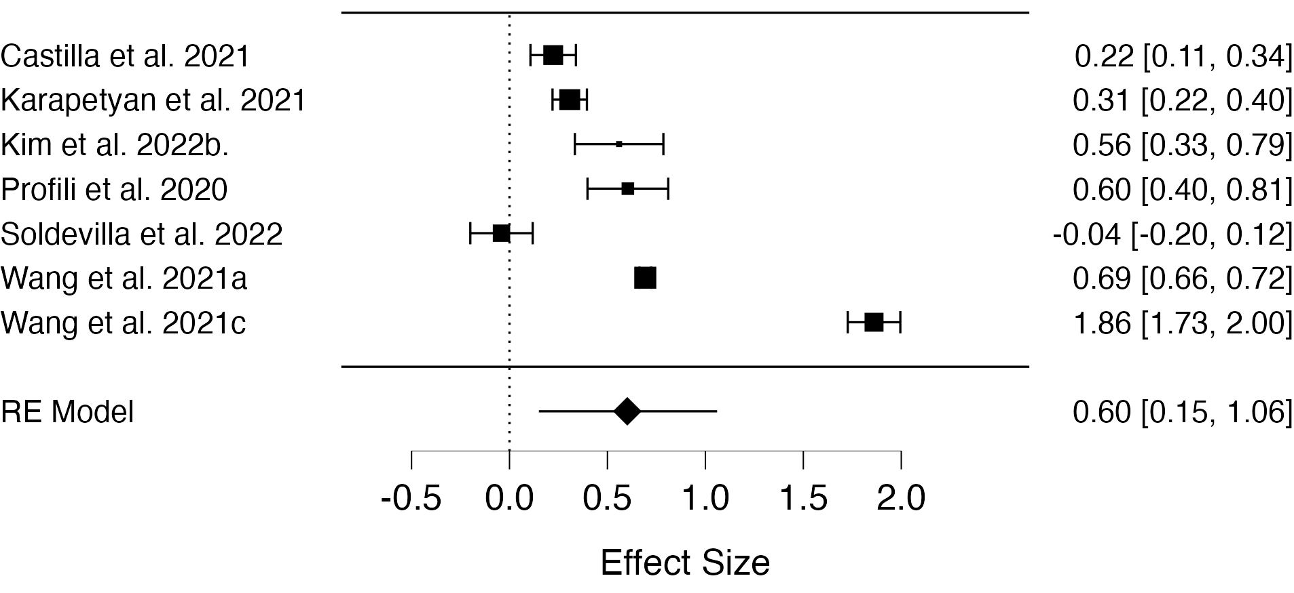
Note. Effect estimates are log odds ratio.

Figure S2. Forest plot for odds of SARS-CoV-2 infection risk and Alzheimer's disease.
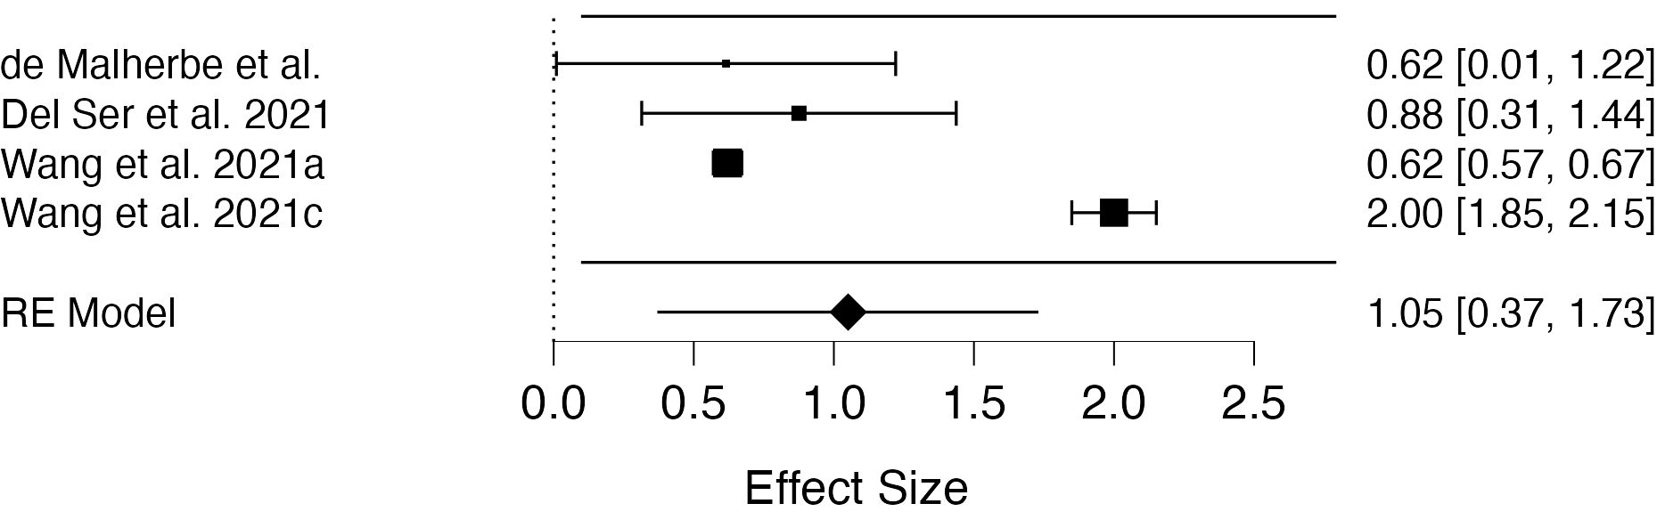
Note. Effect estimates are log odds ratio.

Figure S3. Forest plot for odds of SARS-CoV-2 infection risk mix neurodegenerative disorders.
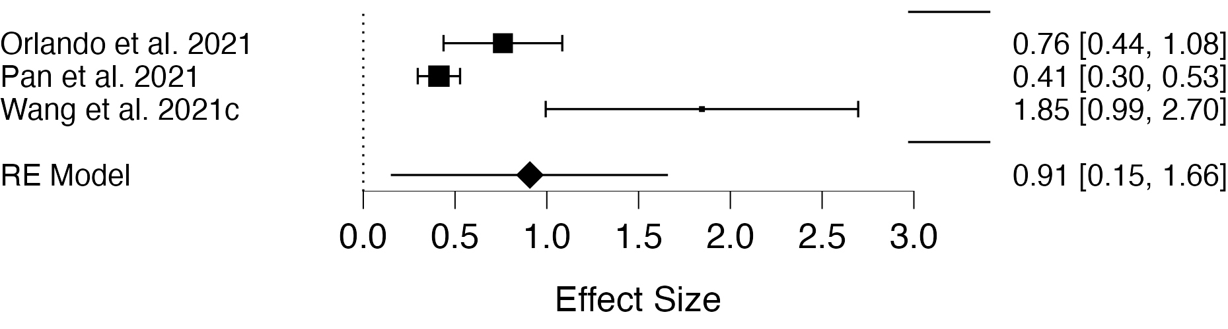
Note. Effect estimates are log odds ratio.

Figure S4. Forest plot for odds of SARS-CoV-2 infection risk and Parkinson's disease.
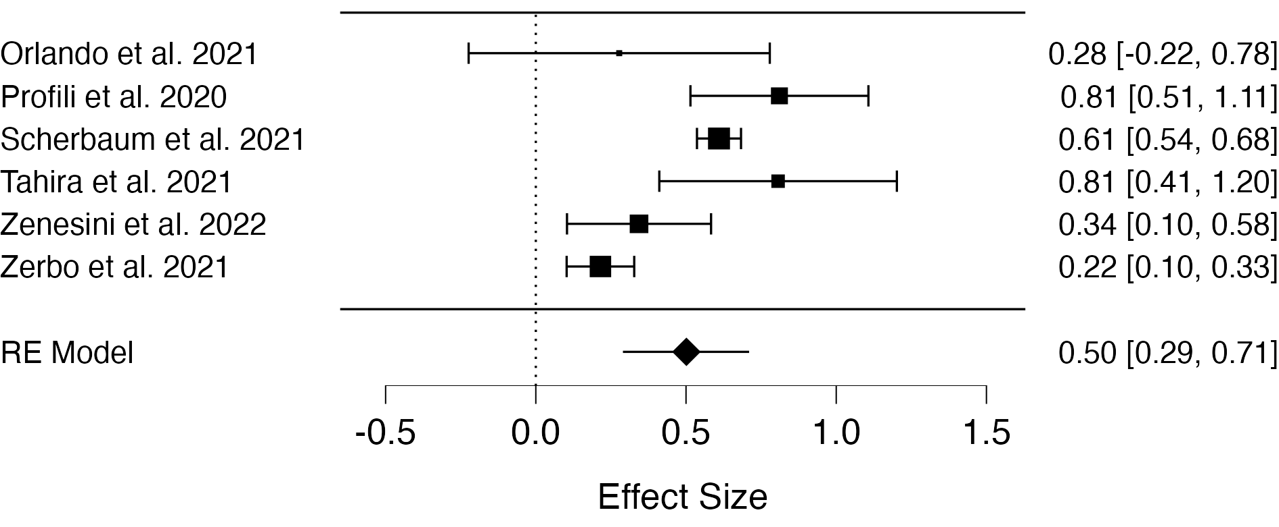
Note. Effect estimates are log odds ratio.

Figure S5. Forest plot for odds of COIVID-19 severity and dementia.
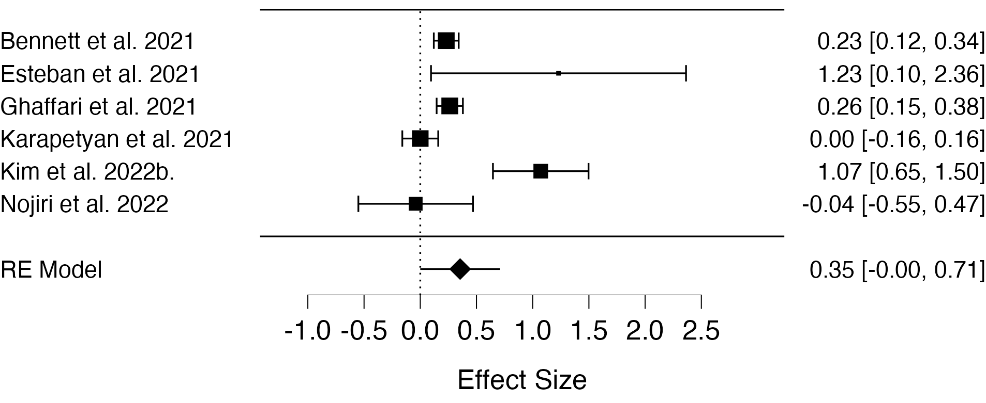
Note. Effect estimates are log odds ratio.

Figure S6. Forest plot for odds of COVID-19 severity and mix neurodegenerative disorders.
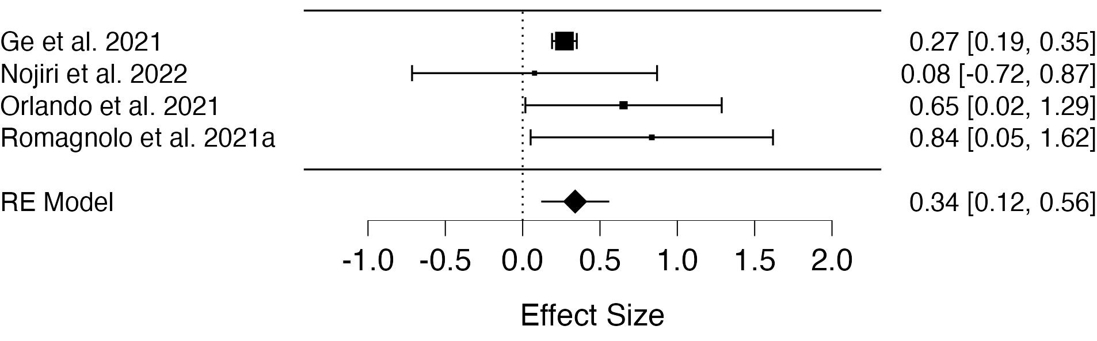
Note. Effect estimates are log odds ratio.

Figure S7. Forest plot for odds of COVID-19 hospitalization and dementia.
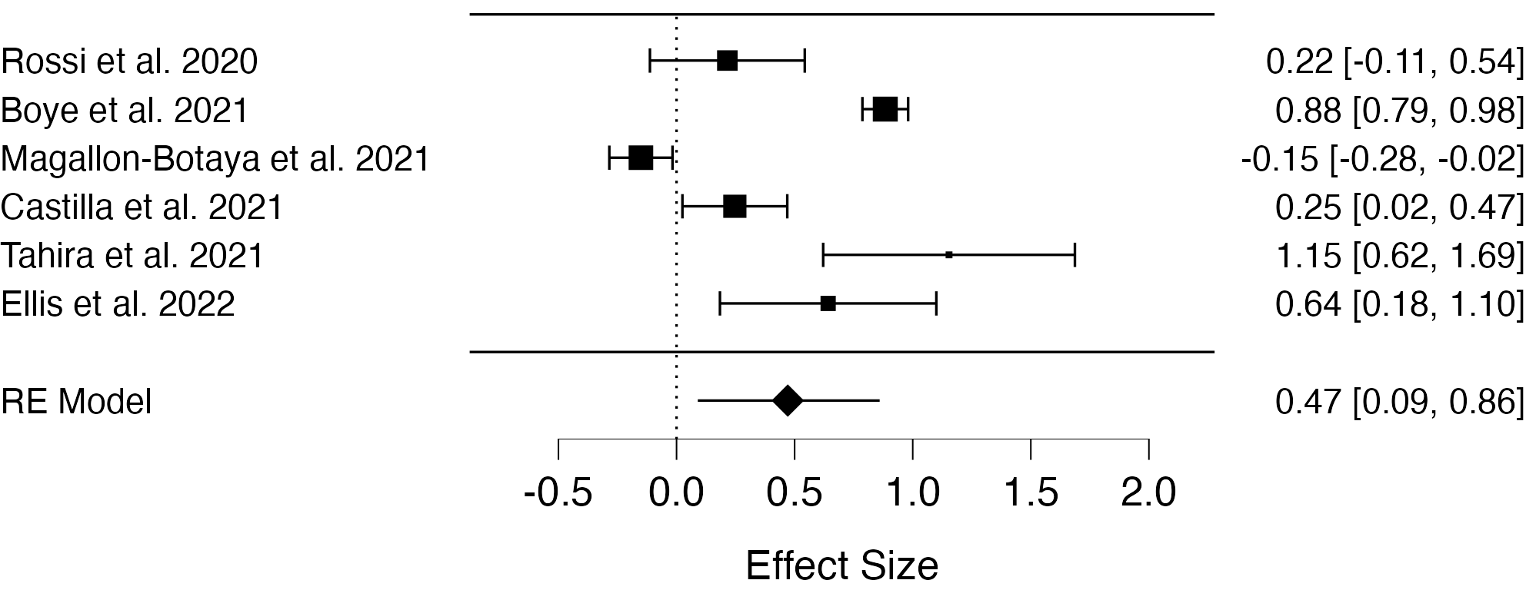
Note. Effect estimates are log odds ratio.

Figure S8. Forest plot for odds of COVID-19 hospitalization and Alzheimer's disease.
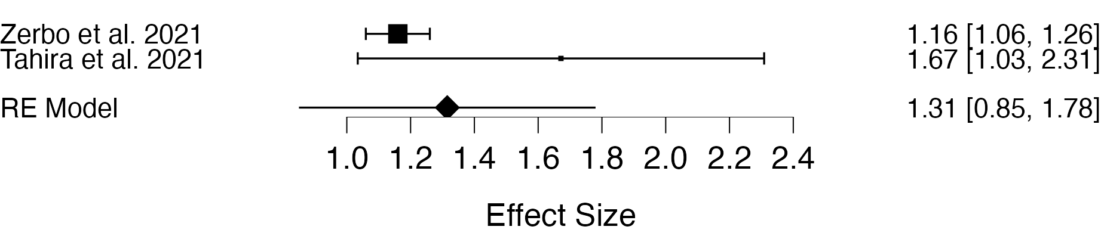
Note. Effect estimates are log odds ratio.

Figure S9. Forest plot for odds of COVID-19 hospitalization and Parkinson's disease.
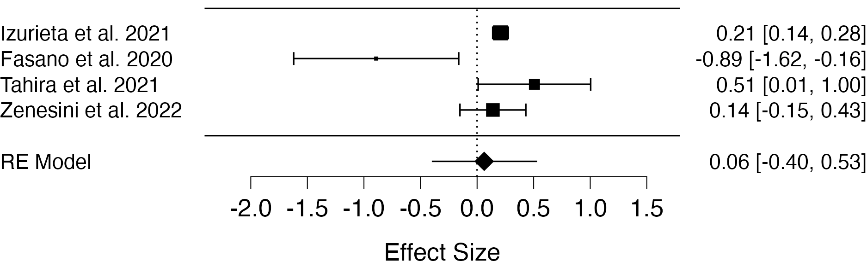
Note. Effect estimates are log odds ratio.

Figure S10. Forest plot for odds of COVID-19 hospitalization and MCI.
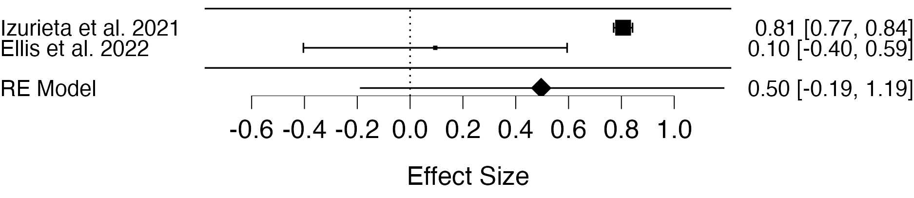
Note. Effect estimates are log odds ratio.

Figure S11. Forest plot for odds of COVID-19 related ICU admissions and dementia.
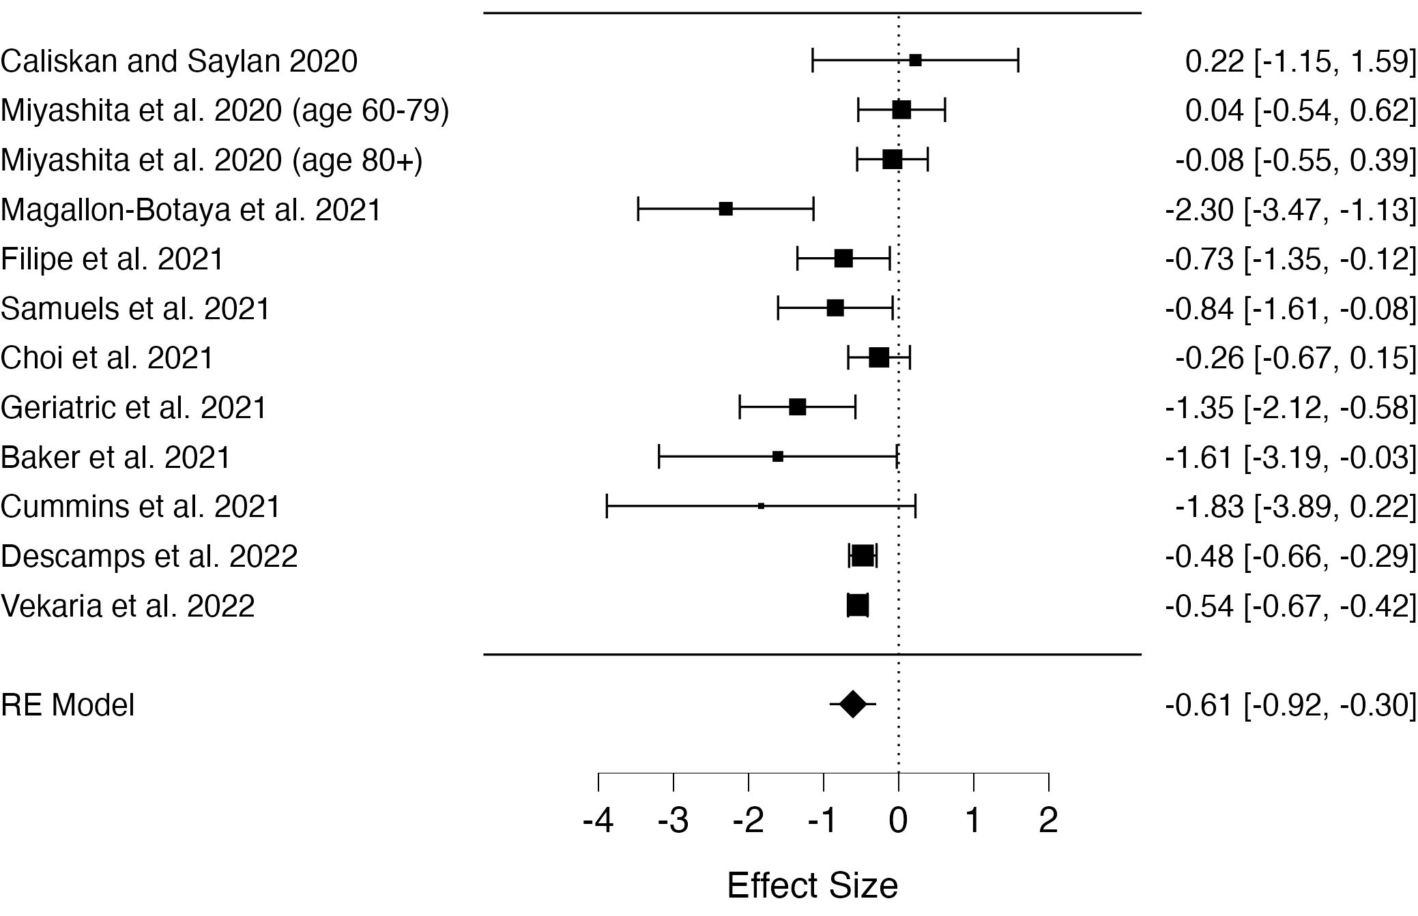
Note. Effect estimates are log odds ratio.

Figure S12. Forest plot for odds of COVID-19 mortality and Alzheimer's disease.
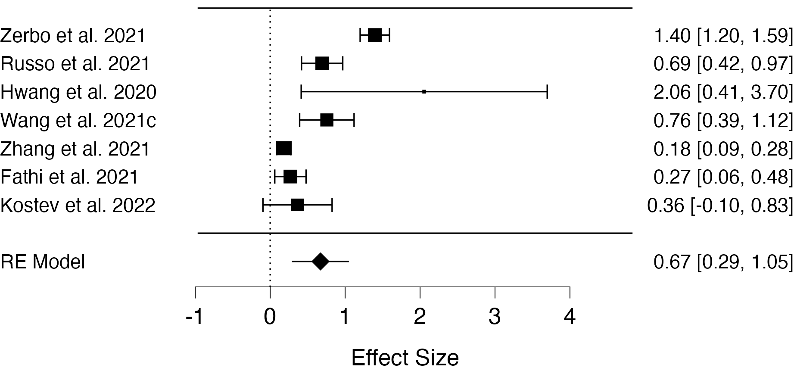
Note. Effect estimates are log odds ratio.

Figure S13. Forest plot for odds of COVID-19 mortality and Parkinson's disease.
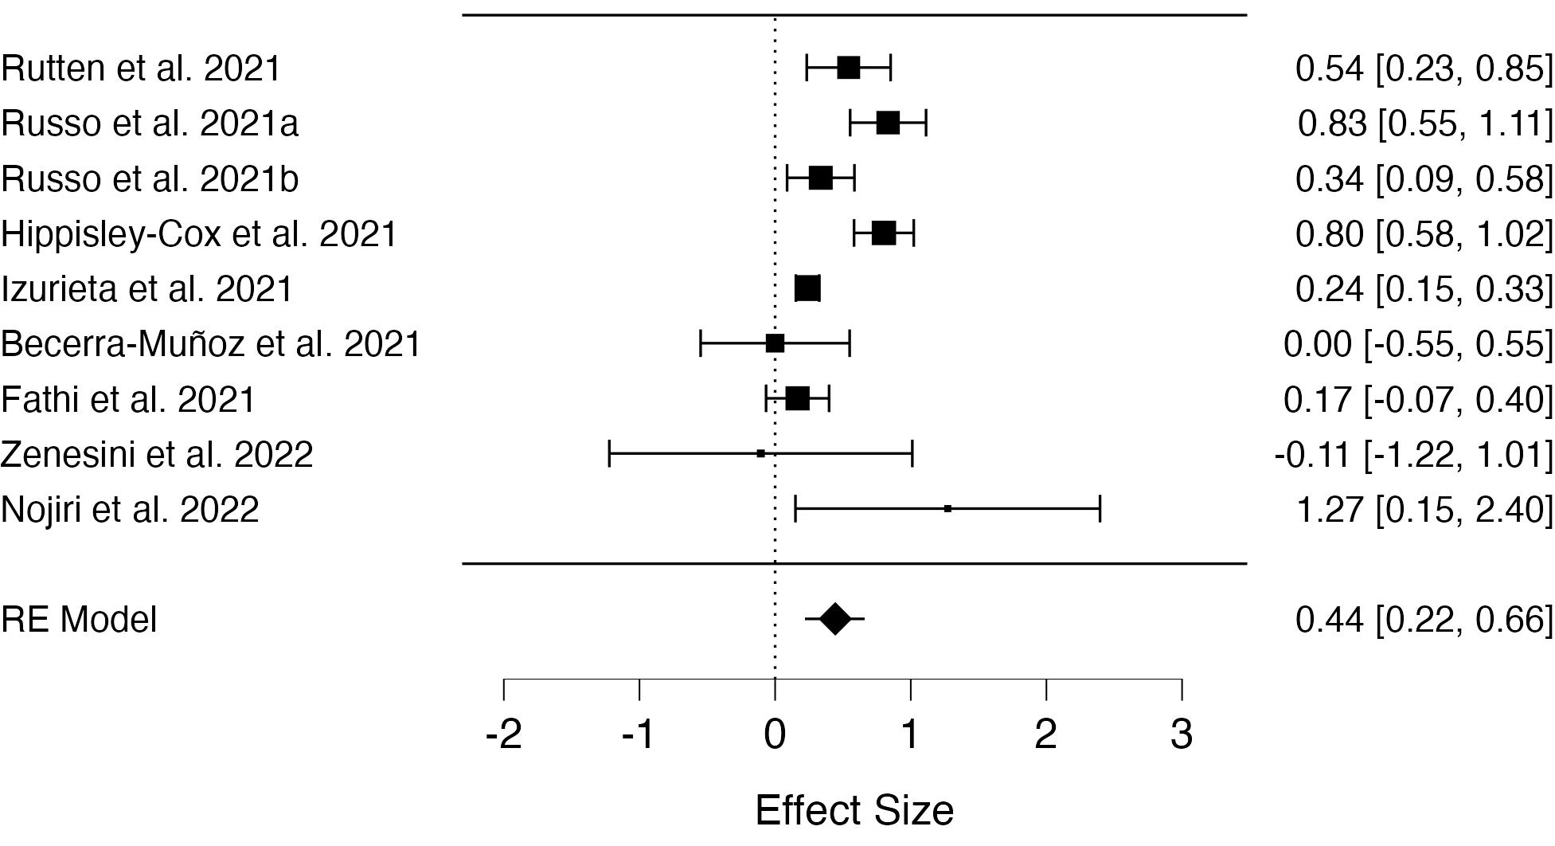
Note. Effect estimates are log odds ratio.

Figure S14. Forest plot for odds of COVID-19 mortality and MCI.
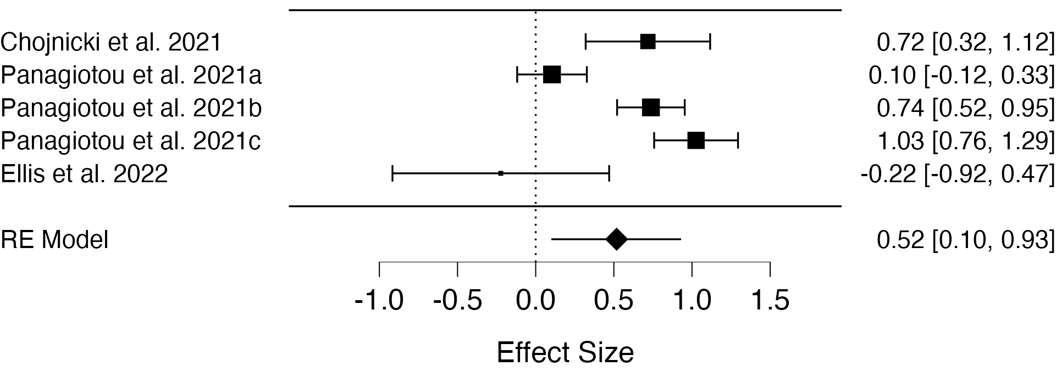
Note. Effect estimates are log odds ratio.

Figure S15. Forest plot for odds of COVID-19 mortality and mix neurodegenerative disorder.
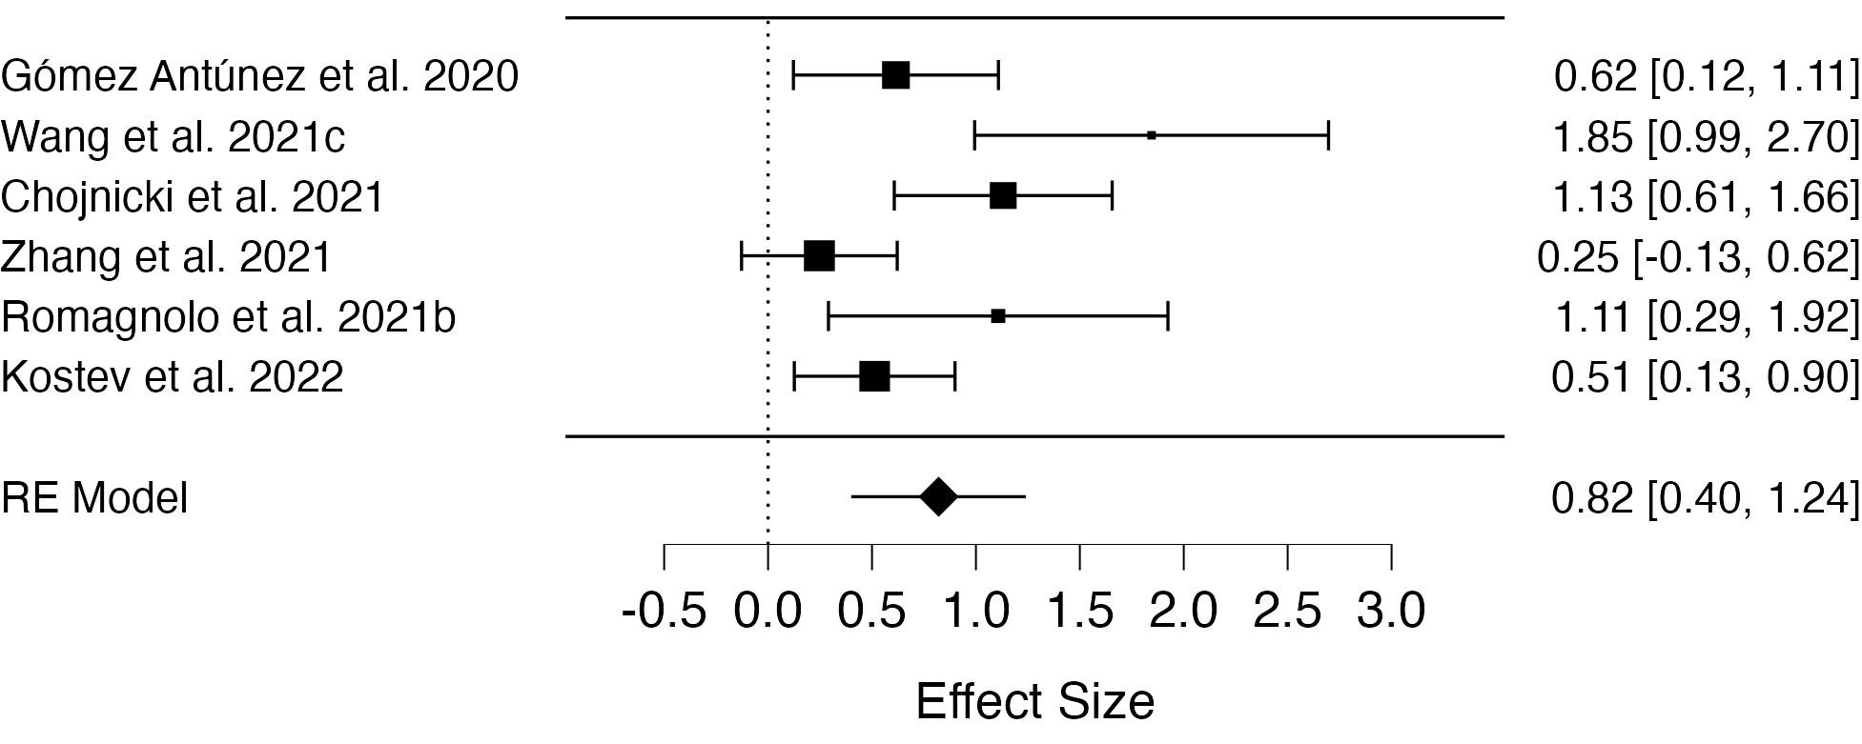
Note. Effect estimates are log odds ratio.

Publication bias and Trim-and-fill analysis
We found evidence for publication bias in five of the analyses (see Table 3 and Table S4-S5 for tua statistic). Three of the analyses had a small number of studies (less than 10) and therefore were difficult to interpret and thought to be unreliable. Accounting for this by means of trim-and-fill methods did not result in different estimates. For the analyses on the association of dementia and mortality, and of mix neurodegenerative and mortality, the trim-and-fill effect size estimates were slightly smaller.

For the analysis on the association of dementia and mortality the ‘trim and ﬁll’ method imputed 6 missing studies (Figure S16) and the resulting adjusted estimate of the overall effect size was (OR = 1.46, 95% CI = 1.27 to 1.66, p < 0.001). When using local data the trim and fill method imputed 11 studies (Figure S17) and the resulting adjusted estimate of the overall effect size was (OR = 1.51, 95 CI% = 1.33 to 1.33, p < 0.001). For the analysis on the association of mix neurodegenerative and mortality the ‘trim and ﬁll’ method imputed 3 missing studies (Figure S18) and the resulting adjusted estimate of the overall effect size was (OR = 1.55, 95% CI = 0.92 to 2.61, p = 0.097).

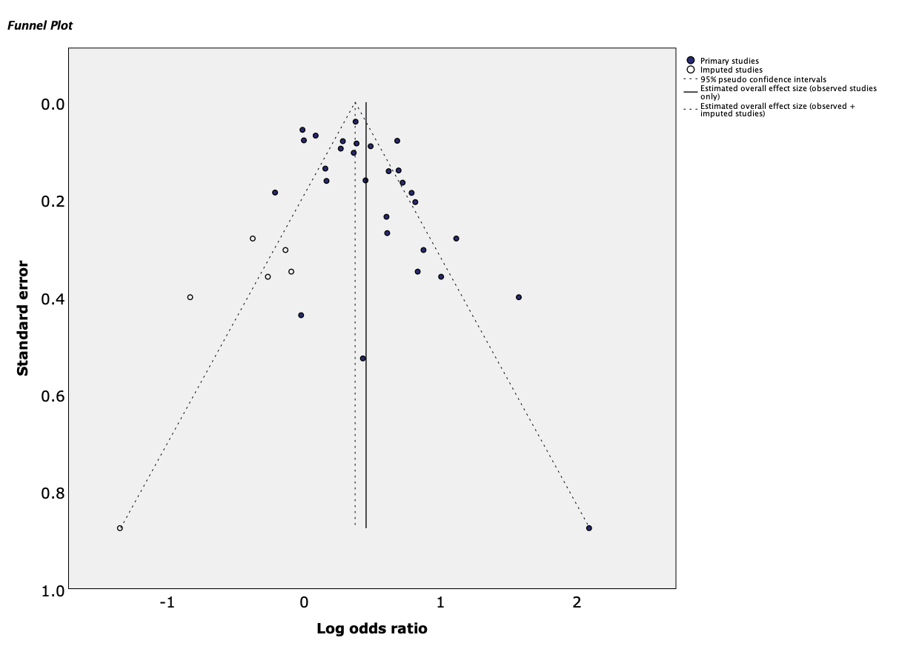

Figure S16. Funnel plot and trim-and-fill analysis for dementia and covid-19 mortality using nationwide data.
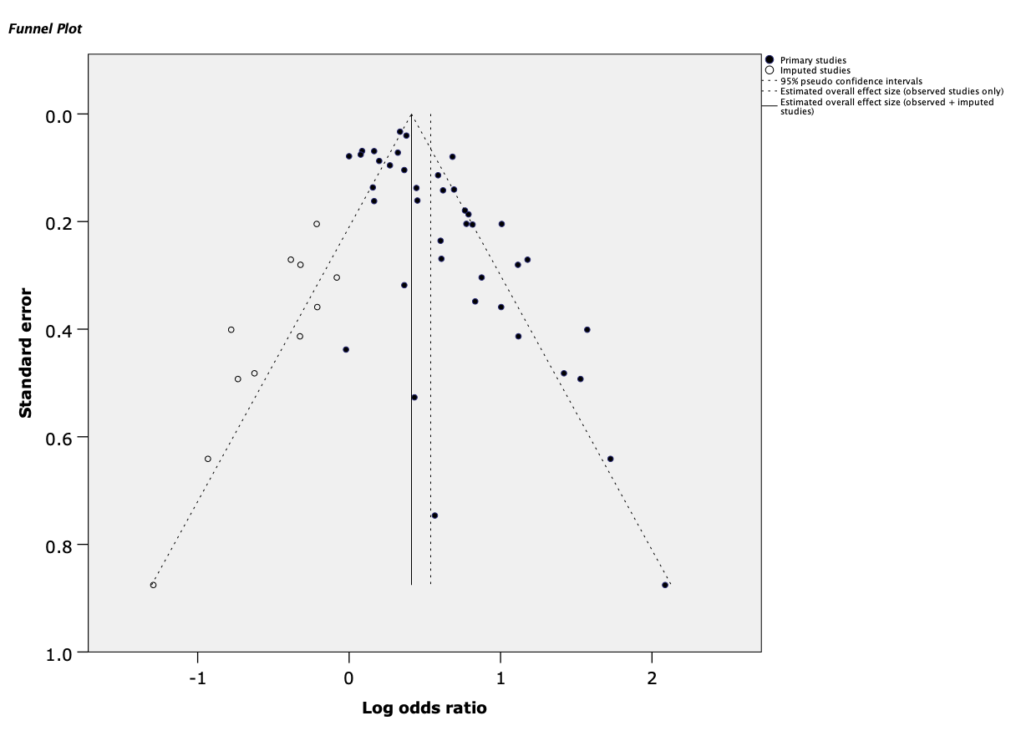

Figure S17. Funnel plot and trim-and-fill analysis for dementia and covid-19 mortality using local data.

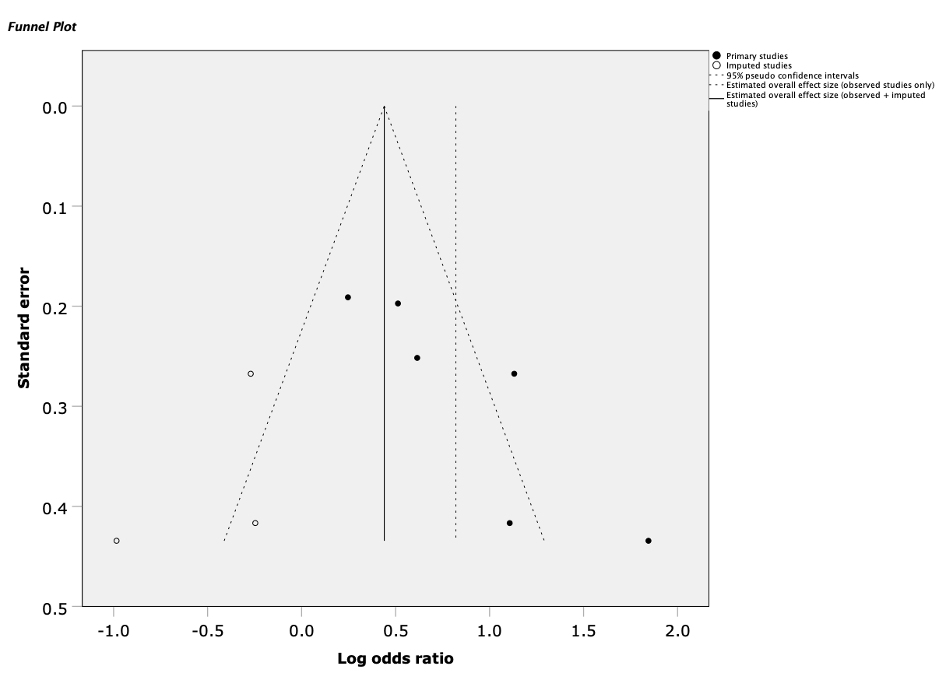

Figure S18. Funnel plot and trim-and-fill analysis for mix neurodegenerative disorders and covid-19 mortality.
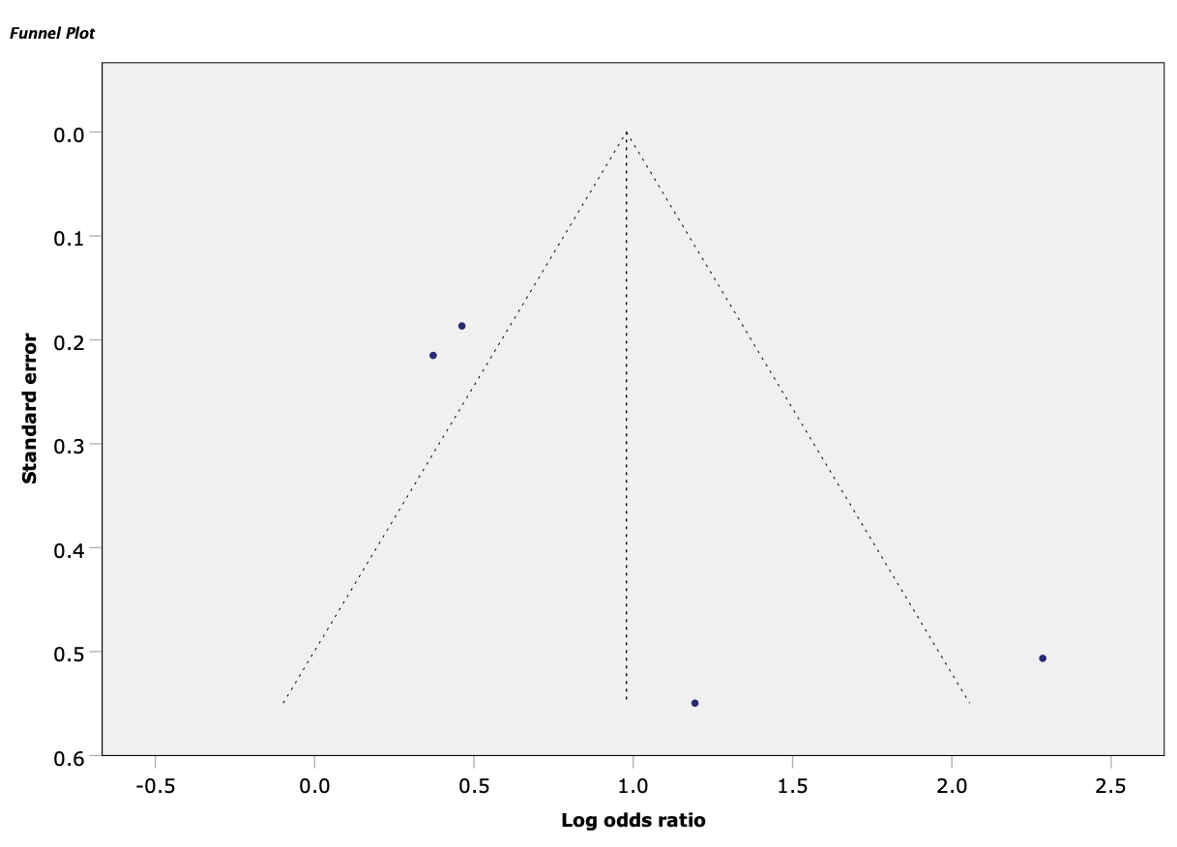

Figure S19. Funnel plot and trim-and-fill analysis for dementia and covid-19 severity from crude analyses.

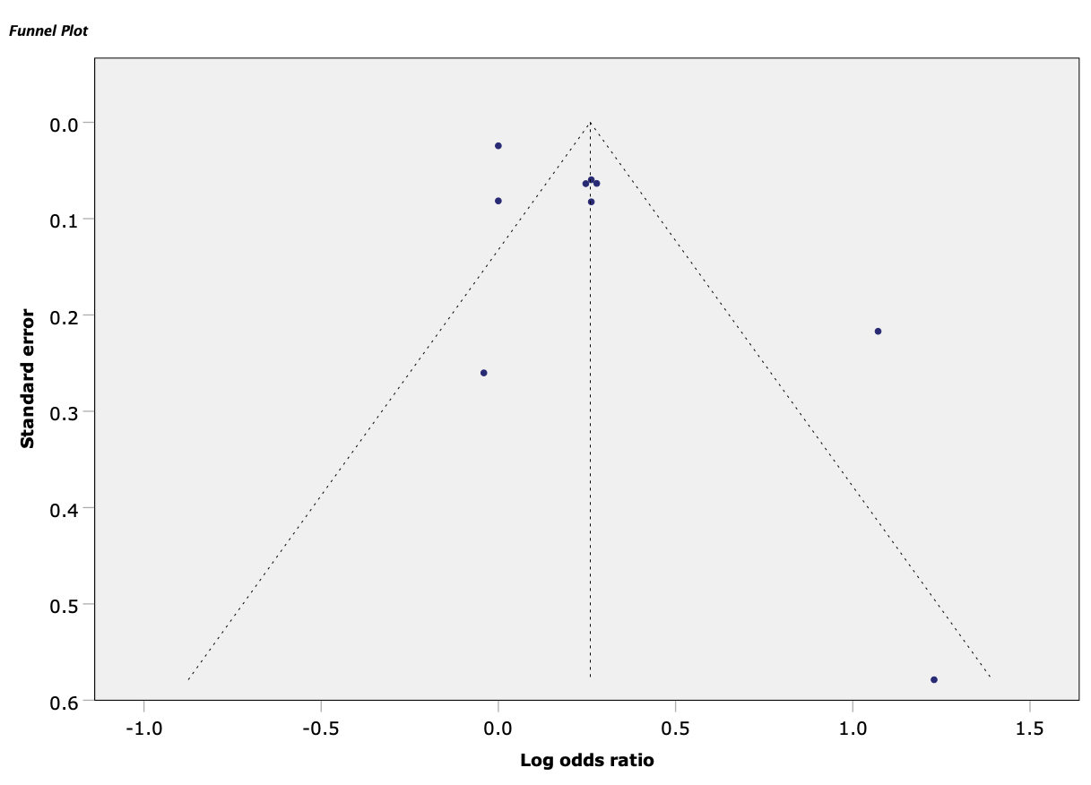

Figure S20. Funnel plot and trim-and-fill analysis for dementia and covid-19 severity multivariable analyses.

Meta-analysis of local data

Table S4. Neurodegenerative disorders and COVID-19 severity, hospitalization, ICU admission, and mortality.
SARS-CoV-2 infection risk | OR (95% CI) | k | N | I² | Egger’s t
Dementia ª | 1.55 (0.82 – 2.96) | 5 | 21009 | 92.2 *** | 0.414
Alzheimer’s disease ^{b} | 2.97 (1.54 – 5.72) *** | 4 | 281241 | 97.6 *** | -0.729
COVID-19 severity | OR (95% CI) | k | N | I² | Egger’s t
Dementia ^{b} | 1.30 (1.07 – 1.57) ** | 9 | 163507 | 93.2 *** | 2.324 *
COVID-19 hospitalization | OR (95% CI) | k | N | I² | Egger’s t
Dementia ^{b} | 1.43 (1.14 – 1.79) ** | 8 | 90030 | 92.1 *** | 2.152
Parkinson’s disease ^{b} | 1.16 (0.65 – 2.09) | 4 | 234086 | 91.6 *** | -1.837
COVID-19 ICU admission | OR (95% CI) | k | N | I² | Egger’s t
Dementia ^{b} | 0.55 (0.36 - 0.84) ** | 12 | 40459 | 81.7 *** | -0.828
COVID-19 mortality | OR (95% CI) | k | N | I² | Egger’s t
Dementia ^{b} | 1.71 (1.53 – 1.92) *** | 40 | 419507 | 87.8 *** | 5.806 ***
Parkinson’s disease ^{b} | 1.61 (1.30 – 1.98) *** | 10 | 7603111 | 74.0 *** | -0.129
Mild Cognitive Impairment ^{b} | 1.20 (0.68 – 2.10) | 3 | 2767 | 81.1 ** | -0.356
Note. The table presents results from analyses using local data only and excluding all other nationwide data (for each respective country).
ª Crude analysis.
^{b} Multivariable analysis.

Meta-analysis of data from crude analyses

Table S5. Neurodegenerative disorders SARS-CoV-2 infection risk, severity, hospitalization, ICU admission, and mortality.
SARS-CoV-2 infection risk | OR (95% CI) | k | N | I² | Egger’s t
Dementia ª | 1.68 (0.80 – 3.52) | 4 | 14665 | 90.6 *** | -1.075
COVID-19 severity | OR (95% CI) | k | N | I² | Egger’s t
Dementia | 2.66 (1.16 – 6.12) * | 4 | 10084 | 87.1 ** | 3.24 ***
Mix Neurodegenerative | 1.58 (0.24 - 10.44) | 1 | 46 | N.A. | N.A.
COVID-19 hospitalization | OR (95% CI) | k | N | I² | Egger’s t
Dementia | 2.20 (0.39 – 12.28) | 2 | 87603 | 94.8 *** | N.A.
Mild Cognitive Impairment | 17.3 (4.72 – 63.44) *** | 1 | 283 | N.A. | N.A.
Mix Neurodegenerative | 0.63 (0.10 – 4.10) | 1 | 46 | N.A. | N.A.
COVID-19 ICU admission | OR (95% CI) | k | N | I² | Egger’s t
Dementia | 1.18 (0.40 – 3.52) | 4 | 89451 | 67.2 * | -0.133
Mix Neurodegenerative | 2.10 (0.18 - 24.87) | 1 | 46 | N.A. | N.A.
COVID-19 mortality | OR (95% CI) | k | N | I² | Egger’s t
Dementia | 2.42 (1.50 - 3.90) *** | 26 | 103154 | 96.4 *** | 0.480
Alzheimer’s disease | 1.75 (0.41 - 7.48) | 3 | 5624 | 79.1 ** | -3.299
Parkinson’s disease | 2.45 (1.65 – 3.62) *** | 7 | 36991 | 34.2 | -0.685
Mild Cognitive Impairment | 3.59 (1.61 - 7.99) | 1 | 224 | N.A. | N.A.
Note. The table presents results from crude analyses.
* P < .05, ** P < .01, *** P < .001
ª Estimates come from analyses including nationwide data, at the expense of local data.

Moderator Analyses

Table S6. Results of moderation analysis of SARS-CoV-2 infection risk for each type of neurodegenerative disease from multivariable analyses.
SARS-CoV-2 infection risk | % Female | Average age | Risk of bias
Dementia | 0.84 (0.02 - 29.20) | 1.00 (0.97 - 1.03) | 1.33 (0.98 - 1.82)
Alzheimer’s disease ª | 0.07 (0.00 - 144.60) | 1.00 (0.95 - 1.05) | 1.26 (0.69 - 2.32)
Alzheimer’s disease ^{b} | 0.10 (0.00 - 96.54) | 1.00 (0.95 - 1.05) | 1.40 (0.81 - 2.43)
Parkinson’s disease | 1.28 (0.01 - 132.82) | 1.01 (1.00 - 1.02) | 1.03 (0.81 - 1.31)
Mix Neurodegenerative |  | 1.00 (0.91 - 1.09) | 1.25 (0.95 - 1.64)
Note. Odds ratio effect estimates, and their 95% confidence intervals are provided.
ª Estimates come from analyses including nationwide data, at the expense of local data. ^{b} Estimates come from analyses using local data only and excluding all other nationwide data (for each respective country).
* P < .05, ** P < .01, *** P < .001

Table S7. Results of moderation analysis for COVID-19 severity and mortality from crude analyses.
SARS-CoV-2 infection risk | % Female | Average age | Risk of bias
Dementia ª | 0.005 (0.001 – 0.028) *** | 0.97 (0.91 – 1.04) | 0.95 (0.49 - 1.85)
Dementia ^{b} | 0.007 (0.002 – 0.026) *** | 0.96 (0.91 – 1.01) | 1.01 (0.55 - 1.84)
COVID-19 severity | % Female | Average age | Risk of bias
Dementia | 0.17 (0.00 – 6045.08) | 0.97 (0.93 – 1.02) | 1.02 (0.68 - 1.52)
COVID-19 ICU admission | % Female | Average age | Risk of bias
Dementia | 0.12 (0.00 – 227804873) | 0.93 (0.85 – 1.02) | 0.67 (0.38 - 1.16)
COVID-19 mortality | % Female | Average age | Risk of bias
Dementia | 0.04 (0.00 - 1.76) | 0.95 (0.91 - 0.98) ** | 1.03 (0.73 - 1.43)
Alzheimer’s disease | 0.0001 (0.00 – 0.02) *** | 0.89 (0.83 - 0.95) *** | 0.58 (0.22 - 1.52)
Note. Odds ratio effect estimates, and t-values are provided.
ª Estimates come from analyses including nationwide data, at the expense of local data. ^{b} Estimates come from analyses using local data only and excluding all other nationwide data (for each respective country).
* P < .05, ** P < .01, *** P < .001

Table S8. Results of moderation analysis of COVID-19 course, hospitalization, ICU admission rates, and mortality for each type of neurodegenerative disease from multivariable analyses.
COVID-19 severity | % Female | Average age | Risk of bias
Dementia ª | 1.38 (0.05 - 34.81) | 1.02 (1.00 - 1.03) | 1.08 (0.80 - 1.47)
Dementia ^{b} | 0.93 (0.10 - 8.76) | 1.01 (1.00 - 1.02) | 1.06 (0.87 - 1.29)
COVID-19 hospitalization | % Female | Average age | Risk of bias
Dementia ª | 0.43 (0 - 620.2) | 1.01 (0.98 - 1.04) | 1.16 (0.66 - 2.02)
Dementia ^{b} | 0.75 (0.01 - 44.0) | 1.01 (1.00 - 1.02) | 1.02 (0.72 - 1.44)
Parkinson’s disease ª | 3.56 (0 – 793334) | 1.20 (1.02 - 1.42) * | 0.82 (0.43 - 1.55)
Parkinson’s disease ^{b} | 60 (0 – 1376761721) | 0.97 (0.91 - 1.04) | 0.95 (0.46 - 1.97)
COVID-19 ICU admission | % Female | Average age | Risk of bias
Dementia ª | 0.50 (0 - 443.2) | 1.01 (0.99 - 1.03) | 0.88 (0.73 - 1.04)
Dementia ^{b} | 0.02 (0 - 90.2) | 1.02 (0.98 - 1.05) | 0.83 (0.66 - 1.04)
COVID-19 mortality | % Female | Average age | Risk of bias
Dementia ª | 1.61 (0.22 - 12.05) | 1.00 (0.99 - 1.01) | 1.00 (0.91 - 1.10)
Dementia ^{b} | 1.03 (0.27 - 3.96) | 1.00 (0.99 - 1.01) | 0.98 (0.89 - 1.08)
Alzheimer’s disease | 0.12 (0.002 - 7.48) | 0.98 (0.95 - 1.02) | 0.96 (0.65 - 1.43)
Parkinson’s disease ª | 0.56 (0.07 - 4.36) | 0.99 (0.96 - 1.01) | 0.89 (0.64 - 1.24)
Parkinson’s disease ^{b} | 0.51 (0.07 - 3.83) | 0.99 (0.98 - 1.01) | 0.92 (0.73 - 1.16)
Mild Cognitive Impairment ª | 7707 (0 – 516197498) | 0.86 (0.71 - 1.04) | 1.02 (0.78 - 1.35)
Mild Cognitive Impairment ^{b} | 41440 (64 – 26615385) ** | 0.86 (0.73 - 1.01) | 1.14 (0.98 - 1.32)
Mix Neurodegenerative | 3.45 (0 – 2045) | 1.02 (0.98 - 1.07) | 1.15 (0.81 - 1.64)
Note. Odds ratio effect estimates, and their 95% confidence intervals are provided.
ª Estimates come from analyses including nationwide data, at the expense of local data. ^{b} Estimates come from analyses using local data only and excluding all other nationwide data (for each respective country).
* P < .05, ** P < .01, *** P < .001

Subgroup Analyses

Table S9. Odds Ratio on the association between neurodegenerative disorders and SARS-CoV-2 infection risk, severity, hospitalization, and ICU admission by geographic region.
SARS-CoV-2 infection risk | Asia | Europe | America
Dementia | 1.75 (1.40 - 2.19) *** | 4.22 (2.68 - 6.64) *** | 1.93 (1.78 - 2.09) ***
Alzheimer’s disease ª | No data | 3.34 (1.40 - 7.94) ** | 1.86 (1.76 - 1.95) ***
Alzheimer’s disease ^{b} | No data | 3.34 (1.40 - 7.94) ** | 2.11 (1.94 - 2.29) ***
Parkinson’s disease | No data | 1.79 (1.49 - 2.15) *** | 1.24 (1.11 - 1.39) ***
Mix Neurodegenerative | No data | 3.42 (1.19 - 9.79) * | 1.51 (1.35 - 1.69) ***
COVID-19 severity | Asia | Europe | America
Dementia ª | 1.54 (0.83 - 2.87) | 1.00 (0.85 - 1.17) | 1.76 (0.70 - 4.42)
Dementia ^{b} | 1.54 (0.83 - 2.87) | 1.00 (0.85 - 1.17) | 1.23 (1.06 - 1.42) **
COVID-19 hospitalization | Asia | Europe | America
Dementia ª | 1.90 (1.20 - 3.00) ** | 1.38 (0.84 - 2.28) | 2.42 (2.20 - 2.67) ***
Dementia ^{b} | 1.90 (1.20 - 3.00) ** | 1.38 (0.84 - 2.28) | 1.45 (1.23 - 1.72) ***
Parkinson’s disease ª | No data | 0.97 (0.45 - 2.06) | 1.23 (1.15 - 1.32) ***
Parkinson’s disease ^{b} | No data | 1.10 (0.65 - 1.86) | 1.33 (0.99 - 1.78)
COVID-19 ICU admission | Asia | Europe | America
Dementia ª | 0.77 (0.51 - 1.16) | 0.48 (0.31 - 0.76) *** | 0.54 (0.29 - 0.99) *
Dementia ^{b} | 0.77 (0.51 - 1.16) | 0.53 (0.21 - 1.34) | 0.54 (0.29 - 0.99) *
Note. Odds ratio effect estimates, and their 95% confidence intervals are provided.
ª Estimates come from analyses including nationwide data, at the expense of local data. ^{b} Estimates come from analyses using local data only and excluding all other nationwide data (for each respective country).
* P < .05, ** P < .01, *** P < .001

Table S10. Odds Ratio on the association between neurodegenerative diseases and COVID-19 mortality by geographic region.
COVID-19 mortality | Asia | Europe | America | Multiple
Dementia ª | 2.26 (1.67 - 3.04) *** | 1.58 (1.37 - 1.81) *** | 1.21 (0.82 - 1.76) | 1.53 (0.86 - 2.72)
Dementia ^{b} | 2.26 (1.67 - 3.04) *** | 1.75 (1.53 - 1.99) *** | 1.53 (1.15 - 2.03) ** | 1.53 (0.86 - 2.72)
Alzheimer’s disease | 2.64 (0.48 - 14.55) | 1.92 (1.57 - 2.34) *** | 2.19 (0.67 - 7.21) | No data
Parkinson’s disease ª | 1.78 (0.62 - 5.08) | 1.83 (1.44 - 2.31) *** | 1.27 (1.17 - 1.38) *** | 1.00 (0.58 - 1.73)
Parkinson’s disease ^{b} | 1.78 (0.62 - 5.08) | 1.83 (1.44 - 2.31) *** | 1.55 (0.90 - 2.70) | 1.00 (0.58 - 1.73)
Mild Cognitive Impairment ª | 0.80 (0.40 - 1.60) | 2.05 (1.38 - 3.05) *** | 1.86 (1.09 - 3.16) * | No data
Mild Cognitive Impairment ^{b} | 0.80 (0.40 - 1.60) | 2.05 (1.38 - 3.05) *** | 0.96 (0.73 - 1.26) | No data
Mix Neurodegenerative | No data | 2.59 (1.69 - 3.96) *** | 1.28 (0.88 - 1.86) | No data
Note. Odds ratio effect estimates, and their 95% confidence intervals are provided.
ª Estimates come from analyses including nationwide data, at the expense of local data. ^{b} Estimates come from analyses using local data only and excluding all other nationwide data (for each respective country).
* P < .05, ** P < .01, *** P < .001

Bayesian Meta-analysis

We provided Bayes factors (BF₁₀) and used Jeffreys,¹ and Lee and Wagenmakers² thresholds for interpretations. For the overall effect size and between-study standard deviation, we considered the default prior settings in JASP, a zero-centered Cauchy distribution with scale parameter equal to $1\sqrt{2}≈0.707$,³ and an Inverse-Gamma (1, 0.15) prior for the latter.^{4,5}

Table S11. Comparison of Bayesian and frequentist analysis for Neurodegenerative disorders and SARS-CoV-2 infection risk from multivariable analyses.
SARS-CoV-2 infection risk | Frequentist analysis | Bayesian analysis
 | OR (95% CI) | OR (95% CI)
Dementia | 1.83 (1.16 – 2.87) ** | 1.70 (1.00- 2.72), BF₁₀ = 2.88
Alzheimer’s disease ª | 2.86 (1.44 – 5.66) ** | 2.39 (0.98 – 5.26), BF₁₀ = 3.86
Parkinson’s disease | 1.65 (1.34 – 2.04) *** | 1.62 (1.27 - 2.03), BF₁₀ = 26.32
Mix Neurodegenerative | 2.48 (1.17 – 5.27) * | 1.95 (0.94 – 3.98), BF₁₀ = 3.77
Note. * P < .05, ** P < .01, *** P < .001
ª Estimates come from analyses including nationwide data, at the expense of local data, hence the number of studies (k) is relatively low.

Table S12. Comparison of Bayesian and frequentist analysis for Neurodegenerative disorders and COVID-19 severity, hospitalization, ICU admission, and mortality from multivariable analyses.
COVID-19 severity | Frequentist analysis | Bayesian analysis
 | OR (95% CI) | OR (95% CI)
Dementia ª | 1.43 (1.00 – 2.03) * | 1.36 (0.98 - 1.99), BF₁₀ = 1.33
Mix Neurodegenerative | 1.40 (1.12 – 1.76) ** | 1.39 (1.06 – 1.95), BF₁₀ = 2.96
COVID-19 hospitalization | OR (95% CI) | OR (95% CI)
Dementia ª | 1.60 (1.09 – 2.35) * | 1.51 (1.02 - 2.27), BF₁₀ = 2.17
Alzheimer’s disease | 3.72 (2.35 – 5.90) *** | 3.39 (1.94 - 5.70), BF₁₀ = 12.38
Parkinson’s disease ª | 1.06 (0.67 – 1.70) | 1.13 (0.74 - 1.52), BF₁₀ = 0.33
Mild Cognitive Impairment | 1.64 (0.82 - 3.28) | 1.57 (0.75 – 2.77), BF₁₀ = 1.20
COVID-19 ICU admission | OR (95% CI) | OR (95% CI)
Dementia | 0.54 (0.40 – 0.74) *** | 0.59 (0.44 - 0.74), BF₁₀ = 89.78
COVID-19 mortality | OR (95% CI) | OR (95% CI)
Dementia ª | 1.58 (1.39 – 1.79) *** | 1.57 (1.38 - 1.79), BF₁₀ = 570319.15
Alzheimer’s disease | 1.96 (1.34 – 2.86) *** | 1.86 (1.23 – 2.86), BF₁₀ = 10.67
Parkinson’s disease ª | 1.56 (1.25 – 1.94) *** | 1.54 (1.21 - 1.94), BF₁₀ = 17.32
Mild Cognitive Impairment ª | 1.68 (1.11 – 2.54) ** | 1.58 (0.96 - 2.40), BF₁₀ = 2.21
Mix Neurodegenerative | 2.27 (1.49 – 3.46) *** | 2.08 (1.38 - 3.16), BF₁₀ = 25.45
Note. * P < .05, ** P < .01, *** P < .001
ª Estimates come from analyses including nationwide data, at the expense of local data.

Table S13. Comparison of Bayesian and frequentist analysis for Neurodegenerative disorders and COVID-19 severity, hospitalization, ICU admission, and mortality from local data.
SARS-CoV-2 infection risk | Frequentist approach | Bayesian approach
 | OR (95% CI) | OR (95% CI)
Dementia ª | 1.55 (0.82 – 2.96) | 1.41 (0.75 – 2.51), BF₁₀ = 0.733
Alzheimer’s disease ^{b} | 2.97 (1.54 – 5.72) *** | 2.56 (1.05 – 5.10), BF₁₀ = 4.64
COVID-19 severity | OR (95% CI) | OR (95% CI)
Dementia ^{b} | 1.30 (1.07 – 1.57) ** | 1.28 (1.06 – 1.58), BF₁₀ = 2.78
COVID-19 hospitalization | OR (95% CI) | OR (95% CI)
Dementia ^{b} | 1.43 (1.14 – 1.79) ** | 1.41 (1.12 – 1.82), BF₁₀ = 5.28
Parkinson’s disease ^{b} | 1.16 (0.65 – 2.09) | 1.17 (0.65 – 1.88), BF₁₀ = 0.404
COVID-19 ICU admission | OR (95% CI) | OR (95% CI)
Dementia ^{b} | 0.55 (0.36 - 0.84) | 0.60 (0.40 – 0.86), BF₁₀ = 8.12
COVID-19 mortality | OR (95% CI) | OR (95% CI)
Dementia ^{b} | 1.71 (1.53 – 1.92) *** | 1.70 (1.51 – 1.94), BF₁₀ = 5.331×10⁺⁹
Parkinson’s disease ^{b} | 1.61 (1.30 – 1.98) *** | 1.58 (1.26 – 1.99), BF₁₀ = 38.12
Mild Cognitive Impairment ^{b} | 1.20 (0.68 – 2.10) | 1.15 (0.61 – 1.92), BF₁₀ = 0.346
Note. The table presents results from analyses using local data only and excluding all other nationwide data (for each respective country).
* P < .05, ** P < .01, *** P < .001
ª Univariate analysis.
^{b} Multivariable analysis.

Table S14. Comparison of Bayesian and frequentist ORs for Neurodegenerative disorders and SARS-CoV-2 infection risk, COVID-19 severity, hospitalization, ICU admission, and mortality from Crude analyses.
SARS-CoV-2 infection risk | Frequentist approach | Bayesian approach
 | OR (95% CI) | OR (95% CI)
Dementia ª | 1.68 (0.80 – 3.52) | 1.46 (0.73 – 2.95), BF₁₀ = 0.88
COVID-19 severity | OR (95% CI) | OR (95% CI)
Dementia | 2.66 (1.16 – 6.12) * | 2.03 (1.04 – 4.48), BF₁₀ = 3.94
COVID-19 hospitalization | OR (95% CI) | OR (95% CI)
Dementia | 2.20 (0.39 – 12.28) | 1.62 (0.49 – 5.76), BF₁₀ = 0.91
COVID-19 ICU admission | OR (95% CI) | OR (95% CI)
Dementia | 1.18 (0.40 – 3.52) | 1.06 (0.58 – 2.03), BF₁₀ = 0.33
COVID-19 mortality | OR (95% CI) | OR (95% CI)
Dementia | 2.42 (1.50 - 3.90) *** | 2.20 (1.35 – 3.60), BF₁₀ = 37.91
Alzheimer’s disease | 1.75 (0.41 - 7.48) | 1.55 (0.45 - 4.95), BF₁₀ = 0.88
Parkinson’s disease | 2.45 (1.65 – 3.62) *** | 2.23 (1.34 – 3.35), BF₁₀ = 23.76
Note. * P < .05, ** P < .01, *** P < .001
ª Estimates come from analyses including nationwide data, at the expense of local data.

Table S15. Study design and type of control of included studies and samples by outcome.
Study | Design | Control
Ajayi et al. 2020 | Retrospective Single-Center Observational | No control
Ajayi et al. 2021 | Retrospective Single-Center Observational | No control
Alqahtani et al. 2021 | Retrospective Hospital-Based | Covariates; age and sex
An et al. 2021 | Retrospective Cohort | Covariates; age, sex, BMI, comorbidities
Atkins et al. 2020 | Retrospective Cohort | No control
Bae et al. 2021 | Retrospective Cohort | Covariates
Baker et al. 2021 | Manual chart review | No control
Banoei et al. 2021 | Retrospective Cohort | Age, Heart rate, respiratory rate, and BMI
Becerra-muñoz et al. 2021 | Retrospective Cohort | Age, sex comorbidities, clinical characteristics.
Bennett et al. 2021 | Retrospective Cohort | Age, diabetes, Kidney impairment
Beobide Telleria et al., 2022 | Retrospective Case-Control | Analyses controlled for covariates but these are not specified
Bhargava et al. 2021 | Retrospective Cohort | Age, CWIC score, and laboratory data
Bianchetti et al. 2020 | Retrospective Cohort | No control
Bielza et al. 2021 | Descriptive, Observational, Retrospective, and Longitudinal | Age, Hospital admission, comorbidities, abdominal pain, cough, anosmia, severe case
Booij et al., 2022 | Retrospective 2-Center Cohort | Age, sex, clinical signs and symptoms
Boye et al. 2021 | Retrospective Cohort | No control
Bucholc et al., 2022 | Retrospective Cohort | Age, sex, comorbidities
Busetto et al. 2020 | Retrospective Cohort | Age, sex, comorbidities
Caliskan and saylan, 2020 | Retrospective Observational | No control
Carrillo-garcia et al. 2021 | Longitudinal Observational | Age, sex, frailty, functional dependency
Castilla et al. 2021 | Prospective Population Based Cohort | Age, sex
Chang et al. 2020 | Retrospective Cohort | Age, sex, urban-rural residence
Chatterjee et al. 2021 | Retrospective Cohort | Not specified
Chen et al., 2022 | Retrospective Cohort | Age, sex, comorbidities and demographics
Choi et al. 2021 | Retrospective Cohort | Age, sex, comorbidities
Chojnicki et al. 2021 | Single-Center Prospective Register Observational | Covariates
Cisterna-garcía et al. 2022 | Retrospective Population-Based | Age, sex
Covidsurg, 2021 | Retrospective Cohort | Covariates
Covino et al. 2020 | Single-Center Prospective Observational Cohort | Covariates
Covino et al. 2021a | Single-Center Prospective Observational | Clinical covariates, disease severity
Covino et al. 2021b | Single-Center Prospective Observational | Age
Cummins et al. 2021 | Retrospective Cohort | Gender, Age, Ethnicity, SES, Smoking status, Obesity, Comorbidities
de Malherbe et al., 2022 | Multicentric Prospective Observational | No control
De marcaida et al. 2020 | Retrospective Cohort | No control
De smet et al. 2020 | Retrospective Single-Center Observational | Covariates
Del ser et al. 2021 | Single-Center, Multidisciplinary, Observational, Longitudinal | Age, sex
Descamps et al., 2022 | Retrospective Cohort | Propensity score matching analysis to control for COVID-19 confounding factors between patients with or without mental disorder, stratified by psychiatric subgroups.
Ellis et al., 2022 | Retrospective Cohort | Age, sex, comorbidities
Emmerson et al., 2022 | Cross-Sectional Retrospective Cohort | No control
Escribà-salvans et al. 2022 | Multicenter Longitudinal Cohort | Covariates
Esme et al. 2021 | Retrospective Cohort | Sex, comorbidities, age-stratification
España et al. 2021 | Retrospective Cohort | Age, sex, dementia
Esteban et al. 2021 | Prospective Cohort | Age, sex, comorbidities
Fasano et al. 2020 | Case-Controlled Survey | Age
Fathi et al. 2021 | Multicenter Cohort | Propensity scoring/matching
Filardo et al. 2020 | Retrospective Chart Review | Age, sex, comorbidities, all socio-demographic factors
Filipe et al. 2021 | Prospective Observational Cohort | Age, sex, comorbidities
Fumagalli et al. 2021 | Retrospective Bicentric Observational | Covariates
Gale and boland, 2021 | Prospective Clinical Chart Review | Propensity scoring/matching
Ge et al. 2021 | Population-Based Retrospective Cohort | Age, sex, socio-economic variables, comorbidities
Genet et al. 2020 | Observational Retrospective | Age, sex, symptoms, comorbidities, disability, biological factors
Geriatric et al. 2021 | Retrospective Cohort | Sex, illness severity, inflammation, comorbidities
Ghaffari et al. 2021 | Observational | Age
Gómez antúnez et al. 2020 | Retrospective Cohort | No control
Harrison et al. 2020 | Retrospective Cohort | Age, sex, comorbidities
Hasani-Azad et al. 2021 | Retrospective Multicenter | No control
Hatamabadi et al., 2022 | Retrospective Cohort | No control
Hippisley-cox et al. 2021 | Prospective Cohort | Age, BMI, vaccination dose, and background infection rate at time of vaccination
Hwang et al. 2020 | Retrospective Cohort | Covariates
Izurieta et al. 2021 | Retrospective Cohort | Demographic and socio-economic factors, comorbidities, immunocompromised status, frailty
Kang and kong, 2021 |  | Age, sex, BMI, comorbidities
Karapetyan et al. 2021 | Retrospective Cohort | Age, sex, urbanization, nursing home living, comorbidities
Ken-dror et al. 2020 | Prospective Cohort | Covariates
Kim et al. 2020 | Retrospective Cohort | Covariates
Kim et al. 2021 | Retrospective Multicenter Cohort | Covariates
Kim et al., 2022a | Retrospective Cohort | Age, sex, BMI, ethnicity, month of diagnosis, comorbidities, frequency of ambulatory visits, hospital system, hospitals
Kim et al., 2022b | Large-Scale Nationwide Cohort | Propensity scoring/matching
Kostev et al., 2022 | Retrospective Cohort | Propensity scoring/matching
Lazcano et al. 2021 | Prospective Population-Based Cohort | Age, sex, comorbidities, SES
Li et al. 2020 | Retrospective Cohort | Propensity scoring/matching
Livingston et al. 2020 | Retrospective Observational | Number of comorbidities
Lozano-montoya et al. 2021 | Single-Center Longitudinal Observational Ambispective | No control
Lucijanić et al., 2022 | Retrospective Cohort | No control
Magallon-botaya et al. 2021 | Retrospective Cohort | Covariates
Maguire et al. 2020 | Medical records | Covariates
Mahmoud et al. 2021 | Retrospective Cohort | Age, sex, multimorbidity, severity of multimorbidity
Maniero et al., 2022 | Retrospective Cohort | No control
Martinot et al. 2021 | Retrospective Observational Cohort | Covariates
Meis-pinheiro et al. 2021 | Retrospective Cohort | Covariates
Menditto et al. 2021 | Retrospective Cohort | No control
Miyashita et al. 2020 | Medical records | Age
Molani et al. 2022 | Retrospective Cohort | Age stratified
Moon et al. 2021 | Retrospective Cohort | Covariates
Munblit et al. 2021 | Observational Cohort | Age, sex
Nojiri et al., 2022 | Retrospective Cohort | Analyses controlled for covariates but these are not specified
Oh et al., 2022 | Retrospective Observational Cohort Analysis | Age, sex, demographic, health, and functional characteristics
Orlando et al. 2021 | Retrospective Case-Control | Propensity scoring/matching
Ouattara et al. 2021 | Retrospective Cohort Analysis | Age, sex, BMI, comorbidities, admission to a CCU/hospital care unit (HCU), death
Pan et al. 2021 | Cross-Sectional Analysis | Propensity scoring/matching
Panagiotou et al. 2021 | Retrospective Observational Cohort | Age group, physical functioning, cognitive impairment
Patel et al., 2022 | Retrospective Cohort | 1:1 ratio age matched controls
Pisaturo et al. 2021 | Multicenter, Observational, 1:2 Matched Case-Control | Propensity scoring/matching
Profili et al. 2020 | Case-Population | Age, sex, comorbidities
Raheja et al. 2021 | Single-Center, Retrospective, Observational | Analyses controlled for covariates but these are not specified
Ramos-rincón et al. 2021a | Cross-Sectional Analysis Within a Retrospective Cohort | Age, sex, functional dependence, comorbidities
Ramos-rincon et al. 2021b | Multicenter, Retrospective, Observational | Analyses controlled for covariates but these are not specified
Rebora et al. 2021 | Observational | Age, sex, functional disability, dementia, number of chronic diseases, use of CPAP, nutritional status, chest X-ray or CT finding, serum CRP
Roig-marín and roig-rico, 2021 | Retrospective Cohort | Analyses controlled for covariates but these are not specified
Romagnolo et al. 2021a | Retrospective Cohort | Age, comorbidities
Romagnolo et al. 2021b | Retrospective Cohort | Propensity scoring/matching; Age and other comorbidities; PS; 1:1 matching
Rossi et al. 2020 | Population-Based Prospective Cohort | Age, sex, comorbidities
Russo et al. 2021 | Population-Based Cohort | Age, sex
Rutten et al. 2021 | Retrospective Cohort | Age, sex, comorbidities
Samuels et al. 2021 | Retrospective Cohort | Demographics, presenting clinical characteristics, and home medication use
Scherbaum et al. 2021 | Cross-Sectional Observational | Age-stratification
Secnik et al., 2023 | Open-Cohort Observational | Age, sex, comorbidities, oxygen saturation, prescription of medication
Seon et al. 2021 | Cohort | Age, sex, region of residence, health insurance premiums, comorbidities
Shin et al. 2021 | Retrospective Cohort | Age, sex, BMI, comorbidities
Smith et al. 2021 | Case-Control | Propensity scoring/matching
Soldevila et al., 2022 | Cross-Sectional Cohort | Covariates
Song et al. 2021 | Retrospective Cohort | Age, sex
Stawinski et al. 2021 | Retrospective Cohort | No control
Tahira et al. 2021 | Prospective Cohort | Age-stratification
Tsai et al. 2020 | Single-Center Propensity-Score Matched Cohort | Propensity scoring/matching
Tyson et al. 2021 | Retrospective Cohort Study (Chart Reviews) | Covariates
Vekaria et al., 2022 | Multi-Center Retrospective Case-Control | Propensity scoring/matching
Venturini et al. 2021 | Retrospective Observational | Covariates
Vignatelli et al. 2021 | Historical-Cohort | Propensity scoring/matching
Wan et al. 2020 | Retrospective Cohort | No control
Wang et al. 2021a | Retrospective Case-Control | Covariates; age groups (adults age 18–65 years, senior age >65 years); sex (female/male); race (White/Black); common comorbidities considered risk factors for COVID-19; transplant procedures (bone marrow, solid organ); and nursing home stay
Wang et al. 2021b | Nationwide Cohort | Propensity scoring/matching: Nearest neighbor matching; Age, gender, systolic blood pressure, diastolic blood pressure, comorbidity, and baseline hematological variables were used as covariates for matching to generate a mother cohort with a 1:1 ratio.
Wang et al. 2021c | Retrospective Cohort | Age, sex, education, ethnicity, BMI, comorbidities
Wong & Lovier, 2022 | Prospective Cohort | Sociodemographic and health covariates
Worcel et al. 2021 | Retrospective Cohort | No control
Yakar et al. 2021 | Retrospective Cohort | Covariates
Yu et al. 2021 | Cohort Study Using National Primary Care Electronic Health Record | Age, sex, comorbidities, SES, demographic and clinical factors
Zakaria et al. 2021 | Retrospective Observational | Propensity scoring/matching
Zenesini et al., 2022 | Historical Cohort | Propensity scoring/matching
Zerbo et al. 2021 | Prospective Cohort | Demographic factors, comorbidities
Zhang et al. 2021 | Retrospective Cohort | Propensity scoring/matching
Zhou et al. 2021a | Large Population-Based Prospective Observational | Propensity scoring/matching
Zhou et al. 2021b | Retrospective Cohort | No control

Assessment of methodological quality
The methodological quality of input studies was scored by 3 members of the author team (MS, MM, and YS) using the quality assessment tool for cross-sectional studies that is recommended by the United States National Institutes of Health (US NIH 2021; https://www.nhlbi.nih.gov/health-topics/study-quality-assessment-tools). The items of this tool are provided below, in Table S7.

Table S16. Items of the quality assessment tool for cross-sectional studies
Item
1 | Was the research question or objective in this paper clearly stated?
2 | Was the study population clearly specified and defined?
3 | Was the participation rate of eligible persons at least 50%?
4a | Were all the subjects selected or recruited from the same or similar populations (including the same time period)?
4b | Were inclusion and exclusion criteria for being in the study prespecified and applied uniformly to all participants?
5 | Was a sample size justification, power description, or variance and effect estimates provided?
6 | For the analyses in this paper, were the exposure(s) of interest measured prior to the outcome(s) being measured?
7 | Was the timeframe sufficient so that one could reasonably expect to see an association between exposure and outcome if it existed?
8 | For exposures that can vary in amount or level, did the study examine different levels of the exposure as related to the outcome (e.g., categories of exposure, or exposure measured as continuous variable)?
9 | Were the exposure measures (independent variables) clearly defined, valid, reliable, and implemented consistently across all study participants?
10 | Was the exposure(s) assessed more than once over time?
11 | Were the outcome measures (dependent variables) clearly defined, valid, reliable, and implemented consistently across all study participants?
12 | Were the outcome assessors blinded to the exposure status of participants?
13 | Was loss to follow-up after baseline 20% or less?
14 | Were key potential confounding variables measured and adjusted statistically for their impact on the relationship between exposure(s) and outcome(s)?
Note.

Table S17. Quality assessment of included studies.
1 Ajayi et al. 2021 | MM. | 1⊕; 2⊕; 3∅; 4a⊕; 4b∅; 5⊗; 6⊕; 7∅; 8∅; 9⊕; 10⊗; 11⊕; 12∅; 13∅; 14⊗: T = 3
1 Ajayi et al. 2021 | MS. | 1⊕; 2⊕; 3∅; 4a⊗; 4b⊕; 5⊗; 6⊕; 7⊕; 8⊗; 9⊕; 10∅; 11⊕; 12∅; 13⊕; 14⊗: T = 4
2 Ajayi et al. 2020 | MM. | 1⊕; 2⊕; 3∅; 4a⊕; 4b⊕; 5⊗; 6⊕; 7∅; 8∅; 9⊕; 10⊗; 11⊕; 12∅; 13∅; 14⊗: T = 4
2 Ajayi et al. 2020 | MS. | 1⊕; 2⊕; 3∅; 4a⊕; 4b⊕; 5⊗; 6⊕; 7⊕; 8⊗; 9⊕; 10∅; 11⊕; 12∅; 13⊕; 14⊗: T = 6
3 Alqahtani et al. 2021 | MM. | 1⊕; 2⊗; 3∅; 4a⊕; 4b∅; 5⊗; 6⊕; 7∅; 8∅; 9⊕; 10⊗; 11⊕; 12∅; 13∅; 14⊗: T = 1
3 Alqahtani et al. 2021 | MS. | 1⊕; 2⊕; 3∅; 4a⊕; 4b⊕; 5⊗; 6⊕; 7⊕; 8⊗; 9⊕; 10∅; 11⊕; 12∅; 13⊕; 14⊕: T = 8
4 An et al. 2021 | MM. | 1⊕; 2⊕; 3∅; 4a⊕; 4b⊕; 5⊗; 6⊕; 7∅; 8∅; 9⊕; 10⊗; 11⊕; 12∅; 13∅; 14⊕: T = 6
4 An et al. 2021 | MS. | 1⊕; 2⊕; 3∅; 4a⊕; 4b⊕; 5⊗; 6⊕; 7⊕; 8⊗; 9⊕; 10∅; 11⊕; 12∅; 13⊕; 14⊕: T = 8
5 Atkins et al. 2020 | MM. | 1⊕; 2⊕; 3∅; 4a⊕; 4b⊕; 5⊗; 6⊕; 7∅; 8∅; 9⊕; 10⊗; 11⊕; 12∅; 13∅; 14⊕: T = 6
5 Atkins et al. 2020 | MS. | 1⊕; 2⊕; 3∅; 4a⊕; 4b⊕; 5⊗; 6⊕; 7⊕; 8⊗; 9⊕; 10∅; 11⊕; 12∅; 13⊕; 14⊗: T = 6
6 Bae et al. 2021 | MM. | 1⊕; 2⊗; 3∅; 4a⊕; 4b⊗; 5⊗; 6⊕; 7∅; 8∅; 9⊕; 10⊗; 11⊕; 12∅; 13∅; 14⊗: T = 0
6 Bae et al. 2021 | MS. | 1⊕; 2⊕; 3∅; 4a⊕; 4b⊕; 5⊗; 6⊕; 7⊕; 8⊗; 9⊕; 10∅; 11⊕; 12∅; 13⊕; 14⊕: T = 8
7 Baker et al. 2021 | MM. | 1⊕; 2⊕; 3∅; 4a⊕; 4b⊗; 5⊗; 6⊕; 7∅; 8∅; 9⊕; 10⊗; 11⊕; 12∅; 13∅; 14⊗: T = 2
7 Baker et al. 2021 | MS. | 1⊕; 2⊕; 3∅; 4a⊕; 4b⊕; 5⊗; 6⊕; 7⊕; 8⊗; 9⊕; 10∅; 11⊕; 12∅; 13⊕; 14⊗: T = 6
8 Banoei et al. 2021 | MM. | 1⊕; 2⊗; 3∅; 4a∅; 4b⊗; 5⊗; 6⊕; 7∅; 8∅; 9⊕; 10⊗; 11⊕; 12∅; 13∅; 14⊗: T = -1
8 Banoei et al. 2021 | MS. | 1⊕; 2⊕; 3∅; 4a⊕; 4b⊕; 5⊗; 6⊕; 7⊕; 8⊗; 9⊕; 10∅; 11⊕; 12∅; 13⊕; 14⊕: T = 8
9 Beceraa-Muñoz et al. 2021 | MM. | 1⊕; 2⊗; 3∅; 4a∅; 4b⊗; 5⊗; 6⊕; 7∅; 8∅; 9⊕; 10⊗; 11⊕; 12∅; 13∅; 14⊕: T = 1
9 Becerra-Muñoz et al. 2021 | MS. | 1⊕; 2⊕; 3∅; 4a⊕; 4b⊕; 5⊗; 6⊕; 7⊕; 8⊗; 9⊕; 10∅; 11⊕; 12∅; 13⊕; 14⊕: T = 8
10 Bennett et al. 2021 | MM. | 1⊕; 2⊕; 3∅; 4a⊕; 4b⊕; 5⊗; 6⊕; 7∅; 8∅; 9⊕; 10⊗; 11⊕; 12∅; 13∅; 14⊗: T = 4
10 Bennett et al. 2021 | MS. | 1⊕; 2⊕; 3∅; 4a⊕; 4b⊕; 5⊗; 6⊕; 7⊕; 8⊗; 9⊕; 10∅; 11⊕; 12∅; 13⊕; 14⊕: T = 8
11 Bhargava et al. 2021 | MM. | 1⊕; 2⊗; 3∅; 4a⊕; 4b⊗; 5⊗; 6⊕; 7∅; 8∅; 9⊕; 10⊗; 11⊕; 12∅; 13∅; 14⊕: T = 2
11 Bhargava et al. 2021 | MS. | 1⊕; 2⊕; 3∅; 4a⊕; 4b⊕; 5⊗; 6⊕; 7⊕; 8⊗; 9⊕; 10∅; 11⊕; 12∅; 13⊕; 14⊕: T = 8
12 Bianchetti et al. 2020 | MM. | 1⊕; 2⊗; 3∅; 4a⊕; 4b⊗; 5⊗; 6⊕; 7∅; 8∅; 9⊕; 10⊗; 11⊕; 12∅; 13∅; 14⊗: T = 0
12 Bianchetti et al. 2020 | MS. | 1⊕; 2⊕; 3∅; 4a⊕; 4b⊕; 5⊗; 6⊕; 7⊕; 8⊗; 9⊕; 10∅; 11⊕; 12∅; 13⊕; 14⊕: T = 8
13 Bielza et al. 2021 | MM. | 1⊕; 2⊕; 3∅; 4a⊕; 4b⊕; 5⊗; 6⊕; 7∅; 8∅; 9⊕; 10⊗; 11⊕; 12∅; 13∅; 14⊕: T = 6
13 Bielza et al. 2021 | MS. | 1⊕; 2⊕; 3∅; 4a⊕; 4b⊕; 5⊗; 6⊕; 7⊕; 8⊗; 9⊕; 10∅; 11⊕; 12∅; 13⊕; 14⊕: T = 8
14 Boye et al. 2021 | MM. | 1⊕; 2⊕; 3∅; 4a⊕; 4b∅; 5⊗; 6⊕; 7∅; 8∅; 9⊕; 10⊗; 11⊕; 12∅; 13∅; 14⊕: T = 5
15 Boye et al. 2021 | MS. | 1⊕; 2⊕; 3∅; 4a⊕; 4b⊕; 5⊗; 6⊕; 7⊕; 8⊗; 9⊕; 10∅; 11⊕; 12∅; 13⊕; 14⊗: T = 6
15 Busetto et al. 2020 | MM. | 1⊕; 2⊕; 3∅; 4a⊕; 4b⊗; 5⊗; 6⊕; 7∅; 8∅; 9⊕; 10⊗; 11⊕; 12∅; 13∅; 14⊕: T = 4
16 Busetto et al. 2020 | MS. | 1⊗; 2⊕; 3∅; 4a⊕; 4b⊗; 5⊗; 6⊕; 7⊕; 8⊗; 9⊗; 10∅; 11⊗; 12⊗; 13∅; 14⊕: T = - 2
16 Caliskan and Saylan 2020 | MM. | 1⊕; 2⊗; 3∅; 4a⊕; 4b⊗; 5⊗; 6⊕; 7∅; 8∅; 9⊕; 10⊗; 11⊕; 12∅; 13∅; 14⊗: T = 0
16 Caliskan and Saylan 2020 | MS. | 1⊕; 2⊕; 3∅; 4a⊕; 4b⊕; 5⊗; 6⊕; 7⊕; 8⊗; 9⊕; 10∅; 11⊕; 12∅; 13⊕; 14⊕: T = 8
17 Carrillo-Garcia et al. 2021 | MM. | 1⊕; 2⊗; 3∅; 4a⊕; 4b⊗; 5⊗; 6⊕; 7∅; 8∅; 9⊕; 10⊗; 11⊕; 12∅; 13∅; 14⊕: T = 2
17 Carrillo-Garcia et al. 2021 | MS. | 1⊕; 2⊕; 3∅; 4a⊕; 4b⊕; 5⊗; 6⊕; 7⊕; 8⊗; 9⊕; 10∅; 11⊕; 12∅; 13⊕; 14⊕: T = 8
18 Castilla et al. 2021 | MM. | 1⊕; 2⊕; 3∅; 4a⊕; 4b⊗; 5⊗; 6⊕; 7∅; 8∅; 9⊕; 10⊗; 11⊕; 12∅; 13∅; 14⊕: T = 3
18 Castilla et al. 2021 | MS. | 1⊕; 2⊕; 3∅; 4a⊕; 4b⊕; 5⊗; 6⊕; 7⊕; 8⊗; 9⊕; 10∅; 11⊕; 12∅; 13⊕; 14⊕: T = 8
19 Chang et al. 2020 | MM. | 1⊕; 2⊕; 3∅; 4a⊕; 4b⊗; 5⊗; 6⊕; 7∅; 8∅; 9⊕; 10⊗; 11⊕; 12∅; 13∅; 14⊕: T = 4
19 Chang et al. 2020 | MS. | 1⊕; 2⊕; 3⊕; 4a∅; 4b∅; 5⊗; 6⊕; 7⊕; 8⊗; 9⊗; 10∅; 11⊕; 12∅; 13⊕; 14⊕: T = 5
20 Chatterjee et al. 2021 | MM. | 1⊕; 2⊗; 3∅; 4a∅; 4b⊗; 5⊗; 6⊕; 7∅; 8∅; 9⊕; 10⊗; 11⊕; 12∅; 13∅; 14⊕: T = 1
20 Chatterjee et al. 2021 | MS. | 1⊕; 2⊕; 3∅; 4a⊕; 4b⊕; 5⊗; 6⊕; 7⊕; 8⊗; 9⊕; 10∅; 11⊕; 12∅; 13⊕; 14⊕: T = 8
21 Choi et al. 2021 | MM. | 1⊕; 2⊗; 3∅; 4a⊕; 4b⊗; 5⊗; 6⊕; 7∅; 8∅; 9⊕; 10⊗; 11⊕; 12∅; 13∅; 14⊕: T = 2
21 Choi et al. 2021 | MS. | 1⊕; 2⊕; 3∅; 4a⊕; 4b⊕; 5⊗; 6⊕; 7⊕; 8⊗; 9⊕; 10∅; 11⊕; 12∅; 13⊕; 14⊕: T = 8
22 Chojnicki et al. 2021 | MM. | 1⊕; 2⊕; 3∅; 4a⊕; 4b⊕; 5⊗; 6⊕; 7∅; 8∅; 9⊕; 10⊗; 11⊕; 12∅; 13∅; 14⊕: T = 6
22 Chojnicki et al. 2021 | MS. | 1⊕; 2⊕; 3∅; 4a⊕; 4b⊕; 5⊗; 6⊕; 7⊕; 8⊗; 9⊕; 10∅; 11⊕; 12∅; 13⊕; 14⊕: T = 8
23 Cisterna-Garcia et al. 2022 | MM. | 1⊕; 2⊗; 3∅; 4a∅; 4b⊗; 5⊗; 6⊕; 7∅; 8∅; 9⊕; 10⊗; 11⊕; 12∅; 13∅; 14∅: T = 0
23 Cisterna-García et al. 2022 | MS. | 1⊕; 2⊕; 3∅; 4a⊕; 4b⊕; 5⊗; 6⊕; 7⊕; 8⊗; 9⊕; 10∅; 11⊕; 12∅; 13⊕; 14⊕: T = 8
24 COVIDsurg et al. 2021 | MM. | 1⊕; 2⊕; 3∅; 4a⊕; 4b⊗; 5⊗; 6⊕; 7∅; 8∅; 9⊕; 10⊗; 11⊕; 12∅; 13∅; 14⊕: T = 4
24 COVIDSurg et al. 2021 | MS. | 1⊕; 2⊕; 3∅; 4a⊕; 4b⊕; 5⊗; 6⊕; 7⊕; 8⊗; 9⊕; 10∅; 11⊕; 12∅; 13⊕; 14⊕: T = 8
25 Covino et al. 2020 | MM. | 1⊕; 2⊕; 3∅; 4a⊕; 4b⊗; 5⊗; 6⊕; 7∅; 8∅; 9⊕; 10⊗; 11⊕; 12∅; 13∅; 14⊗: T = 2
25 Covino et al. 2020 | MS. | 1⊕; 2⊕; 3∅; 4a⊕; 4b⊕; 5⊗; 6⊕; 7⊕; 8⊗; 9⊕; 10∅; 11⊕; 12∅; 13⊕; 14⊕: T = 8
26 Covino et al. 2021a | MM. | 1⊕; 2⊕; 3∅; 4a⊕; 4b⊗; 5⊗; 6⊕; 7∅; 8∅; 9⊕; 10⊗; 11⊕; 12∅; 13∅; 14⊗: T = 2
26 Covino et al. 2021a | MS. | 1⊕; 2⊕; 3∅; 4a⊕; 4b⊕; 5⊗; 6⊕; 7⊕; 8⊗; 9⊕; 10∅; 11⊕; 12∅; 13⊕; 14⊕: T = 8
27 Covino et al. 2021b | MM. | 1⊕; 2⊕; 3∅; 4a⊕; 4b⊗; 5⊗; 6⊕; 7∅; 8∅; 9⊕; 10⊗; 11⊕; 12∅; 13∅; 14⊕: T = 3
27 Covino et al. 2021b | MS. | 1⊕; 2⊕; 3∅; 4a⊕; 4b⊕; 5⊗; 6⊕; 7⊕; 8⊗; 9⊕; 10∅; 11⊕; 12∅; 13⊕; 14⊕: T = 8
28 Cummins et al. 2021 | MM. | 1⊕; 2⊗; 3∅; 4a⊕; 4b⊗; 5⊗; 6⊕; 7∅; 8∅; 9⊕; 10⊗; 11⊕; 12∅; 13∅; 14⊕: T = 2
28 Cummins et al. 2021 | MS. | 1⊕; 2⊕; 3∅; 4a∅; 4b∅; 5⊗; 6⊕; 7⊕; 8⊕; 9⊗; 10∅; 11⊕; 12∅; 13⊕; 14⊕: T = 6
29 De Marcaida et al. 2020 | MM. | 1⊕; 2∅; 3∅; 4a⊕; 4b⊗; 5⊗; 6⊕; 7∅; 8∅; 9⊕; 10⊗; 11⊕; 12∅; 13∅; 14⊗: T = 1
29 De Marcaida et al. 2020 | MS. | 1⊕; 2⊕; 3∅; 4a⊕; 4b⊕; 5⊗; 6⊕; 7⊕; 8⊗; 9⊕; 10∅; 11⊕; 12∅; 13⊕; 14⊕: T = 8
30 De Smet et al. 2021 | MM. | 1⊕; 2⊗; 3∅; 4a⊕; 4b⊗; 5⊗; 6⊕; 7∅; 8∅; 9⊕; 10⊗; 11⊕; 12∅; 13∅; 14⊗: T = 0
30 De Smet et al. 2020 | MS. | 1⊕; 2⊕; 3∅; 4a⊕; 4b⊕; 5⊗; 6⊕; 7⊕; 8⊗; 9⊕; 10∅; 11⊕; 12∅; 13⊕; 14⊕: T = 8
31 Del Ser et al. 2021 | MM. | 1⊕; 2⊗; 3∅; 4a⊕; 4b⊕; 5⊗; 6⊕; 7∅; 8∅; 9⊕; 10⊗; 11⊕; 12∅; 13∅; 14⊗: T = 2
31 Del Ser et al. 2021 | MS. | 1⊕; 2⊕; 3∅; 4a⊕; 4b⊕; 5⊗; 6⊕; 7⊕; 8⊗; 9⊕; 10∅; 11⊕; 12∅; 13⊕; 14⊕: T = 8
32 Escribá-Salvans et al. 2021 | MM. | 1⊕; 2⊕; 3∅; 4a⊕; 4b⊕; 5⊗; 6⊕; 7∅; 8∅; 9⊕; 10⊗; 11⊕; 12∅; 13∅; 14⊕: T = 6
32 Escribà-Salvans et al. 2022 | MS. | 1⊕; 2⊕; 3∅; 4a⊕; 4b⊕; 5⊗; 6⊕; 7⊕; 8⊗; 9⊕; 10∅; 11⊕; 12∅; 13⊕; 14⊕: T = 8
33 Esme et al. 2021 | MM. | 1⊕; 2⊕; 3∅; 4a⊕; 4b⊕; 5⊗; 6⊕; 7∅; 8∅; 9⊕; 10⊗; 11⊕; 12∅; 13∅; 14⊕: T = 6
33 Esme et al. 2021 | MS. | 1⊕; 2⊕; 3∅; 4a⊕; 4b⊕; 5⊗; 6⊕; 7⊕; 8⊗; 9⊕; 10∅; 11⊕; 12∅; 13⊕; 14⊕: T = 8
34 España et al. 2021 | MM. | 1⊕; 2⊕; 3∅; 4a⊕; 4b⊗; 5⊗; 6⊕; 7∅; 8∅; 9⊕; 10⊗; 11⊕; 12∅; 13∅; 14⊕: T = 4
34 España et al. 2021 | MS. | 1⊕; 2⊕; 3∅; 4a⊕; 4b⊕; 5⊗; 6⊕; 7⊕; 8⊗; 9⊕; 10∅; 11⊕; 12∅; 13⊕; 14⊕: T = 8
35 Esteban et al. 2021 | MM. | 1⊕; 2⊕; 3∅; 4a⊕; 4b⊗; 5⊗; 6⊕; 7∅; 8∅; 9⊕; 10⊗; 11⊕; 12∅; 13∅; 14⊕: T = 4
35 Esteban et al. 2021 | MS. | 1⊕; 2⊕; 3∅; 4a⊕; 4b⊕; 5⊗; 6⊕; 7⊕; 8⊗; 9⊕; 10∅; 11⊕; 12∅; 13⊕; 14⊕: T = 8
36 Fasano et al. 2020 | MM. | 1⊕; 2⊗; 3∅; 4a⊕; 4b⊕; 5⊗; 6⊕; 7∅; 8∅; 9⊕; 10⊗; 11⊕; 12∅; 13∅; 14⊕: T = 3
36 Fasano et al. 2020 | MS. | 1⊕; 2⊕; 3∅; 4a⊕; 4b⊕; 5⊗; 6⊕; 7⊕; 8⊗; 9⊕; 10∅; 11⊕; 12∅; 13⊕; 14⊕: T = 8
37 Fathi et al. 2021 | MM. | 1⊕; 2⊗; 3∅; 4a⊕; 4b⊗; 5⊗; 6⊕; 7∅; 8∅; 9⊕; 10⊗; 11⊕; 12∅; 13∅; 14⊗: T = 0
37 Fathi et al. 2021 | MS. | 1⊕; 2⊕; 3∅; 4a⊕; 4b⊕; 5⊗; 6⊕; 7⊕; 8⊗; 9⊕; 10∅; 11⊕; 12∅; 13⊕; 14⊕: T = 8
38 Filardo et al. 2020 | MM. | 1⊕; 2⊗; 3∅; 4a⊕; 4b⊗; 5⊗; 6⊕; 7∅; 8∅; 9⊕; 10⊗; 11⊕; 12∅; 13∅; 14⊕: T = 2
38 Filardo et al. 2020 | MS. | 1⊕; 2⊕; 3∅; 4a⊕; 4b⊕; 5⊗; 6⊕; 7⊕; 8⊗; 9⊕; 10∅; 11⊕; 12∅; 13⊕; 14⊕: T = 8
39 Filipe et al. 2021 | MM. | 1⊕; 2⊕; 3∅; 4a⊕; 4b⊗; 5⊗; 6⊕; 7∅; 8∅; 9⊕; 10⊗; 11⊕; 12∅; 13∅; 14⊕: T = 4
39 Filipe et al. 2021 | MS. | 1⊕; 2⊕; 3∅; 4a⊕; 4b⊕; 5⊗; 6⊕; 7⊕; 8⊗; 9⊕; 10∅; 11⊕; 12∅; 13⊕; 14⊕: T = 8
40 Fumagalli et al. 2021 | MM. | 1⊕; 2⊕; 3∅; 4a⊕; 4b∅; 5⊗; 6⊕; 7∅; 8∅; 9⊕; 10⊗; 11⊕; 12∅; 13∅; 14⊕: T = 5
40 Fumagalli et al. 2021 | YS. | 1⊕; 2⊕; 3∅; 4a⊕; 4b⊗; 5⊗; 6⊕; 7∅; 8⊗; 9⊕; 10∅; 11⊕; 12⊗; 13∅; 14⊕: T = 2
41 Gale et al. 2021 | MM. | 1⊕; 2⊕; 3∅; 4a⊕; 4b⊕; 5⊗; 6⊕; 7∅; 8∅; 9⊕; 10⊗; 11⊕; 12∅; 13∅; 14⊗: T = 4
41 Gale et al. 2021 | YS. | 1⊕; 2⊕; 3∅; 4a⊕;4b∅; 5⊗; 6⊕; 7∅; 8⊗; 9⊕; 10⊗; 11⊕; 12⊗; 13∅; 14∅: T = 3
42 Ge et al. 2021 | MM. | 1⊕; 2⊕; 3∅; 4a⊕; 4b⊕; 5⊗; 6⊕; 7∅; 8∅; 9⊕; 10⊗; 11⊕; 12∅; 13∅; 14⊕: T = 6
42 Ge et al. 2021 | YS. | 1⊕; 2⊕; 3∅; 4a∅;4b⊗; 5⊗; 6⊕; 7∅; 8⊕; 9⊕; 10⊗; 11⊕; 12⊗; 13∅; 14⊕: T = 3
43 Genet et al. 2020 | MM. | 1⊕; 2⊗; 3∅; 4a⊕; 4b⊗; 5⊗; 6⊕; 7∅; 8∅; 9⊕; 10⊗; 11⊕; 12∅; 13∅; 14⊗: T = 0
43 Genet et al. 2020 | YS. | 1⊕; 2⊕; 3∅; 4a⊕;4b⊗; 5⊗; 6∅; 7∅; 8⊗; 9⊕; 10⊗; 11⊕; 12⊗; 13⊕; 14⊕: T = 2
44 Welch Geriatric et al. 2021 | MM. | 1⊕; 2⊕; 3∅; 4a⊕; 4b⊗; 5⊗; 6⊕; 7∅; 8∅; 9⊕; 10⊗; 11⊕; 12∅; 13∅; 14⊕: T = 4
44 Welch Geriatric et al. 2021 | YS. | 1⊕; 2⊕; 3∅; 4a⊗;4b∅; 5⊗; 6⊕; 7∅; 8⊗; 9⊕; 10∅; 11⊕; 12⊗; 13∅; 14⊕: T = 2
45 Ghaffari et al. 2021 | MM. | 1∅; 2⊕; 3∅; 4a⊕; 4b⊗; 5⊗; 6⊕; 7∅; 8∅; 9⊕; 10⊗; 11⊕; 12∅; 13∅; 14⊕: T = 3
45 Ghaffari et al. 2021 | YS. | 1⊕; 2⊕; 3∅; ⊕4a; 4b⊕; 5⊗; 6⊕; 7∅; 8⊗; 9⊕; 10⊗; 11⊕; 12⊗; 13∅; 14⊕: T = 4
46 Gómez-Atúnez et al. 2020 | MM. | 1⊕; 2⊕; 3∅; 4a⊕; 4b⊕; 5⊗; 6⊕; 7∅; 8∅; 9⊕; 10⊗; 11⊕; 12∅; 13∅; 14⊗: T = 4
46 Gómez-Atúnez et al. 2020 | YS. | 1⊕; 2⊕; 3∅; 4a⊕; 4b⊕; 5⊗; 6⊕; 7∅; 8⊕; 9⊗; 10⊗; 11⊕; 12⊗; 13∅; 14⊕: T = 4
47 Harrison et al. 2020 | MM. | 1⊕; 2∅; 3∅; 4a⊕; 4b⊗; 5⊗; 6⊕; 7∅; 8∅; 9⊕; 10⊗; 11⊕; 12∅; 13∅; 14⊗: T = 1
47 Harrison et al. 2020 | YS. | 1⊕; 2⊕; 3∅; 4a⊕; 4b⊕; 5⊗; 6⊕; 7∅; 8⊗; 9⊕; 10∅; 11⊕; 12⊗; 13∅; 14⊕: T = 5
48 Hasani et al. 2021 | MM. | 1⊗; 2⊕; 3∅; 4a⊕; 4b⊗; 5⊗; 6⊕; 7∅; 8∅; 9⊕; 10⊗; 11⊕; 12∅; 13∅; 14⊗: T = 0
48 Hasani et al. 2021 | YS. | 1⊕; 2⊕; 3∅; 4a⊕; 4b⊗; 5⊗; 6⊕; 7∅; 8⊗; 9⊕; 10⊗; 11⊕; 12⊗; 13∅; 14∅: T = 1
49 Hippisley-Cox et al. 2021 | MM. | 1⊕; 2⊗; 3∅; 4a⊕; 4b⊗; 5⊗; 6⊕; 7∅; 8∅; 9⊕; 10⊗; 11⊕; 12∅; 13∅; 14⊕: T = 2
49 Hippisley-Cox et al. 2021 | YS. | 1⊕; 2⊕; 3∅; 4a⊕; 4b⊕; 5∅; 6⊕; 7∅; 8⊕; 9⊗; 10∅; 11⊕; 12⊗; 13∅; 14∅: T = 5
50 Hwang et al. 2020 | MM. | 1∅; 2⊗; 3∅; 4a⊕; 4b⊗; 5⊗; 6⊕; 7∅; 8∅; 9⊕; 10⊗; 11⊕; 12∅; 13∅; 14⊕: T = 1
50 Hwang et al. 2020 | YS. | 1⊕; 2⊕; 3∅; 4a⊕;4b∅; 5∅; 6⊕; 7∅; 8⊗; 9⊕; 10⊗; 11⊕; 12⊗; 13∅; 14⊕: T =4
51 Izurieta et al. 2021 | MM. | 1⊕; 2⊕; 3∅; 4a⊕; 4b⊗; 5⊗; 6⊕; 7∅; 8∅; 9⊕; 10⊗; 11⊕; 12∅; 13∅; 14⊕: T = 4
51 Izurieta et al. 2021 | YS. | 1⊕; 2⊕; 3∅; 4a∅; 4b⊗; 5∅; 6⊕; 7∅; 8⊕; 9⊕; 10⊗; 11⊕; 12⊗; 13∅; 14⊕: T = 5
52 Kang et al. 2021 | MM. | 1⊕; 2⊕; 3∅; 4a⊕; 4b⊕; 5⊗; 6⊕; 7∅; 8∅; 9⊕; 10⊗; 11⊕; 12∅; 13∅; 14⊕: T = 6
52 Kang et al. 2021 | YS. | 1⊕; 2⊕; 3∅; 4a⊕; 4b⊗; 5⊕; 6⊕; 7∅; 8⊗; 9⊕; 10⊗; 11⊕; 12⊗; 13∅; 14⊕: T = 4
53 Karapetyan et al. 2021 | MM. | 1⊕; 2⊕; 3∅; 4a⊕; 4b⊕; 5⊗; 6⊕; 7∅; 8∅; 9⊕; 10⊗; 11⊕; 12∅; 13∅; 14⊕: T = 6
53 Karapetyan et al. 2021 | YS. | 1⊕; 2⊕; 3∅; 4a⊕; 4b⊕; 5⊗; 6⊕; 7∅; 8⊗; 9⊕; 10⊗; 11⊕; 12⊗; 13∅; 14⊕: T = 4
54 Ken-Dror et al. 2021 | MM. | 1⊕; 2⊗; 3∅; 4a⊕; 4b⊗; 5⊗; 6⊕; 7∅; 8∅; 9⊕; 10⊗; 11⊕; 12∅; 13∅; 14⊕: T = 2
54 Ken-Dror et al. 2021 | YS. | 1⊕; 2⊕; 3∅; 4a⊕; 4b⊗; 5⊕; 6⊕; 7∅; 8⊗; 9⊗; 10∅; 11⊕; 12⊗; 13⊕; 14⊕: T = 4
55 Kim et al. 2020 | MM. | 1⊕; 2⊕; 3∅; 4a⊕; 4b⊕; 5⊗; 6⊕; 7∅; 8∅; 9⊕; 10⊗; 11⊕; 12∅; 13∅; 14⊕: T = 6
55 Kim et al. 2020 | YS. | 1⊕; 2⊗; 3∅; 4a∅; 4b⊕; 5∅; 6⊕; 7∅; 8⊗; 9⊗; 10⊗; 11⊕; 12⊗; 13∅; 14⊕: T = 0
56 Kim et al. 2021 | MM. | 1⊕; 2⊗; 3∅; 4a⊕; 4b⊗; 5⊗; 6⊕; 7∅; 8∅; 9⊕; 10⊗; 11⊕; 12∅; 13∅; 14⊕: T = 2
56 Kim et al. 2021 | YS. | 1⊕; 2⊗; 3∅; 4a⊕; 4b⊗; 5⊕; 6⊕; 7∅; 8⊗; 9⊗; 10⊗; 11⊕; 12⊗; 13∅; 14⊕: T = 0
57 Kong et al. 2021 | MM. | 1⊕; 2⊕; 3∅; 4a⊕; 4b⊕; 5⊗; 6⊕; 7∅; 8∅; 9⊕; 10⊗; 11⊕; 12∅; 13∅; 14⊕: T = 6
57 Kong et al. 2021 | YS. | 1⊕; 2⊕; 3∅; 4a⊕; 4b⊕; 5⊕; 6⊕; 7∅; 8⊗; 9∅; 10⊗; 11⊕; 12⊗; 13∅; 14⊕: T = 5
58 Kyoung et al. 2021 | MM. | 1⊕; 2⊗; 3∅; 4a⊕; 4b⊗; 5⊗; 6⊕; 7∅; 8∅; 9⊕; 10⊗; 11⊕; 12∅; 13∅; 14⊕: T = 2
58 Kyoung et al. 2021 | YS. | 1⊕; 2⊕; 3∅; 4a⊕; 4b⊗; 5⊕; 6⊕; 7∅; 8⊗; 9⊕; 10⊗; 11⊕; 12⊗; 13∅; 14⊕: T = 4
59 Lazcano et al. 2021 | MM. | 1⊕; 2⊗; 3∅; 4a⊕; 4b⊗; 5⊗; 6⊕; 7∅; 8∅; 9⊕; 10⊗; 11⊕; 12∅; 13∅; 14⊕: T = 2
59 Lazcano et al. 2021 | YS. | 1⊕; 2⊕; 3∅; 4a⊕; 4b⊗; 5⊕; 6⊕; 7∅; 8⊗; 9⊕; 10⊗; 11⊕; 12⊗; 13⊕; 14⊕: T = 5
60 Li et al. 2020 | MM. | 1⊕; 2⊗; 3∅; 4a⊕; 4b⊕; 5⊗; 6⊕; 7∅; 8∅; 9⊕; 10⊗; 11⊕; 12∅; 13∅; 14⊗: T = 2
60 Li et al. 2020 | YS. | 1⊕; 2⊕; 3∅; 4a⊕; 4b⊕; 5⊕; 6⊕; 7∅; 8⊗; 9⊕; 10⊗; 11⊕; 12⊗; 13∅; 14⊕: T = 6
61 Livingston et al. 2021 | MM. | 1⊕; 2⊕; 3∅; 4a⊕; 4b⊗; 5⊗; 6⊕; 7∅; 8∅; 9⊕; 10⊗; 11⊕; 12∅; 13∅; 14⊕: T = 4
61 Livingston et al. 2021 | YS. | 1⊕; 2⊕; 3∅; 4a⊕; 4b⊗; 5⊗; 6⊕; 7∅; 8⊗; 9⊕; 10⊗; 11⊕; 12⊗; 13∅; 14⊗: T =0
62 Lozano-Montoya et al. 2021 | MM. | 1⊕; 2⊕; 3∅; 4a⊕; 4b⊕; 5⊗; 6⊕; 7∅; 8∅; 9⊕; 10⊗; 11⊕; 12∅; 13∅; 14⊕: T = 6
62 Lozano-Montoya et al. 2021 | YS. | 1⊕; 2⊕; 3∅; 4a⊕; 4b⊕; 5⊗; 6⊕; 7∅; 8∅; 9⊕; 10∅; 11⊕; 12⊗; 13∅; 14⊕: T = 6
63 Lu et al. 2021 | MM. | 1⊕; 2⊕; 3∅; 4a⊕; 4b⊗; 5⊗; 6⊕; 7∅; 8∅; 9⊕; 10⊗; 11⊕; 12∅; 13∅; 14⊕: T = 4
63 Lu et al. 2021 | YS. | 1⊕; 2⊕; 3∅; 4a⊕; 4b⊗; 5⊗; 6⊕; 7∅; 8⊗; 9⊕; 10⊗; 11⊕; 12⊗; 13∅; 14⊕: T = 2
64 Magallon-Botoya et al. 2021 | MM. | 1⊕; 2⊕; 3∅; 4a⊕; 4b⊕; 5⊗; 6⊕; 7∅; 8∅; 9⊕; 10⊗; 11⊕; 12∅; 13∅; 14⊕: T = 6
64 Magallon-Botoya et al. 2021 | YS. | 1⊕; 2⊕; 3∅; 4a⊕; 4b⊕; 5⊗; 6⊕; 7∅; 8⊗; 9⊕; 10⊗; 11⊕; 12⊗; 13∅; 14∅: T = 3
65 Maguire et al. 2020 | MM. | 1⊕; 2⊗; 3∅; 4a⊕; 4b⊗; 5⊗; 6⊕; 7∅; 8∅; 9⊕; 10⊗; 11⊕; 12∅; 13∅; 14⊕: T = 2
65 Maguire et al. 2020 | YS. | 1⊕; 2⊕; 3∅; 4a⊕; 4b⊕; 5⊗; 6⊕; 7∅; 8∅; 9⊗; 10⊗; 11⊕; 12⊗; 13∅; 14⊕: T = 3
66 Mahmoud et al. 2021 | MM. | 1⊕; 2⊕; 3∅; 4a⊕; 4b⊕; 5⊗; 6⊕; 7∅; 8∅; 9⊕; 10⊗; 11⊕; 12∅; 13∅; 14⊕: T = 6
66 Mahmoud et al. 2021 | YS. | 1⊕; 2⊕; 3∅; 4a⊕; 4b⊗; 5⊗; 6⊕; 7∅; 8⊗; 9⊕; 10⊗; 11⊕; 12⊗; 13∅; 14⊕: T = 2
67 Martinot et al. 2021 | MM. | 1⊕; 2⊗; 3∅; 4a⊕; 4b⊗; 5⊗; 6⊕; 7∅; 8∅; 9⊕; 10⊗; 11⊕; 12∅; 13∅; 14⊕: T = 2
67 Martinot et al. 2021 | YS. | 1⊕; 2∅; 3∅; 4a⊕; 4b⊗; 5⊗; 6⊕; 7∅; 8⊗; 9⊕; 10⊗; 11⊕; 12⊗; 13∅; 14⊕: T = 1
68 Meis Pinheiro et al. 2021 | MM. | 1⊕; 2⊕; 3∅; 4a⊕; 4b⊗; 5⊗; 6⊕; 7∅; 8∅; 9⊕; 10⊗; 11⊕; 12∅; 13∅; 14⊗: T = 2
68 Meis Pinheiro et al. 2021 | YS. | 1∅; 2∅; 3∅; 4a⊕; 4b⊗; 5⊗; 6⊕; 7∅; 8⊗; 9⊗; 10⊗; 11⊕; 12⊗; 13∅; 14⊕: T = -2
69 Menditto et al. 2021 | MM. | 1⊕; 2⊗; 3∅; 4a⊕; 4b⊗; 5⊗; 6⊕; 7∅; 8∅; 9⊕; 10⊗; 11⊕; 12∅; 13∅; 14∅: T = 0
69 Menditto et al. 2021 | YS. | 1⊕; 2⊕; 3∅; 4a⊕; 4b⊗; 5⊗; 6⊕; 7∅; 8⊗; 9∅; 10⊗; 11⊕; 12⊗; 13∅; 14⊕: T = 1
70 Miyashita et al. 2020 | MM. | 1⊕; 2⊗; 3∅; 4a⊕; 4b⊗; 5⊗; 6⊕; 7∅; 8∅; 9⊕; 10⊗; 11⊕; 12∅; 13∅; 14⊗: T = -1
70 Miyashita et al. 2020 | YS. | 1⊕; 2⊕; 3∅; 4a⊕; 4b⊗; 5⊗; 6⊕; 7∅; 8⊕; 9⊗; 10⊗; 11⊕; 12⊗; 13∅; 14⊕: T = 2
71 Molani et al. 2022 | MM. | 1⊕; 2⊗; 3∅; 4a⊕; 4b⊗; 5⊗; 6⊕; 7∅; 8∅; 9⊕; 10⊗; 11⊕; 12∅; 13∅; 14⊗: T = 0
71 Molani et al. 2022 | YS. | 1⊕; 2⊕; 3∅; 4a⊗; 4b⊗; 5⊗; 6⊕; 7∅; 8⊗; 9⊕; 10⊗; 11⊕; 12⊗; 13∅; 14⊕: T = 0
72 Moon et al. 2021 | MM. | 1⊕; 2⊗; 3∅; 4a⊕; 4b⊗; 5⊗; 6⊕; 7∅; 8∅; 9⊕; 10⊗; 11⊕; 12∅; 13∅; 14⊕: T = 2
72 Moon et al. 2021 | YS. | 1⊕; 2⊕; 3⊕; 4a⊕; 4b⊗; 5∅; 6⊗; 7∅; 8⊗; 9⊗; 10⊗; 11⊕; 12⊗; 13∅; 14⊕: T = 0
73 Munblit et al. 2021 | MM. | 1⊕; 2⊗; 3∅; 4a⊕; 4b⊗; 5⊗; 6⊕; 7∅; 8∅; 9⊕; 10⊗; 11⊕; 12∅; 13∅; 14⊕: T = 2
73 Munblit et al. 2021 | YS. | 1⊕; 2⊕; 3∅; 4a⊕; 4b⊗; 5⊗; 6⊕; 7∅; 8⊗; 9⊗; 10⊗; 11⊕; 12⊗; 13∅; 14⊕: T = -1
74 Orlando et al. 2021 | MM. | 1⊕; 2∅; 3∅; 4a⊕; 4b∅; 5⊗; 6⊕; 7∅; 8∅; 9⊕; 10⊗; 11⊕; 12∅; 13∅; 14⊕: T = 3
74 Orlando et al. 2021 | YS. | 1⊕; 2⊕; 3∅; 4a⊕; 4b∅; 5⊕; 6⊕; 7∅; 8⊕; 9⊕; 10⊗; 11⊕; 12⊗; 13∅; 14∅: T = 6
75 Quattara et al. 2021 | MM. | 1⊕; 2⊗; 3∅; 4a⊕; 4b⊕; 5⊗; 6⊕; 7∅; 8∅; 9⊕; 10⊗; 11⊕; 12∅; 13∅; 14⊕: T = 4
75 Quattara et al. 2021 | YS. | 1⊕; 2⊕; 3∅; 4a⊕; 4b⊕; 5⊗; 6⊕; 7∅; 8⊗; 9⊕; 10⊗; 11⊕; 12⊗; 13∅; 14⊕: T = 4
76 Pan et al. 2021 | MM. | 1⊕; 2⊗; 3∅; 4a⊕; 4b⊗; 5⊗; 6⊕; 7∅; 8∅; 9⊕; 10⊗; 11⊕; 12∅; 13∅; 14⊕: T = 2
76 Pan et al. 2021 | YS. | 1∅; 2∅; 3∅; 4a⊕; 4b⊗; 5⊗; 6⊕; 7∅; 8⊗; 9⊕; 10⊗; 11⊕; 12⊗; 13∅; 14⊕: T = 0
77 Panagiotou et al. 2021 | MM. | 1⊕; 2⊕; 3∅; 4a⊕; 4b⊗; 5⊗; 6⊕; 7∅; 8∅; 9⊕; 10⊗; 11⊕; 12∅; 13∅; 14⊕: T = 4
78 Pisaturo et al. 2021 | MS. | 1⊕; 2⊕; 3∅; 4a⊕; 4b⊕; 5⊗; 6⊕; 7⊕; 8⊗; 9⊕; 10∅; 11⊕; 12∅; 13⊕; 14⊕: T = 8
78 Pisaturo et al. 2021 | YS. | 1⊕; 2⊕; 3∅; 4a⊕; 4b⊗; 5⊗; 6⊕; 7∅; 8⊕; 9⊕; 10⊗; 11⊕; 12⊗; 13∅; 14⊗: T = 2
79 Profili et al. 2020 | MS. | 1⊕; 2⊕; 3∅; 4a⊕; 4b⊕; 5⊗; 6⊕; 7⊕; 8⊗; 9⊕; 10∅; 11⊕; 12∅; 13⊕; 14⊕: T = 8
79 Profili et al. 2020 | YS. | 1⊕; 2⊕; 3∅; 4a⊕; 4b⊗; 5⊗; 6⊕; 7∅; 8⊕; 9∅; 10⊗; 11⊕; 12⊗; 13∅; 14⊕: T = 3
80 Raheja et al. 2021 | MS. | 1⊕; 2⊕; 3∅; 4a⊕; 4b⊕; 5⊗; 6⊕; 7⊕; 8⊗; 9⊕; 10∅; 11⊕; 12∅; 13⊕; 14⊕: T = 8
80 Raheja et al. 2021 | YS. | 1⊕; 2⊕; 3∅; 4a⊕; 4b⊗; 5⊗; 6⊕; 7∅; 8⊗; 9⊗; 10⊗; 11⊕; 12⊗; 13∅; 14⊕: T = 0
81 Ramos-Rincón et al. 2021a | MS. | 1⊕; 2⊕; 3∅; 4a⊕; 4b⊕; 5⊗; 6⊕; 7⊕; 8⊗; 9⊕; 10∅; 11⊕; 12∅; 13⊕; 14⊕: T = 8
81 Ramos-Rincón et al. 2021a | YS. | 1⊕; 2⊕; 3∅; 4a⊗;4b⊗; 5⊗; 6⊕; 7∅; 8⊗; 9⊕; 10⊗; 11⊕; 12⊗; 13∅; 14⊕: T = 0
82 Ramos-Rincon et al. 2021b | MS. | 1⊕; 2⊕; 3∅; 4a⊕; 4b⊕; 5⊗; 6⊕; 7⊕; 8⊗; 9⊕; 10∅; 11⊕; 12∅; 13⊕; 14⊕: T = 8
82 Ramos-Rincón et al. 2021b | YS. | 1⊕; 2⊕; 3∅; 4a⊗;4b∅; 5⊗; 6⊕; 7∅; 8⊗; 9⊕; 10⊗; 11⊕; 12⊗; 13∅; 14⊕: T = 1
83 Rebora et al. 2021 | MS. | 1⊕; 2⊕; 3∅; 4a⊕; 4b⊕; 5⊗; 6⊕; 7⊕; 8⊗; 9⊕; 10∅; 11⊕; 12∅; 13⊕; 14⊕: T = 8
83 Rebora et al. 2021 | YS. | 1⊕; 2⊕; 3∅; 4a⊕; 4b⊕; 5⊗; 6⊕; 7∅; 8⊗; 9⊕; 10⊗; 11⊕; 12⊗; 13∅; 14⊕: T = 4
84 Roig-Marín & Roig-Rico 2021 | MS. | 1⊕; 2⊕; 3∅; 4a⊕; 4b⊕; 5⊗; 6⊕; 7⊕; 8⊗; 9⊕; 10∅; 11⊕; 12∅; 13⊕; 14⊕: T = 8
84 Roig-Marín & Roig-Rico 2021 | YS. | 1⊕; 2⊕; 3∅; 4a⊕; 4b⊗; 5∅; 6⊕; 7∅; 8⊗; 9⊕; 10∅; 11⊕; 12⊗; 13∅; 14∅: T = 3
85 Romagnolo et al. 2021a | MS. | 1⊕; 2⊕; 3∅; 4a⊕; 4b⊕; 5⊗; 6⊕; 7⊕; 8⊗; 9⊕; 10∅; 11⊕; 12∅; 13⊕; 14⊕: T = 8
85 Romagnolo et al. 2021a | YS. | 1⊕; 2⊕; 3∅; 4a∅; 4b⊗; 5⊗; 6⊕; 7∅; 8⊗; 9⊕; 10⊗; 11⊕; 12⊗; 13∅; 14⊕: T = 1
86 Romagnolo et al. 2021b | MS. | 1⊕; 2⊕; 3∅; 4a⊕; 4b⊕; 5⊗; 6⊕; 7⊕; 8⊗; 9⊕; 10∅; 11⊕; 12∅; 13⊕; 14⊕: T = 8
86 Romagnolo et al. 2021b | YS. | 1⊕; 2⊕; 3∅; 4a⊕; 4b⊗; 5⊗; 6⊕; 7∅; 8∅; 9∅; 10⊗; 11⊕; 12⊗; 13⊗; 14⊕: T = 1
87 Rossi et al. 2020 | MS. | 1⊕; 2⊕; 3∅; 4a⊕; 4b⊕; 5⊗; 6⊕; 7⊕; 8⊗; 9⊕; 10∅; 11⊕; 12∅; 13⊕; 14⊕: T = 8
87 Rossi et al. 2020 | YS. | 1∅; 2⊕; 3∅; 4a∅; 4b⊗; 5⊗; 6⊕; 7∅; 8⊗; 9⊕; 10⊗; 11⊕; 12⊗; 13∅; 14⊕: T = 0
88 Russo et al. 2021 | MS. | 1⊕; 2⊕; 3∅; 4a⊕; 4b⊕; 5⊗; 6⊕; 7⊕; 8⊗; 9⊕; 10∅; 11⊕; 12∅; 13⊕; 14⊕: T = 8
88 Russo et al. 2021 | YS. | 1∅; 2⊕; 3∅; 4a∅; 4b⊗; 5⊗; 6⊕; 7∅; 8⊕; 9⊕; 10⊗; 11⊕; 12⊗; 13∅; 14⊕: T = 2
89 Rutten et al. 2021 | MS. | 1⊕; 2⊕; 3∅; 4a⊕; 4b⊕; 5⊗; 6⊕; 7⊕; 8⊗; 9⊕; 10∅; 11⊕; 12∅; 13⊕; 14⊕: T = 8
89 Rutten et al. 2021 | YS. | 1⊕; 2⊕; 3∅; 4a∅; 4b⊗; 5⊗; 6⊕; 7∅; 8⊗; 9⊕; 10⊗; 11⊕; 12⊗; 13∅; 14⊕: T = 1
90 Salari et al. 2021c | MS. | 1⊕; 2⊕; 3∅; 4a⊕; 4b⊕; 5⊗; 6⊕; 7⊕; 8⊗; 9⊕; 10∅; 11⊕; 12∅; 13⊕; 14⊕: T = 8
90 Salari et al. 2021c | YS. | 1∅; 2∅; 3∅; 4a⊗; 4b⊗; 5⊗; 6⊕; 7∅; 8⊗; 9⊗; 10⊗; 11⊕; 12⊗; 13∅; 14⊗: T = -6
91 Samuels et al. 2021 | MS. | 1⊕; 2⊕; 3∅; 4a⊕; 4b⊕; 5⊗; 6⊕; 7⊕; 8⊗; 9⊕; 10∅; 11⊕; 12∅; 13⊕; 14⊕: T = 8
91 Samuels et al. 2021 | YS. | 1⊕; 2⊕; 3∅; 4a∅; 4b⊗; 5∅; 6⊕; 7∅; 8⊗; 9⊗; 10⊗; 11⊕; 12⊗; 13∅; 14∅: T = -3
92 Scherbaum et al. 2021 | MS. | 1⊕; 2⊕; 3∅; 4a⊕; 4b⊕; 5⊗; 6⊕; 7⊕; 8⊗; 9⊕; 10∅; 11⊕; 12∅; 13⊕; 14⊕: T = 8
92 Scherbaum et al. 2021 | YS. | 1⊕; 2∅; 3∅; 4a⊗; 4b⊗; 5⊗; 6⊕; 7∅; 8⊗; 9⊕; 10⊗; 11⊕; 12⊗; 13∅; 14⊕: T = -1
93 Seon et al. 2021 | MS. | 1⊕; 2⊕; 3∅; 4a⊕; 4b⊕; 5⊗; 6⊕; 7⊕; 8⊗; 9⊕; 10∅; 11⊕; 12∅; 13⊕; 14⊕: T = 8
93 Seon et al. 2021 | YS. | 1⊕; 2⊕; 3∅; 4a⊗; 4b∅; 5⊗; 6⊕; 7∅; 8⊗; 9⊕; 10⊗; 11⊕; 12⊗; 13∅; 14⊕: T = 1
94 Shin et al. 2021 | MS. | 1⊕; 2⊕; 3∅; 4a⊕; 4b⊕; 5⊗; 6⊕; 7⊕; 8⊗; 9⊕; 10∅; 11⊕; 12∅; 13⊕; 14⊕: T = 8
94 Shin et al. 2021 | YS. | 1⊕; 2⊕; 3∅; 4a⊗; 4b⊗; 5⊕; 6⊗; 7∅; 8⊗; 9⊗; 10⊗; 11⊕; 12⊗; 13∅; 14⊕: T = -2
95 Smith et al. 2021 | MS. | 1⊕; 2⊕; 3∅; 4a⊕; 4b⊕; 5⊗; 6⊕; 7⊕; 8⊗; 9⊕; 10∅; 11⊕; 12∅; 13⊕; 14⊕: T = 8
95 Smith et al. 2021 | YS. | 1⊕; 2⊕; 3∅; 4a⊗; 4b⊗; 5⊕; 6⊕; 7∅; 8⊗; 9⊗; 10⊗; 11⊕; 12⊗; 13∅; 14∅: T = -1
96 Song et al. 2021 | MS. | 1⊕; 2⊕; 3∅; 4a⊕; 4b⊕; 5⊗; 6⊕; 7⊕; 8⊗; 9⊕; 10∅; 11⊕; 12∅; 13⊕; 14⊕: T = 8
96 Song et al. 2021 | YS. | 1⊕; 2⊕; 3∅; 4a⊗; 4b⊗; 5⊗; 6⊕; 7∅; 8⊗; 9⊗; 10⊗; 11⊕; 12⊗; 13∅; 14⊕: T = -2
97 Stawinski et al. 2021 | MS. | 1⊕; 2⊕; 3∅; 4a⊕; 4b⊕; 5⊗; 6⊕; 7⊕; 8⊗; 9⊕; 10∅; 11⊕; 12∅; 13⊕; 14⊗: T = 6
97 Stawinski et al. 2021 | YS. | 1⊕; 2⊕; 3∅; 4a⊕; 4b⊕; 5⊗; 6⊕; 7∅; 8⊗; 9⊕; 10⊗; 11⊕; 12⊗; 13∅; 14∅: T = 3
98 Tahira et al. 2021 | MS. | 1⊕; 2⊕; 3∅; 4a⊕; 4b⊕; 5⊗; 6⊕; 7⊕; 8⊗; 9⊕; 10∅; 11⊕; 12∅; 13⊕; 14⊕: T = 8
98 Tahira et al. 2021 | YS. | 1⊕; 2∅; 3∅; 4a⊗; 4b⊗; 5∅; 6⊕; 7∅; 8⊕; 9⊕; 10⊗; 11⊕; 12⊗; 13∅; 14⊕: T = 2
99 Tsai et al. 2020 | MS. | 1⊕; 2⊕; 3∅; 4a⊕; 4b⊕; 5⊗; 6⊕; 7⊕; 8⊗; 9⊕; 10∅; 11⊕; 12∅; 13⊕; 14⊕: T = 8
99 Tsai et al. 2020 | YS. | 1⊕; 2⊕; 3∅; 4a⊕; 4b⊕; 5⊗; 6⊕; 7∅; 8⊗; 9⊕; 10⊗; 11⊕; 12⊗; 13∅; 14∅: T = 3
100 Tyson et al. 2021 | MS. | 1⊕; 2⊕; 3∅; 4a⊕; 4b⊕; 5⊗; 6⊕; 7⊕; 8⊗; 9⊕; 10∅; 11⊕; 12∅; 13⊕; 14⊕: T = 8
100 Tyson et al. 2021 | YS. | 1⊕; 2⊕; 3∅; 4a⊕; 4b⊗; 5⊗; 6⊕; 7∅; 8⊗; 9⊕; 10⊗; 11⊕; 12⊗; 13∅; 14⊕: T = 2
101 Venturini et al. 2021 | MS. | 1⊕; 2⊕; 3∅; 4a⊕; 4b⊕; 5⊗; 6⊕; 7⊕; 8⊗; 9⊕; 10∅; 11⊕; 12∅; 13⊕; 14⊕: T = 8
101 Venturini et al. 2021 | YS. | 1⊕; 2⊕; 3∅; 4a⊕; 4b⊕; 5⊗; 6⊕; 7∅; 8⊗; 9⊗; 10⊗; 11⊕; 12⊗; 13∅; 14⊕: T = 2
102 Vignatelli et al. 2021 | MS. | 1⊕; 2⊕; 3∅; 4a⊕; 4b⊕; 5⊗; 6⊕; 7⊕; 8⊗; 9⊕; 10∅; 11⊕; 12∅; 13⊕; 14⊕: T = 8
102 Vignatelli et al. 2021 | YS. | 1⊕; 2⊕; 3∅; 4a∅; 4b⊗; 5∅; 6⊕; 7∅; 8⊕; 9⊕; 10⊗; 11⊕; 12⊗; 13⊗; 14⊕: T = 3
103 Wan et al. 2020 | MS. | 1⊕; 2⊕; 3∅; 4a⊕; 4b⊕; 5⊗; 6⊕; 7⊕; 8⊗; 9⊕; 10∅; 11⊕; 12∅; 13⊕; 14⊗: T = 6
103 Wan et al. 2020 | YS. | 1⊕; 2⊕; 3∅; 4a⊕; 4b⊕; 5⊗; 6⊕; 7∅; 8⊗; 9⊕; 10⊗; 11⊕; 12⊗; 13∅; 14∅: T = 3
104 Wang et al. 2021a | MS. | 1⊕; 2⊕; 3⊕; 4a⊕; 4b⊕; 5⊗; 6⊕; 7⊕; 8⊕; 9⊕; 10∅; 11⊕; 12∅; 13⊕; 14⊕: T = 11
104 Wang et al. 2021a | YS. | 1∅; 2⊕; 3∅; 4a⊗; 4b⊗; 5⊗; 6⊕; 7∅; 8⊕; 9⊕; 10⊗; 11⊕; 12⊗; 13∅; 14⊕: T = 1
105 Wang et al. 2021b | MS. | 1⊕; 2⊕; 3⊕; 4a⊕; 4b⊕; 5⊗; 6⊕; 7⊕; 8⊕; 9⊕; 10∅; 11⊕; 12∅; 13⊕; 14⊕: T = 11
105 Wang et al. 2021b | YS. | 1⊕; 2⊕; 3∅; 4a⊗; 4b⊗; 5⊗; 6⊕; 7∅; 8⊗; 9⊗; 10⊗; 11⊕; 12⊗; 13∅; 14⊕: T = -2
106 Wang et al. 2021c | MS. | 1⊕; 2⊕; 3⊕; 4a⊕; 4b⊕; 5⊗; 6⊕; 7⊕; 8⊕; 9⊕; 10∅; 11⊕; 12∅; 13⊕; 14⊕: T = 11
106 Wang et al. 2021c | YS. | 1∅; 2⊕; 3∅; 4a⊗; 4b⊗; 5⊗; 6⊕; 7∅; 8⊕; 9⊕; 10⊗; 11⊕; 12⊗; 13∅; 14⊕: T = 1
107 Worcel et al. 2021 | MS. | 1⊕; 2⊕; 3∅; 4a∅; 4b∅; 5⊗; 6⊕; 7⊕; 8⊗; 9⊕; 10∅; 11⊕; 12∅; 13⊕; 14⊗: T = 4
107 Worcel et al. 2021 | YS. | 1⊕; 2⊕; 3∅; 4a⊕; 4b⊗; 5⊕; 6⊕; 7∅; 8⊕; 9⊕; 10∅; 11⊕; 12⊗; 13∅; 14⊕: T = 7
108 Yakar et al. 2021 | MS. | 1⊕; 2⊕; 3∅; 4a⊕; 4b∅; 5⊗; 6⊕; 7⊕; 8⊗; 9⊕; 10∅; 11⊕; 12∅; 13⊕; 14⊕: T = 7
108 Yakar et al. 2021 | YS. | 1⊕; 2⊕; 3∅; 4a⊕; 4b∅; 5⊗; 6⊕; 7∅; 8⊕; 9⊗; 10⊗; 11⊕; 12⊗; 13∅; 14⊕: T = 3
109 Yu et al. 2021 | MS. | 1⊕; 2⊕; 3∅; 4a⊕; 4b⊕; 5⊗; 6⊕; 7⊕; 8⊗; 9⊕; 10∅; 11⊕; 12∅; 13⊕; 14⊕: T = 8
109 Yu et al. 2021 | YS. | 1∅; 2⊕; 3∅; 4a⊕; 4b⊕; 5⊗; 6⊕; 7∅; 8⊕; 9⊕; 10⊗; 11⊕; 12⊗; 13∅; 14⊕: T = 5
110 Zakaria et al. 2021 | MS. | 1⊕; 2⊕; 3∅; 4a⊕; 4b⊕; 5⊗; 6⊕; 7⊕; 8⊗; 9⊕; 10∅; 11⊕; 12∅; 13⊕; 14⊕: T = 8
110 Zakaria et al. 2021 | YS. | 1⊕; 2⊕; 3∅; 4a⊕; 4b⊗; 5∅; 6⊕; 7∅; 8⊗; 9⊕; 10⊗; 11⊕; 12⊗; 13⊗; 14⊕: T = 2
111 Zerbo et al. 2021 | MS. | 1⊕; 2⊕; 3∅; 4a⊕; 4b⊕; 5⊗; 6⊕; 7⊕; 8⊗; 9⊕; 10∅; 11⊕; 12∅; 13⊕; 14⊕: T = 8
111 Zerbo et al. 2021 | YS. | 1∅; 2⊕; 3∅; 4a; 4b⊗; 5⊗; 6⊕; 7∅; 8⊕; 9⊕; 10⊗; 11⊕; 12⊗; 13∅; 14⊕: T = 3
112 Zhang et al. 2021 | MS. | 1⊕; 2⊕; 3∅; 4a⊕; 4b⊕; 5⊗; 6⊕; 7⊕; 8⊗; 9⊕; 10∅; 11⊕; 12∅; 13⊕; 14⊕: T = 8
112 Zhang et al. 2021 | YS. | 1⊕; 2⊕; 3∅; 4a⊕; 4b⊗; 5⊗; 6⊕; 7∅; 8⊕; 9⊕; 10⊗; 11⊕; 12⊗; 13∅; 14⊕: T = 4
113 Zhou et al. 2021a | MS. | 1⊕; 2⊕; 3∅; 4a⊕; 4b⊕; 5⊗; 6⊕; 7⊕; 8⊗; 9⊕; 10∅; 11⊕; 12∅; 13⊕; 14⊕: T = 8
113 Zhou et al. 2021a | YS. | 1⊕; 2⊕; 3∅; 4a⊕; 4b⊗; 5⊗; 6⊕; 7∅; 8⊗; 9⊕; 10⊗; 11⊕; 12⊗; 13⊕; 14⊗: T = 1
114 Zhou et al. 2021b | MS. | 1⊕; 2⊕; 3∅; 4a⊕; 4b⊕; 5⊗; 6⊕; 7⊕; 8⊗; 9⊕; 10∅; 11⊕; 12∅; 13⊕; 14⊗: T = 6
114 Zhou et al. 2021b | YS. | 1∅; 2⊕; 3∅; 4a⊕; 4b⊗; 5⊕; 6⊕; 7∅; 8∅; 9⊗; 10⊗; 11⊕; 12⊗; 13∅; 14 ∅: T = 1
115 Beovide Tellaria et al. 2022 | YS. | 1⊕; 2⊕; 3∅; 4a⊕; 4b⊗; 5⊗; 6⊕; 7∅; 8⊕; 9⊕; 10⊗; 11⊕; 12⊗; 13∅; 14⊗: T = 2
115 Beovide Tellaria et al. 2022 | MS. | 1⊕; 2⊕; 3∅; 4a⊕; 4b⊗; 5⊗; 6⊕; 7∅; 8⊕; 9⊕; 10⊗; 11⊕; 12⊗; 13∅; 14⊗: T = 2
116 Booij et al. 2022 | YS. | 1⊕; 2⊕; 3∅; 4a⊕; 4b⊗; 5⊗; 6⊕; 7∅; 8⊕; 9∅; 10⊗; 11⊕; 12⊗; 13∅; 14⊕: T = 3
116 Booij et al. 2022 | MS. | 1⊕; 2⊕; 3∅; 4a⊕; 4b⊗; 5⊗; 6⊕; 7∅; 8⊕; 9∅; 10⊗; 11⊕; 12⊗; 13∅; 14⊗: T = 3
117 Bucholc et al. 2022 | YS. | 1⊕; 2⊕; 3∅; 4a∅;4b⊗; 5⊗; 6⊕; 7∅; 8⊕; 9⊕; 10⊗; 11⊕; 12⊗; 13∅; 14⊕: T = 3
117 Bucholc et al. 2022 | MS. | 1⊕; 2⊕; 3∅; 4a∅; 4b⊗; 5⊗; 6⊕; 7∅; 8⊕; 9⊕; 10⊗; 11⊕; 12⊗; 13∅; 14⊕: T = 3
118 Chen et al. 2022 | YS. | 1⊕; 2⊕; 3∅; 4a⊕;4b⊗; 5⊗; 6∅; 7∅; 8⊗; 9⊕; 10⊗; 11⊕; 12⊗; 13⊕; 14⊕: T = 2
118 Chen et al. 2022 | MS. | 1⊕; 2⊕; 3∅; 4a⊕; 4b∅; 5⊗; 6⊕; 7∅; 8⊗; 9⊕; 10⊗; 11⊕; 12⊗; 13∅; 14⊕: T = 3
119 De Malherbe et al. 2022 | YS. | 1⊕; 2⊕; 3∅; 4a⊕; 4b⊕; 5⊕; 6⊕; 7∅; 8⊗; 9∅; 10⊗; 11⊕; 12⊗; 13∅; 14⊕: T = 5
119 De Malherbe et al. 2022 | MS. | 1⊕; 2⊕; 3∅ ; 4a⊕; 4b∅; 5⊗ ; 6⊕; 7∅; 8⊗; 9⊕; 10⊗; 11⊕; 12⊗; 13∅; 14⊗: T = 1
120 Descamps et al. 2022 | YS. | 1⊕; 2⊕; 3∅; 4a⊕; 4b⊕; 5⊗; 6⊕; 7∅; 8⊕; 9⊗; 10⊗; 11⊕; 12⊗; 13∅; 14⊕: T = 4
120 Descamps et al. 2022 | MS. | 1⊕; 2⊕; 3∅ ; 4a⊕; 4b∅; 5⊗ ; 6⊕; 7∅; 8⊗; 9⊕; 10⊗; 11⊕; 12⊗; 13∅; 14⊕: T = 3
121 Ellis et al. 2022 | YS. | 1⊕; 2⊕; 3∅; 4a⊕; 4b⊕; 5⊗; 6⊕; 7∅; 8⊗; 9⊕; 10⊗; 11⊕; 12⊗; 13∅; 14⊕: T = 4
121 Ellis et al. 2022 | MS. | 1⊕; 2⊕; 3∅ ; 4a⊕; 4b∅; 5⊗ ; 6⊕; 7∅; 8⊕; 9⊗; 10⊗; 11⊕; 12⊗; 13∅; 14⊕: T = 3
122 Emmerson et al. 2022 | YS. | 1⊕; 2⊕; 3∅; 4a⊕; 4b⊗; 5∅; 6⊕; 7∅; 8⊗; 9⊕; 10∅; 11⊕; 12⊗; 13∅; 14∅: T = 3
122 Emmerson et al. 2022 | MS. | 1⊕; 2⊕; 3∅ ; 4a⊕; 4b∅; 5⊗ ; 6⊕; 7∅; 8⊕; 9⊗; 10⊗; 11⊕; 12⊗; 13∅; 14⊕: T = 3
123 Hatamabadi et al. 2022 | YS. | 1⊕; 2⊕; 3∅; 4a⊕; 4b⊕; 5∅; 6⊕; 7∅; 8⊕; 9⊗; 10∅; 11⊕; 12⊗; 13∅; 14∅: T = 5
123 Hatamabadi et al. 2022 | MS. | 1⊕; 2⊕; 3∅ ; 4a⊕; 4b∅; 5⊗ ; 6⊕; 7∅; 8⊕; 9⊗; 10∅; 11⊕; 12⊗; 13∅; 14⊗: T = 2
124 Kim et al. 2022 b. | YS. | 1⊕; 2⊕; 3∅; 4a⊕;4b∅; 5∅; 6⊕; 7∅; 8⊗; 9⊕; 10⊗; 11⊕; 12⊗; 13∅; 14⊕: T =4
124 Kim et al. 2022 b. | MS. | 1⊕; 2⊕; 3∅ ; 4a⊕; 4b∅; 5⊗ ; 6⊕; 7∅; 8⊕; 9∅; 10⊗; 11⊕; 12⊗; 13∅; 14⊕: T = 4
125 Kim et al. 2022 a. | YS. | 1⊕; 2⊕; 3∅; 4a⊕; 4b∅; 5⊕; 6⊕; 7∅; 8⊕; 9⊕; 10⊗; 11⊕; 12⊗; 13∅; 14∅: T = 6
125 Kim et al. 2022 a. | MS. | 1⊕; 2⊕; 3∅ ; 4a⊕; 4b∅; 5⊗ ; 6⊕; 7∅; 8⊕; 9⊕; 10⊗; 11⊕; 12⊗; 13∅; 14⊕: T = 5
126 Kostev et al. 2022 | YS. | 1⊕; 2⊕; 3∅; 4a⊕; 4b⊗; 5⊗; 6⊕; 7∅; 8⊕; 9⊕; 10⊗; 11⊕; 12⊗; 13∅; 14⊗: T = 2
126 Kostev et al. 2022 | MS. | 1⊕; 2⊕; 3∅ ; 4a⊕; 4b∅; 5⊗ ; 6⊕; 7∅; 8⊕; 9⊕; 10⊗; 11⊕; 12⊗; 13∅; 14⊕: T = 5
127 Lucijanic et al. 2022 | YS. | 1⊕; 2⊕; 3∅; 4a⊕; 4b⊗; 5⊗; 6⊕; 7∅; 8⊕; 9∅; 10⊗; 11⊕; 12⊗; 13∅; 14⊕: T = 3
127 Lucijanic et al. 2022 | MS. | 1⊕; 2⊕; 3∅ ; 4a⊕; 4b∅; 5⊗ ; 6⊕; 7∅; 8⊕; 9⊕; 10⊗; 11⊕; 12⊗; 13∅; 14⊕: T = 5
128 Maniero et al. 2022 | YS. | 1⊕; 2⊕; 3∅; 4a⊕; 4b⊗; 5⊗; 6⊕; 7∅; 8⊗; 9⊕; 10⊗; 11⊕; 12⊗; 13∅; 14⊕: T = 2
128 Maniero et al. 2022 | MS. | 1⊕; 2⊕; 3∅ ; 4a⊕; 4b∅; 5⊗ ; 6⊕; 7∅; 8⊕; 9⊗; 10⊗; 11⊕; 12⊗; 13∅; 14⊗: T = 1
129 Nojiri et al. 2023 | YS. | 1⊕; 2⊕; 3∅; 4a⊕; 4b⊕; 5⊗; 6⊕; 7∅; 8⊗; 9⊗; 10⊗; 11⊕; 12⊗; 13∅; 14⊕: T = 2
129 Nojiri et al. 2023 | MS. | 1⊕; 2⊕; 3∅ ; 4a⊕; 4b∅; 5⊗ ; 6⊕; 7∅; 8⊕; 9⊗; 10⊗; 11⊕; 12⊗; 13∅; 14∅: T = 2
130 Oh et al. 2022 | YS. | 1⊕; 2⊕; 3∅; 4a⊕; 4b∅; 5⊗; 6⊕; 7∅; 8⊕; 9⊗; 10⊗; 11⊕; 12⊗; 13∅; 14⊕: T = 3
130 Oh et al. 2022 | MS. | 1⊕; 2⊕; 3∅ ; 4a⊕; 4b∅; 5⊗ ; 6⊕; 7∅; 8⊕; 9⊕; 10∅; 11⊕; 12⊗; 13∅; 14⊕: T = 6
131 Patel et al. 2022 | YS. | 1⊕; 2⊕; 3∅; 4a⊕; 4b⊗; 5⊕; 6⊕; 7∅; 8⊕; 9⊕; 10∅; 11⊕; 12⊗; 13∅; 14⊕: T = 7
131 Patel et al. 2022 | MS. | 1⊕; 2⊕; 3∅ ; 4a⊕; 4b∅; 5⊗ ; 6⊕; 7∅; 8⊕; 9⊕; 10∅; 11⊕; 12⊗; 13∅; 14⊕: T = 6
132 Scenik et al. 2023 | YS. | 1∅; 2⊕; 3∅; 4a⊕;4b⊕; 5⊗; 6⊕; 7∅; 8⊕; 9⊕; 10⊗; 11⊕; 12⊗; 13∅; 14⊕: T = 5
132 Scenik et al. 2023 | MS. | 1⊕; 2⊕; 3∅ ; 4a⊕; 4b∅; 5⊗ ; 6⊕; 7∅; 8⊕; 9⊕; 10⊗; 11⊕; 12⊗; 13∅; 14⊕: T = 5
133 Soldevila et al. 2022 | YS. | 1⊕; 2⊗; 3∅; 4a⊕; 4b⊗; 5⊕; 6⊕; 7∅; 8⊗; 9⊗; 10⊗; 11⊕; 12⊗; 13∅; 14⊕: T = 0
133 Soldevila et al. 2022 | MS. | 1⊕; 2⊕; 3∅ ; 4a⊕; 4b∅; 5⊗ ; 6⊕; 7∅; 8⊕; 9⊕; 10⊗; 11⊕; 12⊗; 13∅; 14⊕: T = 5
134 Vekaria et al. 2022 | YS. | 1⊕; 2⊕; 3∅; 4a⊕; 4b⊗; 5⊗; 6⊕; 7∅; 8∅; 9∅; 10⊗; 11⊕; 12⊗; 13⊗; 14⊕: T = 1
134 Vekaria et al. 2022 | MS. | 1⊕; 2⊕; 3∅ ; 4a⊕; 4b∅; 5⊗; 6⊕; 7∅; 8⊕; 9⊕; 10⊗; 11⊕; 12⊗; 13∅; 14⊕: T = 5
135 Wong et al. 2022 | YS. | 1∅; 2⊕; 3∅; 4a∅; 4b⊗; 5⊗; 6⊕; 7∅; 8⊗; 9⊕; 10⊗; 11⊕; 12⊗; 13∅; 14⊕: T = 0
135 Wong et al. 2022 | MS. | 1⊕; 2⊕; 3∅ ; 4a⊕; 4b∅; 5⊗ ; 6⊕; 7∅; 8⊕; 9⊕; 10⊗; 11⊕; 12⊗; 13∅; 14⊕: T = 5
136 Zenesini et al. 2022 | YS. | 1⊕; 2⊕; 3∅ ; 4a⊕; 4b⊗; 5⊗; 6⊕; 7∅; 8⊗; 9⊗; 10∅; 11⊕; 12⊗; 13∅; 14⊕: T = 1
136 Zenesini et al. 2022 | MS. | 1⊕; 2⊕; 3∅ ; 4a⊕; 4b∅; 5⊗ ; 6⊕; 7∅; 8⊕; 9⊕; 10⊗; 11⊕; 12⊗; 13∅; 14⊕: T = 5
Note.
⊕ = yes; ∅ = neutral / don’t know; ⊗ = no

References
1 | Jeffreys H. The theory of probability (1st/) Oxford. 1939.
2 | Lee MD, Wagenmakers E-J. Bayesian Cognitive Modeling. Cambridge University Press, 2014.
3 | Morey RD, Rouder JN. BayseFactor: computation of bayes factors for common designs. 2018.
4 | Gronau QF, Van Erp S, Heck DW, Cesario J, Jonas KJ, Wagenmakers E-J. A Bayesian model-averaged meta-analysis of the power pose effect with informed and default priors: the case of felt power. Comprehensive Results in Social Psychology 2017; 2: 123–38.
5 | JASP Team. JASP (Version 0.17.1) [Computer software]. 2023.

