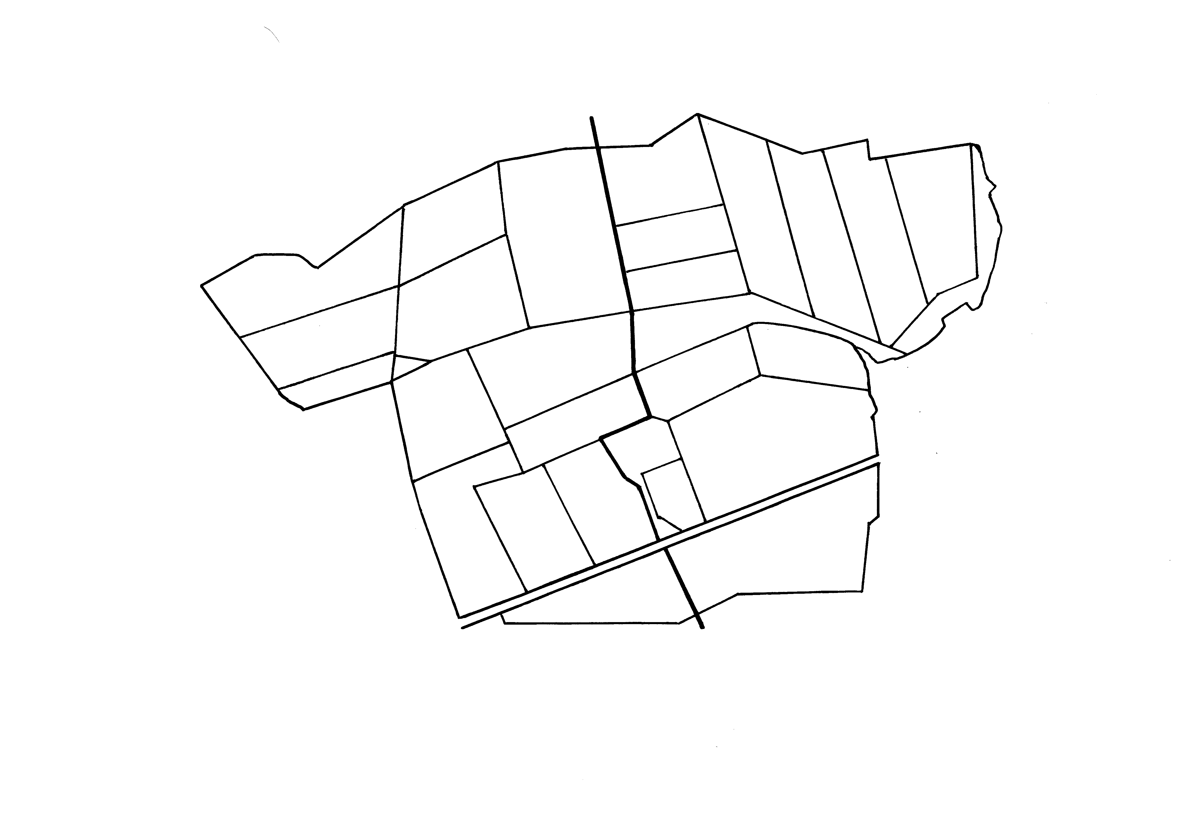
1
2
3
CONVENTIONAL
ORGANIC
N
4
5
6
7
8
9
10 11
12
13
14
15
16
17
18
19
20
Supplementary figure 1. Outline map of the fields in the conventional and organic halves of Nafferton Farm (numbers refer to Supplementary table 1), together with an inset showing the location of the farm in northern England.

