Appendix S3 – Relationships between survival and abundance.
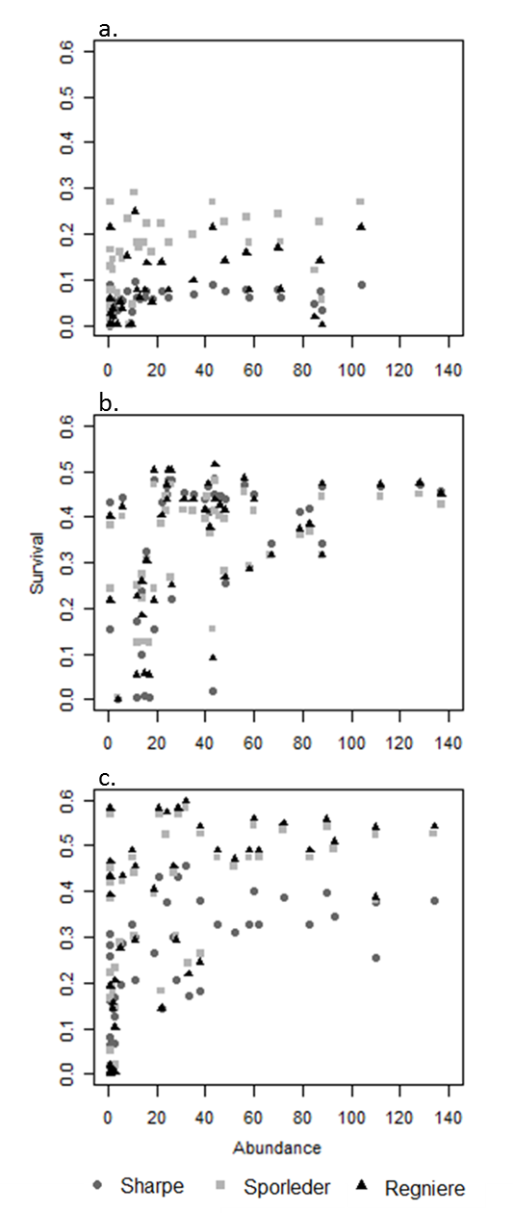
Fig. 1. Predicted survival by the three models in relation to observed abundance at 50 sites in the Ecuadorian Andes of a) P. operculella, b) S. tangolias, and c) T. solanivora.

