Mortality estimates derived from age distributions of two species of tsetse (Glossina spp) sampled in Zimbabwe point to the need for new methodologies

Supplementary Material

Contributions to the paper

JWH: designed and supervised the study, cleaned and analysed the data, wrote the paper. SAA: analysed the data and wrote the paper. Ovarian dissections were carried out by the following personnel: Messrs Edwin Mpandanyama, Claver Chitemere, Claudius Gorwe, David Mukuyu, Solomon Kaseke, Martin Nyarenda, Noel Chipofya and Maxwell Mawarire. The fly capture team was supervised by Mr Pio Chimanga.
Tsetse life cycle

Tsetse reproduce by way of a highly specialised process termed adenotrophic viviparity. That is to say, tsetse give birth to live young that are fed in the uterus by way of a modified adrenal gland. Female tsetse have paired ovaries (Fig. SM1) with two ovarioles in each ovary. Oocytes mature singly in the ovarioles in the following strict order: right inner, left inner, right outer, left outer – with the position of the ovarioles defined viewing the fly from the dorsal abdominal surface. Since these ovulations also occur at regular intervals, of about 9 days at 27⁰C, it will become apparent that the relative sizes of the various oocytes provides a method for estimating the age of a given female fly.

The mature oocyte is ovulated retained as an egg in the uterus, having been fertilized during ovulation by sperm stored in the spermathecae. Female tsetse generally only mate once. At about five days post-ovulation the egg hatches in the uterus to produce a first-instar larva which is fed a mixture of fat and protein from a modified gland, the so-called “milk gland” in the uterus. Over the next 4-5 days, depending on temperature the larva completes the development of three instar stages. The late third instar third larva is deposited, generally on a substrate of loose soil, sand or vegetable litter. The newly independent tsetse larva burrows into this substrate to a depth of a few centimetres, and then forms a hard outer shell called the puparial case, in which it completes its morphological transformation into an adult fly.

The duration of the puparial phase varies in a non-linear fashion with temperature: at 30⁰C the puparial duration is about 20 days, at 25⁰C it is 26 days and at 20⁰C it is 47 days. The pupa does not feed during this time, relying entirely on stored resources during this time. Since the adult that emerges from the puparium has the full linear dimensions of the mature adult it is not surprising that the fully developed third-instar larva weighs almost as much as its mother.

Figure SM1. The reproductive system of the female tsetse (Glossina spp)

Ovarian dissection
To dissect a female tsetse, in order to estimate its ovarian age, the legs and head were first excised and discarded. The wings were also excised, but these were fixed using transparent adhesive tape to the ovarian dissection record form for later analysis of size – and wing-fray status which provided additional information on fly age (Jackson, 1946). The fly was placed dorsal side up on a glass slide with sufficient buffered saline to prevent desiccation of the dissected organs. A small nick was then made on either side of the fifth or sixth tergite. When the tip of the abdomen was gripped with forceps and pulled backwards, the female organs were exposed (Figure SM1).

The content of the uterus (either empty, egg, or first second or third instar larva) was recorded and the length and diameter of any inclusion measured used a binocular microscope with a calibrated eyepiece graticule. The content (volume) of sperm remaining in the spermathecae was judged using the method of Pollock (1982), where ordinal scores range from 0, for an empty spermatheca, to 10, for one that is entirely full, giving a total sperm content of 20 when both spermathecae are full.

The ovarian, or physiological, age of a female fly is determined by the configuration of the ovarioles. In the newly emerged female the largest oocyte is in the inner part of the right ovariole (Fig. SM2). Once this oocyte has matured and been ovulated, at age about 6 days, the largest oocyte is then in the left inner ovariole: thereafter the largest is in the right outer and finally in the left outer. It is thus possible to estimate the ovarian age of the fly, for flies that have ovulated at most three times, from the position of the largest oocyte. Thus, if the largest oocyte is in the right inner position we may conclude that the fly is less than about 6 days old. If the largest oocyte is in the left inner position we estimate that the fly is between about 6 days and 15 days old – assuming a 9-day pregnancy. Similarly, if the largest oocyte is in the right outer position we estimate that the fly is between about 15 days and 24 days old.

The situation becomes more complicated for females that have ovulated more than three times – because we cannot distinguish, from the position and relative sizes of the oocyte alone, between a newly emerged fly and one that has ovulated four times. The two ages can however, be separated because, when an egg is ovulated, the sheath of the egg is left attached to the oocyte: the sheath shrivels with time and is left as a so-called relic on the end of the oocyte. Thus, for a fly that has never ovulated, there will be no relics on any of the oocytes but, for a fly that has ovulated four times, each of the oocytes will have a relic attached. Similarly, one can distinguish between a fly that has ovulated once and one that has ovulated five times, and between flies that have ovulated two and six times and three and seven times.

Unfortunately, serial relics do not accumulate on the ovarioles so that the presence of a relic shows only that the ovariole in question has ovulated at least once. It is therefore impossible to distinguish between a fly that has ovulated four times from one that has ovulated eight, twelve, sixteen etc times. Similarly it is impossible to distinguish between flies that have ovulated five times from one that has ovulated nine, thirteen, seventeen etc times – with analogous statements applying to flies that have ovulated at least six or seven times. Accordingly, flies that have relics on all four ovarioles are denoted as having ovarian ages 4+4n, 5+4n, 6+4n or 7+4n, depending on the configuration of the oocytes.

Detailed examination of the ovaries was carried out by using fine needles or forceps to break the outer membrane of the ovarioles and release the developing egg. These were then examined for the presence or absence of a follicular relic, and the length and diameter of the two largest oocytes was measured using the binocular microscope. These lengths, together with the type and size of the uterine content can be used to estimate the percentage of pregnancy completed by the fly in question – and to give a more accurate estimate of the chronological age where this is required. These latter estimates require the use of temperature data since the rates of ovarian development are temperature dependent (Hargrove, 1994, 1995)

It is possible, in principle, to distinguish between flies that have ovulated, say, four times and those that have ovulated eight, twelve etc times, by using also the observed degree of wing-fray in the fly (Hargrove, 1990, 2012). Thus a fly in ovarian category 4+4n, which has wings with virtually no fray may be confidently be assumed to have ovulated only four (as opposed to eight, twelve etc) times, whereas a fly that has badly frayed wings may be assumed to belong to an older age class. This refinement of the methodology is, however, not well developed, is subject to variability and has accordingly not been used in the present study.

The methodology for ovarian dissection is described further in Mulligan (1970) and the FAO training manual for tsetse control personnel, volume 1 (FAO 1982).
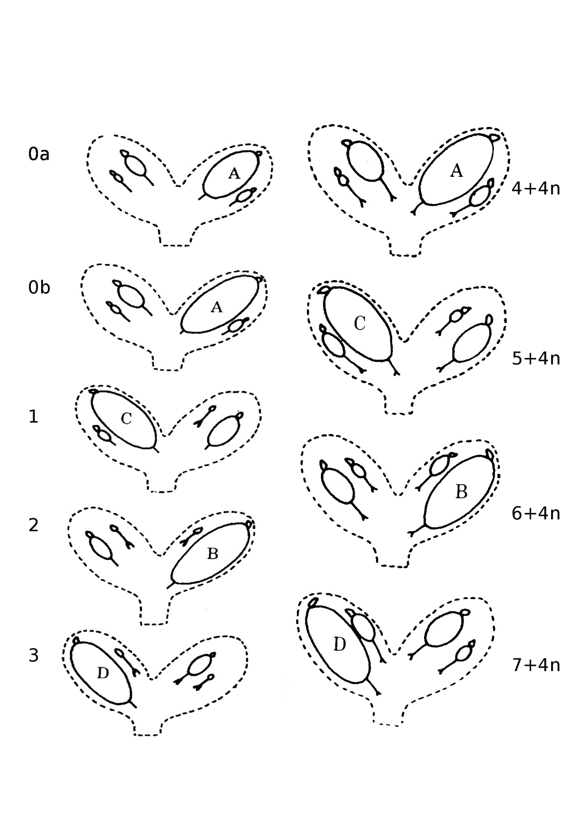
Figure SM2. Diagrammatic representation of the relatives sizes of oocytes of female tsetse (Glossina spp) during successive ovulation cycles. Ovarioles ovulate in the strict order right inner (A), left inner (C), right outer (B) and left outer (D). It has been customary in the past to separate flies in ovarian category 0 (those that have not yet ovulated) into two groups (0a And 0b) depending on the size of the largest oocyte.

Capture methods

Mechanical traps. Mechanical trapping relied largely on the use of odour-baited epsilon traps (Illustration SM3). Artificial host odour consisted of acetone (dispensed at 500 mg h^{–1}), 1-octen-3-ol (0.4 mg h^{–1}), 4-methyl phenol (0.8 mg h^{–1}) and 3-n-propyl phenol (0.1 mg h^{–1}) (Torr et al., 1997).

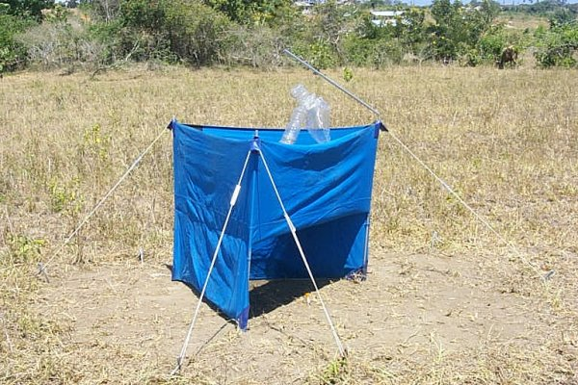

Illustration SM3. Epsilon trap

Electric nets. These devices are described Vale (1974). Capture relies on the electrocution of flies contacting grids of blackened copper wires (spring steel, 0.15 mm in diameter, or copper, 0.2 mm in diameter) running parallel 0.8 cm apart. Two parallel banks of wires are suspended in an aluminium frame approximately 100 × 100 cm m square: the grids are 1.2 cm apart and are separated by a vertical sheet of fine nylon netting, 90 × 90 cm.

Differentials of about 40 kV were created between adjacent wires so that, although spontaneous sparking seldom occurred, the discharge when tsetse touched the grid was sufficient to kill or stun the flies which then fell to a recovery apparatus below. Power was derived from 12 V lead/ acid accumulators. The transformer took an average input current of about 2 amps to produce a low ampere/high volt output pulsing every 15 ms. This output could suitably electrify 1.5-2.0 m² of grid. A generalized circuit diagram, as well as drawings of the electric nets referred to above, are reproduced in the FAO (1992) Training Manual for Tsetse Control Personnel.

Vehicle-mounted electric target (VET). This capture system involved mounting one of the above electric nets on the back of a small pick-up truck (Illustration SM4). The vehicle was driven at a speed of about 5 km/hr through tsetse habitat. Flies colliding with the net were killed, dropping into a tray on the floor of the pick-up where they were collected at 30 min intervals.



Illustration SM4. Vehicle-mounted electric target (VET)
Artificial refuges. The refuge (Illustration SM5) consisted of a 200 l steel oil drum, open at one end, lying on its side, painted matt black inside, covered with a layer of soil for insulation, and shaded at its open end by a porch consisting of an angle-iron frame covered with grass thatch (Vale, 1971). Refuges were generally cleared between 13.30 and14.00 hours: a hessian curtain was placed across the mouth of the porch to prevent flies escaping. A man then ducked behind the curtain and used a cotton flail to agitate the flies, which then flew towards the only light source, which came through a funnel of fabric netting let into the hessian curtain. The funnel led to a retaining cage comprising an 8-gauge wire frame (18.5 x 9 x 9 cm) covered with fabric netting. Fly activity, and consequent wing damage, was reduced by wrapping the cage in a moist black cotton cloth and storing it in a polystyrene box.

Flies were also caught on 1m x 1m electric nets, described above, placed across the mouth of the refuge, either at 06.30 hours and operated all day so as to intercept any tsetse that flew into the refuge, or at 13.30 hours in such a way as not to disturb the flies that had entered the refuge earlier in the day. The latter net caught flies as they left the refuge later in the afternoon, as well as a small number that continued to fly into the entrance from outside the refuge. Flies colliding with the net were killed or stunned and fell into a collecting tray, which was cleared hourly.
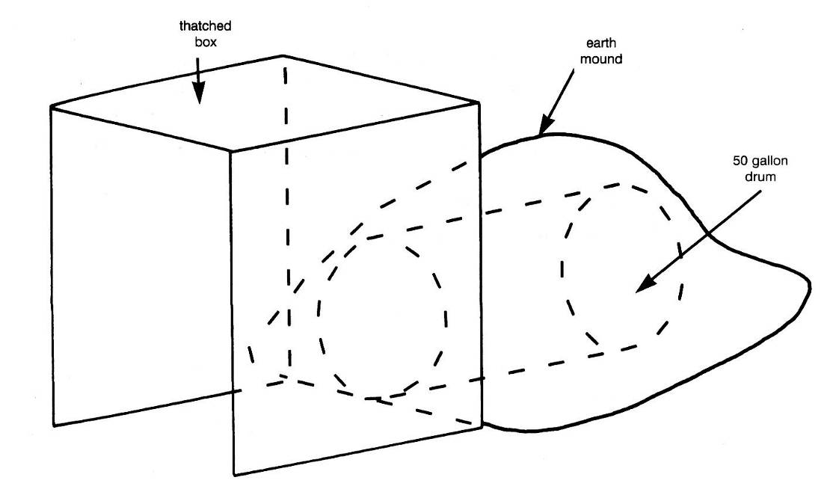
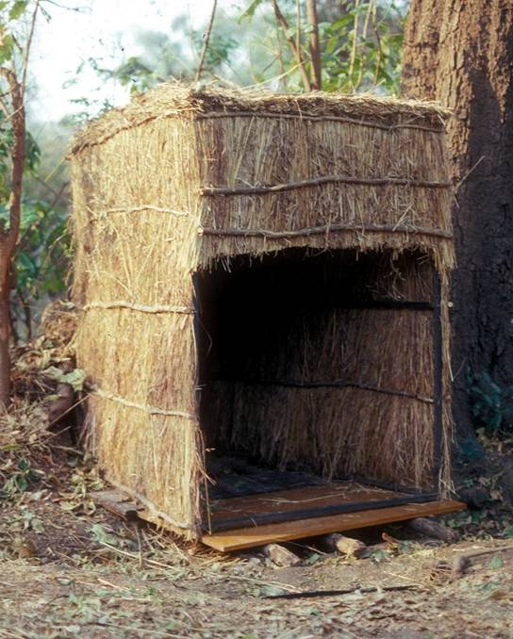

Illustration SM5. Artificial refuge

References
FAO (1992). Use of attractive devices for tsetse survey and control. Training Manual for Tsetse Control Personnel, 4. Food and Agriculture Organisation, Rome.
Hargrove, J. W. (1990). Age-dependent changes in the probabilities of survival and capture of the tsetse fly Glossina morsitans morsitans Westwood. Insect Science and its Application 11, 323-330.
Hargrove, J. W. (1994) Reproductive rates of tsetse flies in the field in Zimbabwe. Physiological Entomology 19, 307-318.
Hargrove, J.W. (1995) Towards a general rule for estimating the day of pregnancy of field-caught tsetse flies. Physiological Entomology 20, 213-223.
Jackson, C. H. N. (1946) An artificially isolated generation of tsetse flies (Diptera). Bulletin of Entomological Research, 37, 291-299.
Mulligan, H.W. (Ed.) (1970) The African Trypanosomiases. London, George Allen and Unwin. 950pp.
Pollock, J.N. (1982). Training Manual for Tsetse Control Personnel. Volume 1: Tsetse biology, systematics and distribution, techniques. Food and Agriculture Organisation of the United Nations, Rome.
Torr S. J. Hall, D., R., Phelps, R. J., & Vale, G. A. (1997) Methods for dispensing odour attractants for tsetse flies (Diptera: Glossinidae). Bulletin of Entomological Research 87, 299-311.
Vale, G.A. (1971) Artificial refuges for tsetse flies (Glossina spp.). Bulletin of Entomological Research, 61, 331-350.
Vale, G.A. (1974) The responses of tsetse flies (Diptera: Glossinidae) to mobile and stationary baits. Bulletin of Entomological Research, 64, 545-588.

