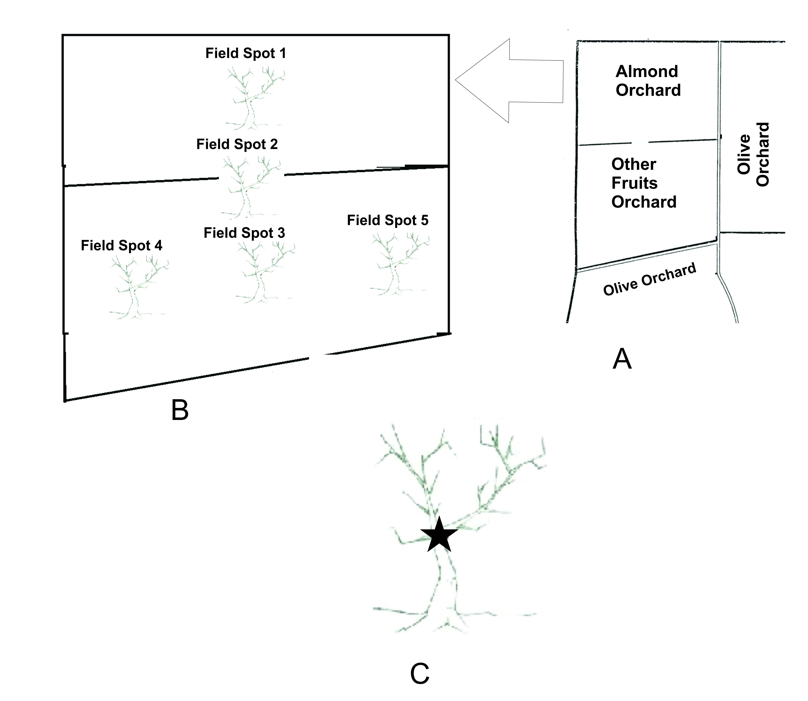

Fig. S1 The layout of the field experiment. (A) The almond experimental orchard. (B) The setup of five equidistant locations in the almond orchard used for the field experiment. (C) The location and position of the experimental branches relative to the rest of the tree.

