Appendix 1
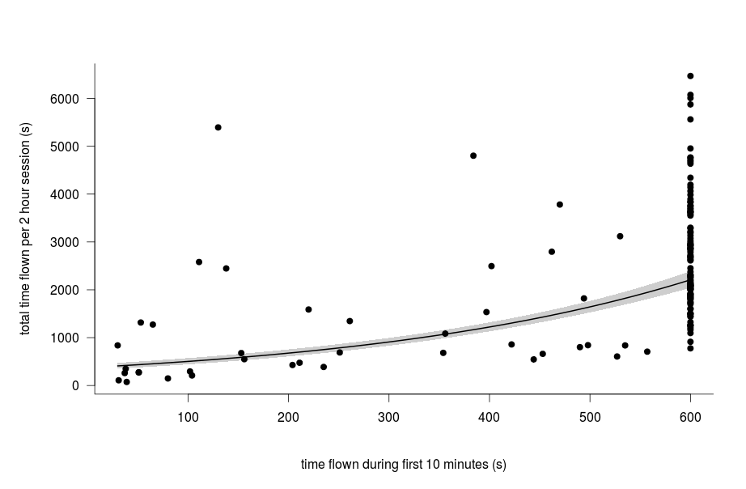
The total flight duration during a 2h session was significantly correlated with the time flown during the 10 first min of each session (Data from David et al. 2014).
We used a mixed effect model to deal with the temporal autocorrelation between flight duration of the same insect across weekly sessions. The same 38 insects were tested once a week until their death.
Y = exp(3.10⁻⁰³ X + 6); P< 0.001; R² marginal = 0.42

Appendix 2
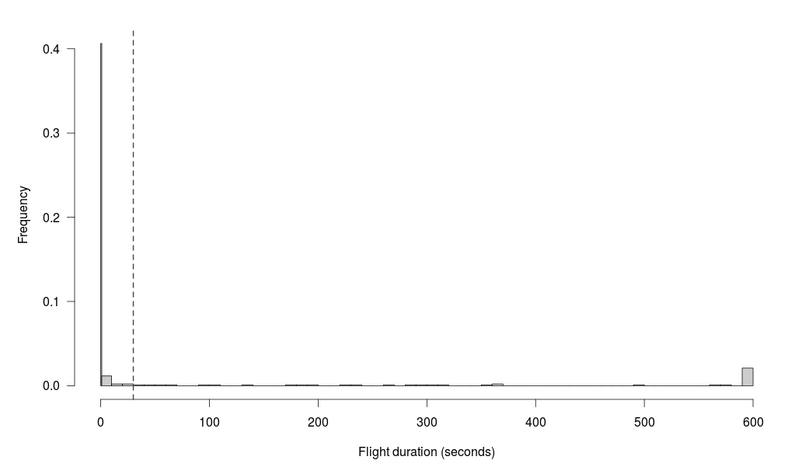
Histogram of frequency distribution of flight duration for cumulated flights over a time test of ten minutes. Each bar represents an interval of 10 seconds and the black dot line marks the limit of 30 seconds that we used as threshold for non-flyers. Among the 54 insects we had considered non flyers (< 30 s of cumulated flight), 40 did not fly at all, 10 flew less than 10 seconds, 2 less than 20s and 2 less than 30s.

