Electronic supplementary material 1
accompanying
“Indirect evidence of pathogen-associated altered oocyte production in queens of the invasive yellow crazy ant, Anoplolepis gracilipes, in Arnhem Land, Australia”
by Cooling et al.

Population survey methods
In late July of 2013 and 2014, I (M.C.) and a crew of five to eight trained volunteers (Conservation Volunteers Australia) mapped four different A. gracilipes populations (Fig. 1). Mapping and subsequent re-surveys of populations were conducted by visual assessments of the presence/absence of A. gracilipes workers. These assessments were conducted between 0600-0930 and 1530-1830, when high temperatures do not greatly hinder A. gracilipes activity in these areas (Hoffmann 2015). Assessments were conducted by teams of people walking in parallel, commencing in any direction from the original A. gracilipes detection point. Assessments were conducted haphazardly, approximately one per every 2 m. Point-level GPS data were collected at each assessment point, A. gracilipes was recorded as present or absent. Two study populations (H1, H2) were not mapped because 1) these A. gracilipes populations were very abundant and dense and every point taken would be a “present” point, and 2) these populations were on the Rio Tinto minesite, which made surveying unfeasible. At sites where the A. gracilipes population was very widespread and therefore too time-consuming to map in its entirety, a sub-section of the population (200 m x 100 m) was mapped in the area where I had previously sampled (see white polygons in Fig. S1).
Population survey results
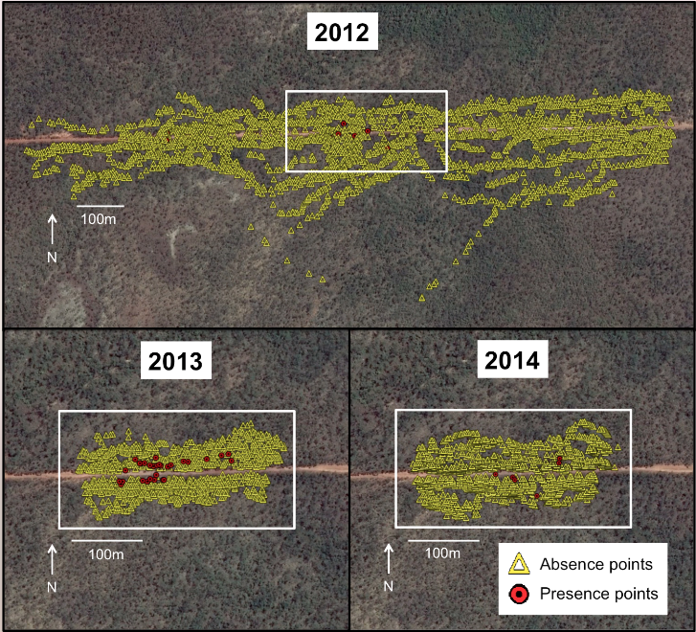
Fig. S1 Low abundance population 1 (L1) showing the A. gracilipes population as mapped in 2012, 2013 and 2014. The white polygon indicates the same area and the location of the study populations on all three maps

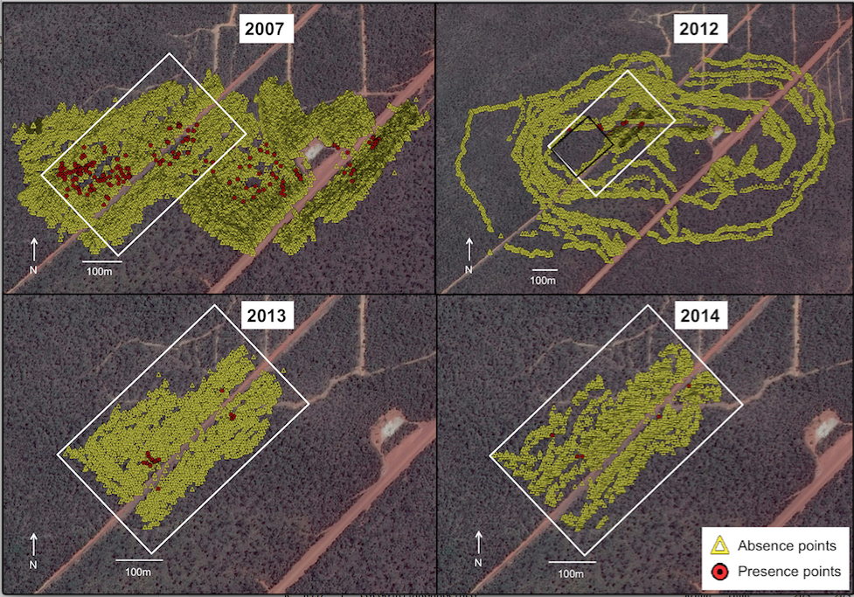
Fig. S2 Low abundance population 2 (L2) showing the A. gracilipes population as mapped in 2007, 2012, 2013 and 2014. The white polygon indicates the same area and the location of the study populations on all three maps. The black rectangle on the 2012 map indicates where GPS data was lost; all lost data were A. gracilipes absence points

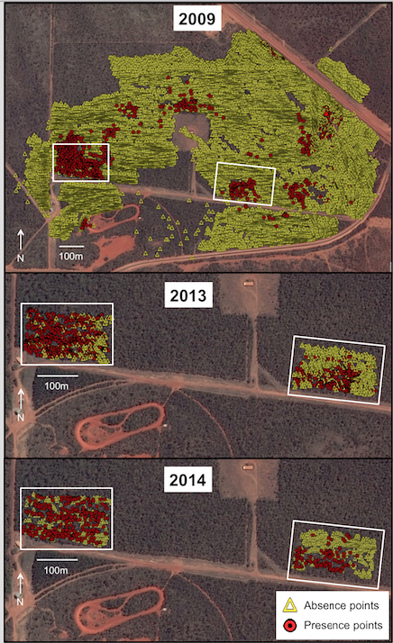
Fig. S3 Medium abundance population 1 (M1) (right) and medium abundance population 2 (M2) (left) showing the A. gracilipes population as mapped in 2009, 2013 and 2014. The white polygon indicates the same area on all three maps, as well as the location of the 200 m x 100 m sub-sampled area of the study populations on all three maps
Table S1 Study population locations (WGS84 decimal degrees), size of population and number of GPS points taken each year. H denotes high abundance populations, M medium abundance populations and L low abundance populations
Population | Latitude | Longitude | Area (m²) | “Absent” points 2013 | “Present” points 2013 | “Absent” points 2014 | “Present” points 2014 | Percent “Present” points 2013 | Percent “Present” points 2014
H1 | -12.286531 | 136.869870 | 20 000 | - | - | - | - | - | -
H2 | -12.291767 | 136.872887 | 20 000 | - | - | - | - | - | -
M1 | -12.260974 | 136.833686 | 20 000 | 609 | 460 | 864 | 109 | 43.0% | 11.2%
M2 | -12.259746 | 136.825716 | 20 000 | 246 | 591 | 419 | 317 | 70.6% | 43.1%
L1 | -12.339775 | 136.889406 | 34 150 | 1454 | 34 | 1425 | 6 | 2.3% | 0.4%
L2 | -12.270554 | 136.793249 | 88 320 | 3776 | 35 | 3402 | 7 | 0.9% | 0.2%

Post-hoc test results
When interactions are present, comparisons can be difficult to extract from GLMM models as significance is measured relative to the lowest level of each factor (the intercept). To overcome this limitation we undertook pairwise tests of significance using least square means. However, as least square means compares the means of terms to each other instead of the intercept, the GLMM interaction term results differ from those of the post-hoc tests.

Table S2 Post-hoc comparisons using least square means for the interaction between population type and nodulation status. “High” denotes high abundance populations, “med” medium abundance populations and “low: low abundance populations
Contrast | ßª | SE^{b} | p^{c}
High × no nodules vs med × no nodules | 0.771 | 0.332 | NS
High × no nodules vs low × no nodules | 0.895 | 0.379 | NS
High × no nodules vs high × with nodules | 0.841 | 0.107 | NS
High × no nodules vs med × with nodules | 1.166 | 0.506 | NS
High × no nodules vs low × with nodules | 1.081 | 0.462 | NS
Med × no nodules vs low × no nodules | 1.160 | 0.474 | NS
Med × no nodules vs high × with nodules | 1.090 | 0.486 | NS
Med × no nodules vs med × with nodules | 1.511 | 0.107 | ***
Med × no nodules vs low × with nodules | 1.401 | 0.580 | NS
Low × no nodules vs high × with nodules | 0.940 | 0.414 | NS
Low × no nodules vs med × with nodules | 1.303 | 0.537 | NS
Low × no nodules vs low × with nodules | 1.208 | 0.088 | NS
High × with nodules vs med × with nodules | 1.386 | 0.621 | NS
High × with nodules vs low × with nodules | 1.285 | 0.569 | NS
Med × with nodules vs low × with nodules | 0.927 | 0.386 | NS
ª Beta coefficient
^{b} Standard error
^{c} Statistical significance: *, p < 0.05; **, p < 0.01; ***, p < 0.001

Immune experiment
In order to have supporting evidence that the black spots were indeed a cellular immune response, we injected ants with various substances to test if they formed similar nodules. On February 14th 2015, 60 queens were collected from site H1. This area was selected as a collection site because it was one of only two sites (H1 and H2) that had high enough population abundances to collect the necessary number of queens. Queens were collected by turning over large rocks and carefully gathering visible queens by hand. Sixty queens were collected and injected one day, then two days later another 40 were collected and injected.
Within 5 hours of collection, queens were placed in a plastic container and chilled in a fridge at 4 C for 90 minutes. There were four treatments in this experiment: sham (queens were handled, but not injected with anything), injection with phosphate buffered saline solution (PBS), lipopolysaccharides (LPS), or spores of the entomopathogenic fungus, Metarhizium anisopliae (BiocaneTM Granules, Becker Underwood, Australia) (hereafter referred to as the fungal treatment). LPS is a significant outer surface membrane component of Gram-negative bacteria and is known to induce an immune response in many eukaryotic organisms including insects and humans (Aubert and Richard 2008). The LPS treatment consisted of a 500 ug ml-1 LPS solution (from Escherichia coli serotype 055:B5, Sigma). This dose was chosen based on previous literature. Korner and Schmid-Hempel (2004) challenged the immune system of Bombus terrestris by injecting bees with LPS; while Aubert and Richard (2008) injected LPS into the similarly sized ant, Formica polyctena. Queens were randomly assigned to a treatment (sham, saline, LPS or fungus). Metarhizium anisopliae is a common fungal pathogen of insects, and often used as an experimental pathogen of ants and termites (Chapter 3; Hughes and Boomsma 2004; Calleri et al. 2006; Konrad et al. 2012; Reber and Chapuisat 2012). The fungal treatment was made up of M. anisopliae spores mixed with PBS to get a final concentration of 106 spores ml-1. This concentration was chosen based on similar studies in the literature and adjusted appropriately for the size of A. gracilipes queens (Dean et al. 2002; Mullen and Goldsworthy 2006). The spore concentration was quantified using a haemocytometer. The volume of the injection was 1.5 μL for all treatments; I measured 1.5 μL of the appropriate mixture out with a pipette. This volume was pippetted onto a glass slide, then taken up using a 1 mL syringe with a 27-gauge needle. Under a dissecting scope (10X), 1.5 μL of PBS, LPS or fungus was injected into the abdominal cavity by slipping the needle in between the 2nd and 3rd gastral tergite into the abdominal cavity of the queens. After being injected, the queen was moved to a holding chamber that contained one small moist plaster block to provide humidity. After 24 hours, the queen was removed, chilled at 4 C for 90 minutes then placed alive into 2 ml of RNAlater (Mullen and Goldsworthy 2006). Vials were kept at room temperature for 36 hours to allow the RNAlater to permeate the ants’ tissue, and then refrigerated at 4 C. Twenty-five queens were used for each of the four treatments. Queens were dissected under a high-powered dissecting scope to check for the presence of nodules.
A Kruskal-Wallis test was used to test the difference in nodule formation between treatment groups. Statistical significance was assumed at p < 0.05.
Immune experiment
Queens in the fungal treatment had 15% more nodules than queens from the LPS and PBS treatments, and 60% more than the sham treatment (H3= 50.736, p< 0.001) (Figure 4.10, 4.11). Queens from the fungal treatment had 60.04 ± 11.63 (mean ± SE) nodules; while queens from the LPS, PBS and sham treatments had 3.96 ± 1.59, 3.86 ± 1.37 and 0.96 ± 0.39 nodules, respectively. One hundred percent of queens from the fungal treatment had at least 5 nodules, while 46% of the LPS treatment had two or more, and 59% of the PBS and 40% of the sham had at least one.

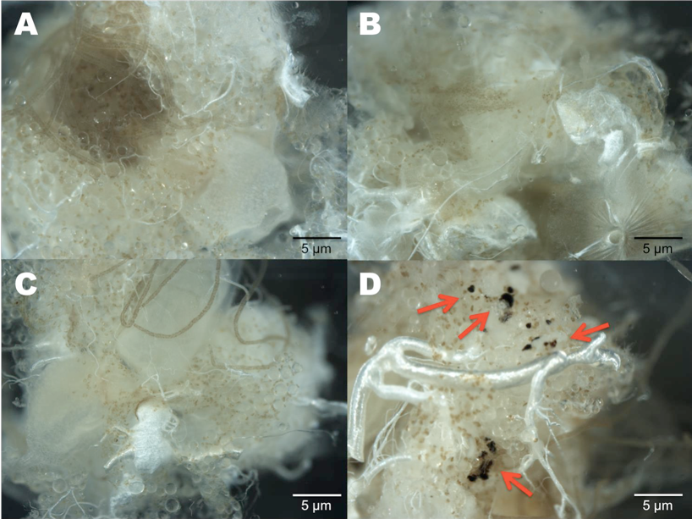
Figure S4 Fat bodies of dissected queens from the four treatments A) sham, B) PBS, C) LPS and D) fungal. The red arrows in photograph D are pointing to melanized nodules

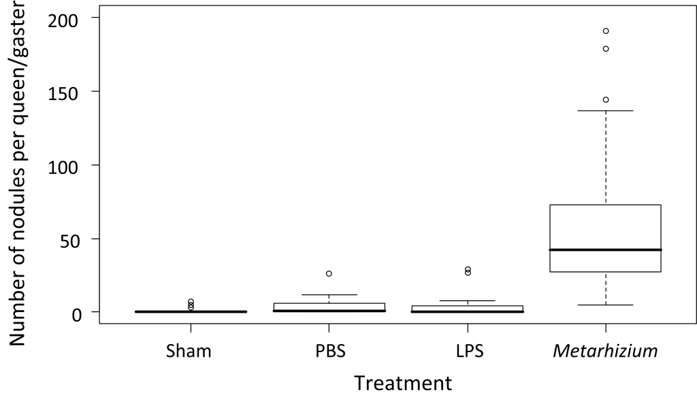
Figure S5 Boxplot showing the median number of nodules found in each queen after 24 hours

