Supplementary Material

Supplementary Table 1. Five paired sites in the Free State, South Africa. Category of infestation 1= patch size less than 50 m², 2 = restricted to a dam or small wetland system (<1 km), 3 = cover large wetland system (>1 km), 4 = cover flowing river system (>1 km). Ad = A. donax, Pa = P. australis.
Site | GPS Point | Elevation (m) | Distance between reeds stands (km) | Coverage scale |  | Surrounding land use
 |  |  |  | Ad | Pa
1 | 28°43’15S,28°01’29E | 1825 | 0.53 | 1 | 2 | Grazing land
2 | 28°51’10S,27°30’18E | 1645 | 0 | 2 | 2 | Mixed farming
3 | 28°51’31S,27°31’25E | 1611 | 1.1 | 1 | 2 | Mixed farming
4 | 28°42’11S,27°26’40E | 1500 | 0 | 2 | 2 | Crop farming
5 | 28°40’05S,27°25’29E | 1505 | 2.02 | 1 | 4 | Urban

Supplementary Table 2. Paired sites across South Africa. Category of infestation 1= patch size less than 50 m², 2 = restricted to a dam or small wetland system (< 1 km), 3 = cover large wetland system (>1 km), 4 = flowing river system (> 1 km). Ad/A= A. donax, Pa/P = P. australis, Pm/M= P. mauritianus, KZN = KwaZulu-Natal, WC = Western Cape, FS = Free State, MP = Mpumalanga Provinces.
Site | GPS Point | Elevation (m) | Distance between  each reed species (km) |  |  | Coverage scale | Surrounding land use
 |  |  | Ad | Pa | Pm
1A-KZN | 29°27’28’’S  31°13’00’’E | 22 | - | 0 | 0 | 1 | Sugarcane farming
1M-KZN | 29°27’28’’S  31°13’00’’E | 22 | 0 | 0 | - | 4 | Sugarcane Farming
2A-KZN | 29°38’47’’S  31°07’18’’E | 10 | - | 0.45 | - | 1 | Sugarcane Farming
2P-KZN | 29°38’47’’S  31°07’18’’E | 5 | 0.45 | - | - | 4 | Sugarcane Farming
2M-KZN | 29°42’45’’S  31°05’35’’E | 14 | - | - | - | 3 | Indigenous coastal forest
3A-KZN | 29°33’38’’S  31°10’19’’E | 16 | - | 0.23 | 0.6 | 1 | Sugarcane farming
3P- KZN | 29°33’38’’S  31°10’19’’E | 8 | 0.23 | - | 0.81 | 2 | Sugarcane farming
3M- KZN | 29°33’38’’S  31°10’19’’E | 7 | 0.6 | 0.81 | - | 4 | Sugarcane farming
4A- KZN | 29°38’41’’S  31°03’55’’E | 21 | 0 | 0 | 0 | 1 | Sewage works
4P- KZN | 29°38’41’’S  31°03’55’’E | 21 | 0 | 0 | 0 | 4 | Sewage works
4M- KZN | 29°38’41’’S  31°03’55’’E | 21 | 0 | 0 | 0 | 1 | Sewage works
5A- KZN | 29°28’50’’S  31°14’10’’E | 93 | - | 1.08 | - | 1 | Urban
5P- KZN | 29°28’17’’S  31°14’28’’E | 74 | 1.08 | - | -- | 2 | Abandoned construction site
5M- KZN | 29°47’48’’S  30°57’57’’E | 60 | - | - | - | 4 | Urban
1A-WC | 34°02’05.64’’S  18°21’13.93’’E | 6 | - | 0 | - | 4 | Urban
1P-WC | 34°02’05.64’’S  18°21’13.93’’E | 6 | 0 | - | - | 4 | Urban
2A-WC | 34°01’24.92’’S  18°26’18.85’’E | 53 | - | 0.09 | - | 1 | Suburban park
2P-WC | 34°01’24.92’’S  18°26’18.85’’E | 51 | 0.09 | - | - | 2 | Suburban park
3A-WC | 33°56’41.89’’S  18°53’51.52’’E | 167 |  | 5.62 |  | 1 | Vineyard
3P-WC | 33°58’33.98’’S  18°56’40.24’E | 273 | 5.62 |  |  | 2 | Nature reserve
4A-WC | 33°58’30.82’’S  18°47’07.84”E | 32 | - | 0.13 | - | 2 | Vineyard
4P-WC | 33°58’30.82’’S  18°47’07.84”E | 34 | 0.13 | - | - | 2 | Vineyard
5A-WC | 33°56’36.68’’S  18°48’07.61”E | 103 | - | 3.52 | - | 2 | Vineyard
5P-WC | 33°56’51.80’’S  18°45’55.06”E | 116 | 3.52 | - | - | 2 | Vineyard
1A-MP | 25°26’22,87’’S  30°55’06.70’’E | 687 | - | - | 5.16 | 1 | Roadside
1M-MP | 25°26’03.57’’S  30°52’02.49’’E | 691 | 5.16 | - | - | 2 | Passion fruit (Passiflora edulis Sims.  (Passifloraceae)) farm
2A-MP | 25°01’56.99’’S  31°02’04.99’’E | 694 | - | - | 0 | 1 | Macadamia nut (Macadamia sp.  (Proteacae)) Farm
2M-MP | 25°01’52.73’’S  31°01’25.43’’E | 694 | 0 | - | - | 2 | Residential
3A-MP | 25°27’17.05’’S  30°53’07.36’’E | 525 | - | - | 1.1 | 2 | Residential area/scrap yard
3M-MP | 25°27’17.05’’S  30°53’07.36’’E | 521 | 1.1 | - | - | 4 | Residential area/scrap yard
4A-MP | 25°03’52.41’’S  31°07’46.59’’E | 566 | - | - | 2.3 | 1 | Petrol Garage
4M-MP | 25°02’10.75’’S  31°07’05.83’’E | 482 | 2.3 | - | - | 3 | Golf course
5A-MP | 24°58’48.04’’S  31°28’53.93’’E | 297 | - | - | 0 | 1 | National Park
5M-MP | 24°58’48.04’’S  31°28’53.93’’E | 297 | 0 | - | - | 4 | National Park

Supplementary Table 3. Comparison of T. romana abundance and injury in the LTS and NWS.
 | LTS | NWS
Mean number of emergence holes in lateral shoots ± SE | 0.88 ± 0.07 | 0.61 ± 0.30
Percent of lateral shoots with: LTS - emergence holes  NWS – T. romana larvae | 19 % | 26 %
Percent of plants with T. romana present | 42.44 % | 41 %
Mean number of larvae per lateral shoot ± SE | _ | 1.13 ± 0.35
Average number of T. romana per culm ± SE | 0.22 ± 1.46* | 6.1 ± 1.60
*based on the number of T. romana adult wasps recorded from the emergence boxes (10 reeds per box).

a A. donax | b P. australis
Supplementary Figure 1. a. Incidence data for the herbivores on A. donax for the LTS for all five sites using the Chao 2 and ICE estimators (Colwell 2013). Both estimators predict that sampling should find about eight species for all sites with as many as twenty if sampling continues (Chao 2 upper 95% CI); b. Incidence data for the herbivores on P. australis for the LTS for all five sites using the Chao 2 and ICE estimators (Colwell 2013). Both estimators predict that six species are expected to be the total number of herbivores to be found at all five sites
a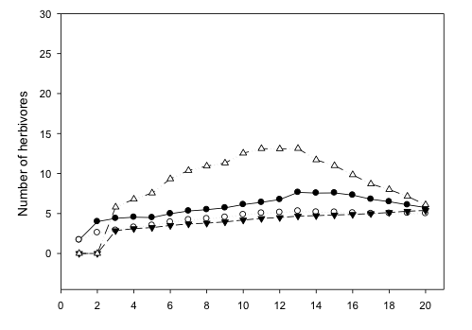
b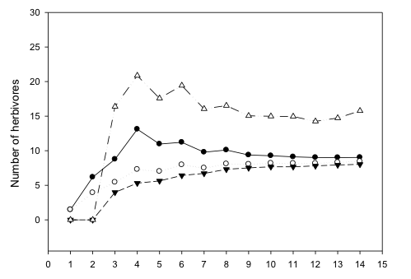
c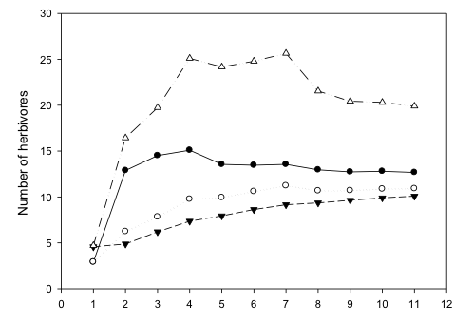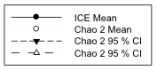
Supplementary Figure 2. Incidence data for the herbivores collected in all NWS using the Chao 2 and ICE estimators (Colwell 2013). a. A. donax: both estimators predict that five species are expected to be the total number of herbivores to be found at all five sites, with as many as six if sampling continues (Chao 2 upper 95% CI). b. P. australis: both estimators predict that twelve species is expected to be the total number of herbivores to be found at all five sites, with as many as twenty if sampling continues (Chao 2 upper 95% CI). c. P. mauritianus: both estimators predict that twelve species is expected to be the total number of herbivores to be found at all five sites, with as many as twenty if sampling continues (Chao 2 upper 95% CI).

