SUPPLEMENTARY MATERIAL
Comparative performance and digestive physiology of Diaphania indica (Lepidoptera: Crambidae) on Trichosanthes anguina (Cucurbitaceae) cultivars
Rahul Debnath, Syed Husne Mobarak, Paroma Mitra and Anandamay Barik*
Ecology Research Laboratory, Department of Zoology, The University of Burdwan, Burdwan – 713 104, West Bengal, India
*e-mail: anandamaybarik@yahoo.co.in
* Corresponding author. Tel.: 0342 2634200; Fax: 0342 2634200

Supplementary material S1
Food utilization indices, i.e., growth rate (GR), consumption rate (CR), relative growth rate (RGR), consumption index (CI), approximate digestibility (AD), efficiency of conversion of ingested food (ECI) and efficiency of conversion of digested food (ECD) of Diaphania indica were measured according to Waldbauer (1968)
Growth rate (GR) = A/B
Consumption rate (CR) = C/B
Relative growth rate (RGR) = A/BD
Consumption index (CI) = C/ BD
Egestion rate (ER) = E/BD
Host consumption rate (HCR) = CI+ER
Approximate digestibility (AD) (%) = 100 (C–E)/C
Efficiency of conversion of ingested food (ECI) (%) = 100A/C
Efficiency of conversion of digested food (ECD) (%) = 100A/(C–E)
Host utilization efficiency (HUE) (%) = 100C/(C+E)
Where, A: dry weight gain of insect; B: duration of experimental period; C: dry weight of food eaten; D: mean dry weight of insect during time B; E: dry weight of faeces produced.

Supplementary Table 1. Head capsule width of Diaphania indica (n=10, mm ± SE) fed with three cultivars of Trichosanthes anguina under laboratory conditions (27 ± 1 °C, 65 ± 5 % r.h. and 12L:12D). Means followed by different letters within the rows are significantly different by Tukey’s test at 5% level of significance.
 | Baruipur Long | Polo No. 1 | MNSR-1 | F _{2,27} | P value
1st instar | 0.33 ± 0.02ab | 0.30 ± 0.01a | 0.36 ± 0.02b | 4.328 | 0.023
2nd instar | 0.51 ± 0.01b | 0.42 ± 0.01a | 0.54 ± 0.02b | 18.961 | 0.0001
3d instar | 0.77 ± 0.03a | 0.64 ± 0.01b | 0.85 ± 0.04c | 15.522 | 0.0001
4th instar | 1.56 ± 0.07ab | 1.40 ± 0.05a | 1.64 ± 0.09b | 3.38 | 0.049
5th instar | 1.79 ± 0.05a | 1.71 ± 0.05a | 2.01 ± 0.09b | 7.039 | 0.003

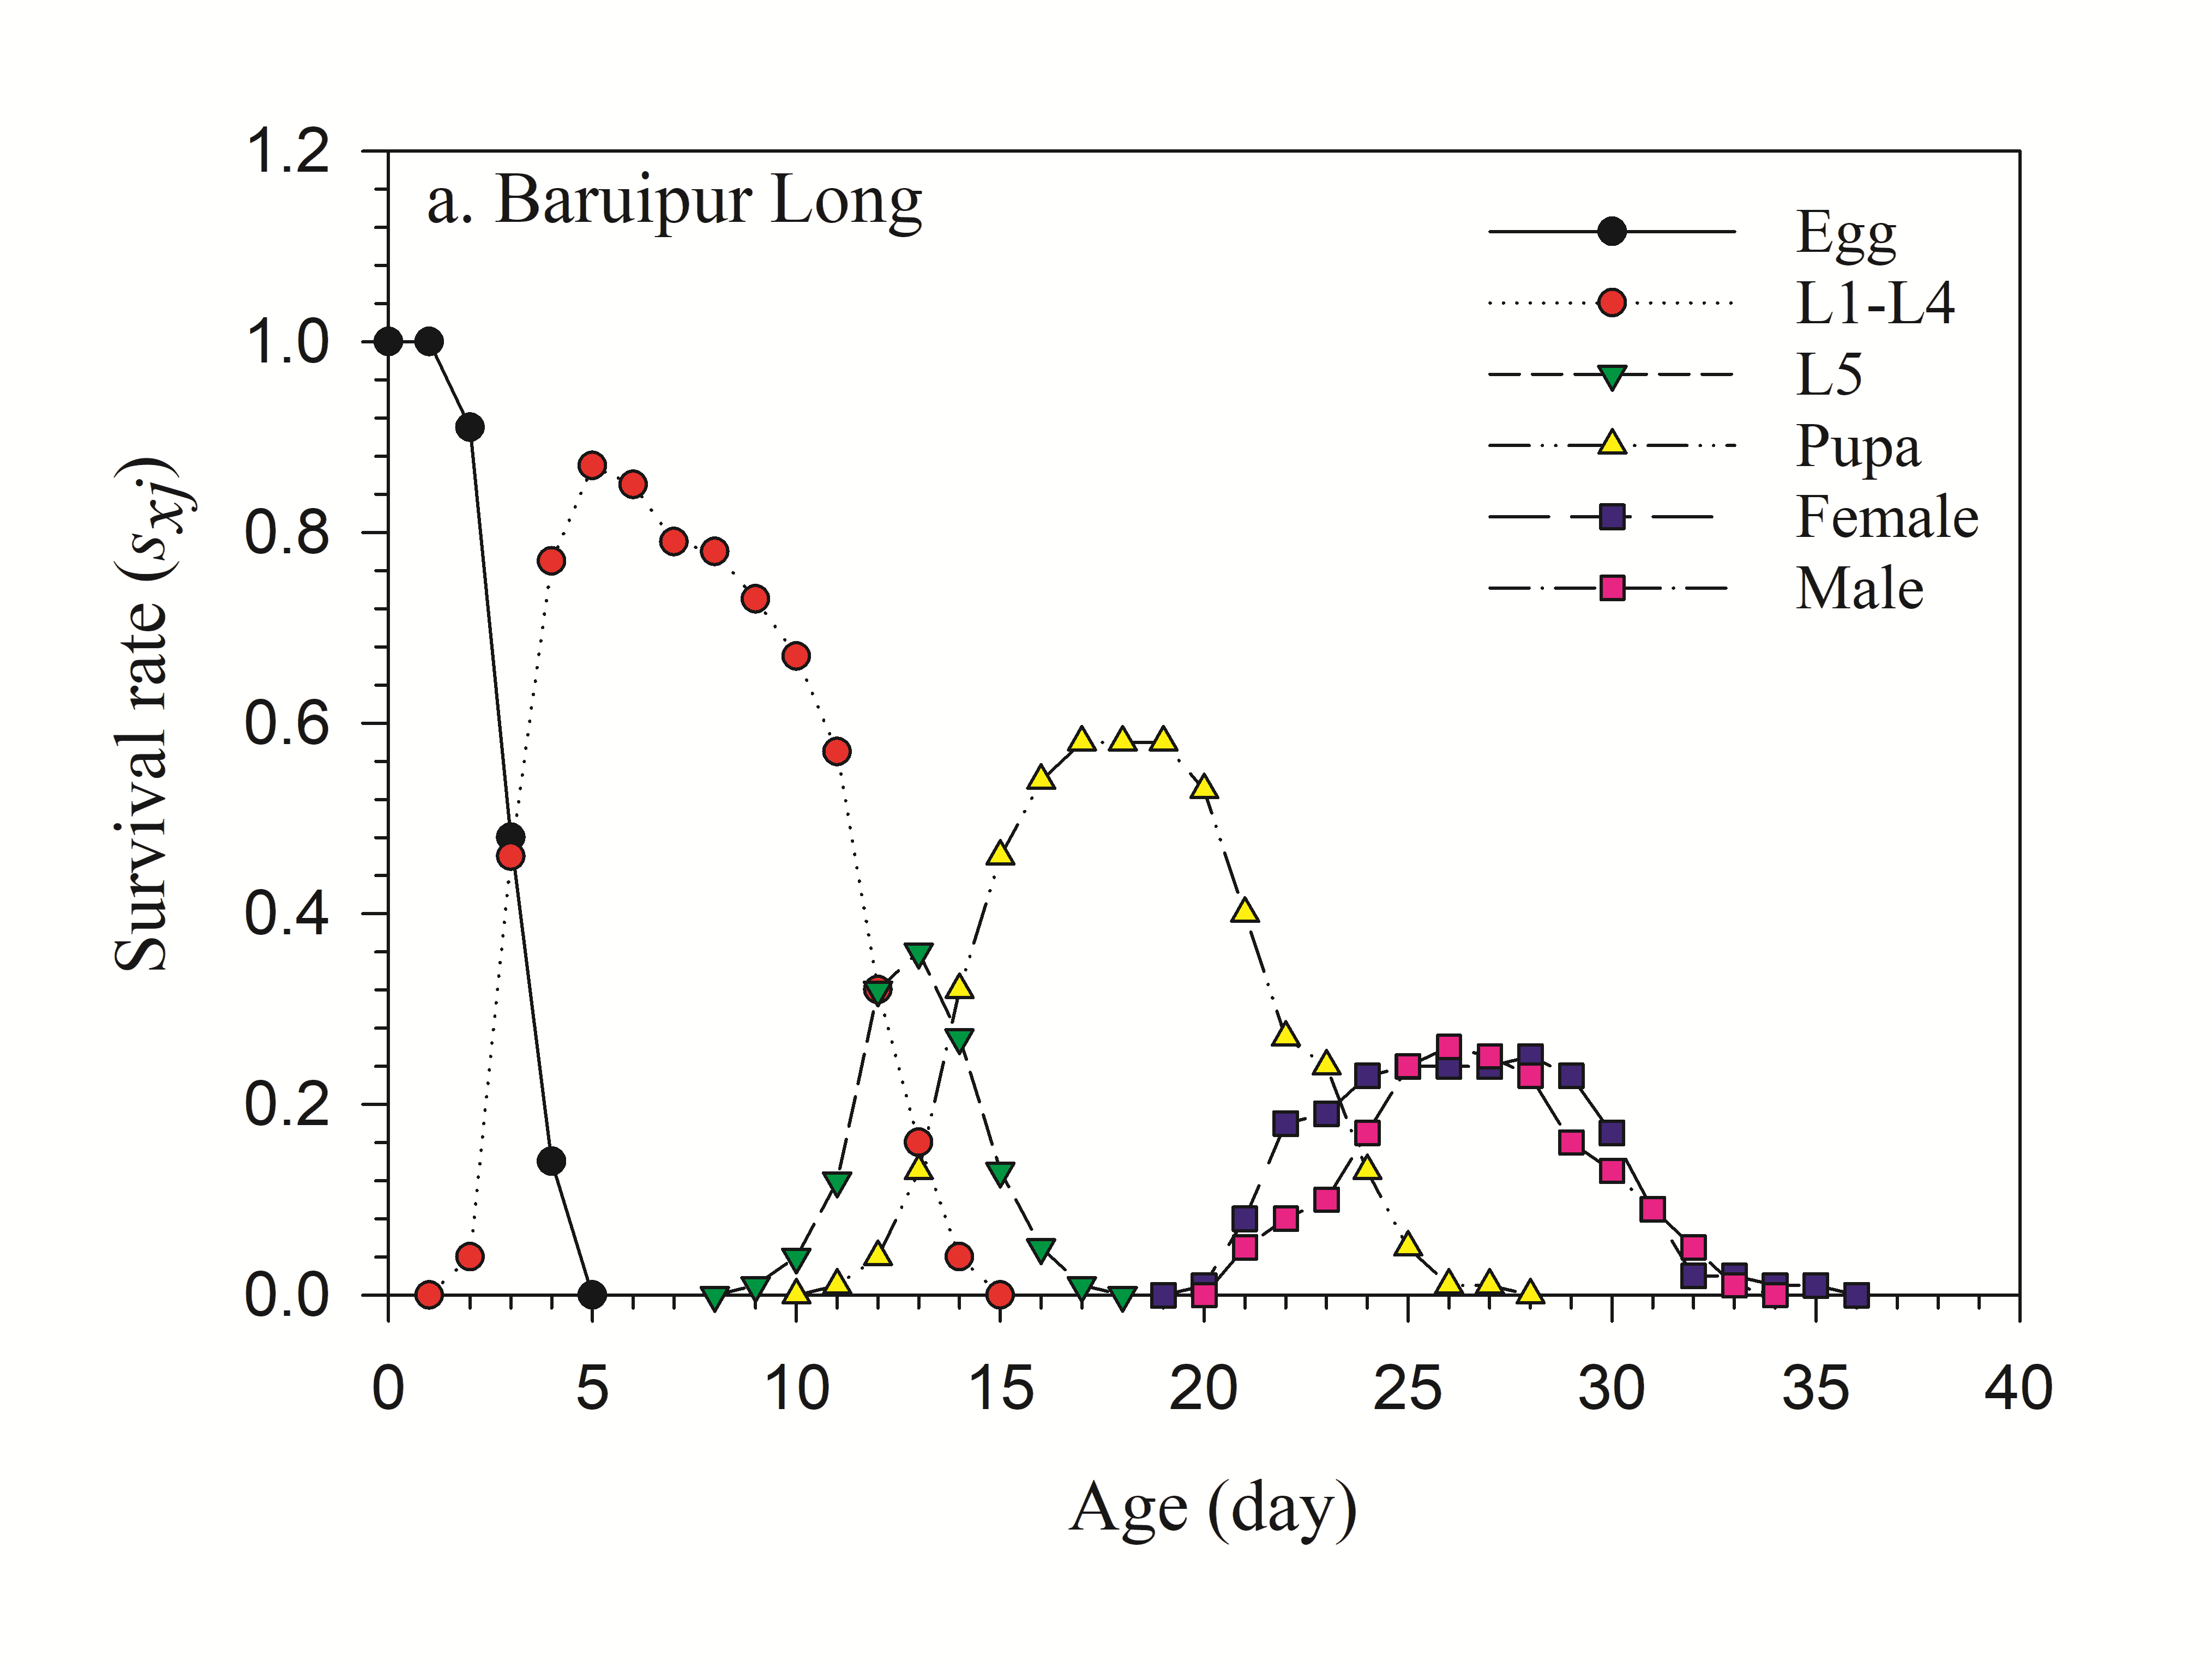
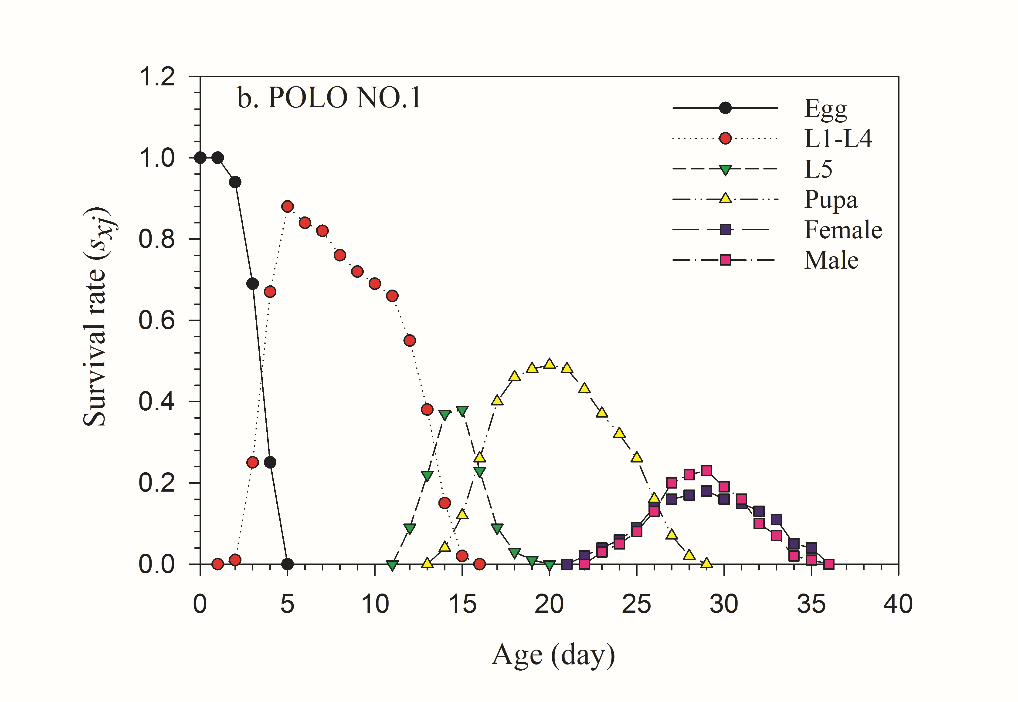
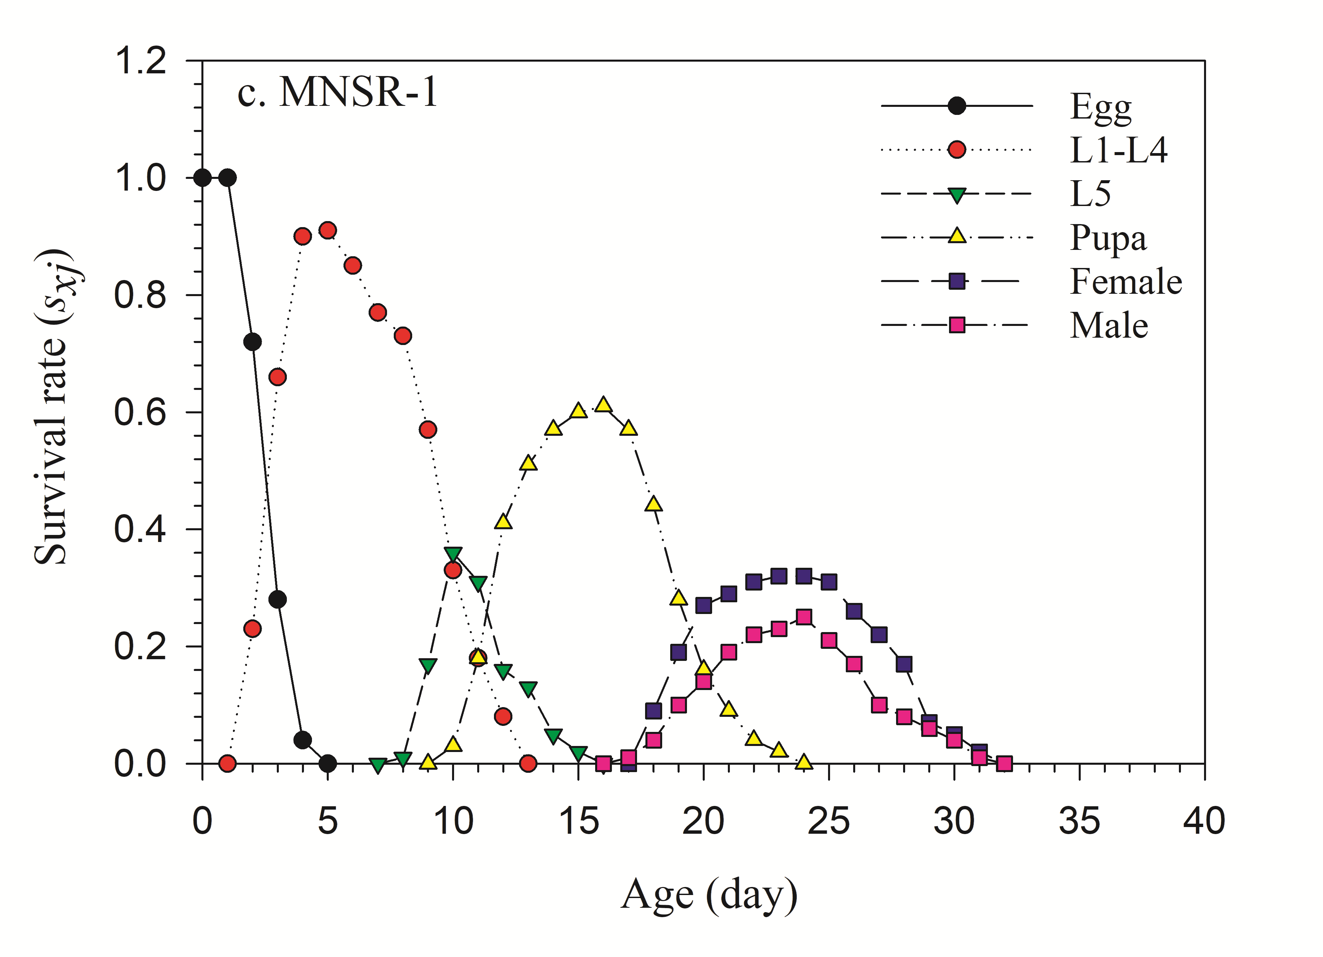
Supplementary Fig. 1. Age-stage-specific survival value (s_{xj}) of Diaphania indica fed with three cultivars of Trichosanthes anguina

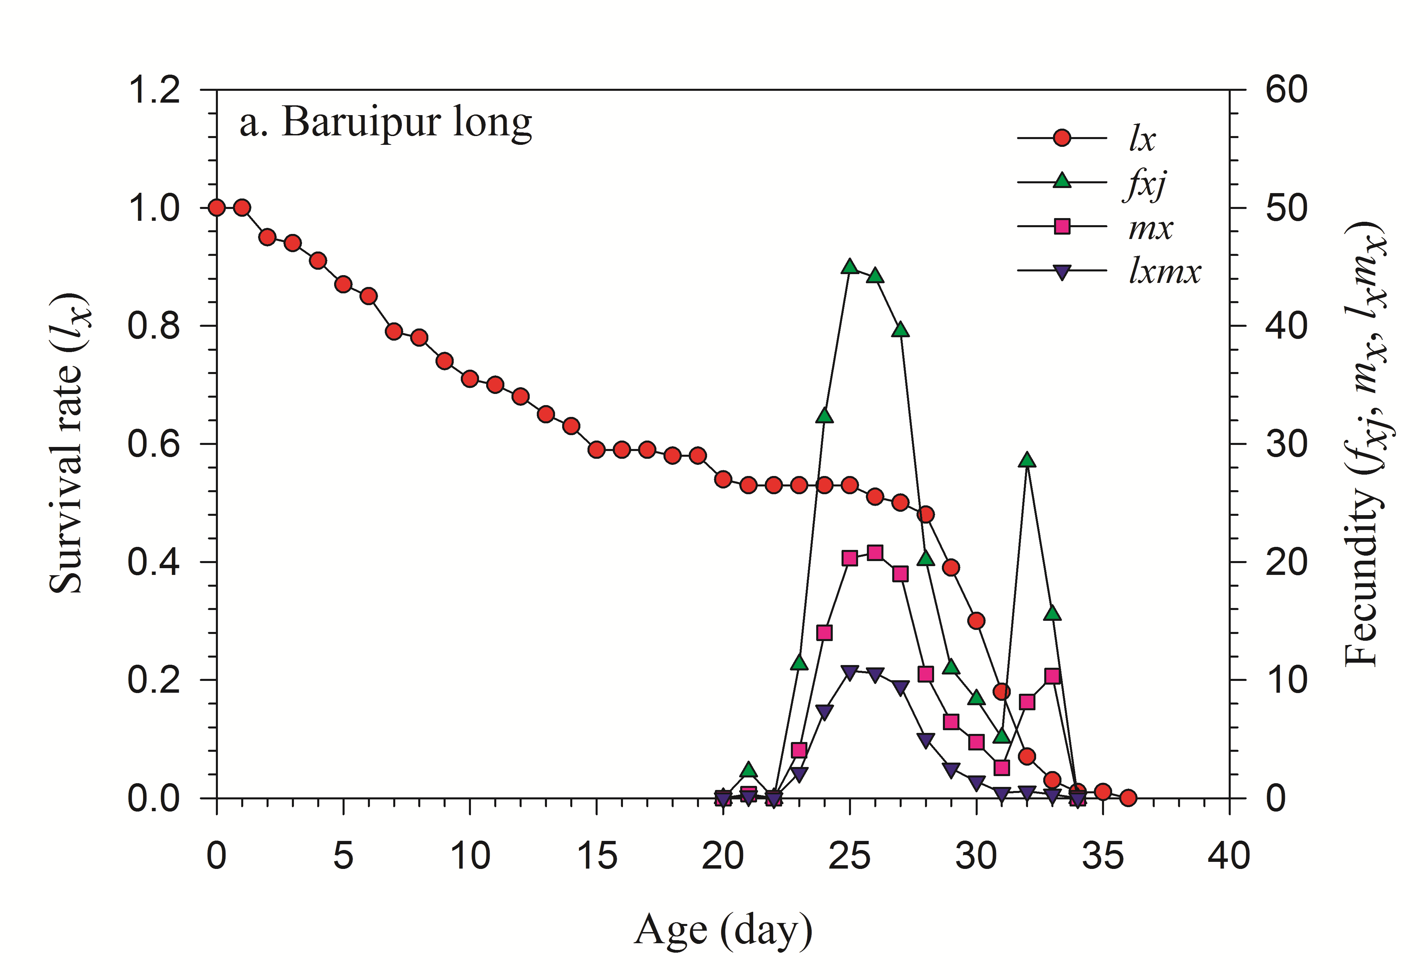
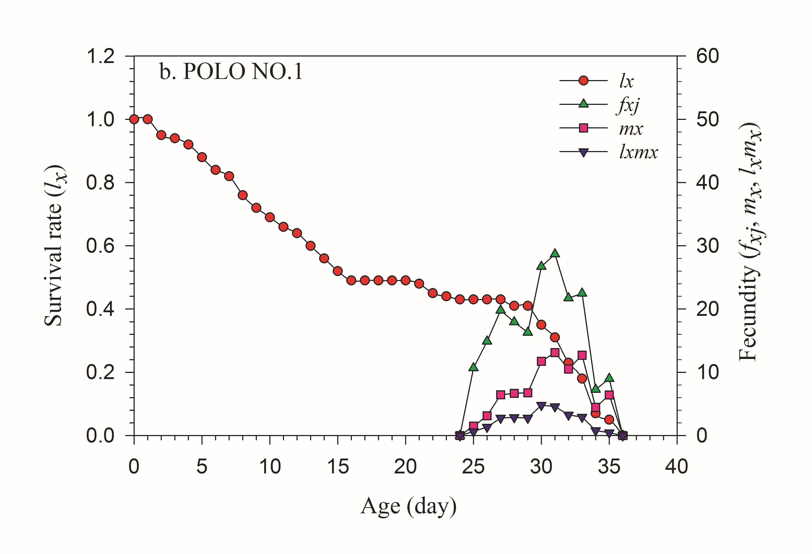
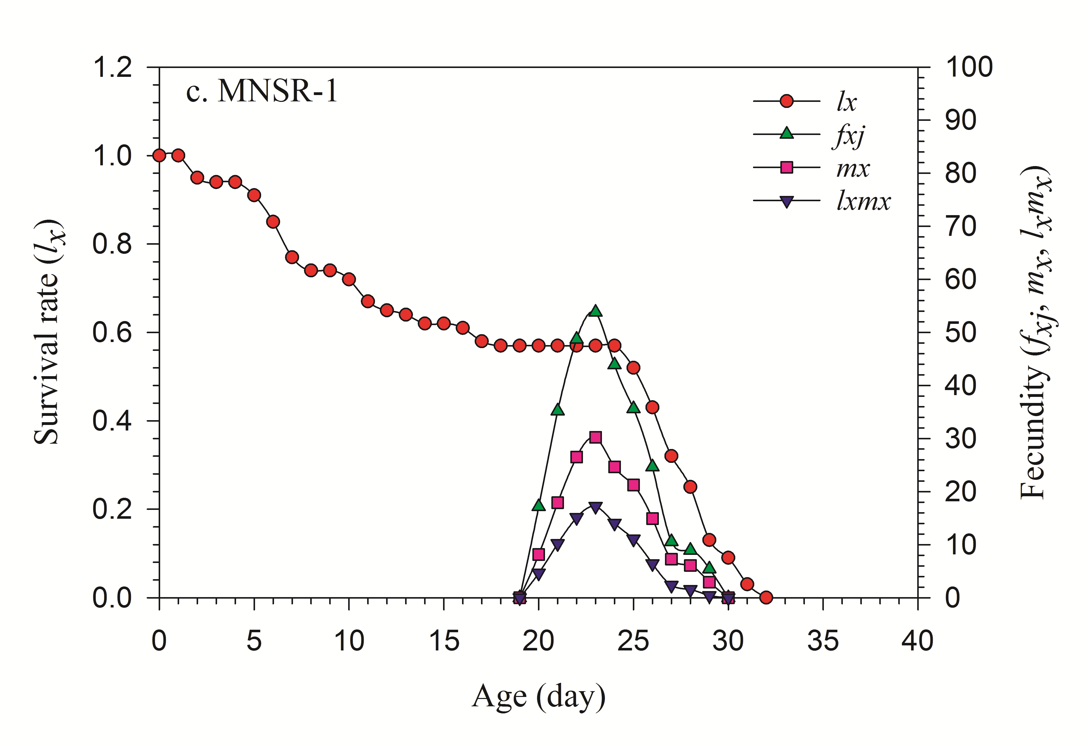Supplementary Fig. 2. Age-specific survival rate (l_{x}), age-stage-specific fecundity (f_{xj}), age-specific fecundity (m_{x}) & age-stage-specific maternity (l_{x}m_{x}) of Diaphania indica fed with three cultivars of Trichosanthes anguina

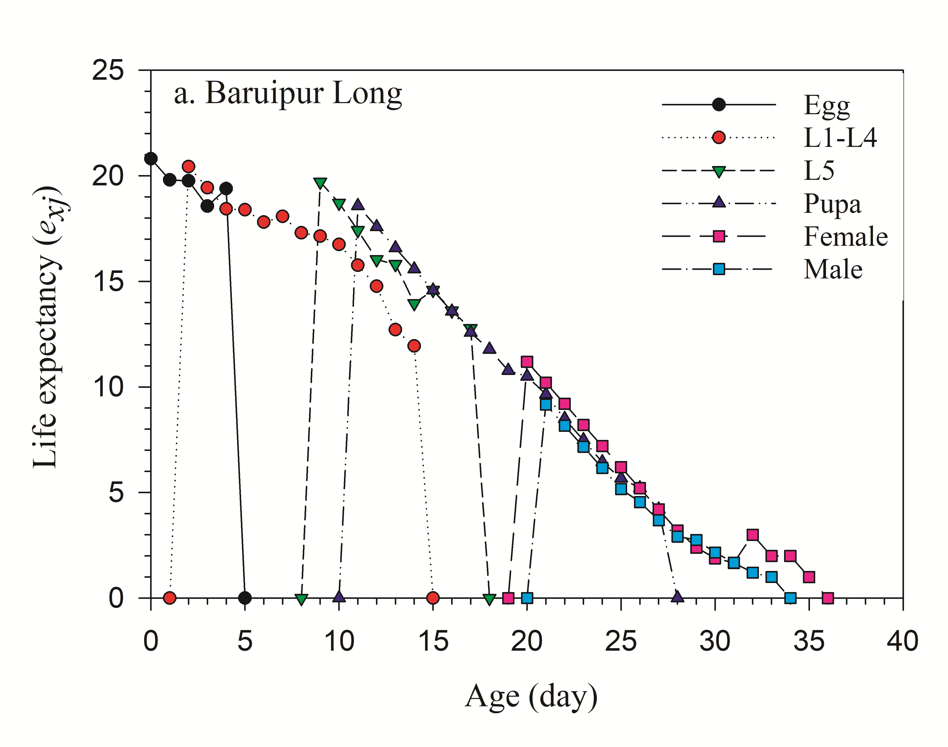
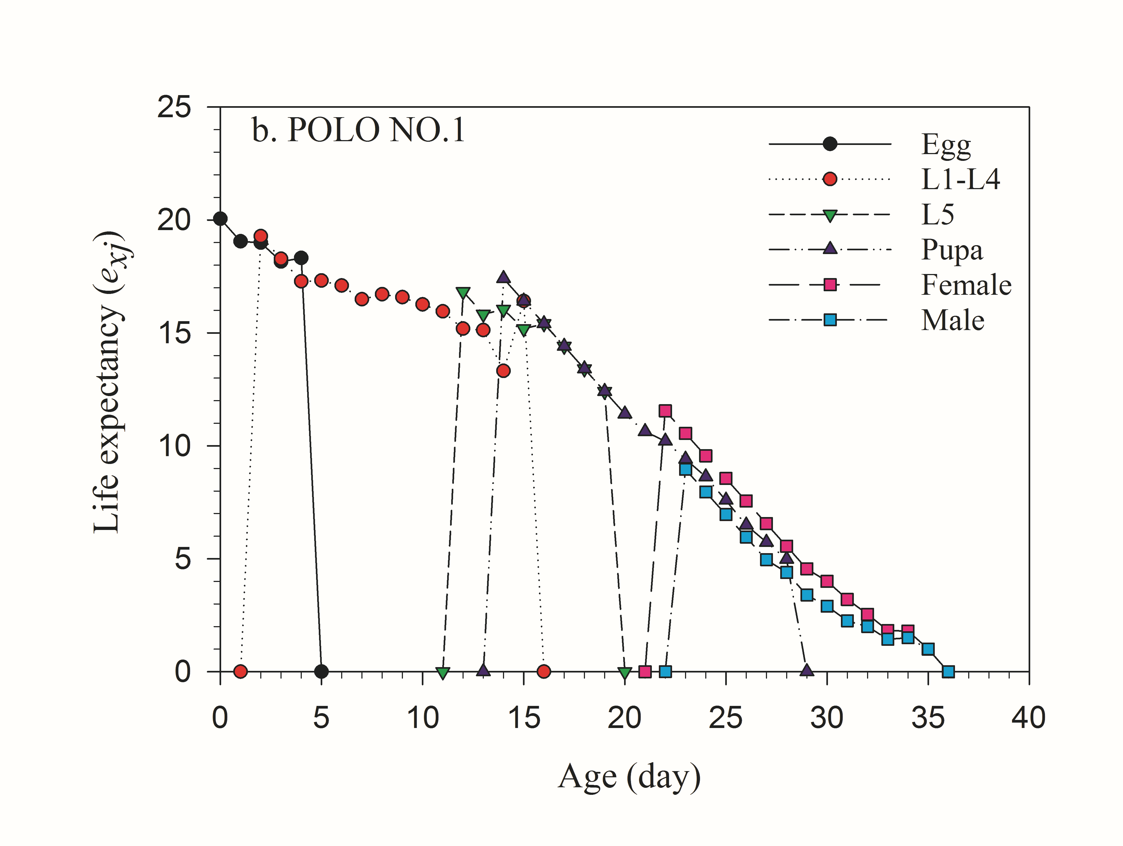
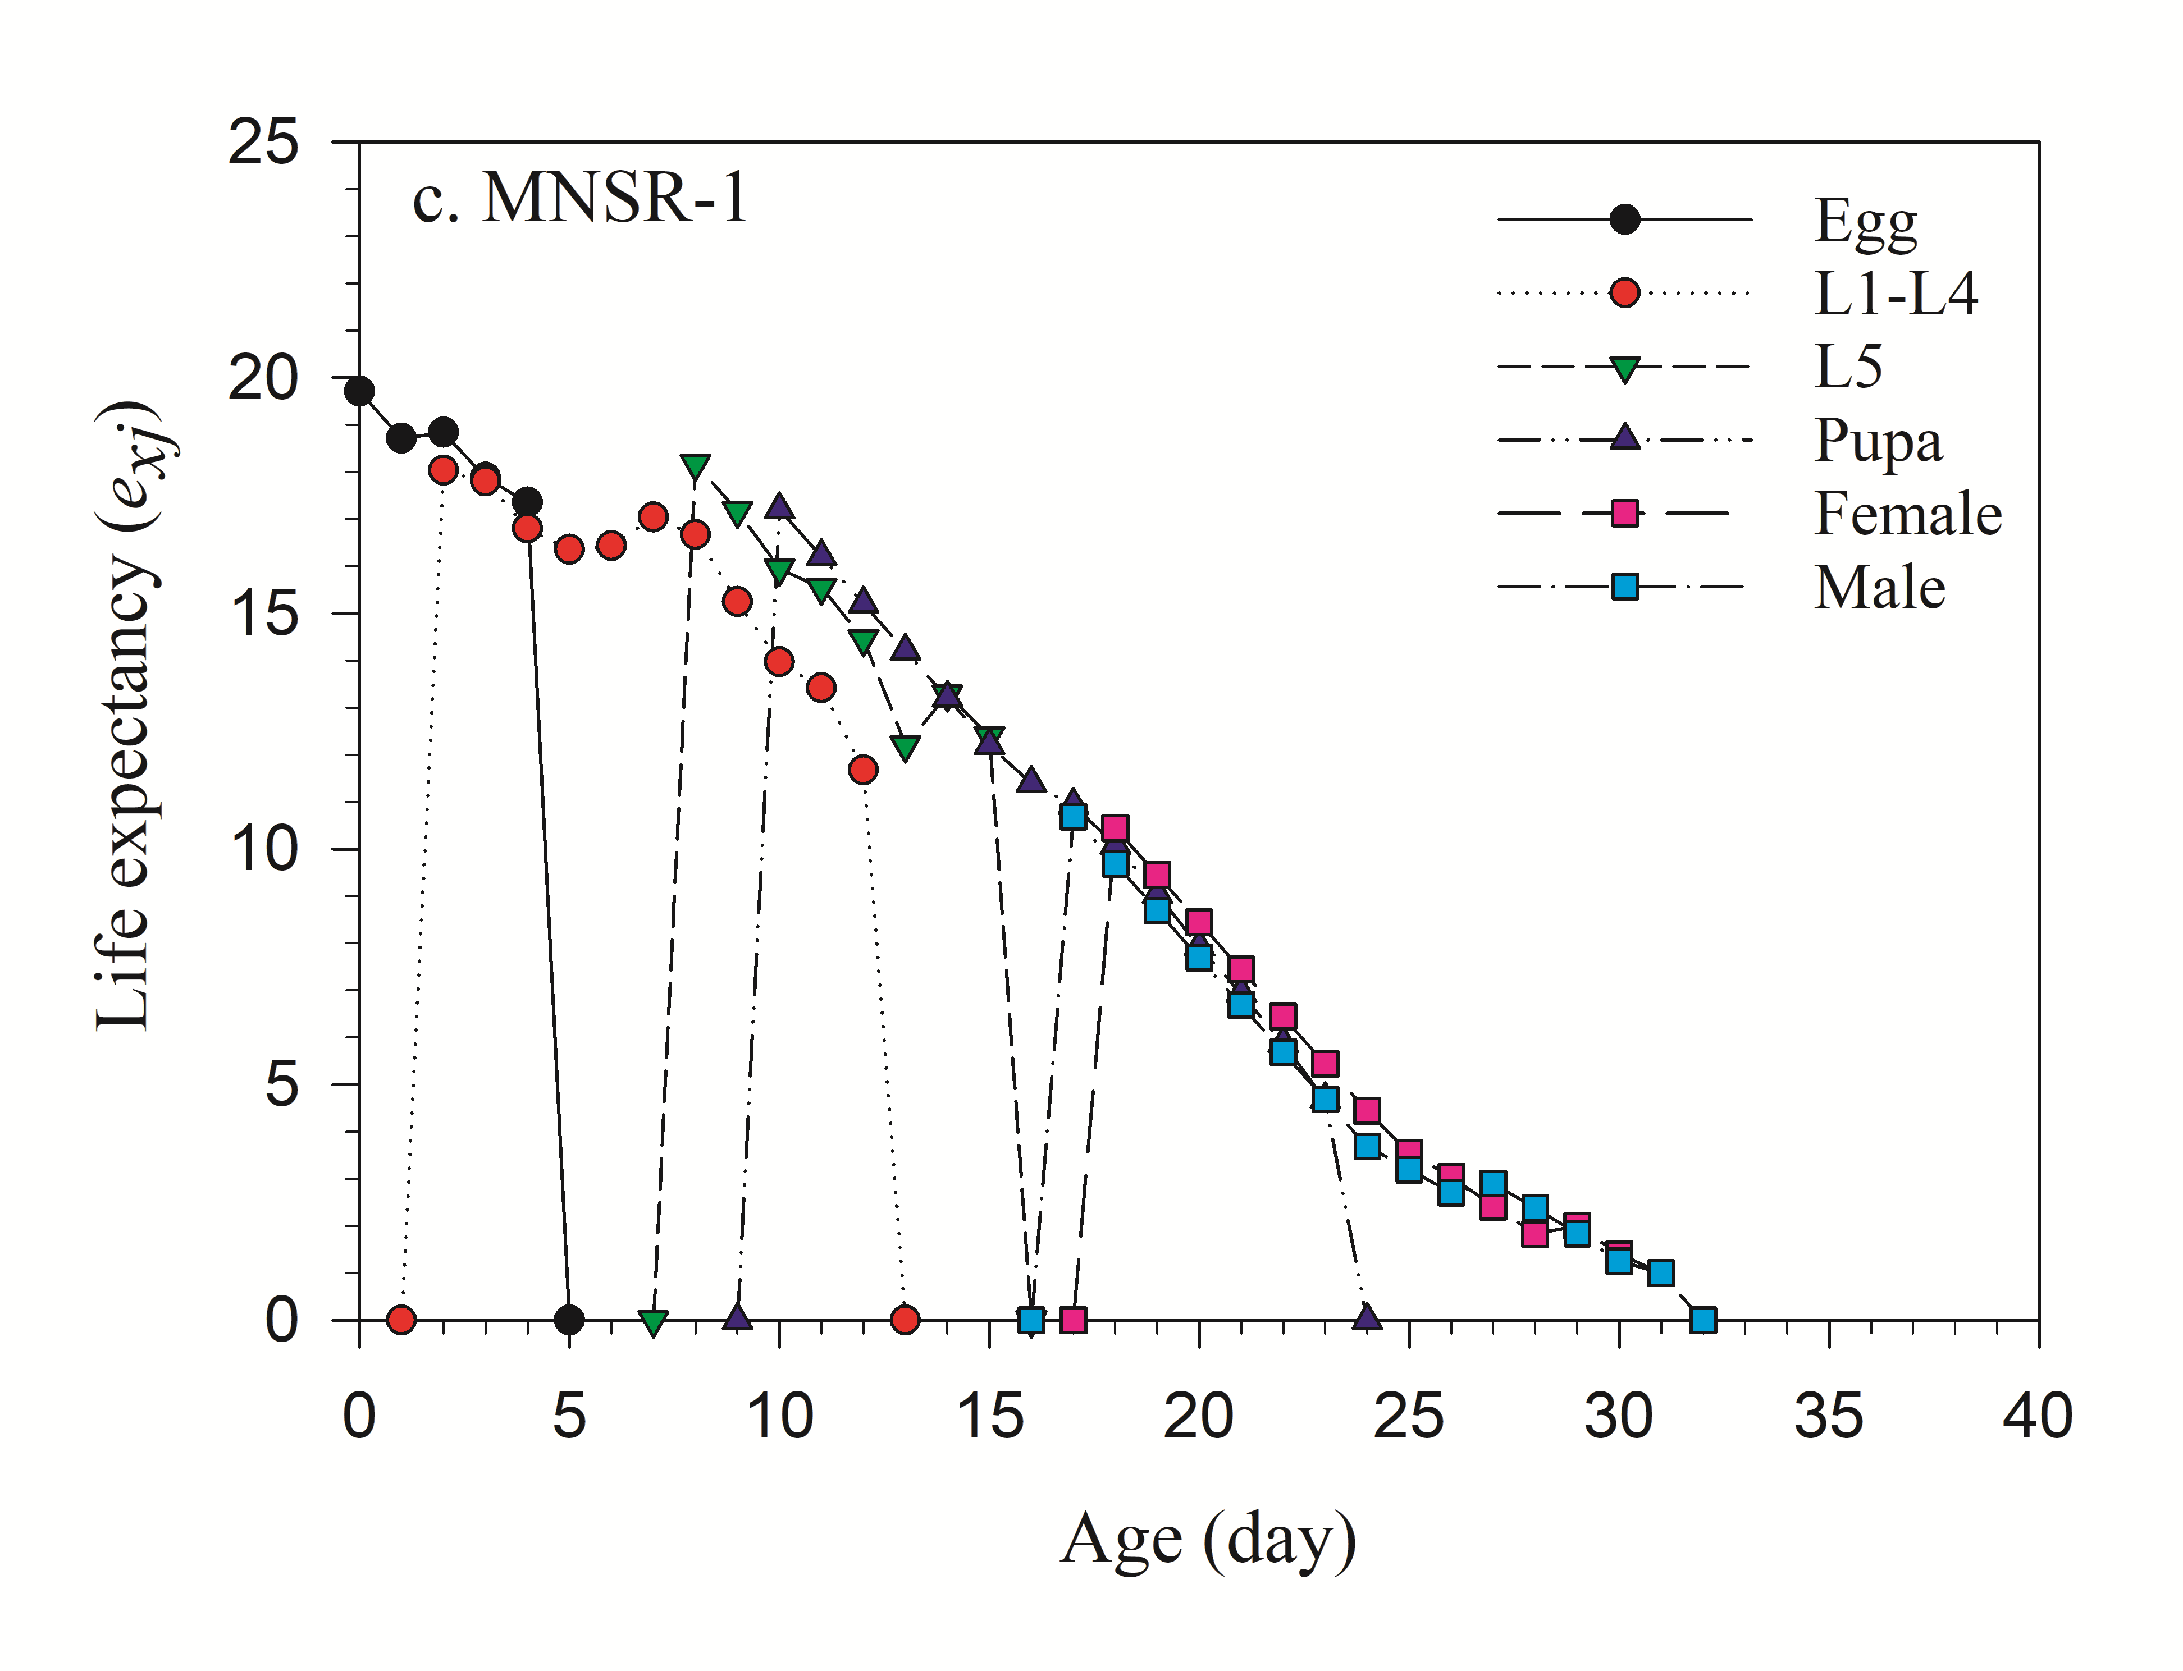Supplementary Fig. 3. Age-stage-specific life expectancy (e_{xj}) of Diaphania indica fed with three cultivars of Trichosanthes anguina.
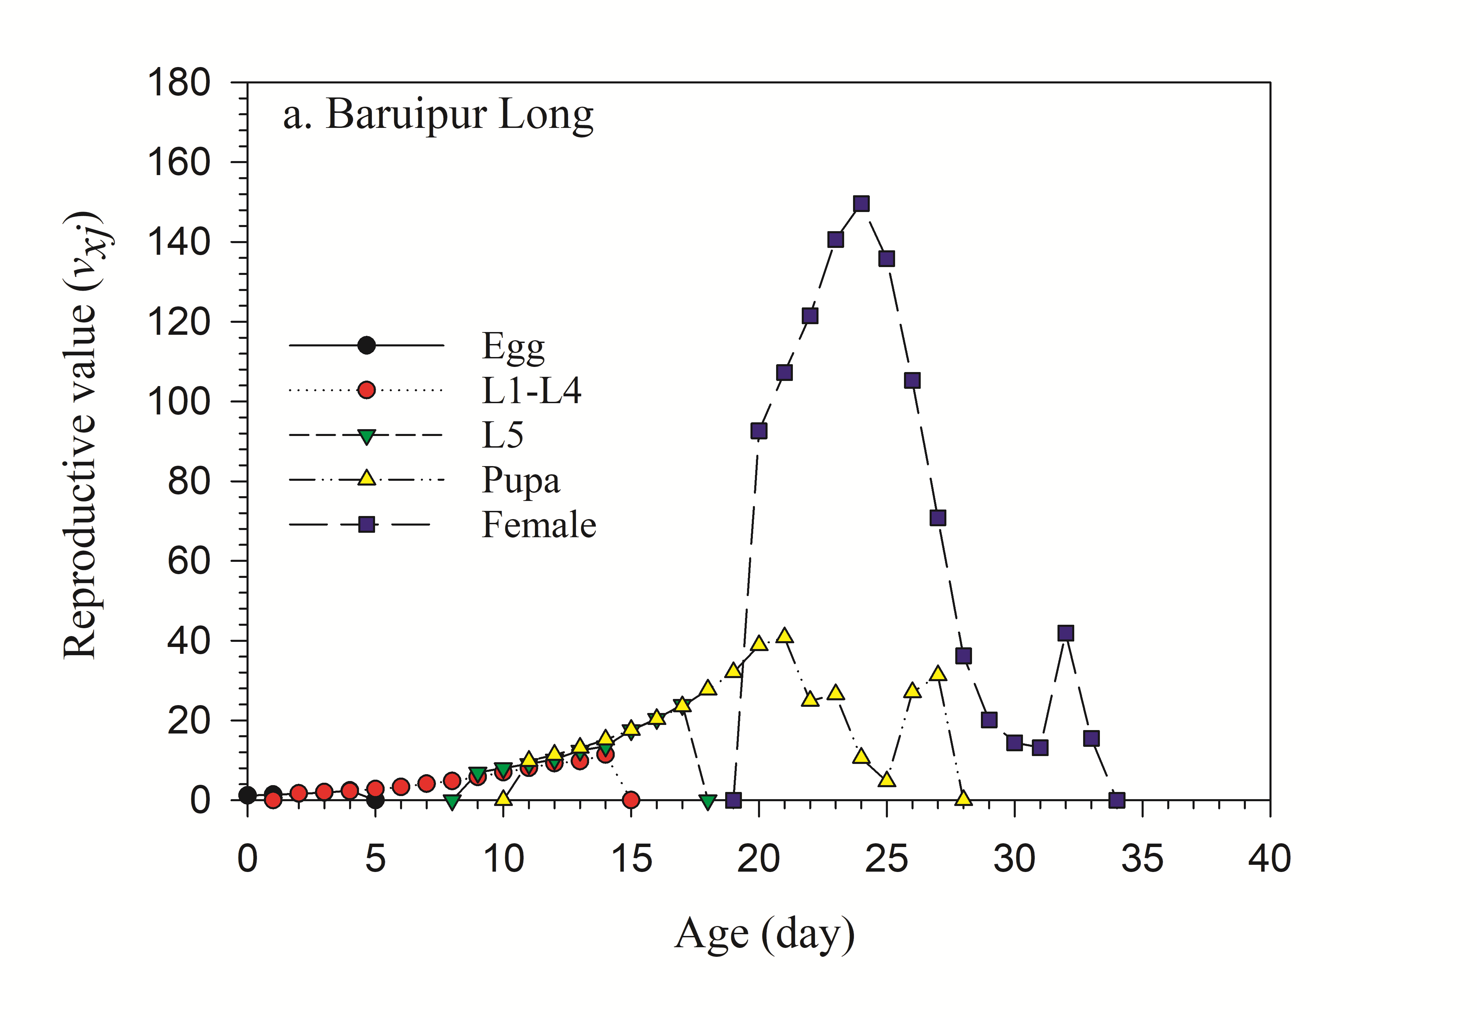
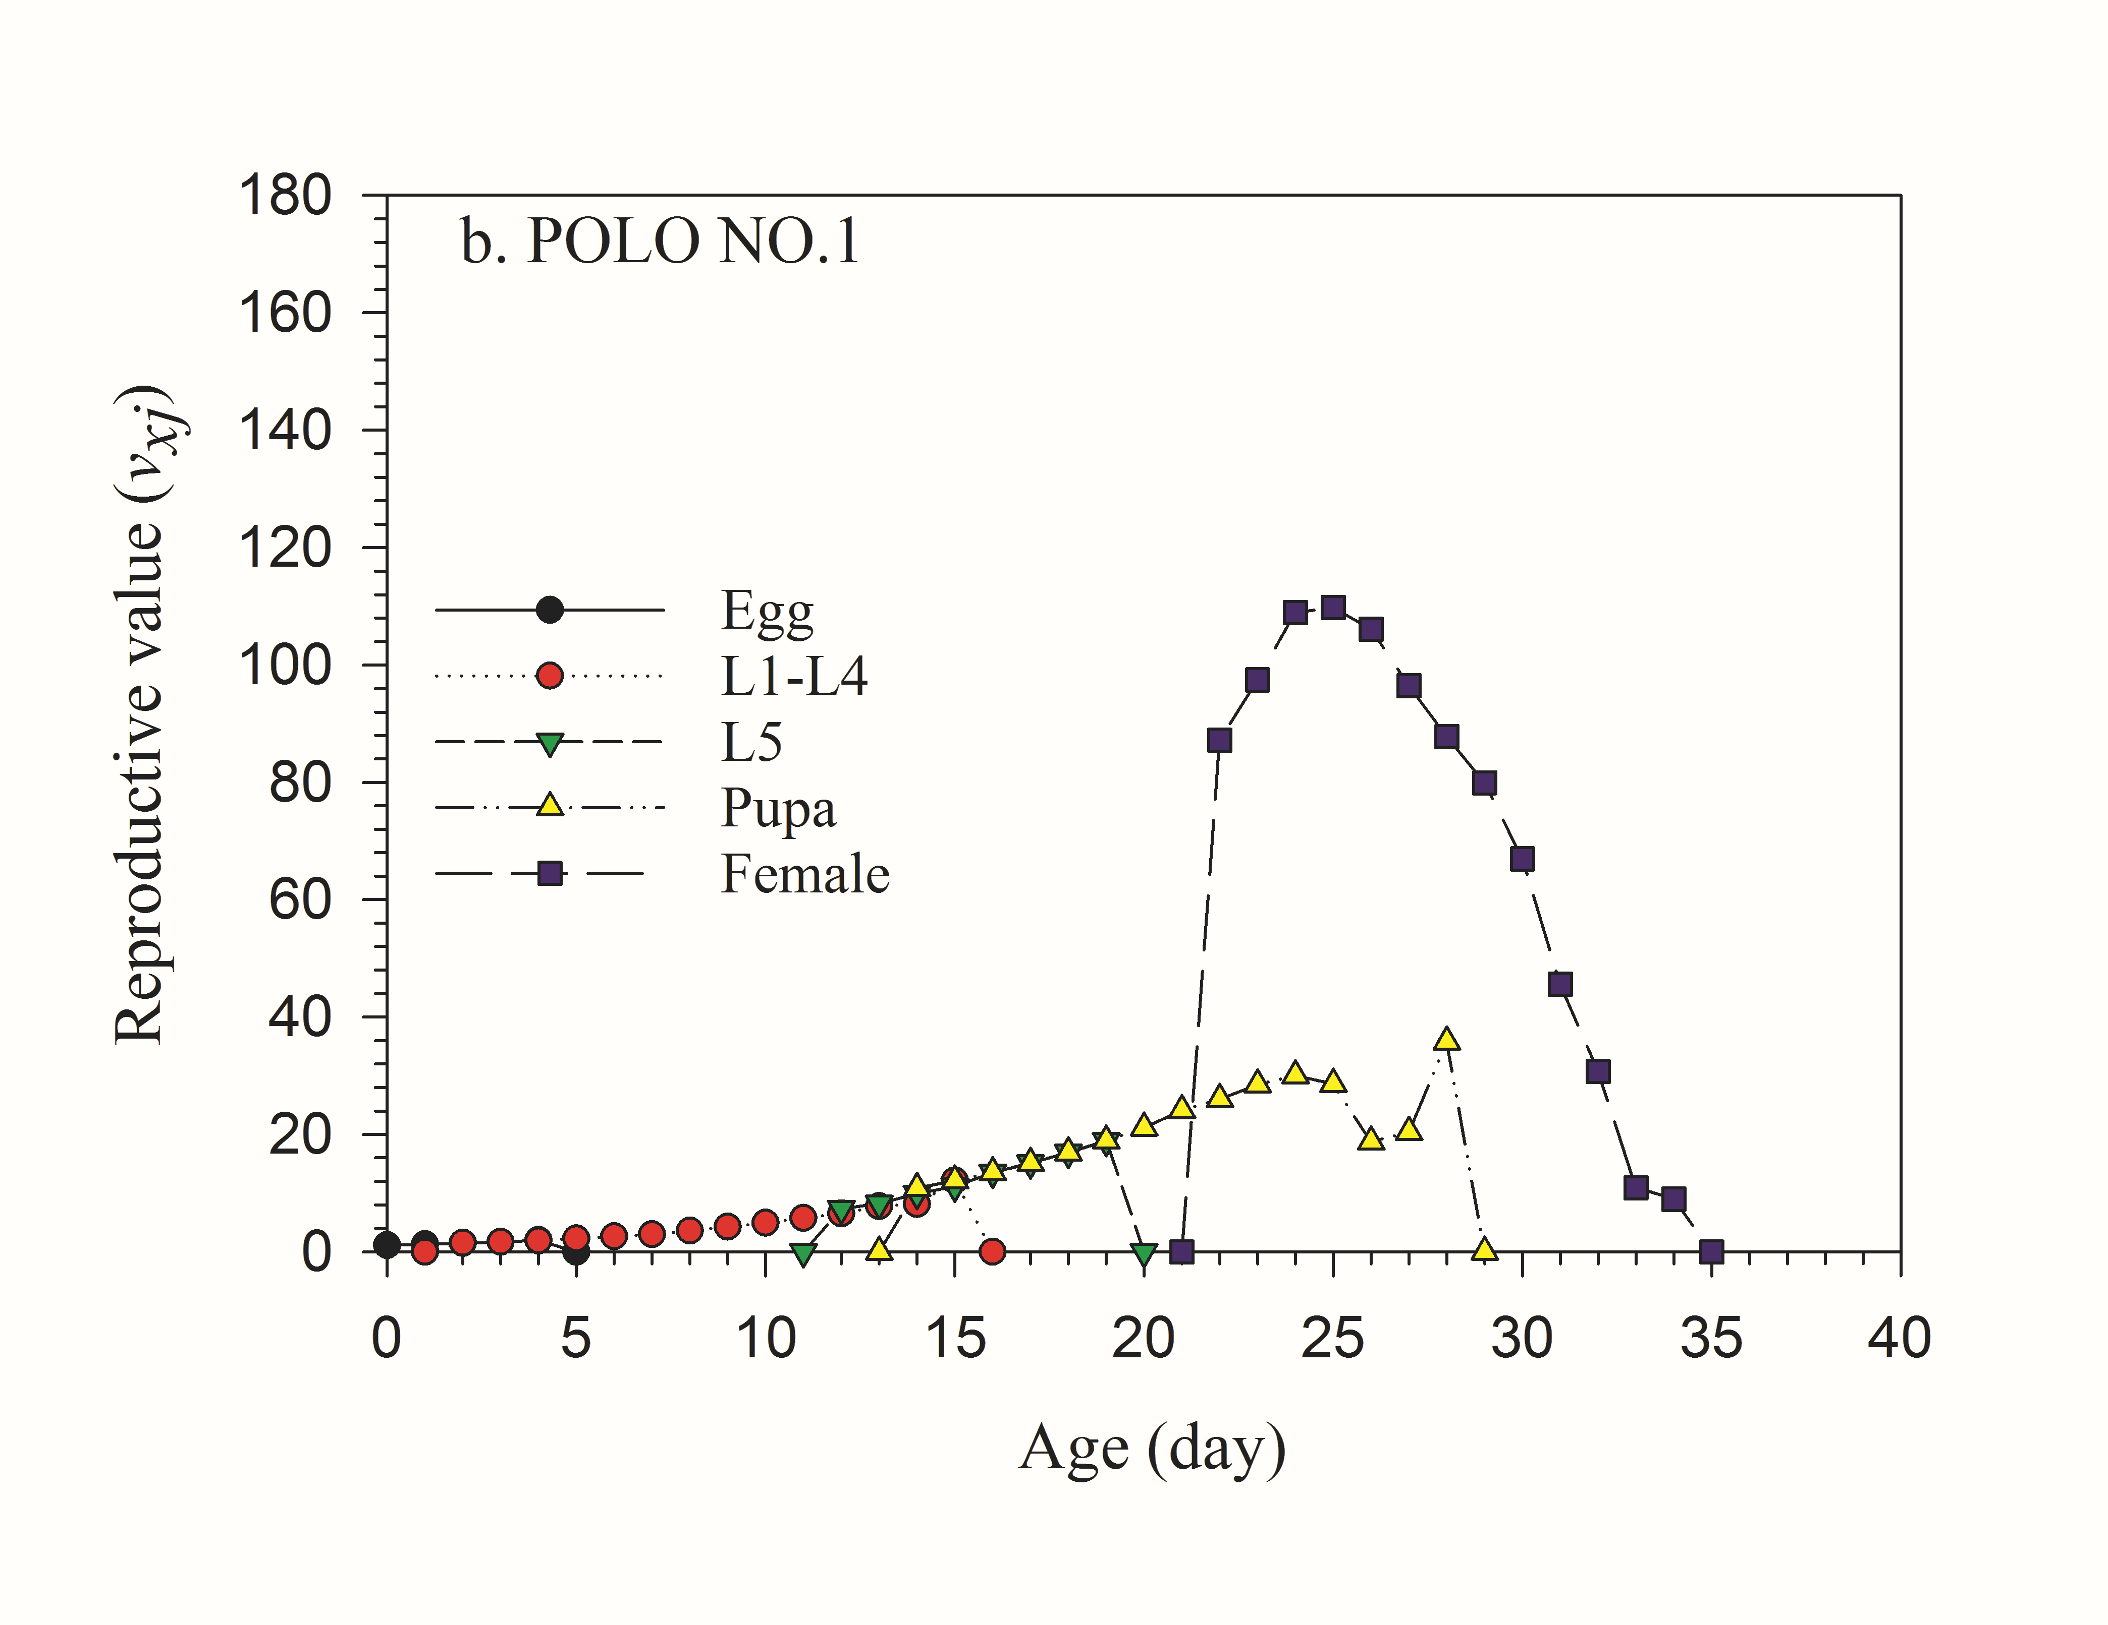
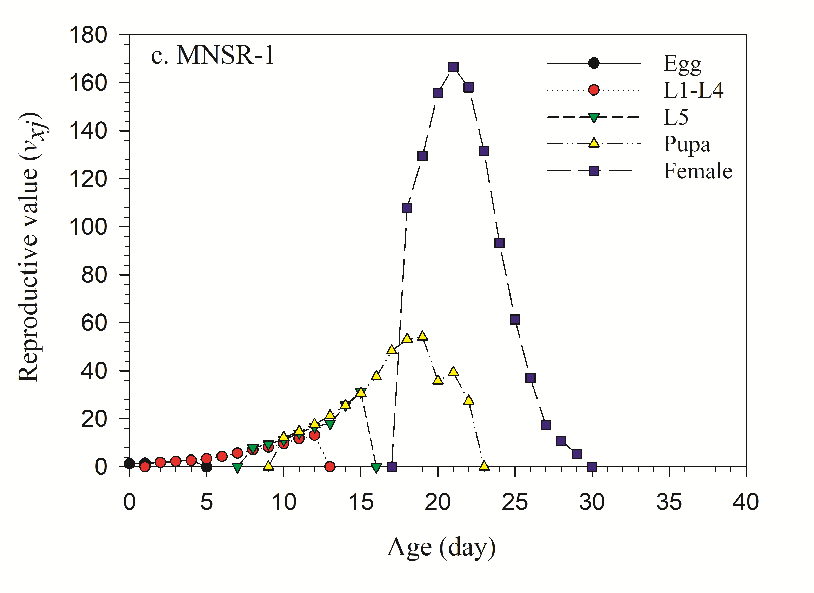
Supplementary Fig. 4. Age-stage-specific reproductive value (v_{xj}) of Diaphania indica fed with three cultivars of Trichosanthes anguina.
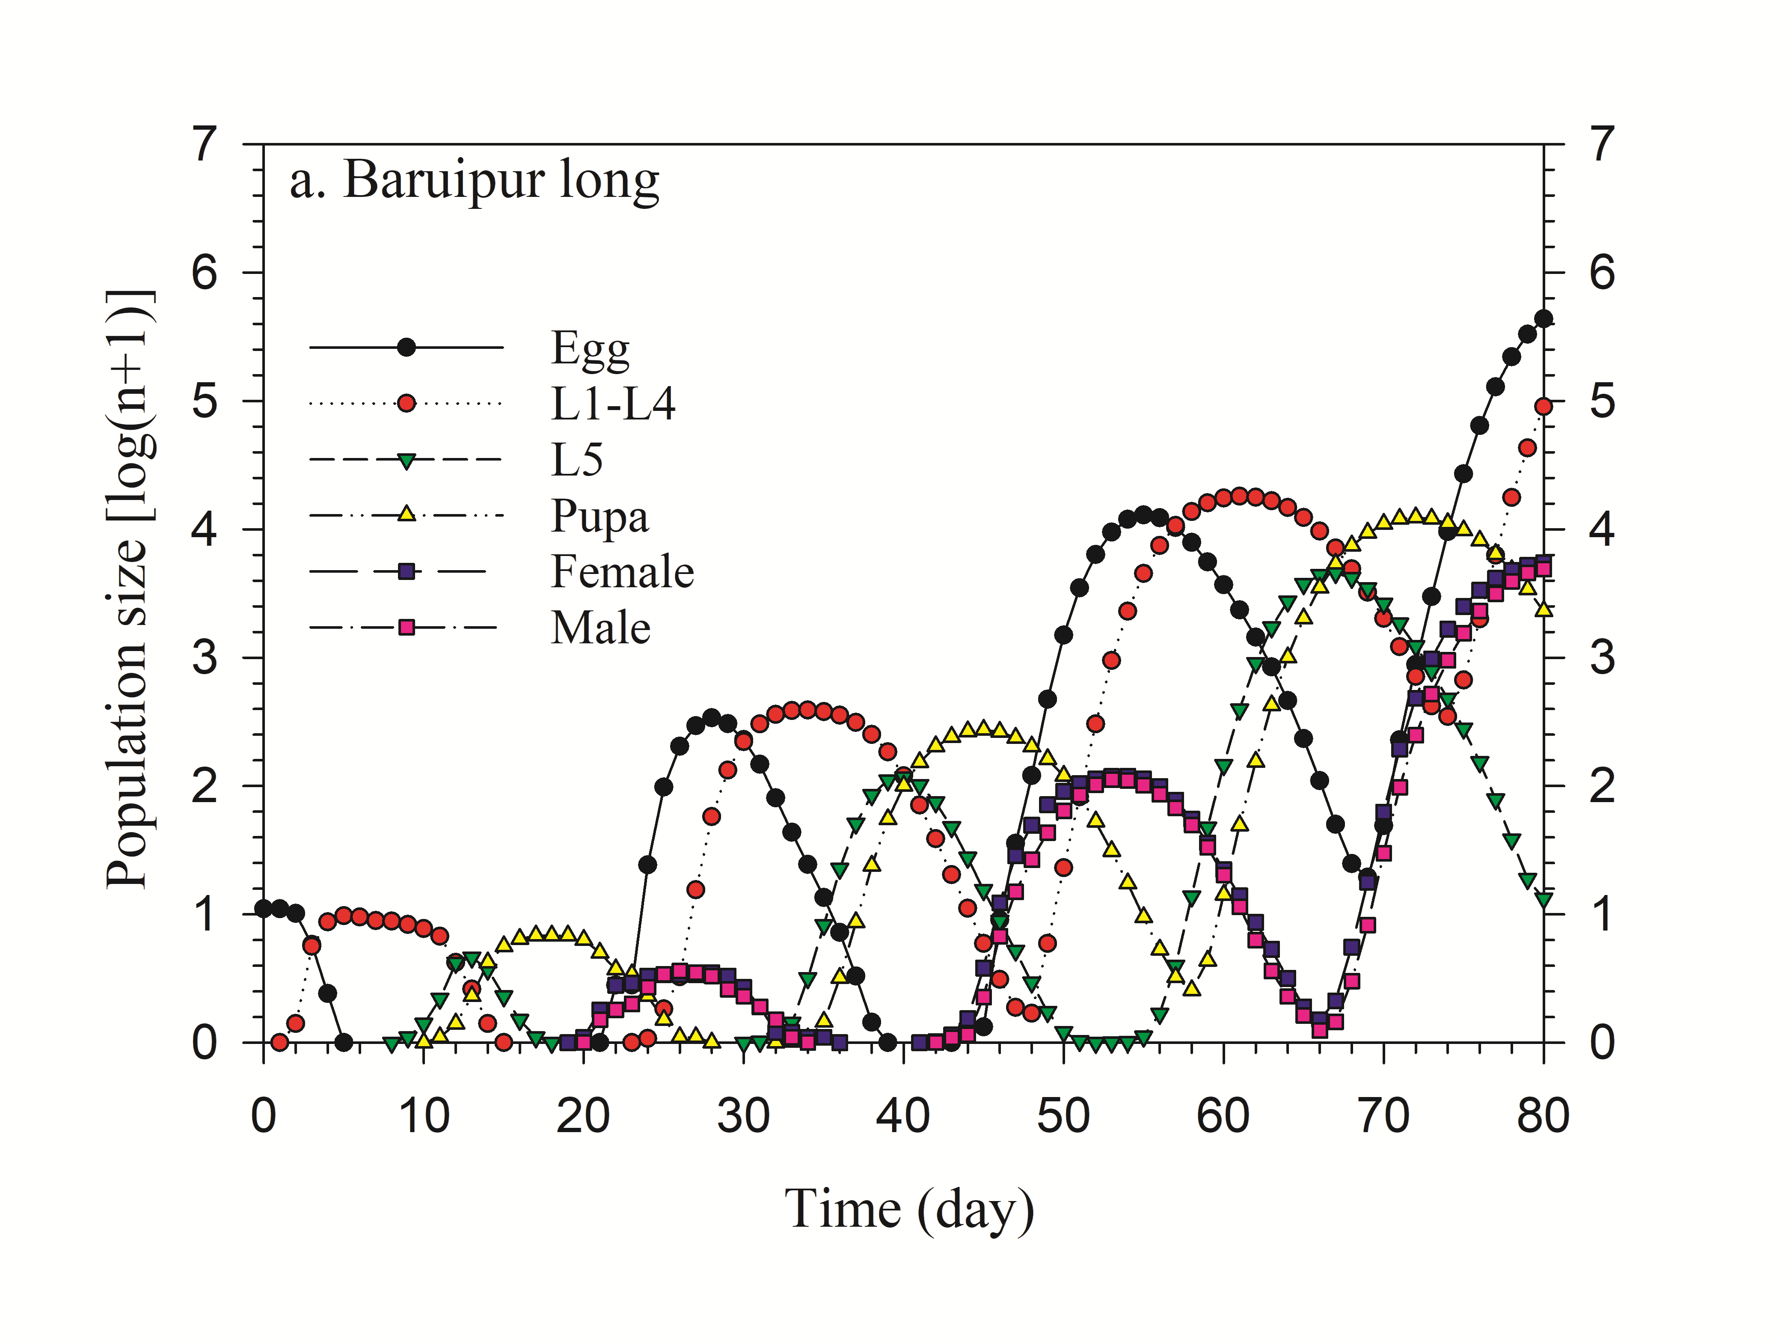
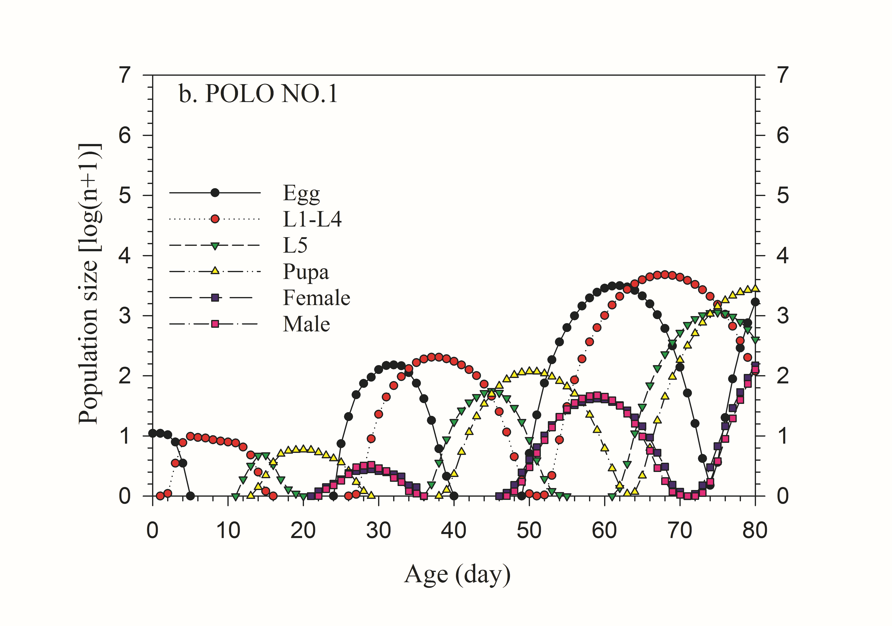
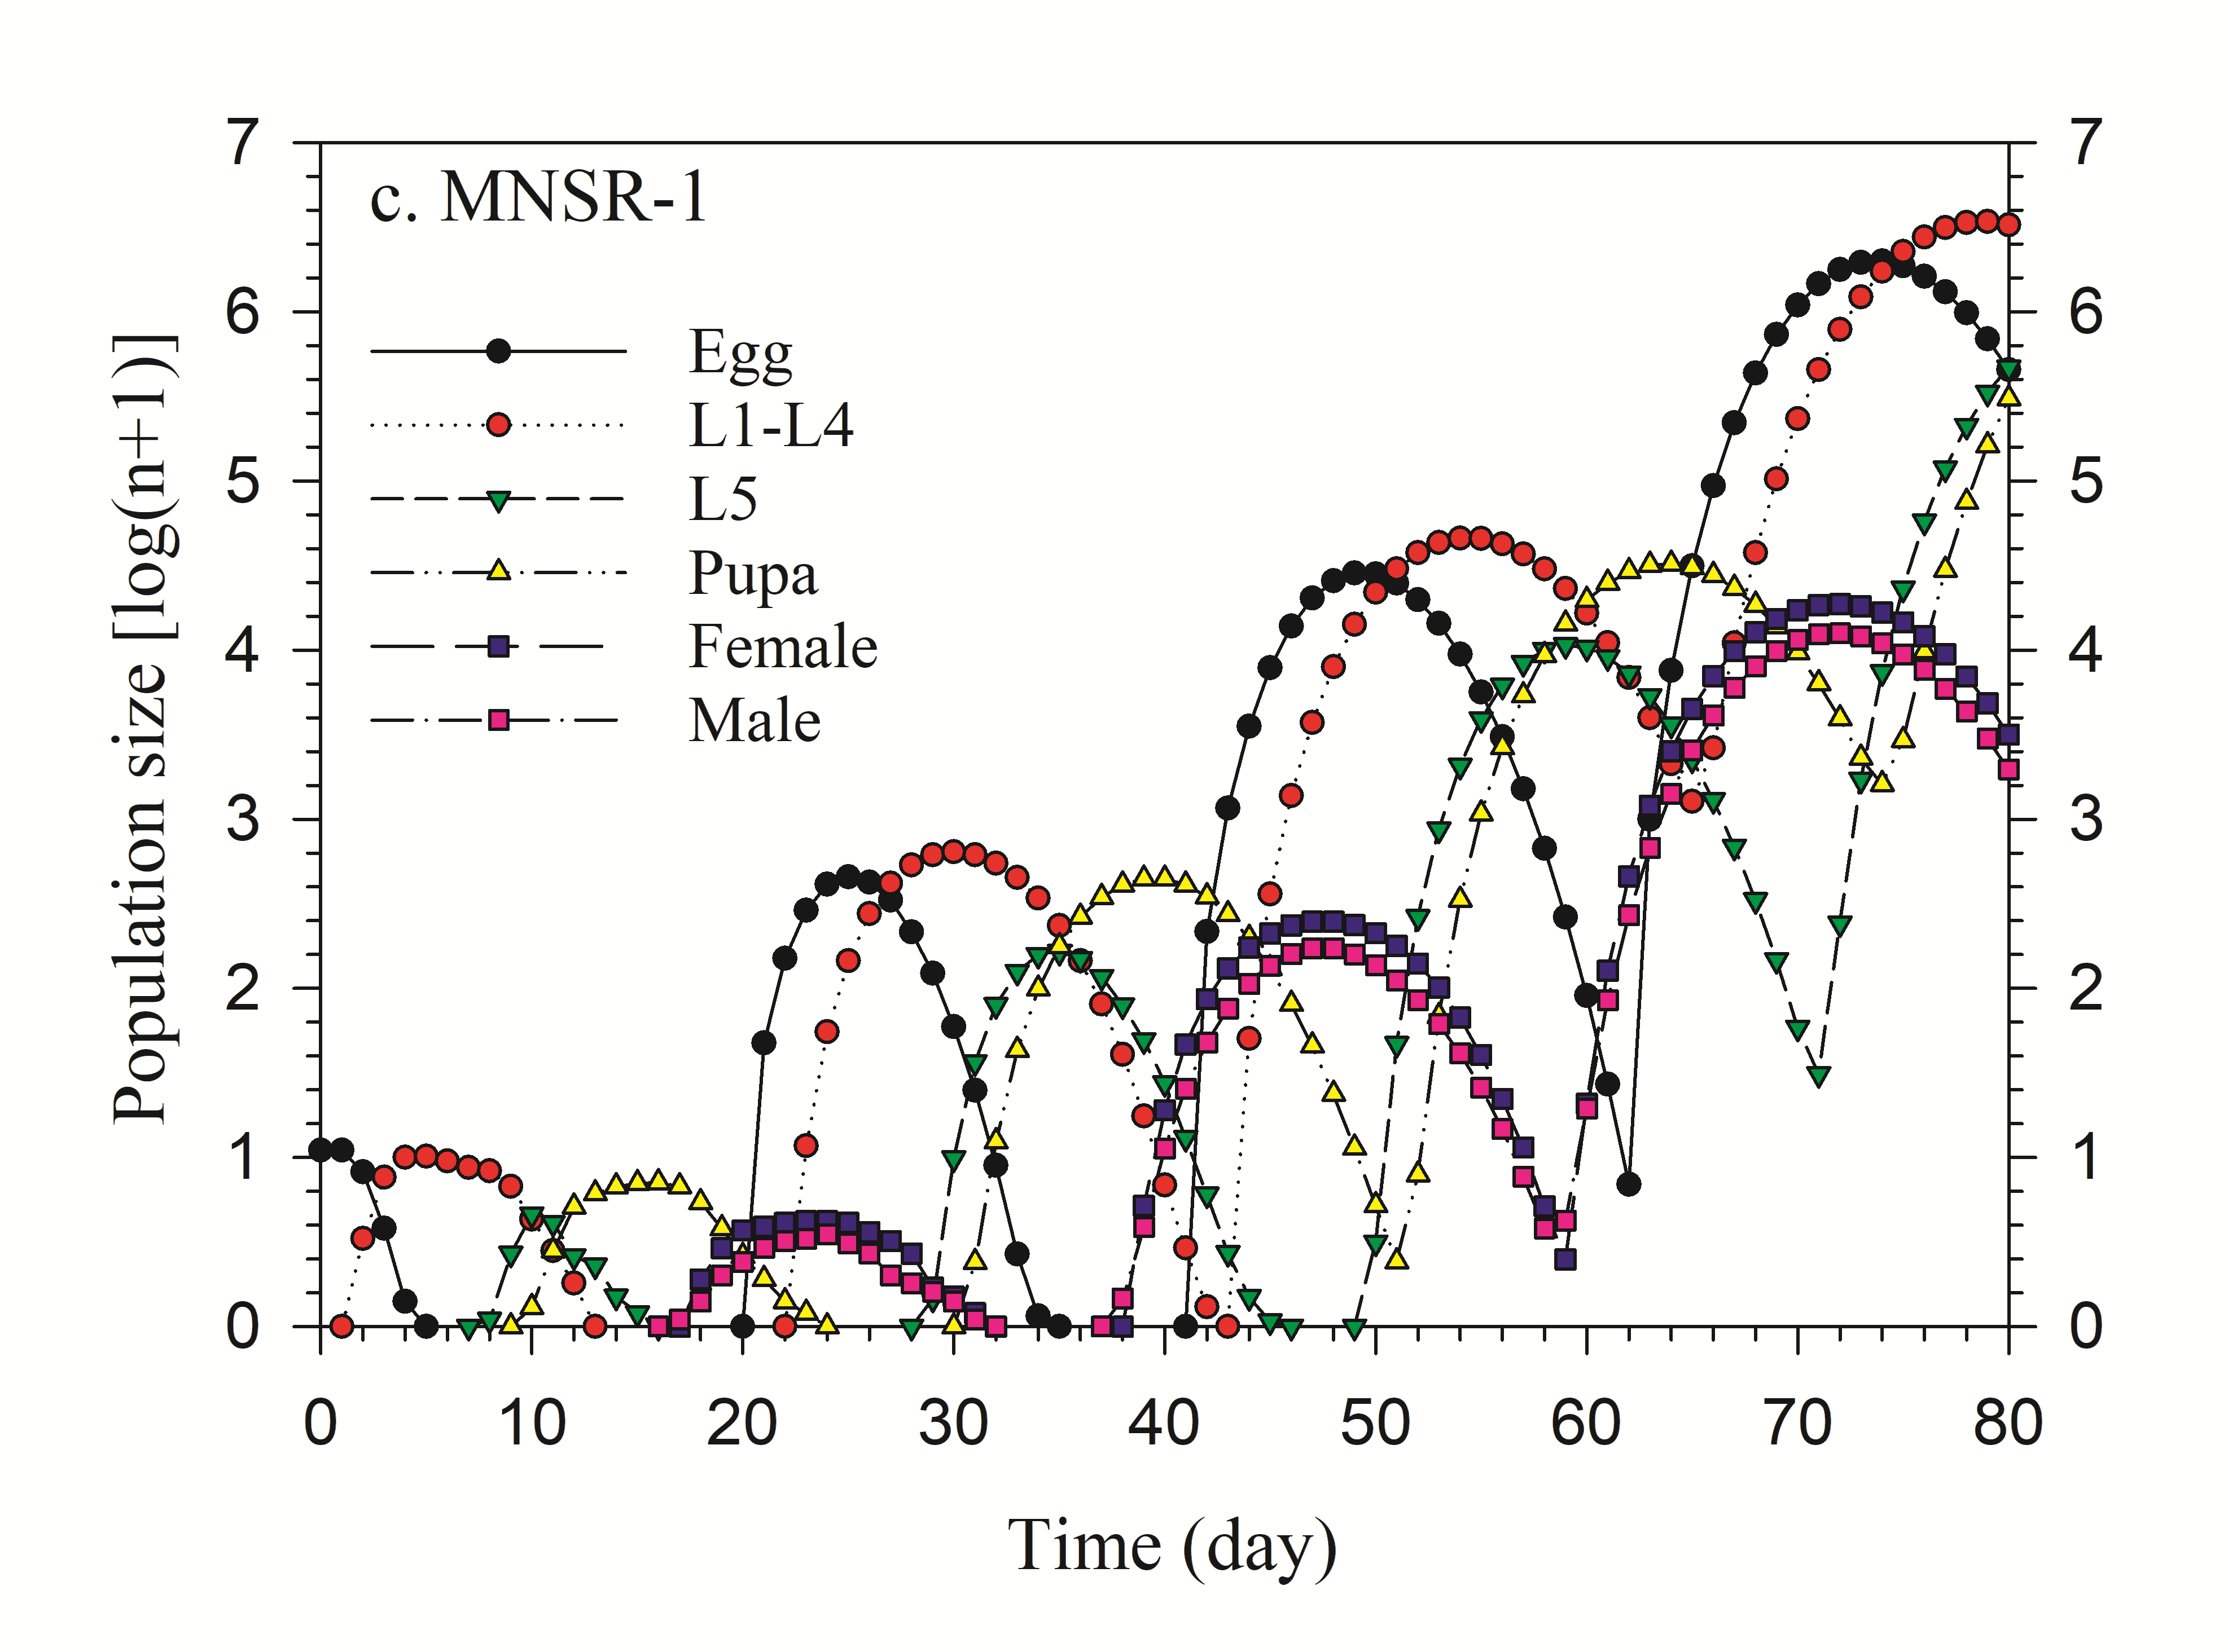
Supplementary Fig. 5. Population projection of Diaphania indica fed with three cultivars of Trichosanthes anguina.
Supplementary Table 2. Food utilization efficiency measures (Mean ± SE) of first instar larvae (n = 10) of Diaphania indica fed with three cultivars of Trichosanthes anguina (Baruipur Long, Polo No. 1 and MNSR-1).
Parameters | Baruipur Long | Polo No. 1 | MNSR-1 | F_{2,27} | P
GR (mg/day) | 0.069 ± 0.006ab | 0.057 ± 0.001a | 0.077 ± 0.005b | 4.555 | 0.027
CR (mg/day) | 0.720 ±.035 | 0.676 ± 0.023 | 0.783 ± 0.065 | 1.431 | 0.257
RGR (mg/day) | 0.481 ±0.042 | 0.460 ± 0.016 | 0.588 ± 0.048 | 3.264 | 0.054
CI (mg/day) | 4.97 ± 0.215a | 5.13 ± 0.187a | 6.29 ± 0.49b | 4.874 | 0.016
ER (mg/day) | 1.14 ± 0.069a | 0.898 ± 0.043b | 1.47 ± 0.071c | 21.55 | 0.0001
HCR (mg/day) | 6.11 ± 0.220 | 7.20 ± 0.5 | 6.61 ± 0.208 | 2.622 | 0.901
AD (%) | 76.67 ± 1.69a | 70.86 ± 1.87b | 84.87 ± 1.41c | 17.8 | 0.0001
ECI (%) | 9.86 ± 0.97a | 11.59 ± 0.98a | 7.68 ± 0.59b | 5.064 | 0.014
ECD (%) | 13.06 ± 1.44a | 16.40 ± 1.33a | 9.17 ± 0.80b | 8.5 | 0.001
HUE (%) | 81.26 ± 1.11a | 77.58 ± 1.07b | 86.97 ± 1.04c | 19.23 | 0.0001

Within the row means followed by same letter(s) are not significantly different by Tukey’s test.
Food utilization efficiency measures: GR- growth rate; CR- consumption rate; RGR- relative growth rate; CI- consumption index; ER- egestion rate; HCR- host consumption rate; AD- approximate digestibility; ECI- efficiency of conversion of ingested food; ECD- efficiency of conversion of digested food; HUE- host utilization efficiency.

Supplementary Table 3. Food utilization efficiency measures (Mean ± SE) of second instar larvae (n = 10) of Diaphania indica fed with three cultivars of Trichosanthes anguina (Baruipur Long, Polo No. 1 and MNSR-1).
Parameter | Baruipur Long | Polo No. 1 | MNSR-1 | F_{2,27} | P
GR (mg/day) | 0.80 ± 0.03a | 0.50 ± 0.02b | 0.92 ± 0.03c | 47.603 | 0.0001
CR (mg/day) | 5.01 ± 0.16a | 4.38 ± 0.08b | 5.93 ± 0.08c | 46.232 | 0.0001
RGR (mg/day) | 0.54 ± 0.03a | 0.38 ± 0.01b | 0.59 ± 0.02a | 25.45 | 0.0001
CI (mg/day) | 2.92 ± 0.10a | 3.33 ± 0.10a | 4.43 ± 0.20b | 30.721 | 0.0001
ER (mg/day) | 0.83 ± 0.05 | 0.94 ± 0.03 | 0.94 ± 0.04 | 2.223 | 0.128
HCR (mg/day) | 3.75 ± 0.13a | 4.26 ± 0.12b | 5.37 ± 0.24c | 22.96 | 0.0001
AD (%) | 71.68 ± 1.66a | 71.78 ± 0.79a | 78.71 ± 0.50b | 13.239 | 0.0001
ECI (%) | 18.50 ± 0.80a | 11.50 ± 0.52b | 13.59 ± 0.65c | 28.81 | 0.0001
ECD (%) | 25.96 ± 1.31a | 16.05 ± 0.74b | 17.28 ± 0.83b | 29.312 | 0.0001
HUE (%) | 78.04 ± 0.96a | 78.01 ± 0.47a | 82.45 ± 0.35b | 15.403 | 0.0001

Within the row means followed by same letter(s) are not significantly different by Tukey’s test.
Food utilization efficiency measures: GR- growth rate; CR- consumption rate; RGR- relative growth rate; CI- consumption index; ER- egestion rate; HCR- host consumption rate; AD- approximate digestibility; ECI- efficiency of conversion of ingested food; ECD- efficiency of conversion of digested food; HUE- host utilization efficiency.

Supplementary Table 4. Food utilization efficiency measures (Mean ± SE) of third instar larvae (n = 10) of Diaphania indica fed with three cultivars of Trichosanthes anguina (Baruipur Long, Polo No. 1 and MNSR-1).
Parameters | Baruipur Long | Polo No. 1 | MNSR-1 | F_{2,27} | P
GR (mg/day) | 1.45 ± 0.12a | 1.35 ± 0.06a | 2.06 ± 0.06b | 21.062 | 0.0001
CR (mg/day) | 12.69 ± 0.42a | 12.23 ± 0.39a | 17.08 ± 0.65b | 28.267 | 0.0001
RGR (mg/day) | 0.35 ± 0.007a | 0.31 ± 0.01b | 0.42 ± 0.01c | 24.33 | 0.0001
CI (mg/day) | 3.47 ± 0.15a | 2.92 ± 0.09b | 3.50 ± 0.15a | 5.838 | 0.008
ER (mg/day) | 1.28 ± 0.07a | 0.68 ± 0.02b | 0.84 ± 0.04c | 35.6 | 0.0001
HCR (mg/day) | 4.46 ± 0.20a | 3.60 ± 0.11b | 4.34 ± 0.17a | 7.581 | 0.002
AD (%) | 76.40 ± 0.52 | 74.43 ± 1.16 | 75.63 ± 1.10 | 1.045 | 0.365
ECI (%) | 10.20 ± 0.35a | 12.19 ± 0.36b | 11.62 ± 0.40b | 7.633 | 0.002
ECD (%) | 13.29 ± 0.43a | 16.16 ± 0.56b | 14.83 ± 0.61b | 7.003 | 0.002
HUE (%) | 81.71 ± 0.34a | 79.11 ± 0.79b | 80.46 ± 0.72ab | 3.968 | 0.031

Within the row means followed by same letter(s) are not significantly different by Tukey’s test.
Food utilization efficiency measures: GR- growth rate; CR- consumption rate; RGR- relative growth rate; CI- consumption index; ER- egestion rate; HCR- host consumption rate; AD- approximate digestibility; ECI- efficiency of conversion of ingested food; ECD- efficiency of conversion of digested food; HUE- host utilization efficiency.

Supplementary Table 5. Food utilization efficiency measures (Mean ± SE) of fourth instar larvae (n = 10) of Diaphania indica fed with three cultivars of Trichosanthes anguina (Baruipur Long, Polo No. 1 and MNSR-1).
Parameters | Baruipur Long | Polo No. 1 | MNSR-1 | F_{2,27} | P
GR (mg/day) | 2.25 ± 0.16a | 1.77 ± 0.05b | 2.41 ± 0.15a | 6.589 | 0.005
CR (mg/day) | 25.26 ± 0.90a | 18.59 ± 0.81b | 33.72 ± 0.77c | 83.608 | 0.0001
RGR (mg/day) | 0.33 ± 0.01 | 0.27 ± 0.006 | 0.31 ± 0.01 | 2.90 | 0.072
CI (mg/day) | 3.26 ± 0.09a | 2.93 ± 0.06a | 4.86 ± 0.17b | 33.952 | 0.0001
ER (mg/day) | 1.06 ± 0.03a | 0.60 ± 0.03b | 1.17 ± 0.04c | 82.364 | 0.0001
HCR (mg/day) | 4.32 ± 0.16a | 3.53 ± 0.16b | 6.03 ± 0.25c | 41.304 | 0.0001
AD (%) | 75.01 ± 0.52a | 66.69 ± 1.80b | 79.39 ± 0.38c | 34.121 | 0.0001
ECI (%) | 9.45 ± 0.43a | 9.71 ± 0.51a | 6.79 ± 0.37b | 13.626 | 0.0001
ECD (%) | 14.51 ± 0.92a | 12.24 ± 0.64b | 9.01 ± 0.55c | 14.616 | 0.0001
HUE (%) | 80.48 ± 0.42a | 75.14 ± 1.02b | 82.62 ± 0.33c | 33.278 | 0.0001

Within the row means followed by same letter(s) are not significantly different by Tukey’s test.
Food utilization efficiency measures: GR- growth rate; CR- consumption rate; RGR- relative growth rate; CI- consumption index; ER- egestion rate; HCR- host consumption rate; AD- approximate digestibility; ECI- efficiency of conversion of ingested food; ECD- efficiency of conversion of digested food; HUE- host utilization efficiency.

The food utilization efficiency measures of first instar larvae of D. indica fed with three cultivars of T. anguina (Baruipur Long, Polo No. 1 and MNSR-1) are presented in Supplementary Table 2. A higher value of GR was recorded on MNSR-1 than Polo No. 1, but there were no significant differences between Baruipur Long and Polo No. 1, and Baruipur Long and MNSR-1. There were no significant differences in CR, RGR and HCR in insects fed with Baruipur Long, Polo No. 1 and MNSR-1 cultivars. The CI was higher on MNSR-1 than the other two cultivars. The ER, AD and HUE values were the highest in insects fed with MNSR-1 followed by Baruipur Long and the lowest on Polo No. 1. The ECI and ECD values were higher on Baruipur Long and Polo No. 1 than MNSR-1.
Supplementary Table 3 presents food utilization efficiency measures of second instar larvae of D. indica. The GR and CR values were the highest in insects fed with MNSR-1 followed by Baruipur Long and the lowest on Polo No. 1. The RGR was higher on Baruipur Long and MNSR-1 than Polo No. 1, while CI, AD and HUE values were higher on MNSR-1 than Baruipur Long and Polo No. 1. There were no significant differences in ER among the three cultivars of T. anguina. The HCR value was the highest on MNSR-1 followed by Polo No. 1 and the lowest on Baruipur Long. The ECD was higher on Baruipur Long than Polo No. 1 and MNSR-1. The value of ECI was the highest on Baruipur Long, intermediate on MNSR-1 and the lowest on Polo No. 1.
The data in Supplementary Table 4 provides food utilization efficiency measures of third instar larvae of D. indica. The values of GR and CR were higher in insects fed with MNSR-1 than Baruipur Long and Polo No. 1. The RGR value was the highest on insects fed with MNSR-1 followed by Baruipur Long and the lowest on Polo No. 1. A higher value of CI was observed on Baruipur Long and MNSR-1 than Polo No. 1. Insects fed with Baruipur Long showed the highest value of ER, whereas the lowest value was recorded on Polo No. 1. The HCR was higher on Baruipur Long and MNSR-1 than Polo No. 1. There were no significant differences in AD among the three cultivars of T. anguina. Both ECI and ECD values were higher on Polo No. 1 and MNSR-1 than Baruipur Long. The value of HUE was higher on Baruipur Long than Polo No. 1, but there were no significant difference between Baruipur Long and MNSR-1, and Polo No. 1 and MNSR-1.
The findings on food utilization efficiency measures of the fourth instar larvae of D. indica are shown in Supplementary Table 5. Insects fed with Baruipur Long and MNSR-1 showed higher values of GR than Polo No. 1. Insects fed with MNSR-1 showed the highest value of CR followed by Baruipur Long and the lowest on Polo No. 1. There were no significant differences in RGR among the three cultivars of T. anguina. A higher value of CI was recorded on MNSR-1 than Baruipur Long and Polo No. 1. The ER, HCR and AD were the highest on MNSR-1 followed by Baruipur Long and the lowest on Polo No. 1. The ECI was higher for insects fed with Baruipur Long and Polo No. 1 than MNSR-1, while ECD was the highest on insects fed with Baruipur Long followed by Polo No. 1 and the lowest on MNSR-1. The HUE value was the highest for insects fed with MNSR-1 followed by Baruipur Long and the lowest on Polo No. 1.

