Online Appendix

List of Appendix Sections:
  - – Survey Question Wording & Original Survey Scale for All Variables
  - – Multivariate Logistic Regression Model of Strategic Voting for the Combined UK and Canada Datasets
  - – Multivariate Logistic Regression Model of Strategic Voting for All Elections
  - – Multivariate Logistic Regression Model of Strategic Voting for the Combined UK and Canada Datasets (Second option with the difference between the Favourite Party Leader and Favourite Viable Party Leader)
  - – Linear Regression Model of Strategic Voting for the Combined UK and Canada Datasets
  - – Preferred Party & Vote Choice Among Non-Viable Party Supporters For Each Election
  - – Tipping Point Values for Each Independent Variable with Confidence Interval (Table & Figure)
  - – Tipping Point Prediction vs. Actual Vote Plot

Online Appendix Section 1.1 – Survey Question Wording & Original Survey Scale for All Variables

Note: While the UK & Canadian electoral surveys each have different scales for estimating each party’s chance of winning, and ranking each favourite party or party leader, we have standardised it across all the output figures to be between 0-100 (not including regression tables, which are between 0-1)

- Electoral Vote:
  - UK Elections – "Which party did you vote for?"
  - CES 2015 – “Which party did you vote for?”
  - LPP 2015 – “Which party did you vote for?”
  - CES 2019 – “Which party did you vote for?”
- Party Chances of Winning:
  - UK Elections – “How likely is it that each of these parties will win the General Election in your local constituency? Please drag and drop each item either onto the scale or into the “Not sure” box in order to continue with the row order. 0-Very unlikely to win; 100-Very likely to win”
  - CES 2015 – “Please rate the chances of each party winning the seat in YOUR OWN LOCAL RIDING on a scale from 0 to 10, where 0 means “no chance at all” and 10 means “certain to win”.”
  - LPP 2015 – “Thinking now about where you live, how likely is each party to win your constituency? (Also known as your riding or district.)” 0 to 100 scale. Labels: 0 “No chance at all of winning your constituency”; 100 “Absolutely certain to win your constituency”.”
  - CES 2019 – “For each of the parties below, how likely is each party to win the seat in your own local riding?” 0 to 100 scale. Labels: 0 No chance at all of winning your riding”; 100 “Absolutely certain to win your riding”.”
- Party Ratings:
  - UK Elections – “How much do you like or dislike each of the following parties? 0-Strongly dislike; 10-Strongly like”
  - CES 2015 – “How do you feel about the political parties? Using a scale from 0 to 100, where 0 means you REALLY DISLIKE the party and 100 means you REALLY LIKE the party”
  - LPP 2015 – “How do you feel about the political parties? On the scale below, 0 means you really dislike the party and 100 means you really like the party”
  - CES 2019 – “How do you feel about the federal political parties below? Set the slider to a number from 0 to 100, where 0 means you really dislike the party and 100 means you really like the party.”
- Leader Ratings:
  - UK Elections – “How much do you like or dislike each of the following party leaders? 0-Strongly dislike; 10-Strongly like”
  - CES 2015 – “Now, how do you feel about the party leaders? On the same scale, where 0 means you REALLY DISLIKE the leader and 100 means you REALLY LIKE the leader”
  - LPP 2015 – “How do you feel about the party leaders who contested the election? 0 to 100 scale. Labels: 0 Really dislike the party leader; 100 Really like the party leader.”
  - CES 2019 – “How do you feel about the federal party leaders below? Set the slider to a number from 0 to 100, where 0 means you really dislike the leader and 100 means you really like the leader.”

Online Appendix Section 1.2 – Multivariate Logistic Regression Model of Strategic Voting for the Combined UK and Canada Datasets

 | Combined UK Elections | Combined Canadian Elections
Coefficient (SE) | Log-Odds | Log-Odds
Intercept | -1.17***  (0.31) | -1.06***  (0.03)
Preferred Party's Distance from Contention | 3.31***  (0.42) | 2.52***  (0.84)
Race Closeness Between Top Two Parties | 0.29  (0.18) | 0.93  (0.69)
Preferred Party's Rating | -1.77***  (0.19) | -4.29***  (0.92)
Favourite Viable Party's Rating | 4.17***  (0.32) | 5.52***  (0.20)
Least Favourite Viable Party's Rating | -1.34***  (0.19) | -0.30***  (0.01)
Preferred Party's Leader Rating | -1.22*  (0.48) | -0.56  (0.35)
Favourite Viable Party's Leader Rating | 2.42***  (0.15) | 1.08***  (0.22)
Least Favourite Viable Party's Leader Rating | -0.59  (0.47) | -0.79***  (0.25)
Male | 0.14***  (0.03) | 0.29  (0.34)
Age | -0.00*  (0.00) | -0.00***  (0.00)
Higher Education | 0.19*  (0.09) | 0.13***  (0.02)
High Income | -0.00  (0.03) | -0.31***  (0.00)
Religious | -0.09***  (0.03) | -0.27***  (0.07)
2015 Election | -0.94***  (0.02) | 0.22*  (0.04)
2017 Election | -0.28***  (0.03)
Observations | 9852 | 2353
Pseudo R² | 0.278 | 0.185
Notes: Standard errors are in parentheses. All significant values are bolded and *** indicates significance at p<0.001 or 99.9%, ** indicates significance at p<0.01 or 99%, and * indicates significance at p<0.05 or 95%. The reference for the Year Fixed Effects model is the 2019 Election, which is why the variable is not included

Online Appendix Section 1.3 – Multivariate Logistic Regression Model of Strategic Voting for All Elections

 | UK 2015 | UK 2017 |  | UK 2019 | CES 2015 | LPP 2015 | CES 2019
Coefficient (SE) | Log-Odds |  | Log-Odds | Log-Odds | Log-Odds | Log-Odds | Log-Odds
Intercept | -1.75***  (0.35) |  | -1.12***  (0.27) | -1.64***  (0.27) | -1.33  (0.72) | -0.62  (0.44) | -1.10  (0.61)
Preferred Party's Distance from Contention | 2.58***  (0.43) |  | 3.04***  (0.34) | 4.04***  (0.38) | 4.31**  (0.91) | 2.64***  (0.54) | 1.02  (0.70)
Race Closeness Between Top Two Parties | -0.36  (0.25) |  | 0.37*  (0.16) | 0.42*  (0.20) | 1.99**  (0.67) | 1.51***  (0.33) | 0.05  (0.31)
Preferred Party's Rating | -2.28***  (0.49) |  | -1.49***  (0.33) | -1.84***  (0.33) | -6.14***  (1.35) | -4.47***  (0.76) | -3.13**  (0.96)
Favourite Viable Party's Rating | 5.65***  (0.46) |  | 3.90***  (0.28) | 4.04***  (0.3) | 7.53***  (1.33) | 5.24***  (0.75) | 5.42***  (0.84)
Least Favourite Viable Party's Rating | -1.99***  (0.35) |  | -1.32***  (0.25) | -1.03***  (0.28) | -0.10  (0.87) | -0.37  (0.46) | -0.34  (0.67)
Preferred Party's Leader Rating | -2.23***  (0.31) |  | -1.55***  (0.19) | -0.50*  (0.20) | 0.28  (0.86) | -0.50  (0.43) | -1.16  (0.60)
Favourite Viable Party's Leader Rating | 1.67***  (0.31) |  | 2.44***  (0.19) | 2.55***  (0.20) | 0.67  (0.89) | 1.33**  (0.47) | 0.81  (0.53)
Least Favourite Viable Party's Leader Rating | 0.46  (0.32) |  | -0.30  (0.22) | -1.57***  (0.27) | -0.72  (0.77) | -0.60  (0.41) | -1.23*  (0.61)
Male | 0.10  (0.10) |  | 0.12  (0.08) | 0.19*  (0.08) | -0.14  (0.22) | 0.12  (0.14) | 0.83***  (0.19)
Age | 0.00  (0.00) |  | -0.01**  (0.00) | -0.00  (0.00) | 0.01  (0.01) | -0.01  (0.00) | -0.00  (0.01)
Higher Education | 0.49***  (0.11) |  | 0.14  (0.08) | 0.10  (0.08) | -0.06  (0.24) | 0.22  (0.14) | 0.12  (0.19)
High Income | 0.06  (0.11) |  | -0.05  (0.08) | -0.00  (0.09) | 0.12  (0.26) | -0.36*  (0.15) | -0.20  (0.19)
Religious | -0.13  (0.10) |  | -0.10  (0.08) | -0.06  (0.09) | -0.42  (0.23) | -0.21  (0.14) | -0.41*  (0.18)
Observations | 2513 |  | 3834 | 3505 | 467 | 1159 | 727
Pseudo R² | 0.243 |  | 0.248 | 0.308 | 0.239 | 0.197 | 0.165
Notes: Standard errors are in parentheses. All significant values are bolded and *** indicates significance at p<0.001 or 99.9%, ** indicates significance at p<0.01 or 99%, and * indicates significance at p<0.05 or 95%

Online Appendix Section 1.4 – Multivariate Logistic Regression Model of Strategic Voting for the Combined UK and Canada Datasets (Second option with the difference between the Favourite Party Leader and Favourite Viable Party Leader)

 | Combined UK Elections | Combined Canadian Elections
Coefficient (SE) | Log-Odds | Log-Odds
Intercept | -1.17***  (0.29) | -1.14***  (0.04)
Preferred Party's Distance from Contention | 3.32***  (0.41) | 2.52**  (0.86)
Race Closeness Between Top Two Parties | 0.32  (0.19) | 0.97  (0.69)
Preferred Party's Rating | -1.23***  (0.32) | -4.07***  (0.62)
Favourite Viable Party's Rating | 4.61***  (0.28) | 5.80***  (0.48)
Least Favourite Viable Party's Rating | -1.73***  (0.18) | -1.00***  (0.19)
Rating Difference Between Favourite & Favourite Viable Party Leaders | -1.81***  (0.19) | -0.78***  (0.01)
Male | 0.17***  (0.05) | 0.29  (0.36)
Age | -0.00  (0.00) | -0.00  (0.00)
Higher Education | 0.19  (0.10) | 0.13***  (0.01)
High Income | 0.00  (0.03) | -0.27***  (0.01)
Religious | -0.09***  (0.02) | -0.27***  (0.04)
2015 Election | -0.96***  (0.01) | 0.24***  (0.05)
2017 Election | -0.31***  (0.01)
Observations | 9852 | 2353
Pseudo R² | 0.278 | 0.185
Notes: Standard errors are in parentheses. All significant values are bolded and *** indicates significance at p<0.001 or 99.9%, ** indicates significance at p<0.01 or 99%, and * indicates significance at p<0.05 or 95%. The reference for the Year Fixed Effects model is the 2019 Election, which is why the variable is not included

Online Appendix Section 1.5 – Linear Regression Model of Strategic Voting for the Combined UK and Canada Datasets

 | Combined UK Elections | Combined Canadian Elections
Coefficient (SE) | Estimates | Estimates
Intercept | 0.25***  (0.05) | 0.25***  (0.00)
Preferred Party's Distance from Contention | 0.61***  (0.07) | 0.50**  (0.17)
Race Closeness Between Top Two Parties | 0.06  (0.04) | 0.16  (0.13)
Preferred Party's Rating | -0.20***  (0.05) | -0.55***  (0.15)
Favourite Viable Party's Rating | 0.64***  (0.01) | 0.78***  (0.00)
Least Favourite Viable Party's Rating | -0.25***  (0.04) | -0.06***  (0.01)
Preferred Party's Leader Rating | -0.21*  (0.09) | -0.09  (0.08)
Favourite Viable Party's Leader Rating | 0.46***  (0.04) | 0.20***  (0.03)
Least Favourite Viable Party's Leader Rating | -0.13  (0.09) | -0.17***  (0.04)
Male | 0.02***  (0.00) | 0.05  (0.06)
Age | -0.00  (0.00) | -0.00***  (0.00)
Higher Education | 0.03*  (0.01) | 0.03***  (0.00)
High Income | -0.00  (0.00) | -0.06***  (0.00)
Religious | -0.02***  (0.00) | -0.05***  (0.01)
2015 Election | -0.17***  (0.00) | 0.04***  (0.01)
2017 Election | -0.05***  (0.00)
Observations | 9852 | 2353
R² / R² Adjusted | 0.265 / 0.263 | 0.159 / 0.154
Notes: Standard errors are in parentheses. All significant values are bolded and *** indicates significance at p<0.001 or 99.9%, ** indicates significance at p<0.01 or 99%, and * indicates significance at p<0.05 or 95%

Online Appendix Section 1.6 – Preferred Party & Vote Choice Among Non-Viable Party Supporters For Each Election

Table 1.6.1 – Preferred Party & Vote Choice Among Non-Viable Party Supporters (UK 2015 Election)
Vote Choice | Highest Preferred Party |  |  |  |  |  |  | Total
 | CON | LAB | LD | PC | SNP | GREENS | UKIP
CON | 529  (74.1) | 20  (3.6) | 57  (12.5) | 3  (4.5) | 1  (1) | 57  (5.9) | 186  (25) | 853  (119.5)
LAB | 60  (8.4) | 422  (75.5) | 107  (23.5) | 13  (19.7) | 2  (2) | 394  (41) | 69  (9.3) | 1067  (190.9)
LD | 82  (11.5) | 82  (14.7) | 243  (53.4) | 3  (4.5) | 2  (2) | 106  (11) | 15  (2) | 533  (117.1)
PC | 5  (0.7) | 3  (0.5) | 3  (0.7) | 38  (57.6) | 0  (0) | 9  (0.9) | 3  (0.4) | 61  (92)
SNP | 8  (1.1) | 5  (0.9) | 6  (1.3) | 0  (0) | 94  (94.9) | 62  (6.5) | 12  (1.6) | 187  (188.9)
GREEN | 3  (0.4) | 14  (2.5) | 17  (3.7) | 3  (4.5) | 0  (0) | 319  (33.2) | 3  (0.4) | 359  (37.4)
UKIP | 27  (3.8) | 13  (2.3) | 22  (4.8) | 6  (9.1) | 0  (0) | 14  (1.5) | 457  (61.3) | 539  (72.3)
Total | 714  (100) | 559  (100) | 455  (100) | 66  (100) | 99  (100) | 961  (100) | 745  (100) | 3599  (100)
Notes: Number of column observations are in the main cells and percentages of the columns are in parentheses. The final row percentages are the percentage of individuals who voted for the party compared to the number of party supporters (green percentages show that the party gained non-viable party supporter votes in the election on an overall basis, red means they lost those votes)

Table 1.6.2 – Preferred Party & Vote Choice Among Non-Viable Party Supporters (UK 2017 Election)
Vote Choice | Highest Preferred Party |  |  |  |  |  |  | Total
 | CON | LAB | LD | PC | SNP | GREENS | UKIP
CON | 665  (81.7) | 26  (3) | 128  (10.9) | 1  (2) | 19  (4.4) | 141  (7.5) | 589  (55.6) | 1569  (192.8)
LAB | 63  (7.7) | 683  (78.1) | 469  (39.9) | 22  (44.9) | 227  (52.5) | 1120  (59.6) | 171  (16.1) | 2755  (314.9)
LD | 57  (7) | 139  (15.9) | 524  (44.6) | 2  (4.1) | 65  (15) | 277  (14.7) | 26  (2.5) | 1090  (92.7)
PC | 6  (0.7) | 1  (0.1) | 5  (0.4) | 24  (49) | 18  (4.2) | 11  (0.6) | 3  (0.3) | 68  (138.8)
SNP | 5  (0.6) | 11  (1.3) | 16  (1.4) | 0  (0) | 79  (18.3) | 116  (6.2) | 6  (0.6) | 233  (54)
GREEN | 6  (0.7) | 10  (1.1) | 28  (2.4) | 0  (0) | 19  (4.4) | 212  (11.3) | 10  (0.9) | 285  (15.2)
UKIP | 12  (1.5) | 5  (0.6) | 6  (0.5) | 0  (0) | 5  (1.2) | 3  (0.2) | 255  (24.1) | 286  (27)
Total | 814  (100) | 875  (100) | 1176  (100) | 49  (100) | 432  (100) | 1880  (100) | 1060  (100) | 6286  (100)

Table 1.6.3 – Preferred Party & Vote Choice Among Non-Viable Party Supporters (UK 2019 Election)
Vote Choice | Highest Preference Party |  |  |  |  |  |  | Total
 | CON | LAB | LD | PC | SNP | GREEN | BREXIT
CON | 777  (84.7) | 34  (5.2) | 110  (8.2) | 7  (17.9) | 23  (4.7) | 220  (9.5) | 952  (80.3) | 2123  (231.5)
LAB | 26  (2.8) | 460  (70.1) | 521  (38.9) | 15  (38.5) | 249  (50.8) | 1198  (51.6) | 54  (4.6) | 2523  (384.6)
LD | 51  (5.6) | 134  (20.4) | 625  (46.7) | 2  (5.1) | 114  (23.3) | 447  (19.3) | 15  (1.3) | 1388  (103.6)
PC | 8  (0.9) | 0  (0) | 9  (0.7) | 13  (33.3) | 8  (1.6) | 8  (0.3) | 0  (0) | 46  (117.9)
SNP | 3  (0.3) | 22  (3.4) | 24  (1.8) | 0  (0) | 72  (14.7) | 127  (5.5) | 6  (0.5) | 254  (51.8)
GREEN | 7  (0.8) | 6  (0.9) | 45  (3.4) | 0  (0) | 20  (4.1) | 316  (13.6) | 10  (0.8) | 404  (17.4)
BREXIT | 45  (4.9) | 0  (0) | 5  (0.4) | 2  (5.1) | 4  (0.8) | 5  (0.2) | 149  (12.6) | 210  (17.7)
Total | 917  (100) | 656  (100) | 1339  (100) | 39  (100) | 490  (100) | 2321  (100) | 1186  (100) | 6948  (100)

Table 1.6.4 – Preferred Party & Vote Choice Among Non-Viable Party Supporters (CAN 2015 Election – CES Data)
Vote Choice | Highest Preference Party |  |  |  |  | Total
 | CON | LIB | NDP | BLOC | GREEN
CON | 64  (77.1) | 4  (8) | 8  (4.8) | 6  (7.9) | 13  (6.2) | 95  (114.5)
LIB | 13  (15.7) | 31  (62) | 69  (41.8) | 11  (14.5) | 73  (35.1) | 197  (394)
NDP | 5  (6) | 73  (35.1) | 82  (49.7) | 8  (10.5) | 56  (26.9) | 164  (99.4)
BLOC | 1  (1.2) | 0  (0) | 4  (2.4) | 49  (64.5) | 10  (4.8) | 64  (84.2)
GREEN | 0  (0) | 2  (4) | 2  (1.2) | 2  (2.6) | 56  (26.9) | 62  (29.8)
Total | 83  (100) | 50  (100) | 165  (100) | 76  (100) | 208  (100) | 582  (100)

Table 1.6.5 – Preferred Party & Vote Choice Among Non-Viable Party Supporters (CAN 2015 Election – LPP Data)
Vote Choice | Highest Preference Party |  |  |  |  | Total
 | CON | LIB | NDP | BLOC | GREEN
CON | 192  (66.7) | 34  (12.6) | 22  (7.5) | 8  (6.6) | 62  (11.7) | 318  (110.4)
LIB | 49  (17) | 187  (69.3) | 134  (45.9) | 13  (10.7) | 211  (39.7) | 594  (220)
NDP | 25  (8.7) | 38  (14.1) | 117  (40.1) | 24  (19.8) | 121  (22.7) | 325  (111.3)
BLOC | 11  (3.8) | 3  (1.1) | 8  (2.7) | 74  (61.2) | 14  (2.6) | 110  (90.1)
GREEN | 11  (3.8) | 8  (3) | 11  (3.8) | 2  (1.7) | 124  (23.3) | 156  (29.3)
Total | 288  (100) | 270  (100) | 292  (100) | 121  (100) | 532  (100) | 1503  (100)

Table 1.6.6 – Preferred Party & Vote Choice Among Non-Viable Party Supporters (CAN 2019 Election – CES Data)
Vote Choice | Highest Preference Party |  |  |  |  |  | Total
 | CON | LIB | NDP | BLOC | GREEN | PEOPLE
CON | 79  (73.1) | 5  (4.3) | 17  (5.8) | 7  (13) | 24  (6.6) | 45  (45.5) | 177  (163.9)
LIB | 13  (12) | 87  (75) | 76  (26) | 6  (11.1) | 131  (36) | 6  (6.1) | 319  (275)
NDP | 6  (5.6) | 17  (14.7) | 170  (58.2) | 2  (3.7) | 69  (19) | 8  (8.1) | 272  (93.2)
BLOC | 4  (3.7) | 2  (1.7) | 13  (4.5) | 36  (66.7) | 8  (2.2) | 1  (1) | 64  (118.5)
GREEN | 3  (2.8) | 4  (3.4) | 13  (4.5) | 2  (3.7) | 128  (35.2) | 6  (6.1) | 156  (42.9)
PEOPLE | 3  (2.8) | 1  (0.9) | 3  (1) | 1  (1.9) | 4  (1.1) | 33  (33.3) | 45  (45.5)
Total | 108  (100) | 116  (100) | 292  (100) | 54  (100) | 364  (100) | 99  (100) | 1033  (100)

Online Appendix Section 1.7 – Tipping Point Values for Each Independent Variable with Confidence Interval

UK Variable Average Ratings & Tipping Points
 | Only Strategic Voter Average Ratings | All Non-Viable Party Supporter Average Ratings | Tipping Point | 95% Confidence Interval at Tipping Point
Influential Predictors
Preferred Party Distance from Contention | 19.4 | 16.6 | > 29.3 | 0.48-0.52
Favourite Party Rating | 81.8 | 81.3 | < 57.5 | 0.48-0.52
Preferred Viable Party Rating | 59.6 | 49.0 | > 59.1 | 0.49-0.51
Relevant Predictors
Favourite Viable Party Leader Rating | 60.3 | 47.9 | > 65.3 | 0.48-0.52
Least Favourite Viable Party Rating | 17.6 | 16.7 | No Tipping Point | No Tipping Point
Inconclusive Predictors
Preferred Party Leader Rating | 67.6 | 70.0 | < 35.5 | 0.48-0.52
Least Favourite Viable Party Leader Rating | 17.1 | 16.7 | No Tipping Point | No Tipping Point
Race Closeness Between Top Two Parties | 18.0 | 19.3 | No Tipping Point | No Tipping Point
Notes: Less-than sign (<) denotes tipping point is anything less than the value, while greater-than sign (>) means the tipping point is above the value

Canadian Variable Average Ratings & Tipping Points
 | Only Strategic Voter Average Ratings | All Non-Viable Party Supporter Average Ratings | Tipping Point | 95% Confidence Interval at Tipping Point
Influential Predictors
Preferred Party Distance from Contention | 16.8 | 14.0 | > 47.0 | 0.43-0.57
Preferred Party Rating | 79.9 | 80.2 | < 60.8 | 0.45-0.55
Favourite Viable Party Rating | 66.8 | 58.3 | > 73.4 | 0.46-0.54
Relevant Predictors
Favourite Viable Party Leader Rating | 65.5 | 56.4 | No Tipping Point | No Tipping Point
Least Favourite Viable Party Rating | 26.7 | 25.6 | No Tipping Point | No Tipping Point
Inconclusive Predictors
Preferred Party Leader Rating | 74.3 | 74.9 | No Tipping Point | No Tipping Point
Least Favourite Viable Party Leader Rating | 25.5 | 26.2 | No Tipping Point | No Tipping Point
Race Closeness Between Top Two Parties | 17.7 | 17.3 | No Tipping Point | No Tipping Point
Notes: Less-than sign (<) denotes tipping point is anything less than the value, while greater-than sign (>) means the tipping point is above the value

Online Appendix Section 1.8 – Tipping Point Prediction vs. Actual Vote Plot

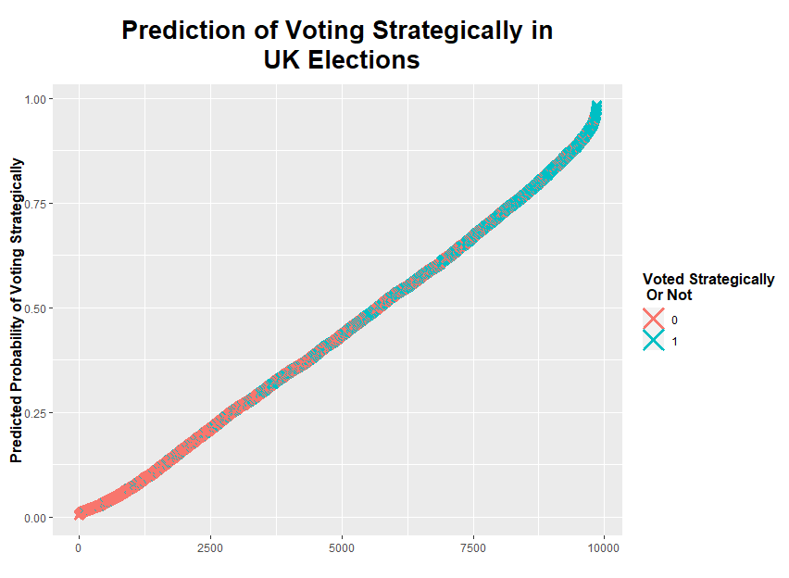

UK Confusion Matrix (Prediction based on 50% level):
N = 9,852 | Predicted:  Sincere Vote (<50%) | Predicted: Strategic Vote (>50%)
Actual:  Sincere Vote | 4,367 (44%) | 1,357 (14%)
Actual:  Strategic Vote | 1,320 (13%) | 2,808 (29%)
Accurate Predictions = 72.8%
UK Confusion Matrix (Prediction based on 30 and 70% levels):
N = 5,556 | Predicted:  Sincere Vote (<30%) | Predicted: Strategic Vote (>70%)
Actual:  Sincere Vote | 3,019 (54%) | 430 (8%)
Actual:  Strategic Vote | 476 (9%) | 1,631 (29%)
Accurate Predictions = 83.7%

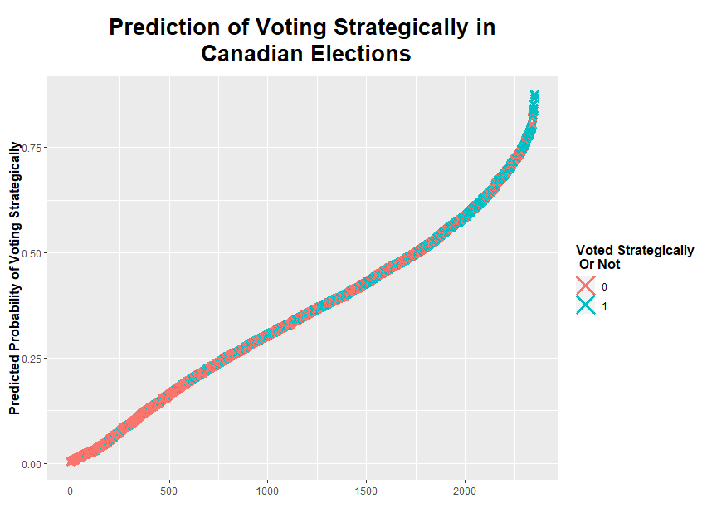
Canada Confusion Matrix (Prediction based on 50% level):
N = 2,353 | Predicted:  Sincere Vote (<50%) | Predicted: Strategic Vote (>50%)
Actual:  Sincere Vote | 1,286 (55%) | 217 (9%)
Actual:  Strategic Vote | 463 (20%) | 387 (16%)
Accurate Predictions = 71.1%
Canada Confusion Matrix (Prediction based on 30 and 70% levels):
N = 1,111 | Predicted:  Sincere Vote (<30%) | Predicted: Strategic Vote (>70%)
Actual:  Sincere Vote | 832 (75%) | 35 (3%)
Actual:  Strategic Vote | 147 (13%) | 97 (9%)
Accurate Predictions = 83.6%

Only survey respondents who have responses to all variables are included in regression calculations, which is why the number of observations in the model is lower than the total number of non-viable party supporters.
We use the pseudo R2 measurement as it acts as the logistic model equivalent of the R2 measurement that is used commonly for linear regression models, and thus provides an indication of goodness of fit.
Standard errors are clustered by election to account for the similar strategic voting effects in the same elections
Standard errors are clustered by election to account for the similar strategic voting effects in the same elections
Standard errors are clustered by election to account or the similar strategic voting effects in the same elections

