**Appendix A: variables in the analyses**

**Canadian Election Studies (Canada)**

Dependent variables (note that these have been rescaled so that the minimum value is 0 and the maximum value 1)

-*Ideology*: Respondents were asked where they would position themselves on a scale ranging from 0 (political left) to 10 (political right);

-*Economy*: Respondents rated the statement ‘how much should be done to reduce the gap between the rich and the poor in Canada?’ on a scale ranging from much less over somewhat less, about the same as now, somewhat more, to much more;

-*Immigration*: Respondents were asked to evaluate the statement that “immigrants make an important contribution to this country” on a scale ranging from strongly disagree over disagree, agree, to strongly agree. In 2015 and 2019 this question was not included, and an alternative is used: respondents indicated whether they wanted Canada to allow less immigrants, about the same as now, or more immigrants;

-*Gay marriage*: Respondents indicated to what extent they think that gays and lesbians should be allowed to get married on a scale ranging from strongly disagree over somewhat disagree to somewhat agree and strongly agree. In 2011 and 2015, respondents indicated whether they were in favour of or opposed to same-sex marriage. In 2019, the measure is not included.

-*Québec*: Respondents were asked to indicate how they feel about Québec on a scale ranging from 0 (really dislike) to 100 (really like). In 2000, the measure is only included for respondents not residing in Québec. In 2019, the measure is not included.

Control variables

-*Gender*: Gender of the respondent: 0 (male) or 1 (female);

-*Age*: Age of the respondent, calculated as the difference between the election year and the year of birth. Rescaled to range between 0 and 1;

-*Educational level*: Highest attained educational level, coded as less than completed high school (“lowly educated” – reference category), completed high school (“middle educated”), or more than high school (“highly educated”);

-*Income*: Total household incomes, divided into broad categories. Note that the amount and width of the income categories differ somewhat between the years. However, this variable has been rescaled so that 0 always indicates the lowest income category and 1 the highest category.

-*Language*: Language the respondent first learned and still speaks, distinguishing English (reference) from French and other languages.

**European Social Survey (United Kingdom & Spain)**

Dependent variables (note that these have been rescaled so that the minimum value is 0 and the maximum value 1)

-*Ideology*: Respondents were asked where they would position themselves on a scale ranging from 0 (political left) to 10 (political right);

-*Economy*: Respondents indicated to what extent they agreed with the statement that the government should take measures to reduce differences in income levels on a scale ranging from disagree strongly over disagree and neither agree nor disagree to agree and agree strongly;

-*Immigration*: Respondents indicated their position on three different questions:

-Would you say that it is generally good or bad for [country]’s economy that people come to live here from other countries?

-Would you say that [country]’s cultural life is general undermined or enriched by people coming to live here from other countries?

-Is [country] made a worse or a better place to live by people coming to live here from other countries?

Respondents could each time indicate their position on a 0-10-scale, with 0 indicating the most negative and 10 the most positive position. The answers to these different questions are strongly correlated, and load onto one latent factor (see table below). We therefore construct the immigration-variable as the average answer to the different questions;

|  |  |
| --- | --- |
| Item | Factor loading |
| Bad/good economy | 0.767 |
| Cultural life undermined/enriched | 0.779 |
| Worse/better place to live | 0.809 |
| Eigenvalue | 1.850 |
| Cronbach’s Alpha | 0.853 |

-*Gay rights*: Respondents indicated to what extent they think that gays and lesbians should be free to live their own live as they wish on a scale ranging from disagree strongly over disagree and neither agree nor disagree to agree and agree strongly;

-*European unification*: Respondents indicated whether they think European unification has already gone too far (score 0) or should go further (score 10). This measure is not available in the first and fifth rounds.

Control variables

-*Gender*: Gender of the respondent: 0 (male) or 1 (female);

-*Age*: Age of the respondent. Only respondents older than 18 are included in the analyses;

-*Educational level*: Number of years full-time education completed. This variable was heavily skewed to the right. Therefore, all values higher than 3 standard deviations above the mean, have been set on that value, by country. Then, the variable was rescaled to range from 0 to 1;

-*Income*: A measure of how the respondent feels about their household’s income, ranging from “very difficult on present income” and “difficult on present income” to “coping on present income” and “living comfortably on present income”. This variable has been rescaled so that 0 always indicates the lowest income category and 1 the highest category.

-*Language*: Language usually spoken at home, distinguishing English from other languages (U.K.), or Spanish from Catalan and other languages (Spain).

**Appendix B: Full tables of the models reported in the figures in the main text**

Table B.1: Full table for Canada

|  |  |  |  |  |  |  |  |  |
| --- | --- | --- | --- | --- | --- | --- | --- | --- |
|  | General ideology | | Redistribution | | Immigration | | Gay rights | |
|  | B  (s.e.) | B  (s.e.) | B  (s.e.) | B  (s.e.) | B  (s.e.) | B  (s.e.) | B  (s.e.) | B  (s.e.) |
| Female | -0.054*** | -0.054*** | 0.033*** | 0.033*** | 0.011*** | 0.011*** | 0.132*** | 0.132*** |
|  | (0.000) | (0.000) | (0.000) | (0.000) | (0.000) | (0.000) | (0.000) | (0.000) |
| Age | 0.154*** | 0.154*** | -0.029*** | -0.029*** | 0.116*** | 0.116*** | -0.551*** | -0.551*** |
|  | (0.000) | (0.000) | (0.000) | (0.000) | (0.001) | (0.001) | (0.000) | (0.001) |
| Education (ref.=low) |  |  |  |  |  |  |  |  |
| Middle | 0.086*** | 0.086*** | -0.031*** | -0.031*** | 0.076*** | 0.076*** | 0.085*** | 0.085*** |
|  | (0.001) | (0.001) | (0.000) | (0.000) | (0.000) | (0.000) | (0.000) | (0.000) |
| High | -0.010*** | -0.010*** | -0.010*** | -0.010*** | 0.196*** | 0.196*** | 0.223*** | 0.223*** |
|  | (0.000) | (0.000) | (0.000) | (0.000) | (0.000) | (0.000) | (0.000) | (0.000) |
| Income | -0.039*** | -0.039*** | -0.030*** | -0.030*** | 0.088*** | 0.088*** | 0.176*** | 0.176*** |
|  | (0.000) | (0.000) | (0.000) | (0.000) | (0.000) | (0.000) | (0.001) | (0.000) |
| Language (ref.= English) |  |  |  |  |  |  |  |  |
| French | -0.070*** | -0.070*** | -0.051*** | -0.051*** | 0.016*** | 0.016*** | 0.017*** | 0.017*** |
|  | (0.001) | (0.001) | (0.000) | (0.000) | (0.001) | (0.001) | (0.000) | (0.000) |
| Other | 0.048*** | 0.048*** | -0.001*** | -0.001*** | -0.072*** | -0.072*** | -0.114*** | -0.114*** |
|  | (0.000) | (0.000) | (0.000) | (0.000) | (0.001) | (0.001) | (0.000) | (0.000) |
| Region (ref.=rest of Canada) |  |  |  |  |  |  |  |  |
| Québec | 0.099*** | 0.019*** | 0.085*** | 0.129*** | -0.076*** | -0.101*** | 0.195*** | 0.024*** |
|  | (0.001) | (0.000) | (0.000) | (0.000) | (0.001) | (0.001) | (0.001) | (0.000) |
| Election year (ref.=2000) |  |  |  |  |  |  |  |  |
| 2004 |  |  | -0.004*** | -0.002*** | -0.028*** | -0.028*** | 0.047*** | 0.042*** |
|  |  |  | (0.000) | (0.000) | (0.000) | (0.000) | (0.000) | (0.000) |
| 2006 | -0.002*** | 0.000*** | -0.019*** | -0.011*** | -0.032*** | -0.041*** | 0.046*** | 0.060*** |
|  | (0.000) | (0.000) | (0.000) | (0.000) | (0.000) | (0.000) | (0.000) | (0.000) |
| 2008 | -0.015*** | 0.001*** | -0.023*** | -0.007*** | -0.040*** | -0.049*** | 0.113*** | 0.143*** |
|  | (0.000) | (0.000) | (0.000) | (0.000) | (0.000) | (0.000) | (0.000) | (0.000) |
| 2011 | -0.021*** | -0.038*** | -0.042*** | -0.032*** | -0.063*** | -0.067*** | 0.159*** | 0.120*** |
|  | (0.000) | (0.000) | (0.000) | (0.000) | (0.000) | (0.000) | (0.000) | (0.000) |
| 2015 | -0.016*** | -0.010*** | -0.329*** | -0.309*** | -0.287*** | -0.296*** | 0.187*** | 0.192*** |
|  | (0.000) | (0.000) | (0.000) | (0.000) | (0.000) | (0.000) | (0.000) | (0.000) |
| 2019 | -0.015*** | -0.019*** | -0.023*** | -0.012*** | -0.208*** | -0.238*** |  |  |
|  | (0.000) | (0.000) | (0.000) | (0.000) | (0.000) | (0.000) |  |  |
| Québec x 2000 |  |  |  |  |  |  |  |  |
| Québec x 2004 |  |  |  | -0.015*** |  | 0.002*** |  | 0.014*** |
|  |  |  |  | (0.000) |  | (0.000) |  | (0.000) |
| Québec x 2006 |  | -0.015*** |  | -0.032*** |  | 0.045*** |  | -0.073*** |
|  |  | (0.000) |  | (0.000) |  | (0.000) |  | (0.000) |
| Québec x 2008 |  | -0.009*** |  | -0.061*** |  | 0.039*** |  | -0.006*** |
|  |  | (0.000) |  | (0.000) |  | (0.000) |  | (0.000) |
| Québec x 2011 |  | 0.081*** |  | -0.044*** |  | 0.024*** |  | 0.171*** |
|  |  | (0.000) |  | (0.000) |  | (0.000) |  | (0.000) |
| Québec x 2015 |  | 0.010*** |  | -0.075*** |  | 0.040*** |  | 0.049*** |
|  |  | (0.000) |  | (0.000) |  | (0.000) |  | (0.000) |
| Québec x 2019 |  | 0.021*** |  | -0.049*** |  | 0.137*** |  |  |
|  |  | (0.000) |  | (0.000) |  | (0.000) |  |  |
| Constant | 0.484*** | 0.501*** | 0.818*** | 0.808*** | 0.487*** | 0.491*** | 0.322*** | 0.360*** |
|  | (0.000) | (0.000) | (0.000) | (0.000) | (0.001) | (0.001) | (0.001) | (0.000) |
| *N* | 8488 | 8488 | 13364 | 13364 | 10344 | 10344 | 8659 | 8659 |
| *R2* | 0.084 | 0.084 | 0.021 | 0.021 | 0.118 | 0.118 | 0.198 | 0.198 |

*Note*: Entries are unstandardised OLS coefficients, standard errors in parentheses. Significance levels: *: p<0.05; **: p<0.01; ***: p<0.001.

Table B.2: Full table for the United Kingdom

|  |  |  |  |  |  |  |  |  |  |  |
| --- | --- | --- | --- | --- | --- | --- | --- | --- | --- | --- |
|  | General ideology | | Redistribution | | Immigration | | Gay rights | | EU unification | |
|  | B  (s.e.) | B  (s.e.) | B  (s.e.) | B  (s.e.) | B  (s.e.) | B  (s.e.) | B  (s.e.) | B  (s.e.) | B  (s.e.) | B  (s.e.) |
| Female | -0.014* | -0.014* | 0.038*** | 0.038*** | -0.022*** | -0.022*** | 0.049*** | 0.050*** | 0.028* | 0.028* |
|  | (0.004) | (0.004) | (0.005) | (0.005) | (0.003) | (0.003) | (0.003) | (0.003) | (0.010) | (0.010) |
| Age | 0.001*** | 0.001*** | -0.000 | -0.000 | -0.001*** | -0.001*** | -0.003*** | -0.003*** | -0.002*** | -0.002*** |
|  | (0.000) | (0.000) | (0.000) | (0.000) | (0.000) | (0.000) | (0.000) | (0.000) | (0.000) | (0.000) |
| Years of education | -0.039* | -0.039* | -0.107** | -0.106** | 0.405*** | 0.405*** | 0.109*** | 0.109*** | 0.158*** | 0.159*** |
|  | (0.016) | (0.015) | (0.024) | (0.024) | (0.010) | (0.010) | (0.012) | (0.012) | (0.019) | (0.019) |
| Income | 0.049*** | 0.049*** | -0.143*** | -0.143*** | 0.107*** | 0.107*** | 0.034*** | 0.033*** | 0.049** | 0.048** |
|  | (0.007) | (0.007) | (0.008) | (0.008) | (0.008) | (0.008) | (0.005) | (0.005) | (0.009) | (0.009) |
| Language (ref.=English) | 0.009 | 0.009 | 0.005 | 0.007 | 0.113*** | 0.113*** | -0.175*** | -0.175*** | 0.076** | 0.076** |
|  | (0.008) | (0.008) | (0.004) | (0.005) | (0.011) | (0.011) | (0.012) | (0.012) | (0.014) | (0.014) |
| Region (ref.=rest of U.K.) | -0.024* | -0.038*** | 0.030* | 0.033*** | 0.036*** | 0.046*** | -0.000 | 0.006*** | 0.030** | -0.008** |
|  | (0.008) | (0.001) | (0.011) | (0.001) | (0.004) | (0.001) | (0.004) | (0.001) | (0.008) | (0.002) |
| ESS round (ref.=one) |  |  |  |  |  |  |  |  |  |  |
| Two | -0.013*** | -0.017*** | 0.007*** | 0.002* | 0.020*** | 0.019*** | 0.034*** | 0.036*** |  |  |
|  | (0.000) | (0.000) | (0.001) | (0.001) | (0.000) | (0.000) | (0.000) | (0.000) |  |  |
| Three | -0.003*** | -0.004*** | -0.009*** | -0.007*** | -0.021*** | -0.018*** | 0.036*** | 0.038*** | -0.049*** | -0.052*** |
|  | (0.001) | (0.000) | (0.001) | (0.001) | (0.000) | (0.000) | (0.000) | (0.000) | (0.001) | (0.001) |
| Four | -0.015*** | -0.016*** | 0.003* | 0.004** | -0.008*** | -0.007*** | 0.051*** | 0.051*** | -0.049*** | -0.052*** |
|  | (0.001) | (0.001) | (0.001) | (0.001) | (0.000) | (0.000) | (0.001) | (0.001) | (0.001) | (0.001) |
| Five | -0.010*** | -0.010*** | 0.004*** | 0.009*** | -0.006*** | -0.005*** | 0.093*** | 0.094*** |  |  |
|  | (0.000) | (0.000) | (0.000) | (0.000) | (0.001) | (0.001) | (0.001) | (0.000) |  |  |
| Six | -0.009*** | -0.015*** | 0.028*** | 0.026*** | -0.003** | -0.001 | 0.096*** | 0.096*** | -0.061*** | -0.064*** |
|  | (0.001) | (0.001) | (0.001) | (0.001) | (0.001) | (0.001) | (0.001) | (0.001) | (0.001) | (0.001) |
| Seven | -0.013*** | -0.012*** | 0.030*** | 0.030*** | 0.005*** | 0.005** | 0.111*** | 0.110*** | -0.087*** | -0.090*** |
|  | (0.001) | (0.001) | (0.001) | (0.001) | (0.001) | (0.001) | (0.001) | (0.001) | (0.001) | (0.001) |
| Eight | -0.025*** | -0.025*** | 0.055*** | 0.057*** | 0.080*** | 0.080*** | 0.133*** | 0.135*** | -0.045*** | -0.050*** |
|  | (0.001) | (0.001) | (0.001) | (0.001) | (0.001) | (0.001) | (0.001) | (0.001) | (0.001) | (0.001) |
| Nine | -0.027*** | -0.027*** | 0.070*** | 0.068*** | 0.095*** | 0.096*** | 0.144*** | 0.143*** | -0.020*** | -0.024*** |
|  | (0.001) | (0.001) | (0.001) | (0.001) | (0.001) | (0.001) | (0.001) | (0.001) | (0.002) | (0.002) |
| Scotland x ESS round one |  |  |  |  |  |  |  |  |  |  |
| Scotland x two |  | 0.049*** |  | 0.062*** |  | 0.008*** |  | -0.019*** |  |  |
|  |  | (0.001) |  | (0.001) |  | (0.000) |  | (0.001) |  |  |
| Scotland x three |  | 0.014*** |  | -0.027*** |  | -0.029*** |  | -0.018*** |  | 0.038*** |
|  |  | (0.001) |  | (0.001) |  | (0.001) |  | (0.000) |  | (0.001) |
| Scotland x four |  | 0.014*** |  | -0.011*** |  | -0.010*** |  | 0.003*** |  | 0.037*** |
|  |  | (0.000) |  | (0.001) |  | (0.001) |  | (0.000) |  | (0.002) |
| Scotland x five |  | 0.002 |  | -0.052*** |  | -0.013*** |  | -0.008*** |  |  |
|  |  | (0.001) |  | (0.001) |  | (0.001) |  | (0.002) |  |  |
| Scotland x six |  | 0.062*** |  | 0.018*** |  | -0.028*** |  | -0.009*** |  | 0.032*** |
|  |  | (0.000) |  | (0.000) |  | (0.000) |  | (0.000) |  | (0.001) |
| Scotland x seven |  | -0.006*** |  | 0.001 |  | -0.001 |  | 0.004*** |  | 0.040*** |
|  |  | (0.001) |  | (0.001) |  | (0.001) |  | (0.001) |  | (0.001) |
| Scotland x eight |  | -0.000 |  | -0.024*** |  | -0.005*** |  | -0.020*** |  | 0.071*** |
|  |  | (0.001) |  | (0.001) |  | (0.001) |  | (0.001) |  | (0.001) |
| Scotland x nine |  | -0.003* |  | 0.023*** |  | -0.006*** |  | 0.008*** |  | 0.045*** |
|  |  | (0.001) |  | (0.001) |  | (0.001) |  | (0.001) |  | (0.001) |
| Constant | 0.444*** | 0.445*** | 0.766*** | 0.765*** | 0.223*** | 0.223*** | 0.718*** | 0.717*** | 0.419*** | 0.422*** |
|  | (0.010) | (0.010) | (0.013) | (0.013) | (0.011) | (0.011) | (0.011) | (0.011) | (0.009) | (0.010) |
| *N* | 17071 | 17071 | 18867 | 18867 | 18351 | 18351 | 19002 | 19002 | 13742 | 13742 |
| *R2* | 0.029 | 0.031 | 0.042 | 0.043 | 0.170 | 0.171 | 0.128 | 0.128 | 0.066 | 0.066 |

*Note*: Entries are unstandardised OLS coefficients, standard errors in parentheses. Significance levels: *: p<0.05; **: p<0.01; ***: p<0.001.

Table B.3: Full table for Spain

|  |  |  |  |  |  |  |  |  |  |  |
| --- | --- | --- | --- | --- | --- | --- | --- | --- | --- | --- |
|  | General ideology | | Redistribution | | Immigration | | Gay rights | | EU unification | |
|  | B  (s.e.) | B  (s.e.) | B  (s.e.) | B  (s.e.) | B  (s.e.) | B  (s.e.) | B  (s.e.) | B  (s.e.) | B  (s.e.) | B  (s.e.) |
| Female | 0.005 | 0.005 | 0.016** | 0.016** | -0.029*** | -0.029*** | 0.031*** | 0.031*** | -0.023* | -0.023* |
|  | (0.004) | (0.004) | (0.004) | (0.004) | (0.004) | (0.005) | (0.003) | (0.003) | (0.007) | (0.007) |
| Age | 0.001*** | 0.001*** | -0.000 | -0.000 | -0.001*** | -0.001*** | -0.003*** | -0.003*** | -0.001** | -0.001** |
|  | (0.000) | (0.000) | (0.000) | (0.000) | (0.000) | (0.000) | (0.000) | (0.000) | (0.000) | (0.000) |
| Years of education | -0.005 | -0.005 | -0.047** | -0.046** | 0.154*** | 0.154*** | 0.113*** | 0.113*** | 0.140*** | 0.140*** |
|  | (0.013) | (0.013) | (0.012) | (0.012) | (0.029) | (0.029) | (0.016) | (0.016) | (0.014) | (0.015) |
| Income | 0.042*** | 0.042*** | -0.097*** | -0.096*** | 0.067*** | 0.066*** | 0.043** | 0.044** | 0.037** | 0.037** |
|  | (0.007) | (0.007) | (0.008) | (0.008) | (0.011) | (0.011) | (0.011) | (0.011) | (0.008) | (0.008) |
| Language (ref.=Spanish) |  |  |  |  |  |  |  |  |  |  |
| Catalan | -0.021 | -0.019 | 0.009 | 0.006 | -0.008 | -0.010 | 0.023* | 0.018 | 0.000 | -0.001 |
|  | (0.012) | (0.012) | (0.008) | (0.008) | (0.010) | (0.009) | (0.009) | (0.008) | (0.016) | (0.013) |
| Other | -0.015 | -0.015 | -0.010 | -0.010 | 0.059*** | 0.058*** | -0.065** | -0.065** | 0.017 | 0.017 |
|  | (0.009) | (0.009) | (0.007) | (0.007) | (0.006) | (0.006) | (0.015) | (0.015) | (0.012) | (0.012) |
| Region (ref.=rest of Spain) | -0.054*** | -0.042*** | -0.003 | -0.017*** | -0.009 | 0.002 | -0.001 | 0.024*** | 0.006 | -0.029** |
|  | (0.006) | (0.004) | (0.005) | (0.003) | (0.013) | (0.003) | (0.013) | (0.003) | (0.021) | (0.006) |
| ESS round (ref.=one) |  |  |  |  |  |  |  |  |  |  |
| Two | -0.004*** | 0.001 | -0.006*** | -0.009*** | 0.014*** | 0.014*** | -0.027*** | -0.028*** |  |  |
|  | (0.001) | (0.001) | (0.001) | (0.000) | (0.001) | (0.001) | (0.001) | (0.001) |  |  |
| Three | 0.006*** | 0.008*** | 0.026*** | 0.028*** | 0.007*** | 0.004*** | 0.011*** | 0.015*** | -0.026*** | -0.040*** |
|  | (0.001) | (0.000) | (0.000) | (0.000) | (0.001) | (0.000) | (0.001) | (0.001) | (0.001) | (0.001) |
| Four | 0.010*** | 0.009*** | -0.007*** | -0.008*** | -0.006*** | 0.003** | 0.041*** | 0.053*** | -0.064*** | -0.058*** |
|  | (0.001) | (0.001) | (0.001) | (0.000) | (0.001) | (0.001) | (0.001) | (0.001) | (0.001) | (0.001) |
| Five | 0.020*** | 0.024*** | 0.004*** | 0.003*** | -0.008*** | -0.003** | 0.042*** | 0.052*** |  |  |
|  | (0.001) | (0.001) | (0.000) | (0.000) | (0.001) | (0.001) | (0.001) | (0.001) |  |  |
| Six | 0.008*** | 0.010*** | 0.017*** | 0.014*** | 0.020*** | 0.020*** | 0.064*** | 0.064*** | 0.006*** | 0.005** |
|  | (0.001) | (0.001) | (0.001) | (0.001) | (0.002) | (0.001) | (0.001) | (0.001) | (0.001) | (0.001) |
| Seven | -0.006*** | -0.006*** | 0.068*** | 0.066*** | -0.005* | -0.003 | 0.120*** | 0.121*** | -0.026*** | -0.036*** |
|  | (0.001) | (0.001) | (0.001) | (0.001) | (0.002) | (0.002) | (0.001) | (0.001) | (0.001) | (0.001) |
| Eight | -0.003** | -0.003 | 0.030*** | 0.024*** | 0.033*** | 0.035*** | 0.118*** | 0.120*** | 0.022*** | 0.016*** |
|  | (0.001) | (0.001) | (0.001) | (0.001) | (0.002) | (0.002) | (0.001) | (0.001) | (0.001) | (0.001) |
| Nine | -0.008*** | 0.001 | 0.003* | -0.005*** | 0.050*** | 0.047*** | 0.104*** | 0.104*** | 0.018*** | 0.009*** |
|  | (0.001) | (0.001) | (0.001) | (0.001) | (0.002) | (0.002) | (0.001) | (0.001) | (0.001) | (0.001) |
| Catalonia x ESS round one |  |  |  |  |  |  |  |  |  |  |
| Catalonia x two |  | -0.032*** |  | 0.025*** |  | 0.003 |  | 0.014*** |  |  |
|  |  | (0.001) |  | (0.001) |  | (0.002) |  | (0.001) |  |  |
| Catalonia x three |  | -0.006** |  | -0.016*** |  | 0.018*** |  | -0.027*** |  | 0.096*** |
|  |  | (0.001) |  | (0.001) |  | (0.002) |  | (0.002) |  | (0.002) |
| Catalonia x four |  | 0.010*** |  | 0.003* |  | -0.061*** |  | -0.074*** |  | -0.030*** |
|  |  | (0.002) |  | (0.001) |  | (0.001) |  | (0.001) |  | (0.003) |
| Catalonia x five |  | -0.031*** |  | 0.007*** |  | -0.034*** |  | -0.072*** |  |  |
|  |  | (0.001) |  | (0.001) |  | (0.001) |  | (0.001) |  |  |
| Catalonia x six |  | -0.012*** |  | 0.023*** |  | 0.008*** |  | -0.000 |  | 0.016*** |
|  |  | (0.001) |  | (0.001) |  | (0.001) |  | (0.001) |  | (0.001) |
| Catalonia x seven |  | 0.006** |  | 0.009*** |  | -0.014*** |  | -0.006** |  | 0.080*** |
|  |  | (0.001) |  | (0.001) |  | (0.001) |  | (0.001) |  | (0.001) |
| Catalonia x eight |  | -0.001** |  | 0.042*** |  | -0.010*** |  | -0.009*** |  | 0.041*** |
|  |  | (0.000) |  | (0.001) |  | (0.001) |  | (0.001) |  | (0.001) |
| Catalonia x nine |  | -0.062*** |  | 0.056*** |  | 0.025*** |  | 0.003** |  | 0.069*** |
|  |  | (0.001) |  | (0.001) |  | (0.001) |  | (0.001) |  | (0.001) |
| Constant | 0.360*** | 0.358*** | 0.840*** | 0.842*** | 0.485*** | 0.483*** | 0.809*** | 0.805*** | 0.544*** | 0.549*** |
|  | (0.014) | (0.013) | (0.008) | (0.008) | (0.013) | (0.013) | (0.011) | (0.010) | (0.011) | (0.012) |
| *N* | 14264 | 14264 | 16005 | 16005 | 14911 | 14911 | 15925 | 15925 | 11657 | 11657 |
| *R2* | 0.028 | 0.030 | 0.031 | 0.032 | 0.077 | 0.079 | 0.141 | 0.143 | 0.041 | 0.044 |

*Note*: Entries are unstandardised OLS coefficients, standard errors in parentheses. Significance levels: *: p<0.05; **: p<0.01; ***: p<0.001.

**Appendix C: Models including all variables of interest as control variables**

Figure C.1. Replication of Figure 1 including additional control variables

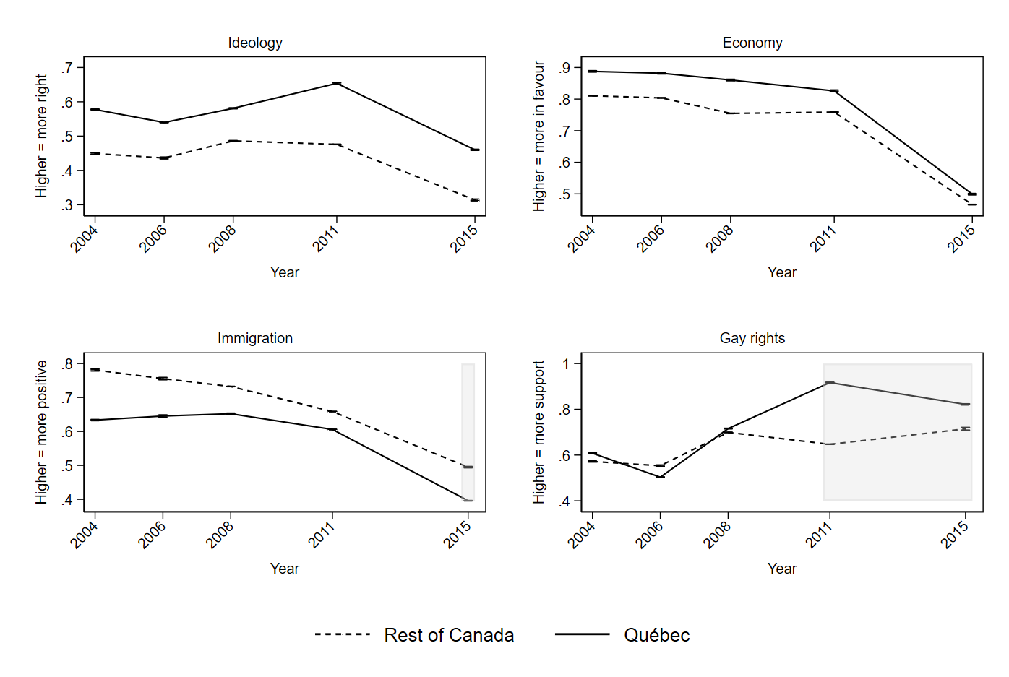

*Note*: Results from a model included an interaction between survey year wave and region.

Figure C.2. Replication of Figure 2 including additional control variables

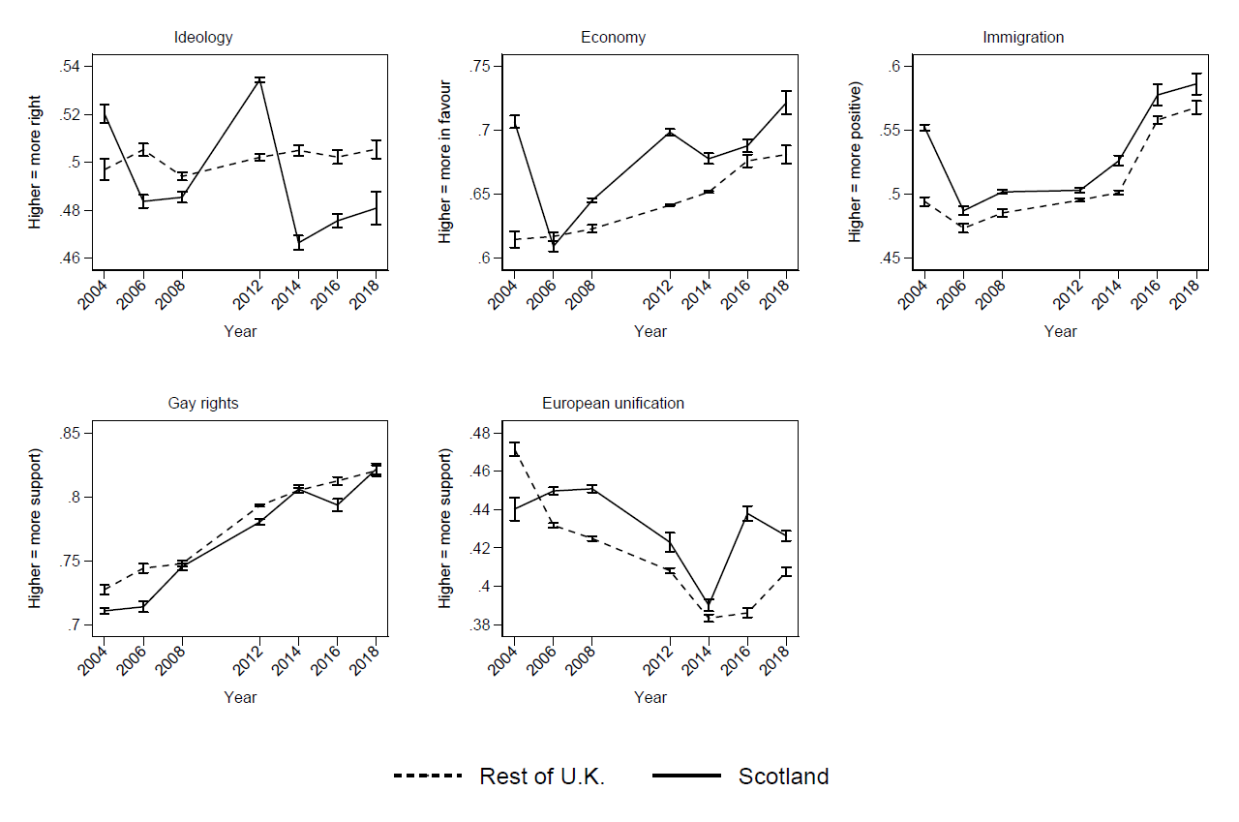

*Note*: Results from a model included an interaction between survey year wave and region.

Figure C.3. Replication of Figure 3 including additional control variables

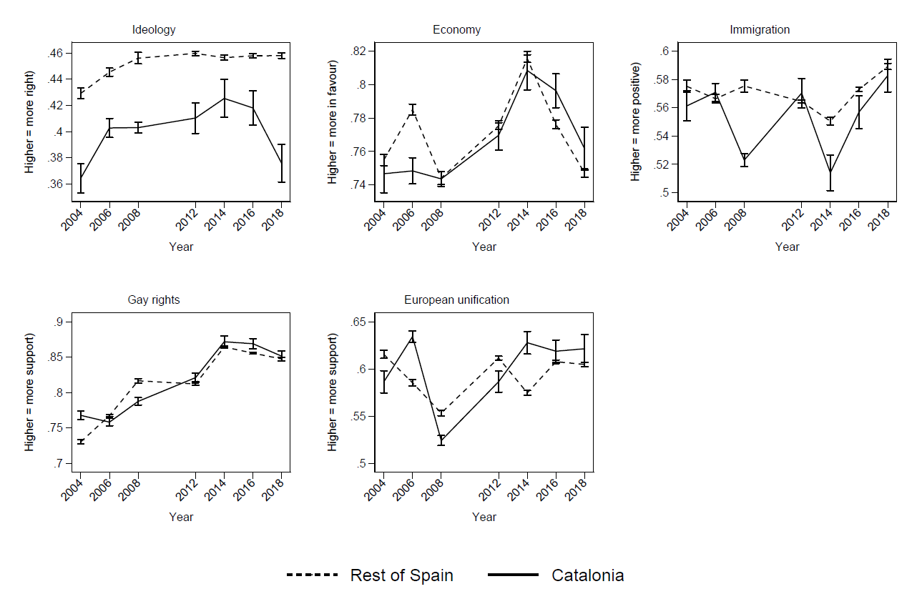

*Note*: Results from a model included an interaction between survey year wave and region.

**Appendix D: Replication for Italy and Germany**

Figure D.1. Political attitudes in North Italy and the rest of the Italy over time 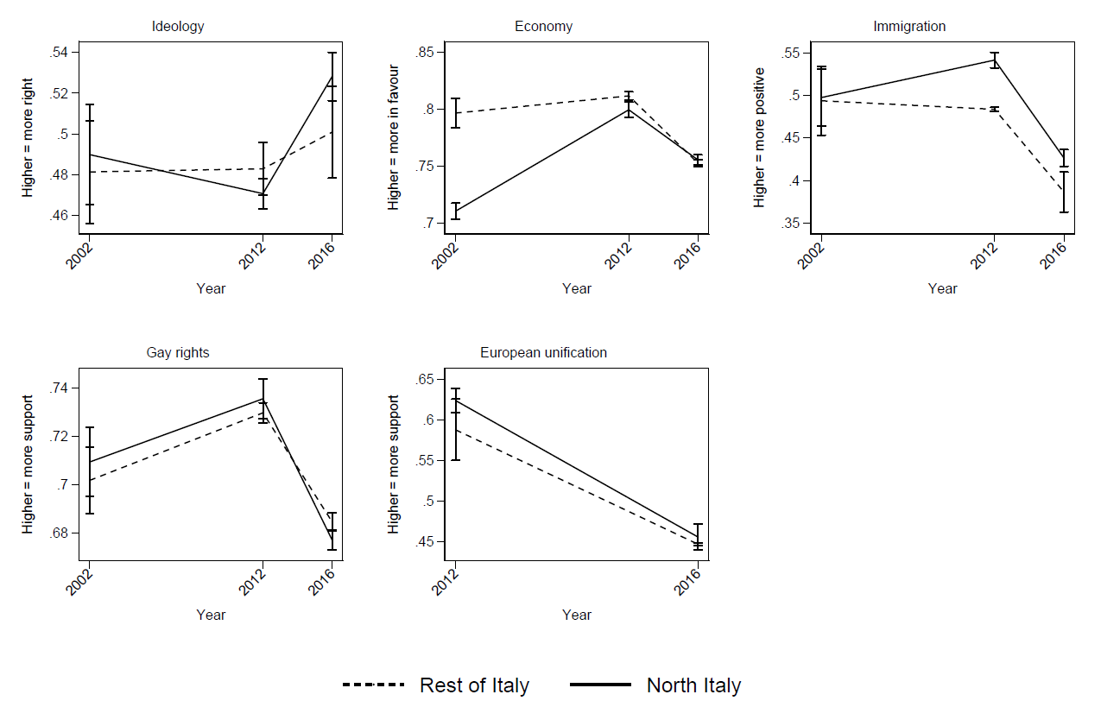

*Note*: Results from a model included an interaction between survey year wave and region.

Figure D.2. Political attitudes in Bavaria and the rest of the Germany over time

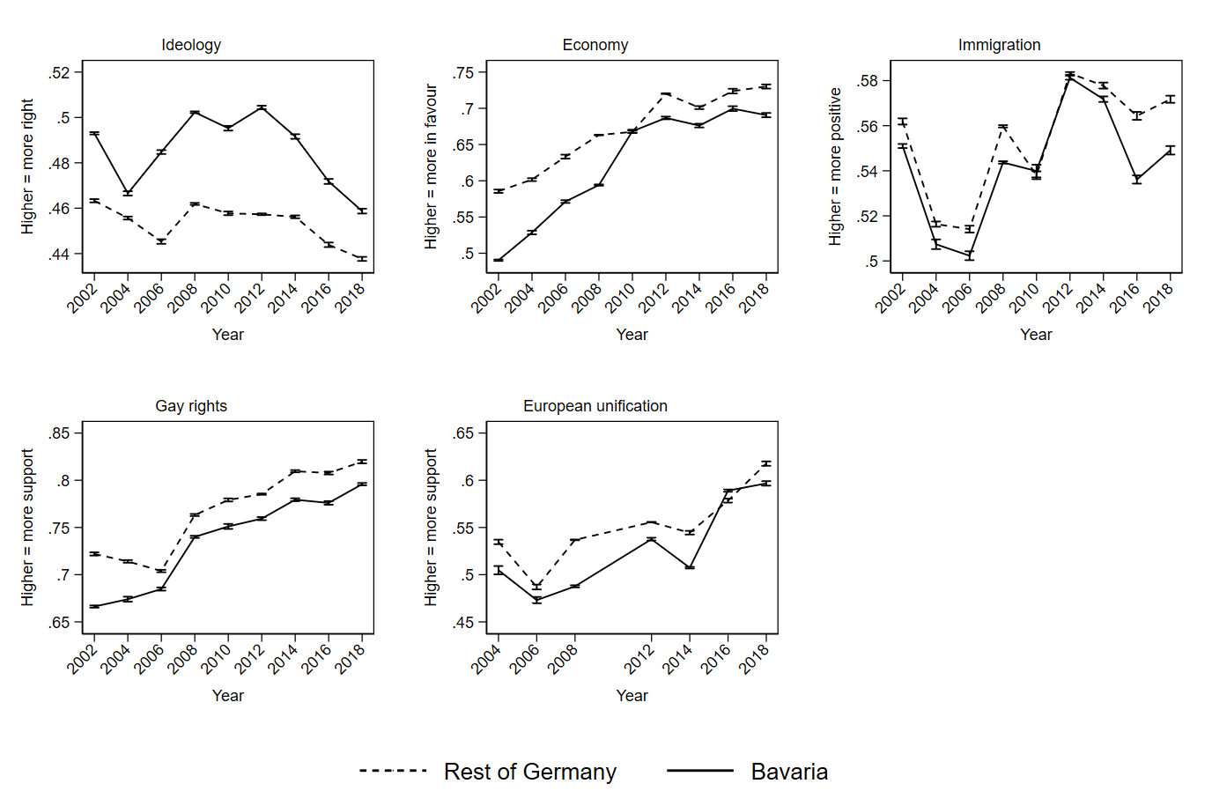

*Note*: Results from a model included an interaction between survey year wave and region.

**Appendix E: Results distinguishing all regions**

Figure E.1. Replication of Figure 1 distinguishing all regions

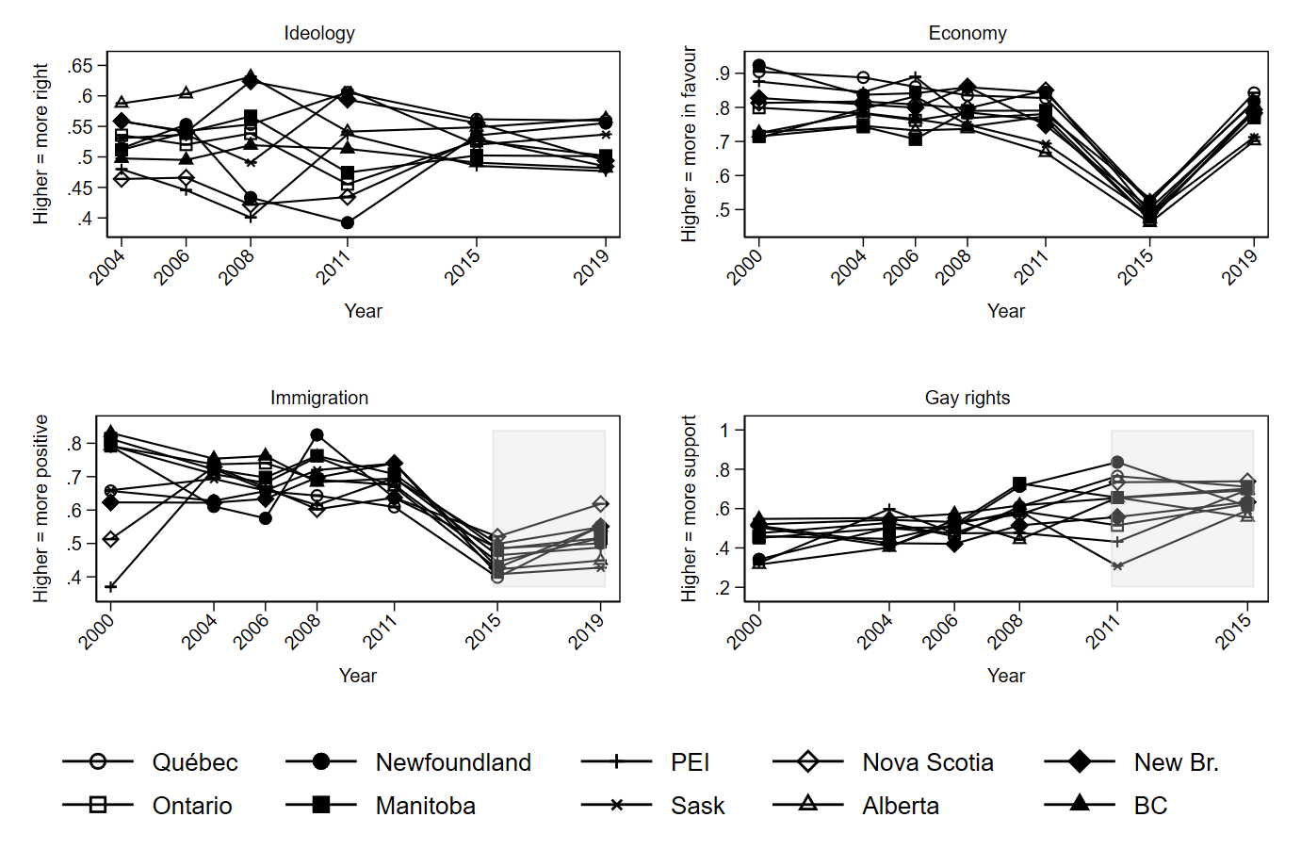

*Note*: Results from a model included an interaction between survey year wave and region.

Figure E.2. Replication of Figure 2 distinguishing all regions

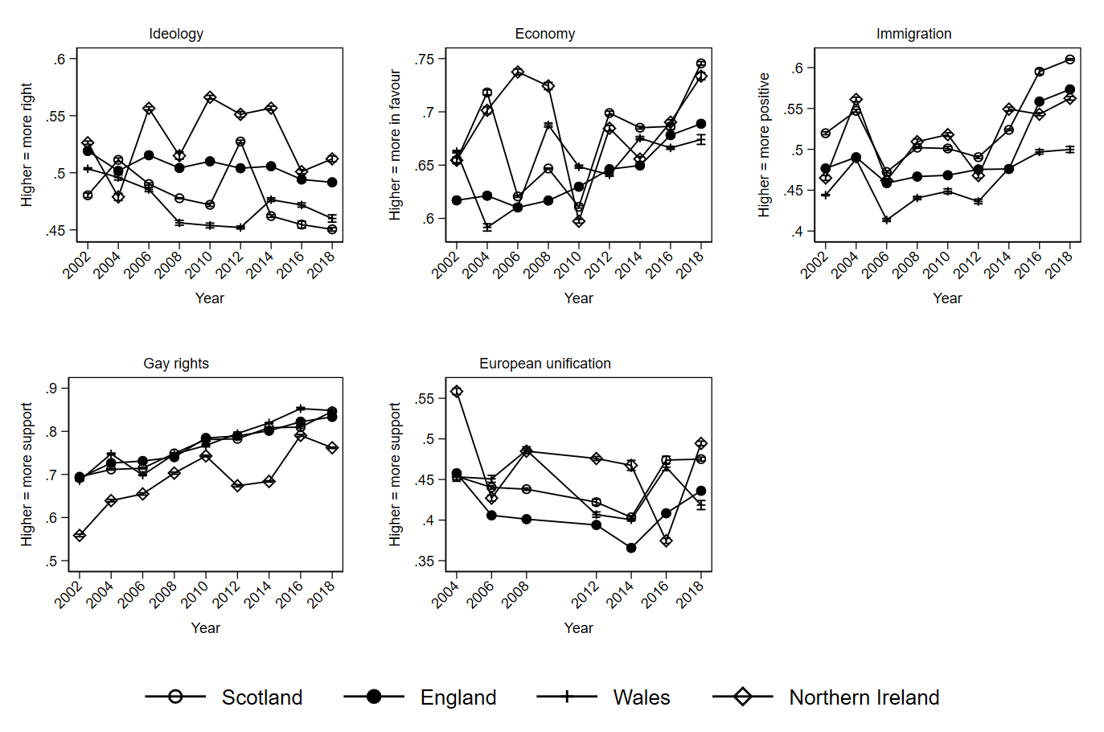

*Note*: Results from a model included an interaction between survey year wave and region.

Figure E.3. Replication of Figure 3 distinguishing all regions

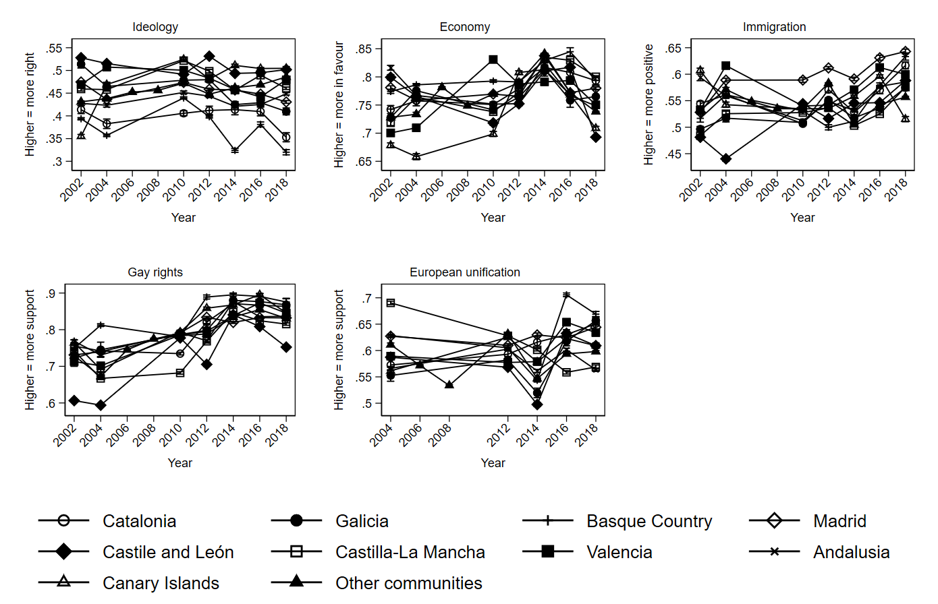

*Note*: Results from a model included an interaction between survey year wave and region.

**Appendix F: Tests using preferences for institutional design**

British Election Study: Support for Scottish independence

Figure F.1. Support for Scottish independence in the U.K.

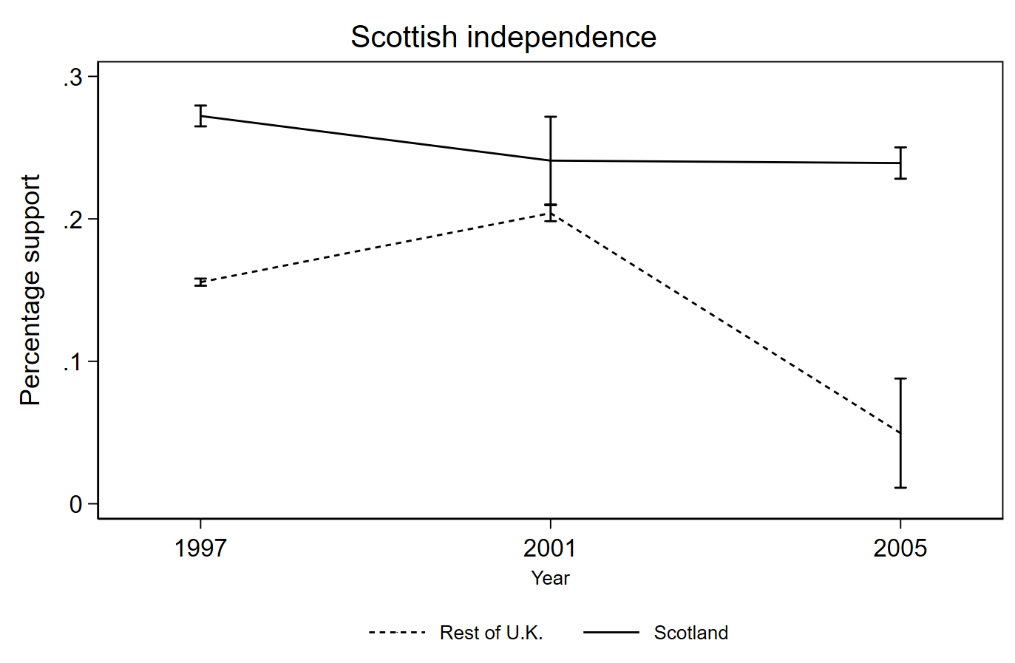

*Note*: Results from a model included an interaction between survey year wave and region.

CIS Spain: Preference for state structure and regional sentiment

Figure F.2. Preferences for state structure in Spain

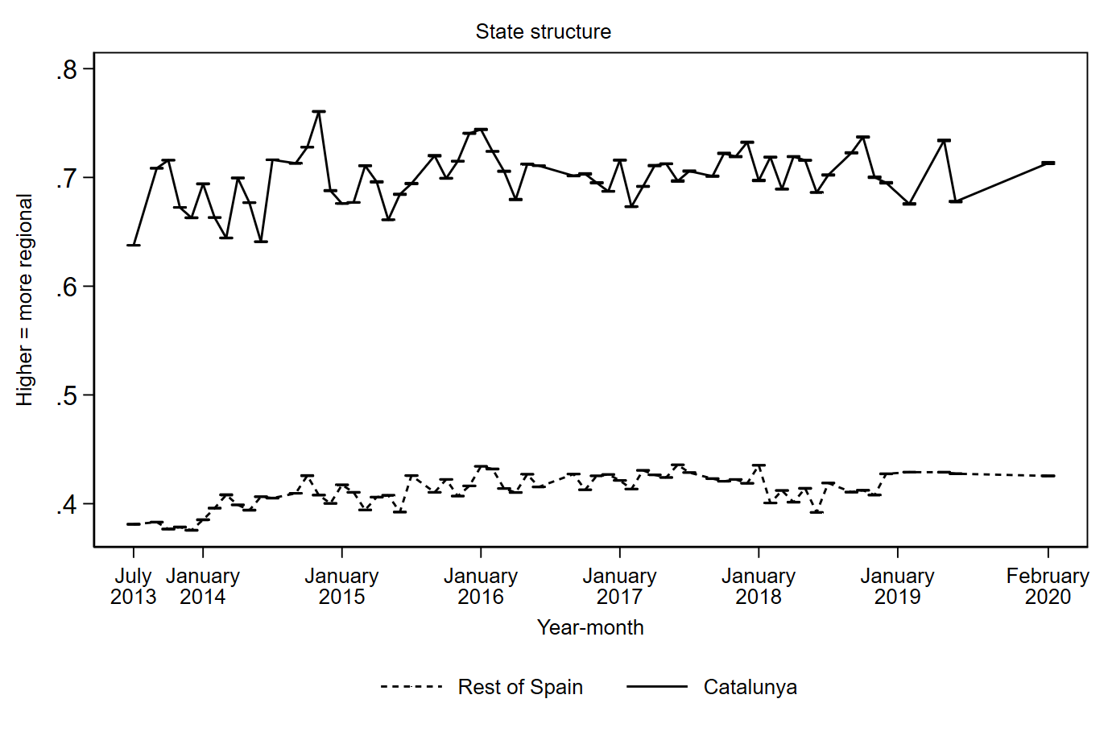

*Note*: Results from a model included an interaction between survey year wave and region.

Figure F.3. Feelings of identity in Spain

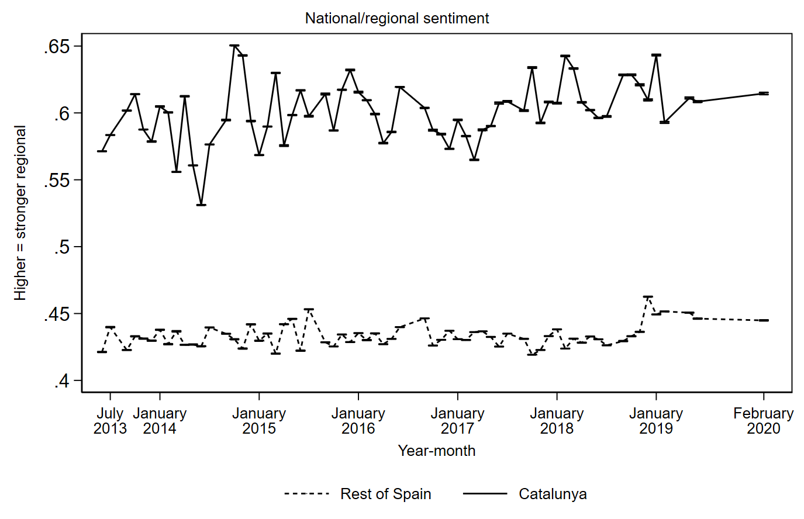

*Note*: Results from a model included an interaction between survey year wave and region.

**Appendix G: Results of a single item measuring attitudes towards immigration**

Figure G.1. Single immigration item U.K.

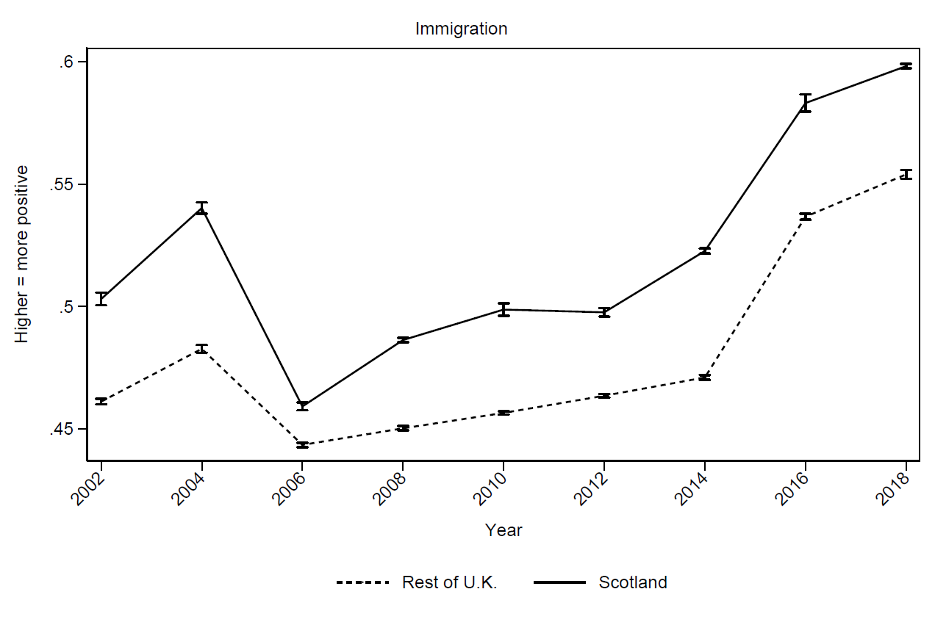

*Note*: Results from a model included an interaction between survey year wave and region.

Figure G.2. Single immigration item Spain

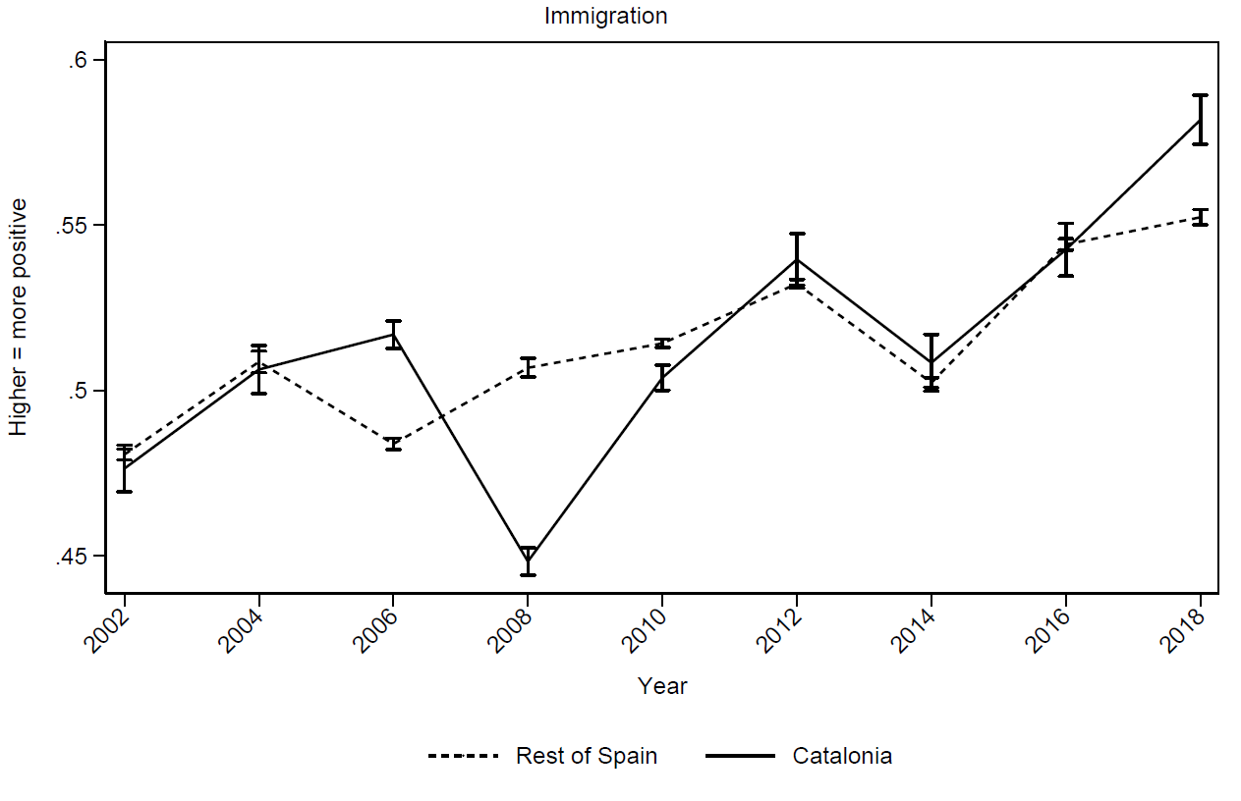

*Note*: Results from a model included an interaction between survey year wave and region.

**Appendix H: Figure showing difference scores**

Figure H.1. Replication of Figure 1 showing difference scores

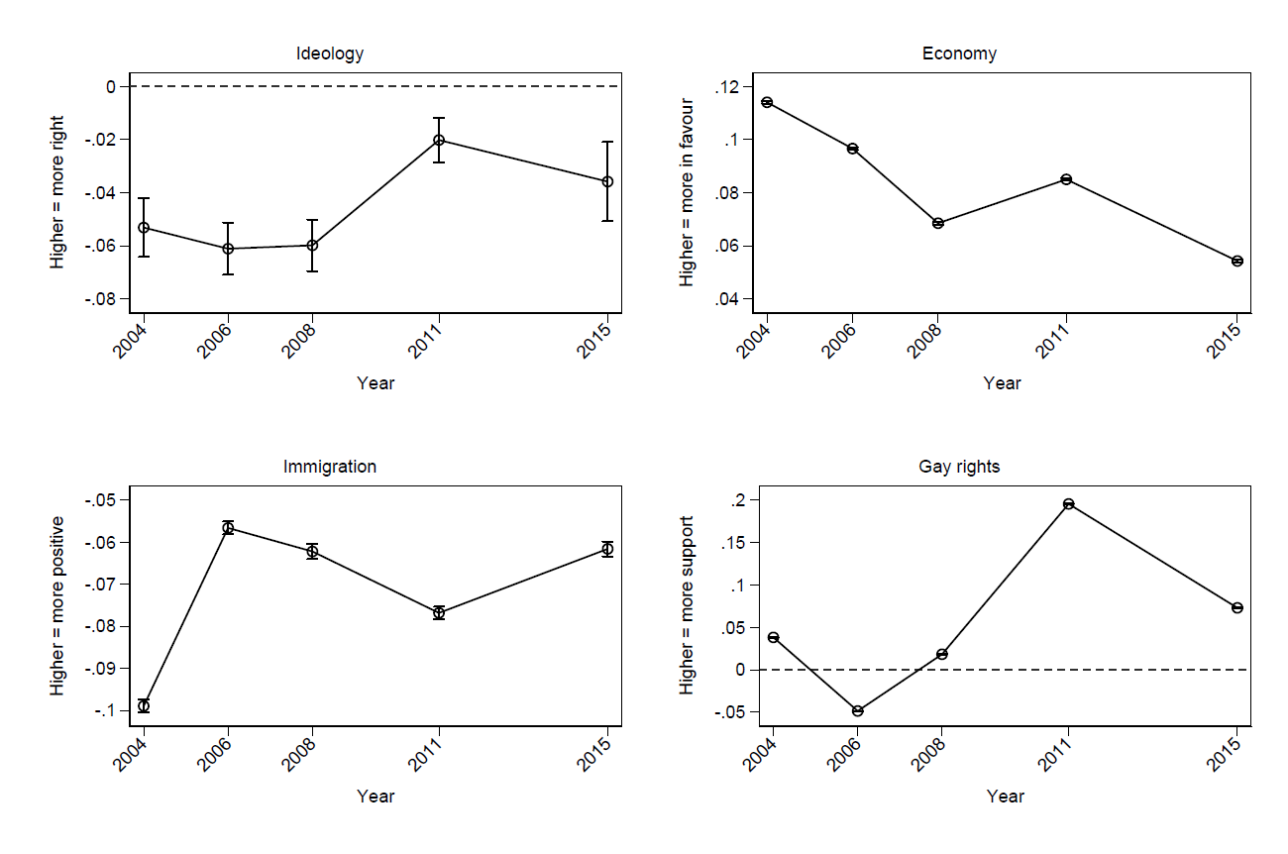

*Note*: Results from a model included an interaction between survey year wave and region.

Figure H.2. Replication of Figure 2 showing difference scores

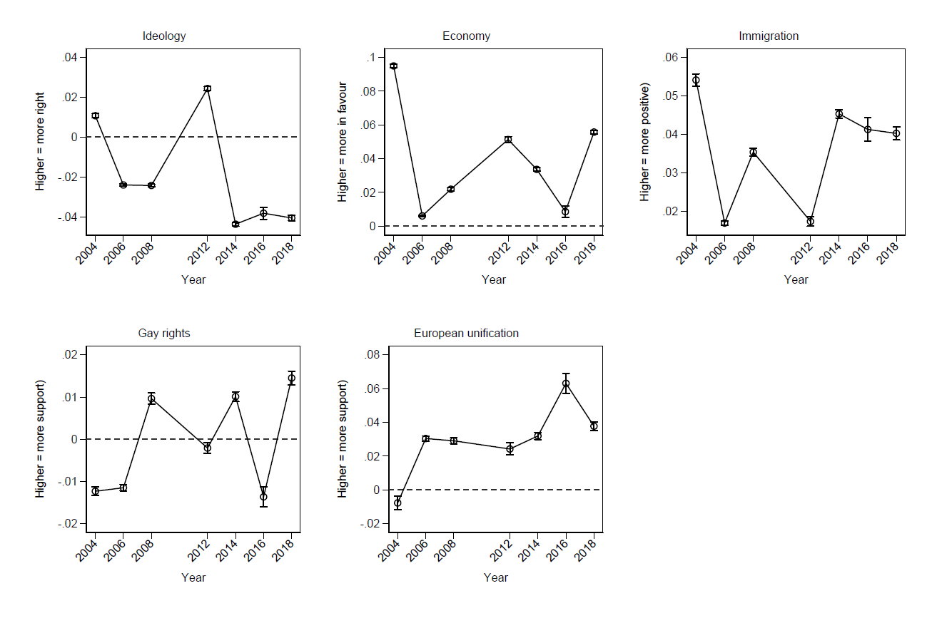

*Note*: Results from a model included an interaction between survey year wave and region.

Figure H.3. Replication of Figure 3 showing difference scores

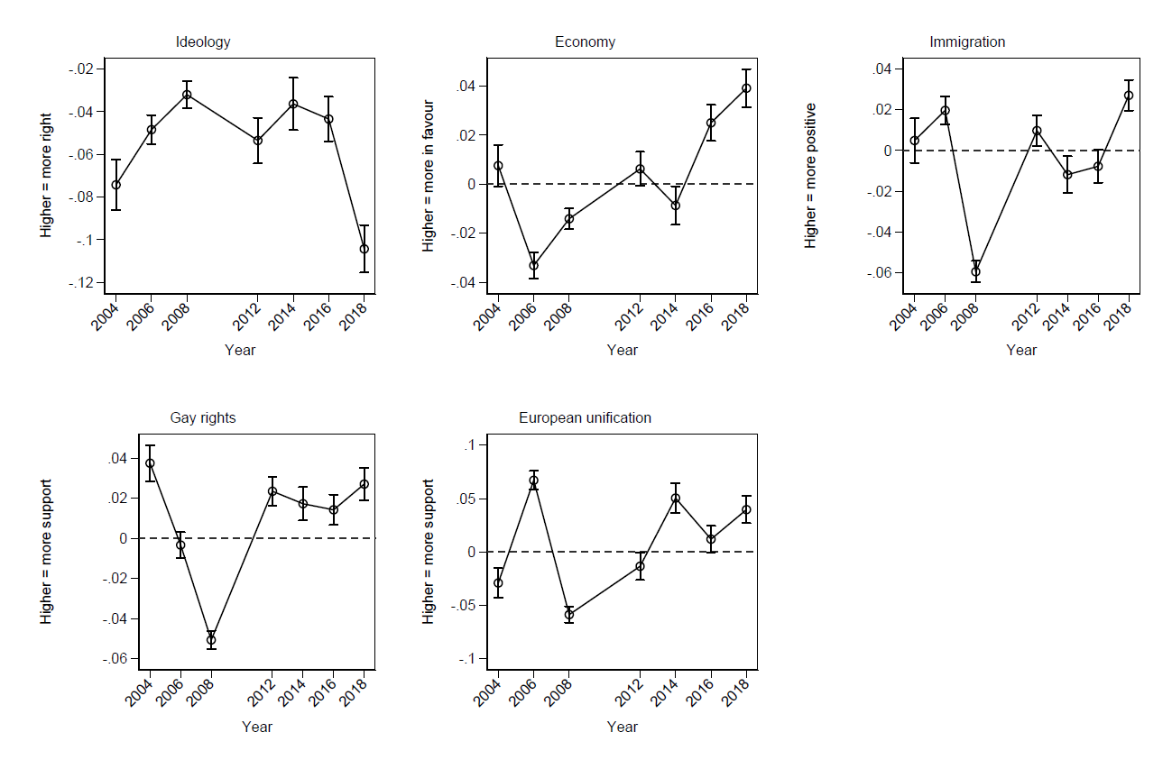

*Note*: Results from a model included an interaction between survey year wave and region.