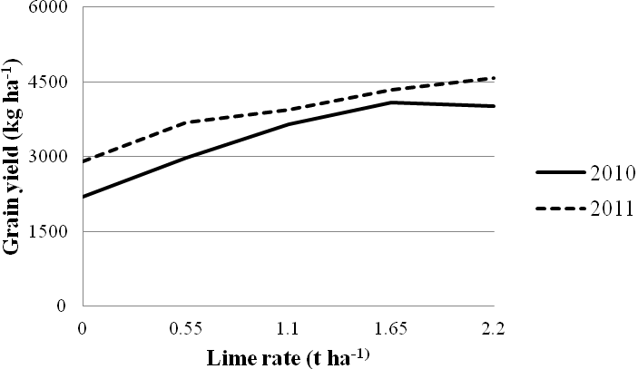
Figure S2 Mean grain yield of barley as affected by year cultivation

