**Supplementary Material Figure File**

Supplementary Material Figure (S1) used in the research paper titled, ***“CONSTRAINTS TO ADOPTION OF IMPROVED TECHNOLOGY FOR BERSEEM CLOVER (Trifolium alexandrinum) CULTIVATION IN PUNJAB, PAKISTAN”*** ispresented below;

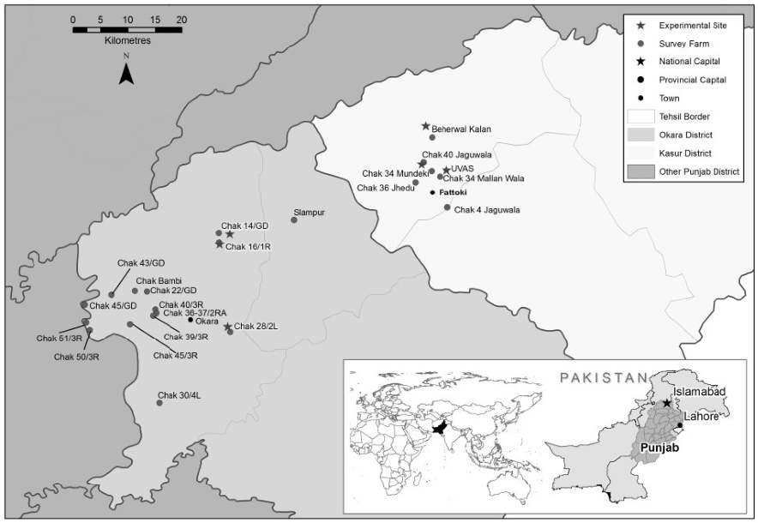

**Supplementary Material Figure S1:** Locations of the survey villages of berseem clover growers of Kasur and Okara districts of Punjab, Pakistan.