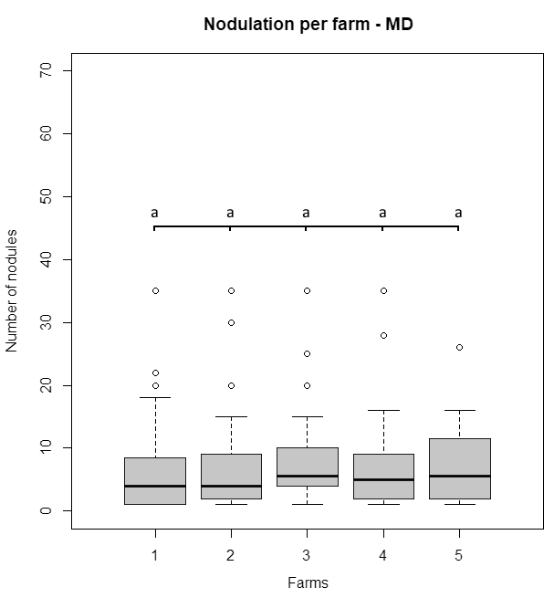

Farms

Number of nodules per plant

Figure S1. Preliminary investigation of cowpea natural nodulation at Mau Dong commune, Van Yen district, Yen Bai province, Vietnam in 2017

Means followed by the same letter are not significantly different according to Tukey’s HSD test at *P<0.05*.