**Supplement materials**

**Table S1**

Basic information of sampling points in Fuzhou Jasmine cultivation area.

|  |  |  |  |  |  |  |  |  |
| --- | --- | --- | --- | --- | --- | --- | --- | --- |
| Number | Sampling point | Longitude and latitude | Altitude (m) | Sand (%) | Silt (%) | Clay (%) | Geography | pH |
| S1 | Huangshi Village, Yingqian Street, Changle District | E 119°24'29"；  N 25°56'45" | 1 | 4.26 | 29.88 | 65.86 | Plain | 7.00 |
| S2 | Huangshi Village, Yingqian Street, Changle District | E 119°24'34"；  N 25°56'7" | 28 | 13.33 | 25.89 | 60.79 | Hilltop | 6.34 |
| S3 | Chunyang Village, Wutong Town, Yongtai County | E 118°45'13"；  N 25°44'1" | 96 | 9.07 | 40.77 | 50.16 | Plain | 5.95 |
| S4 | Chunguang Village, Wutong Town, Yongtai County | E 118°45'51"；  N 25°44'7" | 95 | 3.90 | 44.48 | 51.62 | The crook plain | 6.02 |
| S5 | Suyang Village, Zhuqi Township, Minhou County | E 119°9'27"；  N 26°6'11" | 18 | 7.03 | 44.34 | 48.63 | Flood plains | 6.00 |
| S6 | Nanjie Village, Toubao Township, Lianjiang County | E 119°37'12"；  N 26°20'22" | 27 | 6.18 | 31.35 | 62.48 | Basin | 6.18 |
| S7 | Meili Village, Guanban Town, Lianjiang County | E 119°39'19"；  N 26°18'41" | 22 | 8.67 | 32.88 | 58.45 | Plain | 5.93 |
| S8 | Lanpu Village, Yuxi Town, Fuqing City | E 119°18'36"；  N 25°36'24" | 12 | 4.66 | 18.50 | 76.84 | Plain | 5.93 |
| S9 | Huashi Village, Dongzhang Town, Fuqing City | E 119°11'45"；  N 25°41'7" | 86 | 5.57 | 28.20 | 66.22 | Gentle slope | 5.89 |
| S10 | Huashi Village, Dongzhang Town, Fuqing City | E 119°11'22"；  N 25°41'10" | 75 | 8.71 | 27.54 | 63.75 | Gentle slope | 5.98 |
| S11 | Fushan Village, Jingyang Town, Fuqing City | E 119°15'31"；  N 25°44'33" | 124 | 2.59 | 27.46 | 69.96 | Gentle slope | 5.96 |

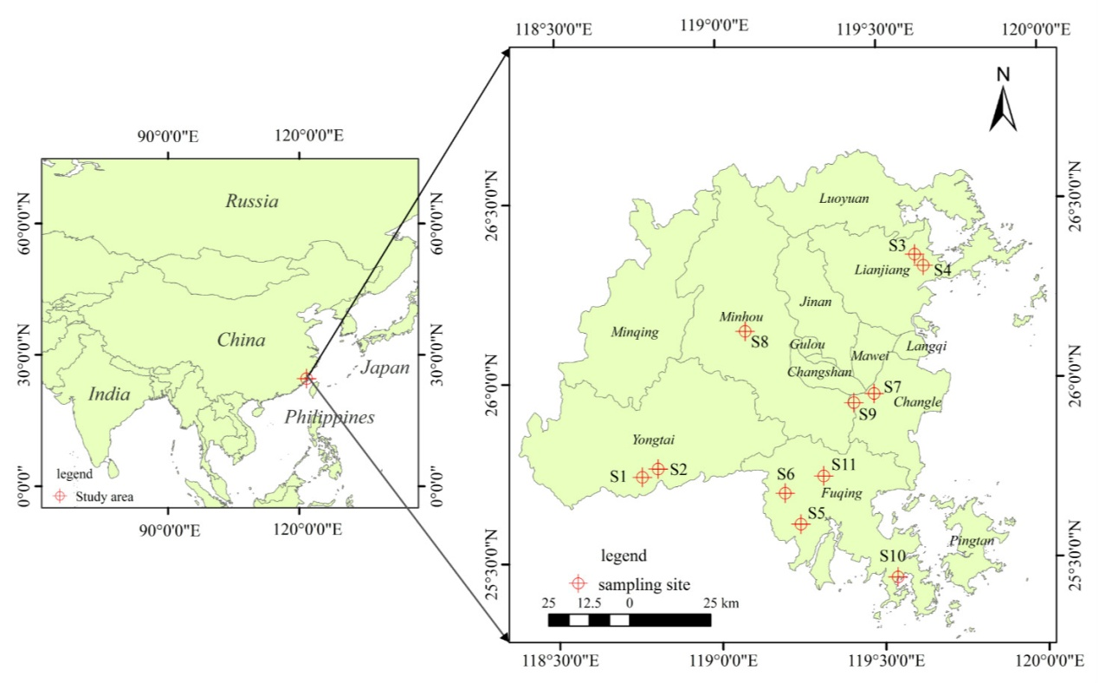

**Figure S1:** The location of the study area and sampling sites in Fujian province, South East China.



**Figure S2:** Variation in St (%) in the 0-15 cm soil depth acrosssampling sites in Fujian province, South East China