**Supplement materials**

**Table S1**

Summary of the RM-ANOVAs for soil nutrients and environmental factors in rice paddy fields throughout the study in response to different biochar application rates.

|  |  |  |  |  |  |  |  |  |  |  |  |
| --- | --- | --- | --- | --- | --- | --- | --- | --- | --- | --- | --- |
|  | Soil temperature | Bulk density | pH | Salinity | NH4+-N | NO3--N | MBC | LOC | Total Fe | Fe2+ | Fe3+ |
| Early rice |  | | | | | | | | | | |
| Treatment | ns | ns | ns | ** | ns | ns | ns | ns | * | * | ns |
| Time | ** | ** | ns | ** | ns | * | * | * | ** | ** | ** |
| Treatment × Time | ** | ns | ns | * | ns | ns | ns | ns | ns | ** | ** |
| Late rice |  | | | | | | | | | | |
| Treatment | ns | ns | ns | ** | ** | ** | ns | ns | ns | ** | ns |
| Time | ** | ** | * | ** | ** | ** | * | * | ** | ** | ** |
| Treatment × Time | ** | ns | ns | ** | ** | ** | ns | ns | * | ** | ** |

ns, not significant.

* significant at *p* < 0.05 level.

** significant at *p* < 0.01 level.

**Table S2**

Correlation between GHG fluxes and environmental factors in the early and late rice growing season after biochar application (Pearson correlation coefficient).

|  |  |  |  |  |  |
| --- | --- | --- | --- | --- | --- |
| GHG | Factors | Control | 10 t ha-1 | 20 t ha-1 | 40 t ha-1 |
| Early rice |  |  |  |  |  |
| CH4 | Salinity | 0.451** | 0.474** | 0.612** | 0.581** |
| Soil temperature | -0.231 | -0.262 | -0.641** | -0.352* |
| pH | 0.162 | -0.316 | 0.250 | -0.219 |
| Bulk density | -0.075 | -0.031 | -0.233 | -0.174 |
| Total Fe | 0.062 | 0.008 | -0.008 | 0.056 |
| Fe2+ | 0.419* | 0.156 | -0.139 | 0.086 |
| Fe3+ | -0.156 | -0.057 | 0.047 | 0.033 |
| N2O | Salinity | 0.296 | 0.212 | 0.597** | 0.294 |
| Soil temperature | -0.330* | -0.124 | -0.442** | -0.131 |
| pH | 0.188 | 0.285 | 0.116 | -0.057 |
| Bulk density | -0.253 | -0.020 | -0.322 | 0.020 |
| Total Fe | -0.239 | 0.021 | -0.108 | -0.178 |
| Fe2+ | -0.120 | -0.029 | -0.044 | -0.125 |
| Fe3+ | -0.201 | 0.036 | -0.100 | -0.157 |
| Late rice |  |  |  |  |  |
| CH4 | Salinity | 0.554** | 0.510** | 0.718** | 0.483** |
| Soil temperature | 0.480** | 0.444** | 0.551** | 0.541** |
| pH | 0.302* | 0.239 | 0.294* | 0.098 |
| Bulk density | -0.087 | -0.368* | -0.027 | 0.080 |
| Total Fe | 0.039 | 0.088 | -0.255 | 0.035 |
| Fe2+ | 0.111 | 0.411** | -0.485** | -0.051 |
| Fe3+ | -0.050 | -0.050 | -0.139 | 0.053 |
| N2O | Salinity | -0.334* | -0.283 | 0.238 | -0.034 |
| Soil temperature | -0.214 | -0.135 | 0.383** | -0.095 |
| pH | -0.221 | 0.196 | -0.088 | -0.068 |
| Bulk density | 0.188 | 0.022 | -0.220 | 0.331* |
| Total Fe | -0.283 | 0.223 | -0.310* | 0.060 |
| Fe2+ | -0.141 | 0.219 | -0.325* | -0.016 |
| Fe3+ | -0.055 | 0.163 | -0.246 | 0.063 |

**Table S3**

Correlation between soil nutrients and organic carbon fractions and GHG fluxes in rice paddy fields (Pearson correlation coefficient).

|  |  |  |  |  |  |
| --- | --- | --- | --- | --- | --- |
| GHG | Factors | Control | 10 t ha-1 | 20 t ha-1 | 40 t ha-1 |
| Early rice |  |  |  |  |  |
| CH4 | NH4+-N | -0.100 | -0.335 | -0.173 | -0.129 |
| NO3--N | -0.290 | 0.156 | 0.123 | 0.014 |
| MBC | -0.292 | 0.266 | -0.222 | 0.475 |
| LOC | -0.075 | -0.411 | -0.654* | -0.348 |
| N2O | NH4+-N | -0.018 | -0.053 | -0.095 | -0.344 |
| NO3--N | 0.342 | -0.306 | -0.773** | -0.210 |
| MBC | -0.344 | -0.358 | 0.536 | 0.167 |
| LOC | 0.338 | 0.440 | -0.205 | -0.226 |
| Late rice |  |  |  |  |  |
| CH4 | NH4+-N | 0.974** | 0.761** | 0.610* | 0.645* |
| NO3--N | -0.458 | -0.531 | -0.545 | -0.612* |
| MBC | -0.053 | -0.469 | -0.182 | -0.597* |
| LOC | 0.188 | -0.159 | -0.312 | 0.060 |
| N2O | NH4+-N | -0.064 | 0.042 | 0.333 | -0.520 |
| NO3--N | 0.119 | -0.107 | -0.463 | 0.415 |
| MBC | 0.475 | -0.019 | -0.543 | 0.366 |
| LOC | -0.119 | -0.072 | 0.238 | -0.067 |

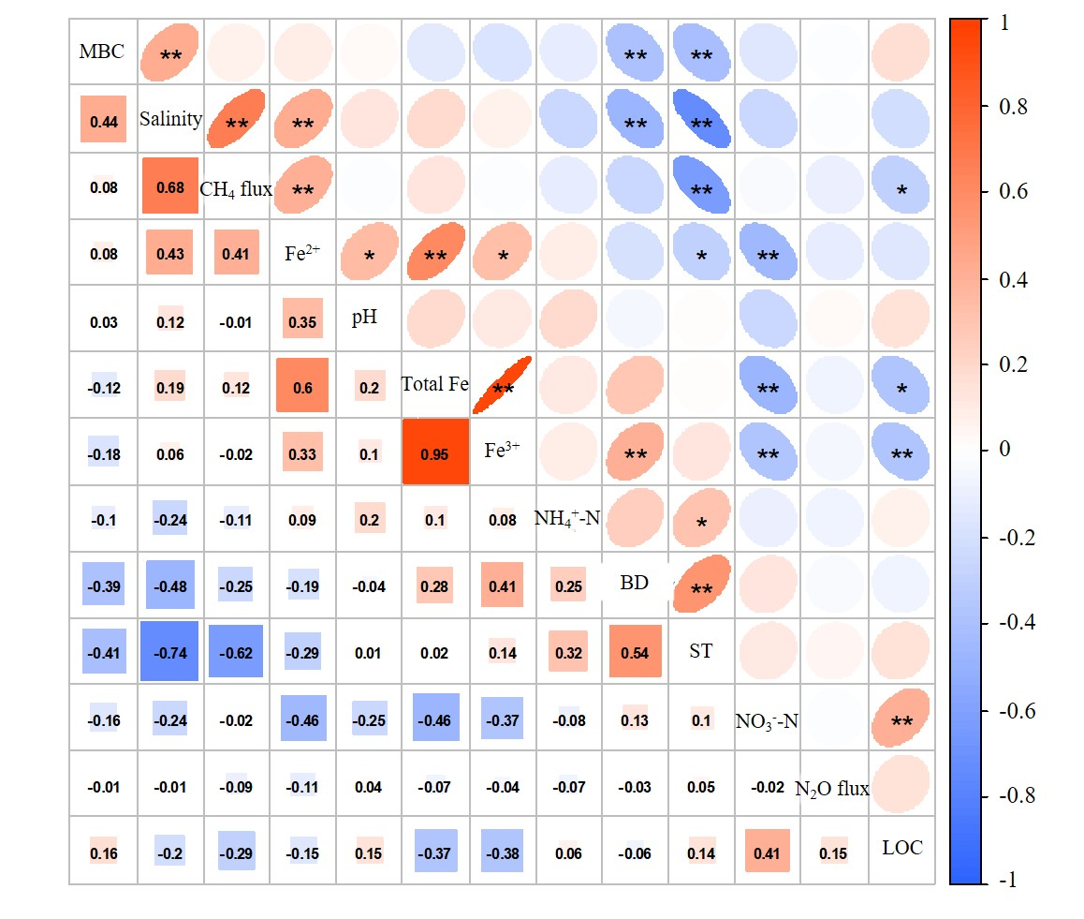

**Figure S1.** Correlation between GHG fluxes and environmental factors and soil nutrients of early rice. (Total Fe, Fe2+, Fe3+: Soil total Fe, Fe2+ and Fe3+ concentrations; pH: Soil pH; Salinity: Soil salinity; BD: Bulk density; ST: Soil temperature; LOC: Liable organic carbon; MBC: Microbial biomass carbon. \**p* < 0.05, \*\**p* < 0.01.)

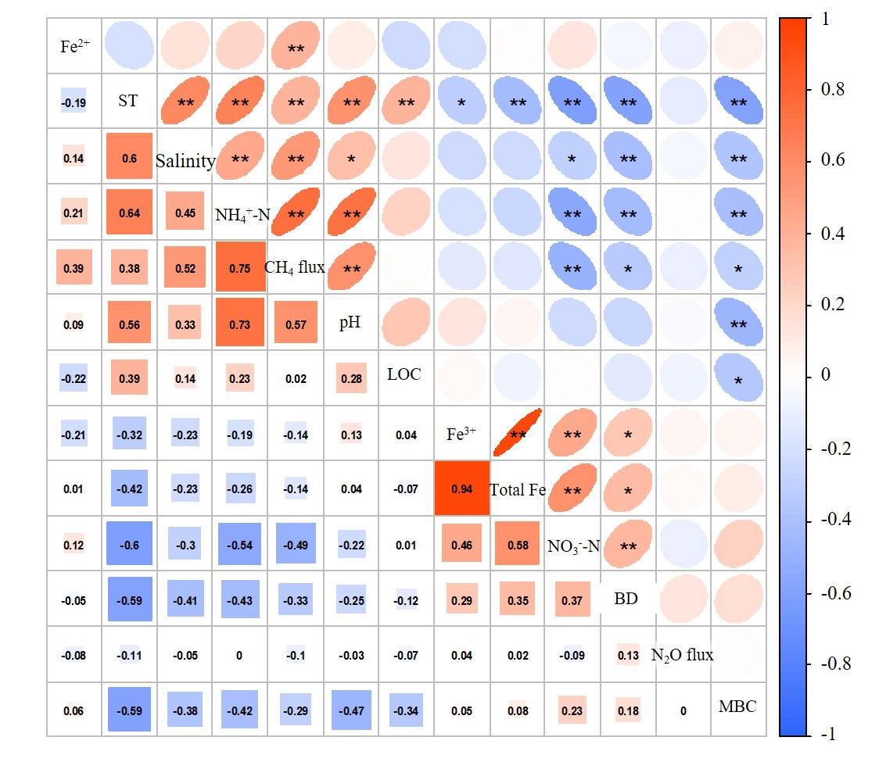

**Figure S2.** Correlation between GHG fluxes and environmental factors and soil nutrients of late rice. (Total Fe, Fe2+, Fe3+: Soil total Fe, Fe2+ and Fe3+ concentrations; pH: Soil pH; Salinity: Soil salinity; BD: Bulk density; ST: Soil temperature; LOC: Liable organic carbon; MBC: Microbial biomass carbon. \**p* < 0.05, \*\**p* < 0.01.)



**Figure S3.** Air temperature and relative humidity during the experiment.