**SUPPLEMENTARY MATERIAL (Original SM)**



**Supplementary Material Figure S1**. *Location of the study area. The experimental sites were located in Northern Rwanda at altitude range of 2245 m and 2269m.*



**Supplementary Material Figure S2**. *The soil taxonomy of the study area.* The soils of the area are Alfisols (*Ultic Tropudalf*), Inceptisols (*Andic Eutropept*; *Typic Dystrandept*; *Entic Eutrandept*), and Mollisols (*Cumulic Hapludoll*).

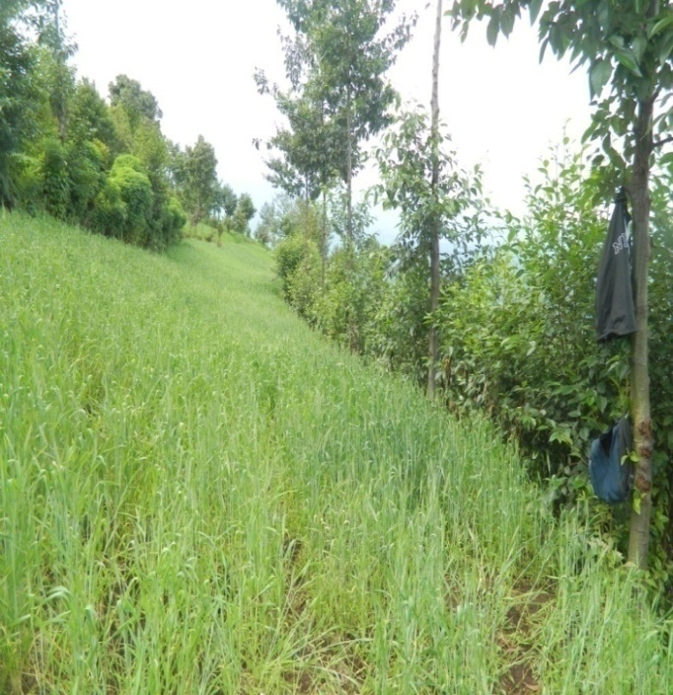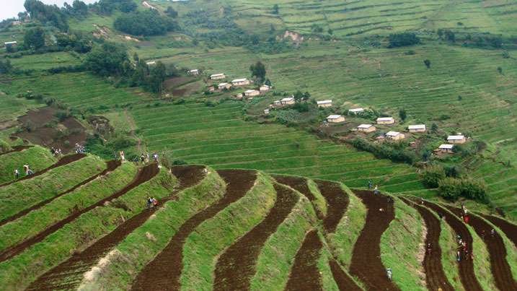

**Supplementary Material Figure S3**. *The intercrop wheat was grown in the farmer’s field on bench terraces. The terraces were established in 2010 with transplants of Alnus acuminata trees on the terrace risers.*