Supplementary material

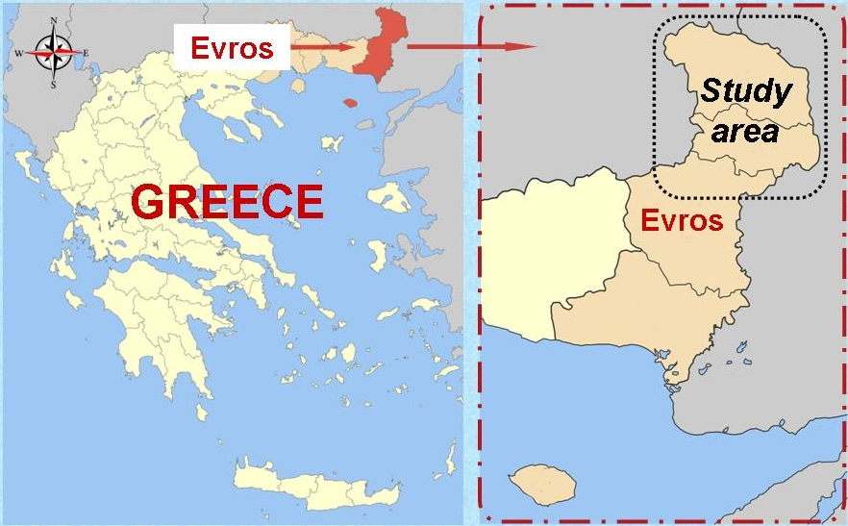

Fig. S1 Map of the study area

