SUPPLEMENTAL FIGURE LEGENDS
SUPPLEMENTAL FIGURE 1: Pilot study to determine the high-throughput 22- minute assay time point. Variation in chill-coma recovery profiles is shown for thirteen randomly chosen Raleigh-inbred lines. Two replicates of 25 flies per line and sex was subjected to the standard chill-coma stress (i.e., 3 hours at 0º C) and then recovery time was measured in minutes at 23º C. The x-axis is the time in minutes at 23º C after cold stress, while the y-axis is the cumulative percentage of flies recovered from chill coma each minute during the 60-minute observation period. The average 50% recovery time of these thirteen lines was approximately 22 minutes (see methods).

SUPPLEMENTAL FIGURE 1.

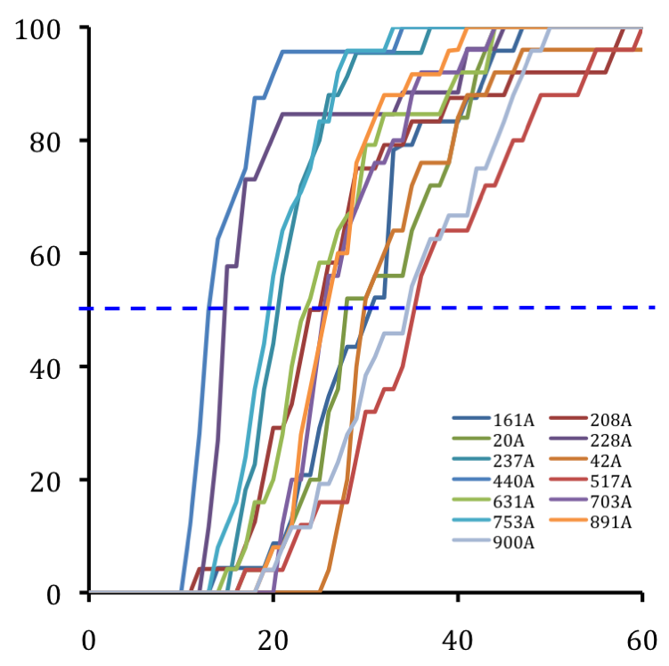
Time at 23ºC (Minutes)
% Recovery from Chill Coma
SUPPLEMENTAL TABLE 1: Allele frequencies for the polymorphisms identified in Smp-30. Marker names correspond to the common allele, the position in base pairs relative to the ATG start site (i.e., the beginning of exon 2), then the minor allele. In cases were three allelic classes were discovered the minor alleles are listed in order of descending allele frequency. Markers listed in bold had significant associations with variation in percent recovery from chill coma.
 |  | Allele Frequencies |  |  |  |  | Allele Frequencies
# | Marker name | Common | Rare (1) | Rare (2) | # | Marker Name | Common | Rare (1) | Rare (2)
1 | Del-702In | 0.87 (Del) | 0.13 (In) |  | 41 | T389A | 0.95 (T) | 0.05 (A)
2 | T-692G | 0.96 (T) | 0.04 (G) |  | 42 | C395T | 0.58 (C) | 0.42 (T)
3 | A-677G | 0.85 (A) | 0.15 (G) |  | 43 | A398C | 0.53 (A) | 0.47 (C)
4 | C-668T | 0.83 (C) | 0.17 (T) |  | 44 | C464T | 0.79 (C) | 0.21 (T)
5 | A-660G | 0.95 (A) | 0.05 (G) |  | 45 | G493A | 0.97 (G) | 0.03 (A)
6 | T-652C | 0.95 (T) | 0.05 (C) |  | 46 | A545G | 0.92 (A) | 0.08 (G)
7 | G-632A | 0.83 (G) | 0.17 (A) |  | 47 | A581G | 0.60 (A) | 0.40 (G)
8 | A-630G | 0.56 (A) | 0.44 (G) |  | 48 | G620A | 0.95 (G) | 0.05 (A)
9 | AT-623TA | 0.61 (AT) | 0.39 (TA) |  | 49 | T659C | 0.81 (T) | 0.19 (C)
10 | Del-603In,Del2 | 0.47 (9bp) | 0.43 (In) | 0.09 (10bp) | 50 | T665G | 0.63 (T) | 0.37 (G)
11 | A-555T | 0.87 (A) | 0.13 (T) |  | 51 | G726A | 0.97 (G) | 0.03 (A)
12 | T-519C | 0.95 (T) | 0.05 (C) |  | 52 | C730T | 0.66 (C) | 0.34 (T)
13 | G-484T | 0.87 (G) | 0.13 (T) |  | 53 | C778T | 0.86 (C) | 0.14 (T)
14 | T-441C | 0.87 (T) | 0.13 (C) |  | 54 | T793C | 0.78 (T) | 0.22 (C)
15 | G-404A | 0.76 (G) | 0.24 (A) |  | 55 | C853T | 0.75 (C) | 0.25 (T)
16 | C-402T | 0.60 (C) | 0.40 (T) |  | 56 | G895A | 0.95 (G) | 0.05 (A)
17 | G-401T | 0.82 (G) | 0.18 (T) |  | 57 | A898G | 0.68 (A) | 0.32 (G)
18 | G-344A,T | 0.72 (G) | 0.20 (A) | 0.08 (T) | 58 | T910C | 0.66 (T) | 0.34 (C)
19 | A-289G | 0.77 (A) | 0.23 (G) |  | 59 | T999C | 0.85 (T) | 0.15 (C)
20 | T-275C | 0.93 (T) | 0.07 (C) |  | 60 | G1041T | 0.84 (G) | 0.16 (T)
21 | T-171A | 0.84 (T) | 0.16 (A) |  | 61 | G1047A | 0.93 (G) | 0.07 (A)
22 | Del-160In | 0.86 (Del) | 0.14 (In) |  | 62 | G1050T | 0.55 (G) | 0.45 (T)
23 | Del-141In | 0.53 (Del) | 0.47 (In) |  | 63 | T1060C | 0.50 (T) | 0.50 (C)
24 | C-134T | 0.60 (C) | 0.40 (T) |  | 64 | C1073T | 0.51 (C) | 0.49 (T)
25 | G-117A | 0.71 (G) | 0.29 (A) |  | 65 | T1077A | 0.95 (T) | 0.05 (A)
26 | In-74Del | 0.89 (In) | 0.11 (Del) |  | 66 | T1088C | 0.67 (T) | 0.33 (C)
27 | Del-52In,Del2 | 0.64 (Del) | 0.32 (In) | 0.04 (Del2) | 67 | In1095Del | 0.96 (In) | 0.04 (Del)
28 | T-37A | 0.94 (T) | 0.06 (A) |  | 68 | C1107T | 0.77 (C) | 0.23 (T)
29 | A-14G | 0.86 (A) | 0.14 (G) |  | 69 | C1117T | 0.90 (C) | 0.10 (T)
30 | C-11T | 0.92 (C) | 0.08 (T) |  | 70 | T1124A | 0.96 (T) | 0.04 (A)
31 | A20G | 0.55 (A) | 0.45 (G) |  | 71 | A1127G | 0.97 (A) | 0.03 (G)
32 | G86T | 0.96 (G) | 0.04 (T) |  | 72 | G1132A | 0.63 (G) | 0.37 (A)
33 | C125T | 0.97 (C) | 0.03 (T) |  | 73 | T1136A | 0.96 (T) | 0.04 (A)
34 | A151G | 0.52 (A) | 0.48 (G) |  | 74 | G1154A | 0.96 (G) | 0.04 (A)
35 | G182C | 0.78 (G) | 0.22 (C) |  | 75 | G1184T | 0.61 (G) | 0.39 (T)
36 | C269T | 0.83 (C) | 0.17 (T) |  | 76 | A1185T | 0.93 (A) | 0.07 (T)
37 | G302A | 0.93 (G) | 0.07 (A) |  | 77 | T1192C | 0.92 (T) | 0.08 (C)
38 | C314T | 0.60 (C) | 0.40 (T) |  | 78 | T1197A | 0.71 (T) | 0.29 (A)
39 | A385C | 0.60 (A) | 0.40 (C) |  | 79 | G1201A | 0.96 (G) | 0.04 (A)
40 | C386A | 0.65 (C) | 0.35 (A)

