Supplementary Table 1. Complete or partial copia sequences obtained in the FlyBase section on natural transposons
Genome Described | Type of Sequence | Accession number (NCBI)
D. antonietae | 5' LTR | AY655749
D. buzzatii | Complete | X96972
D. erecta | 5' LTR-URL | AF063869
D. gouveai | 5' LTR | AY655748
bD. Koepferae | Complete | X96971
D. mauritiana | 5' LTR-URL | AF063872
D. sechellia | 5' LTR-URL | AF063878
D. serido | 5' LTR | AY655747
D. seriema | 5' LTR | AY655750
D. simulans | Complete | D10880
D. teissieri | 5' LTR-URL | AF063883
D. willistoni | LTR and polyprotein gene | AF175766
D. yakuba | 5' LTR-URL | AF063884
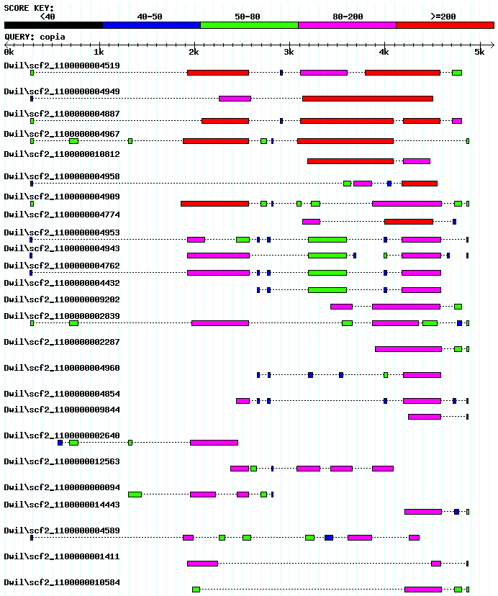
A

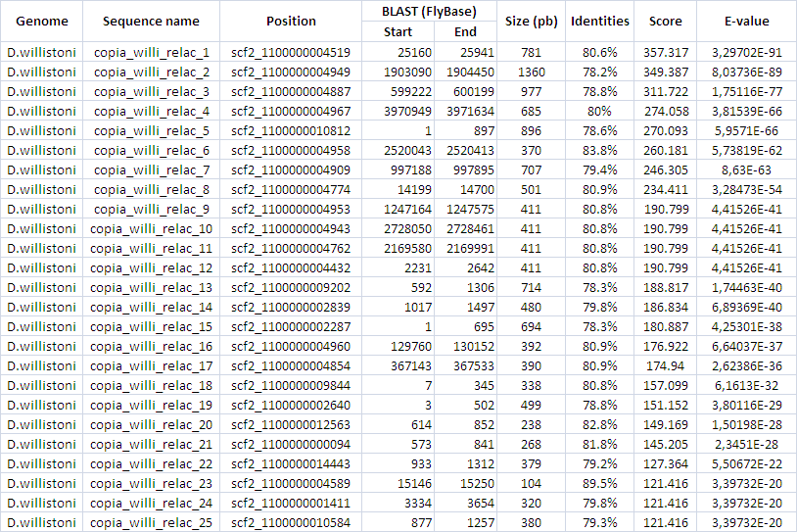
B

Supplementary Figure 1. FlyBase BLAST hits in D. willistoni genome using the canonical copia element of D. melanogaster as query. A) Output similarity scheme of Blast search, showing that the obtained hits have some regions with high similarity and other with median or low similarity. B) Scaffold position, size, identity, Score and e-value as obtained for the Blast hits.

