###
Genetics Research

msechBari, a new MITE-like element in Drosophila sechellia related to the Bari transposon

Elaine Silva Dias and Claudia Marcia Aparecida Carareto

Figures S1, S2 and S3 give information about the secondary structure (Figure S1), the alignment of the sequences obtained in a laboratory strain (Figure S2) and the full-length sequences of the transposon Bari found in sequenced genome of D. sechellia (Figure S3).
###

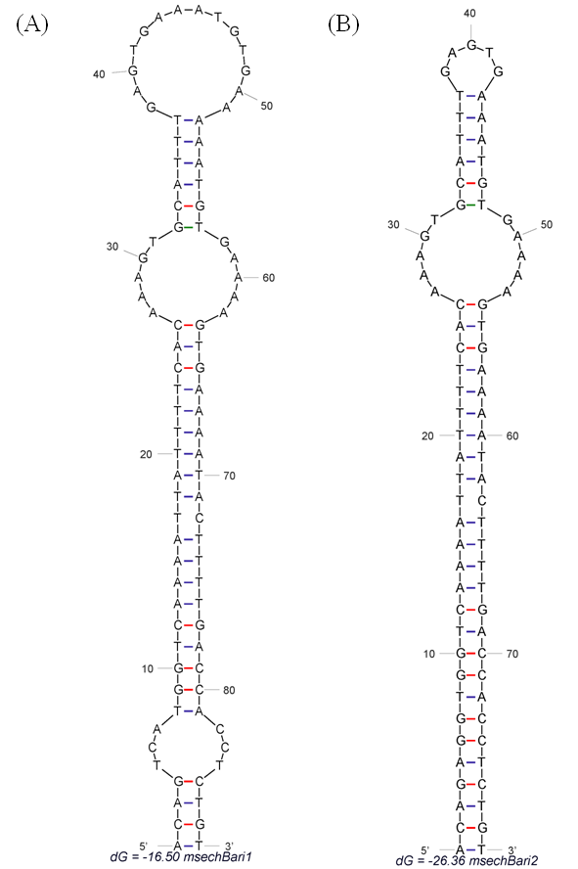

Fig. S1. Secondary structures obtained using both consensus sequences of the miniature inverted transposable elements found in this study. (A) msecBari1, dG = -16.5 kkal/mol; (B) msecBari2, dG = -26.36 kkal/mol.
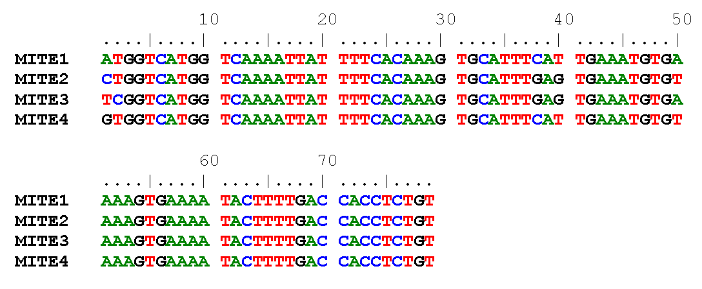

Fig. S2. Alignment of the sequences obtained in laboratory strain of D. sechellia.

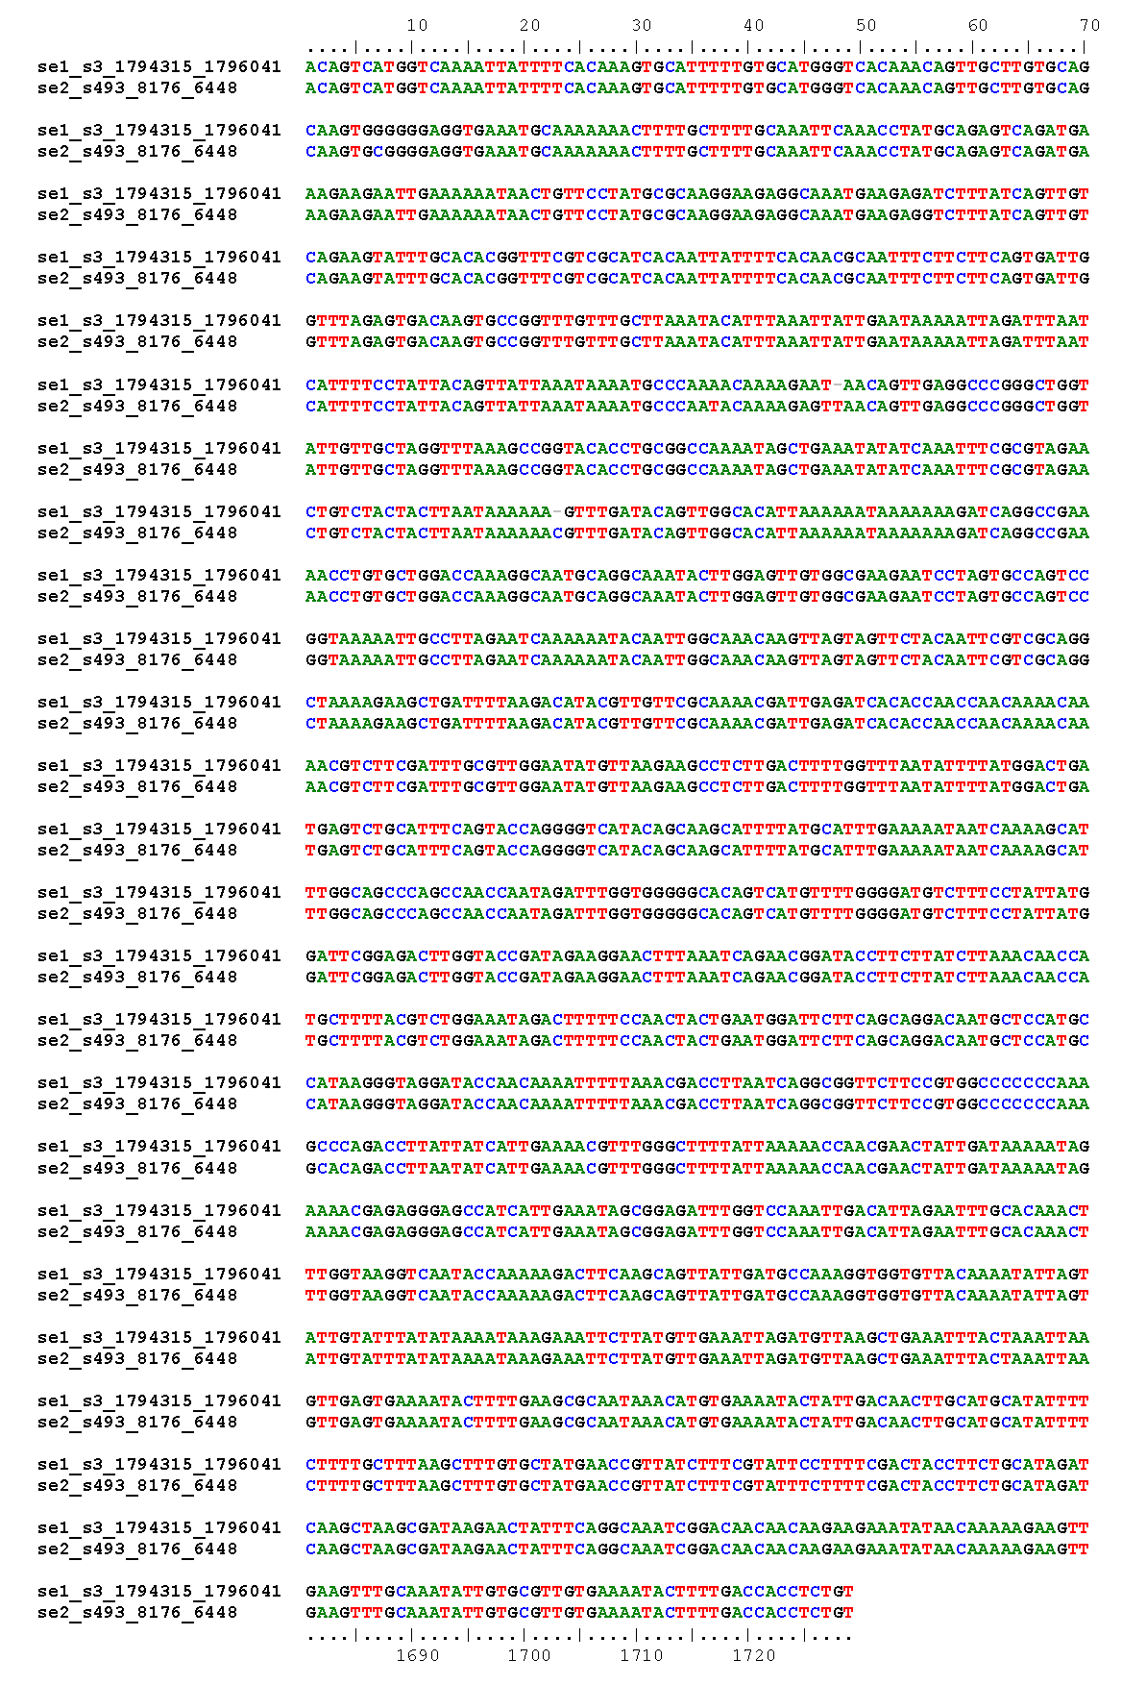
Fig. S3. The full sequences of the transposon Bari found in the sequenced genomes of D. sechellia. The name of the sequences correspond to their localization in the genome (s3 = scaffold 3; s493 = scaffold 4930.

