Geological Magazine

Authigenesis of native sulphur and dolomite in a lacustrine evaporitic setting (Hellín basin, Late Miocene, SE Spain)

J. LINDTKE, S. B. ZIEGENBALG, B. BRUNNER, J. M. ROUCHY, C. PIERRE & J. PECKMANN

Appendix

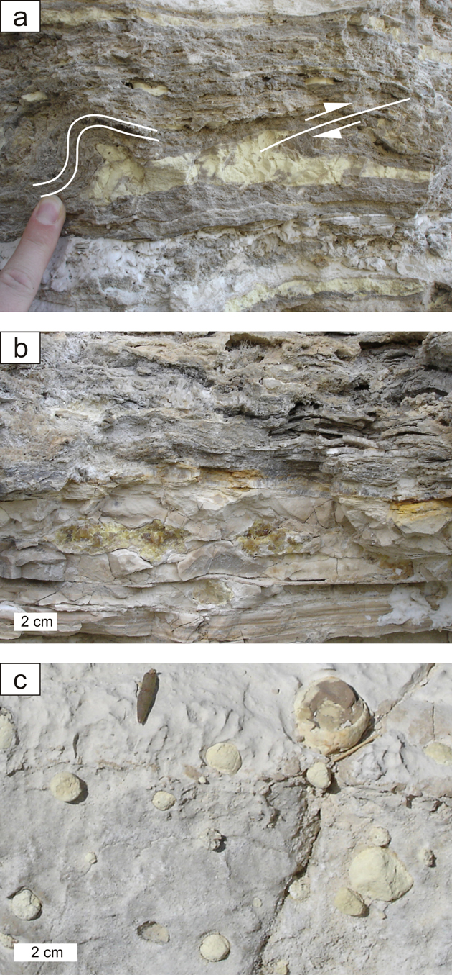
Figure 2. Native sulphur. (a) Sulphur enclosed in secondary gypsum; overlying laminar gypsum beds are bent and faulted (see indication), Las Minas. (b) Sulphur enclosed in carbonate deposits, Las Minas. (c) Sulphur nodules embedded in a carbonate bed, Cenajo.

