Geological Magazine

Thermal maturity of the Upper Triassic–Middle Jurassic Shemshak Group (Alborz Range, Northern Iran) based on organic petrography, geochemistry and basin modelling: implications for source rock evaluation and petroleum exploration

ALI SHEKARIFARD, FRANÇOIS BAUDIN, KAZEM SEYED-EMAMI, JOHANN SCHNYDER, FATIMA LAGGOUN-DEFARGE, ARMELLE RIBOULLEAU, MARIE-FRANÇOISE BRUNET & ALIREZA SHAHIDI

Appendix

Figure 5. Microphotographs of dispersed organic matter in the samples from the Shemshak Group (incident white light). (a) Dark grey vitrinite; CCS units, Damavand section. (b) Vitrinite with a lot of pyrite; UTS unit, Jajarm section. (c) Autochthonous vitrinite (AV) and reworked vitrinite (RV); over-mature sample, UTS unit, Tazareh section. Vitrinite appears bright brown in the high maturity samples. (d) Coke from vitrinite showing irregular pores resulting from gas expulsion; over-mature sample, UTS unit, Tazareh section. (e) Over-mature sporinite (Sp) with the same reflectance as vitrinite (V), UTS unit, Tazareh section. (f) Solid bitumen; basal shales of the Ekrasar Formation, Galanderud section. (g) Inertinite with oxidation rims; over mature sample, UTS unit, Tazareh section. (h) Semifusinite with cellular structure and pyrite framboids; mature sample, UTS unit, Jajarm section.

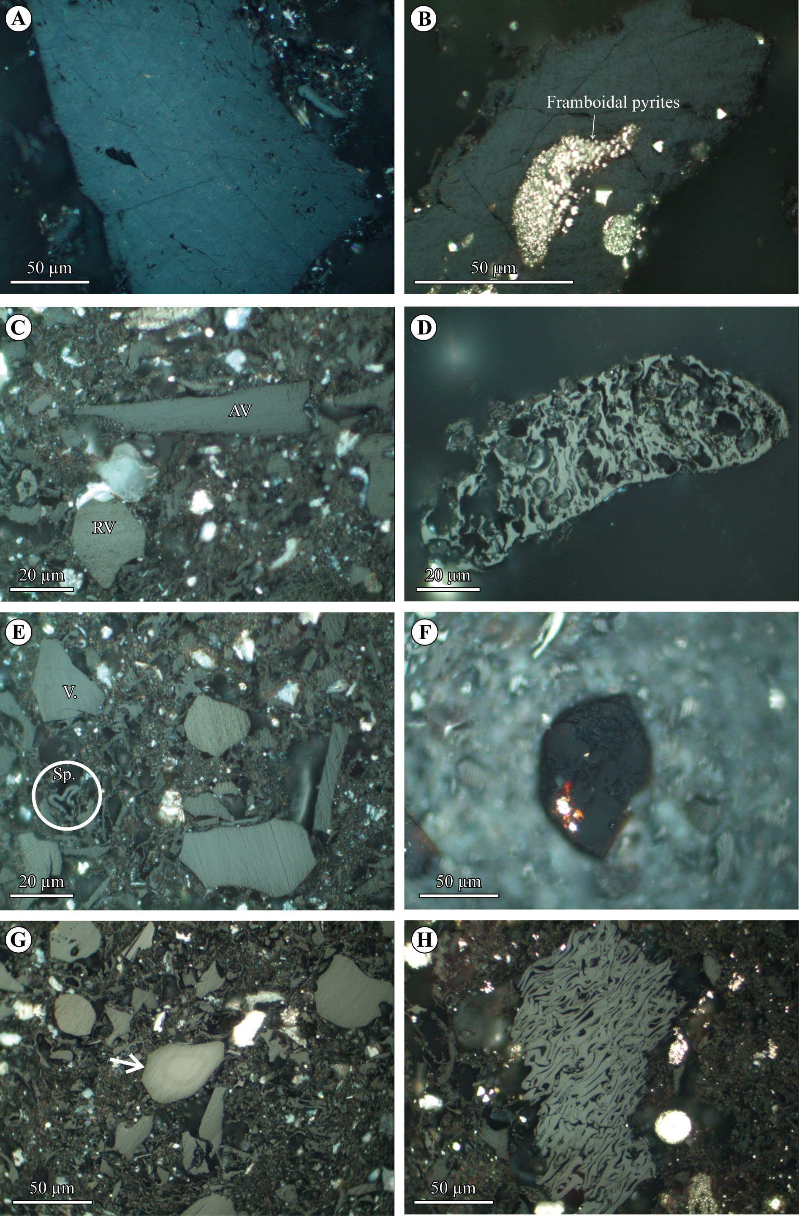

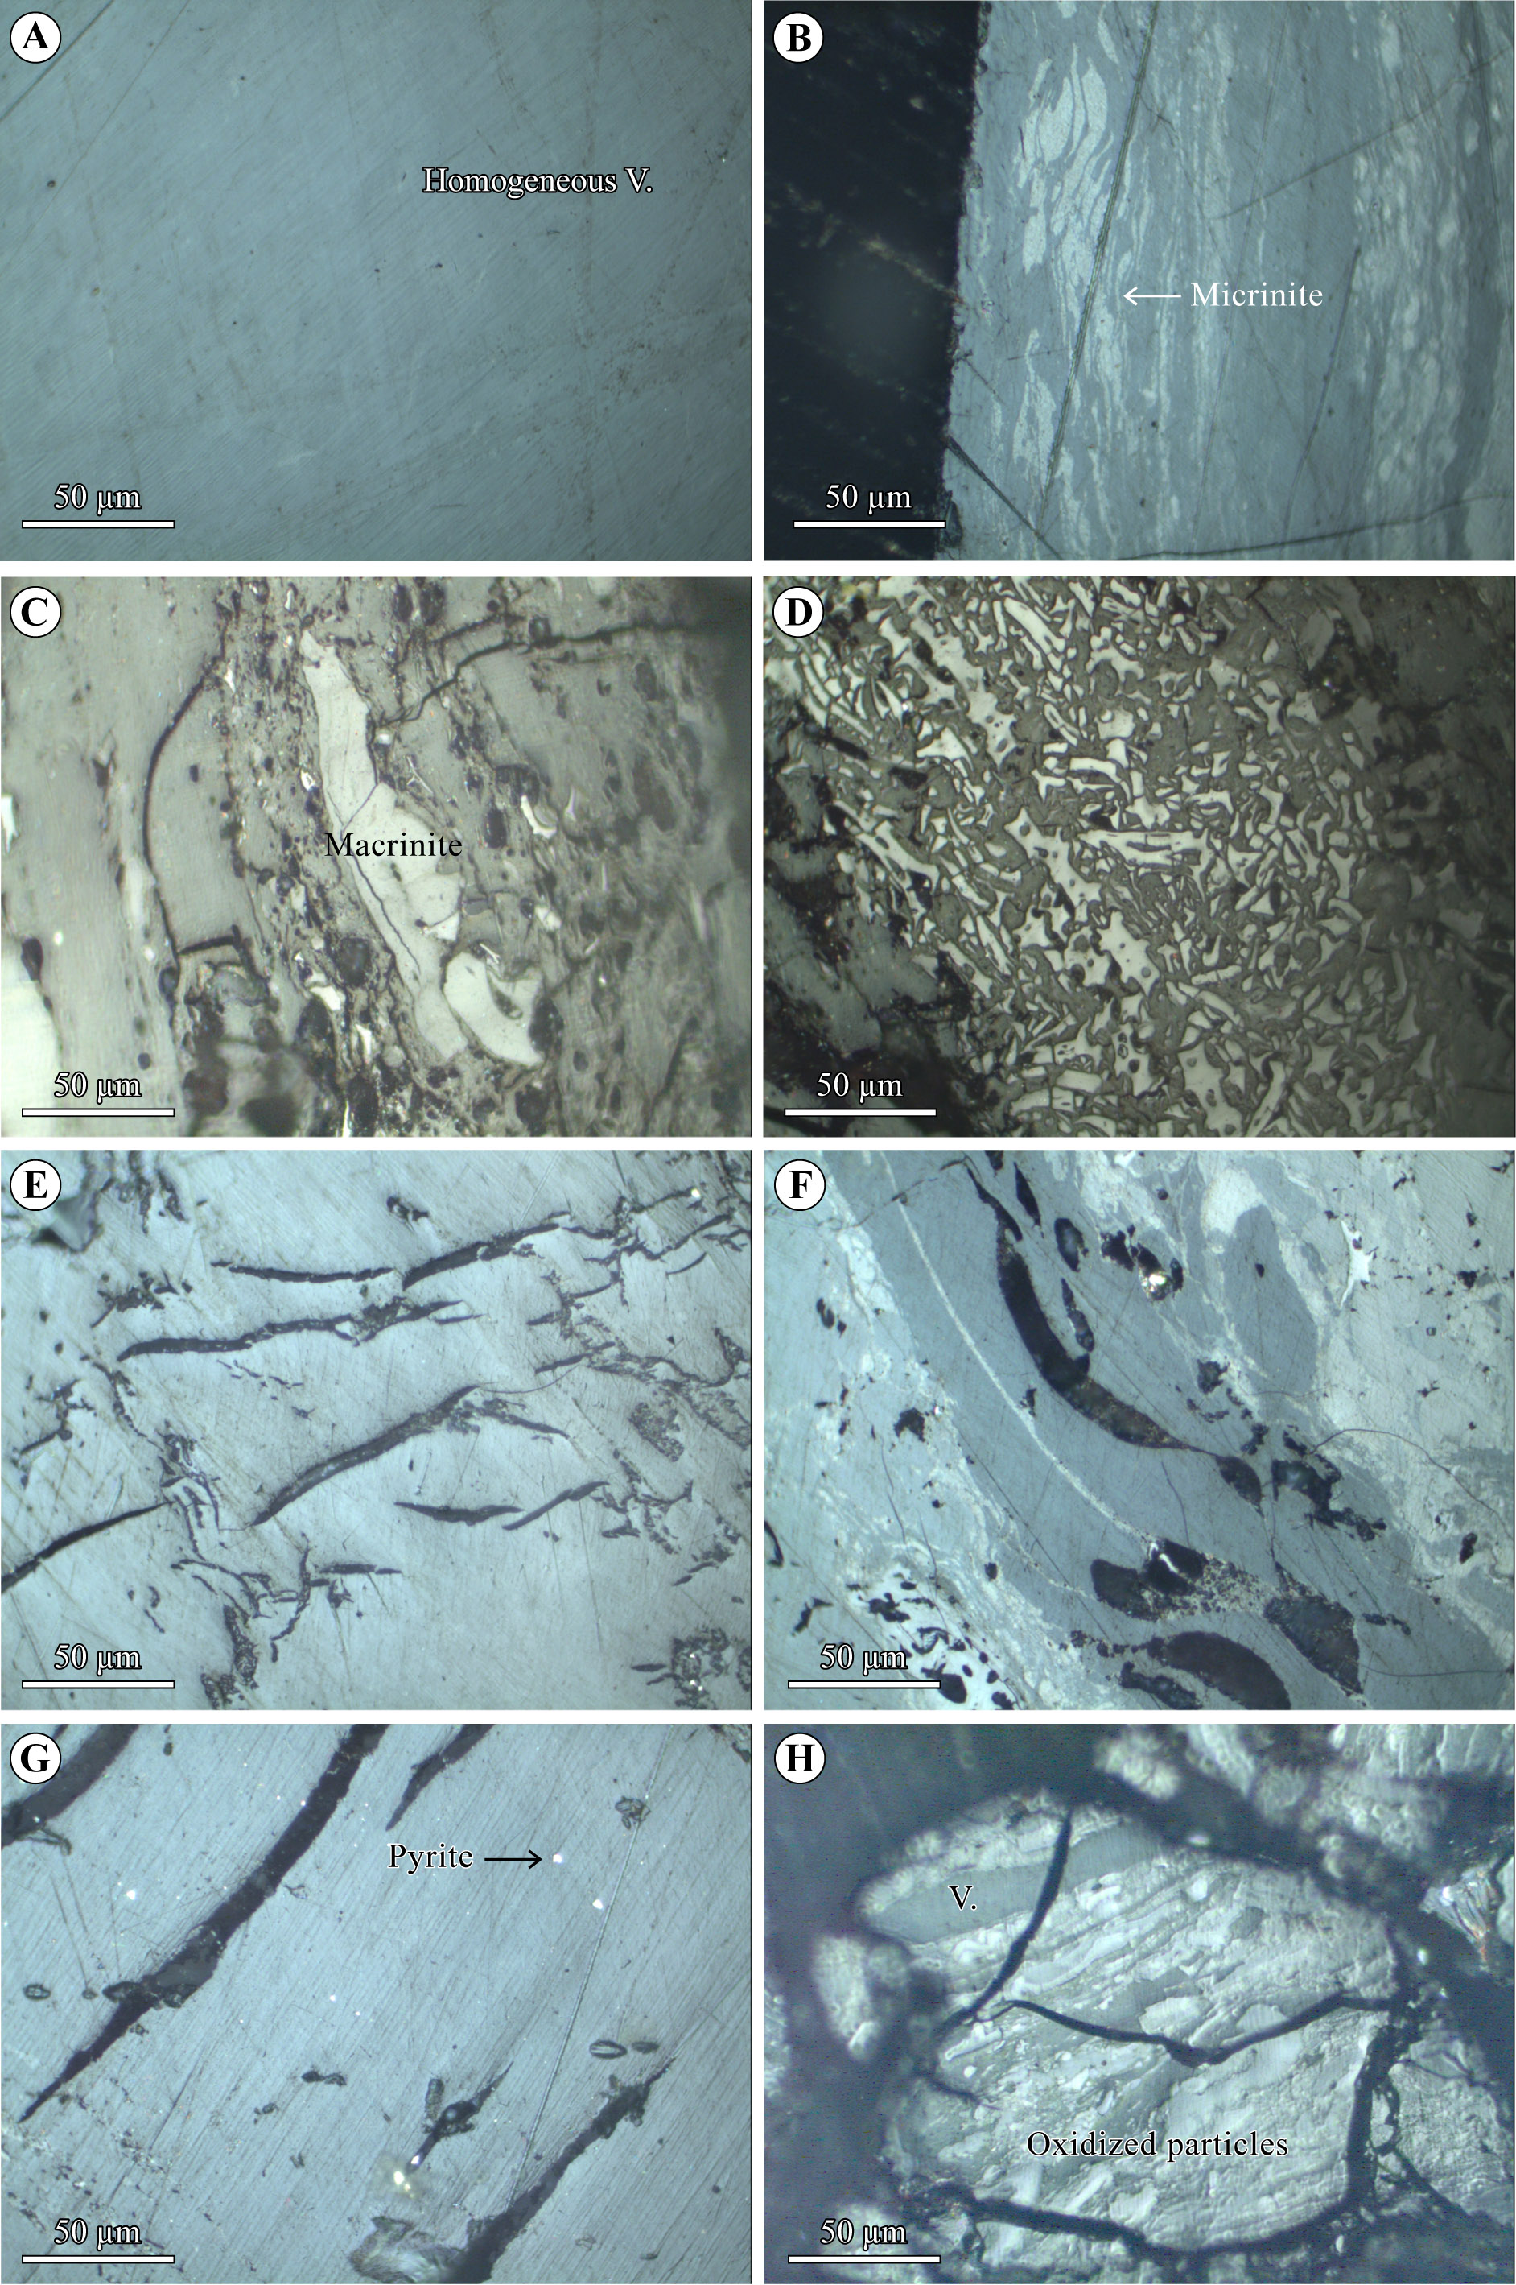
Figure 6. Microphotographs of the selected coals from the Shemshak Group in the Alborz Range (incident white light). Images (a), (b), (e), (f) and (g) belong to the Hive coals; (c) and (d) are from the Maragheh coals. (a) Homogeneous vitrinite (V). (b) Micrinite with homogeneous vitrinite. (c) Macrinite. (d) Fusinite. (e) Microfractures within pure homogenous vitrinite showing pinch and swell structure. (f) Selected concentrations of cracks and cavities in a vitrinite-dominated part of coal, filled by possible solid bitumen. (g) Parallel microfractures in vitrinite with disseminated pyrites. Cracks filled by possible solid bitumen. (h) Dominance of oxidized particles in the coals of the Shahmirzad section.

