Geological Magazine

Kinematics of rock flow and fabric development associated with shear deformation within the Zagros transpression zone, Iran

ALI FAGHIH & KHALIL SARKARINEJAD

Appendix

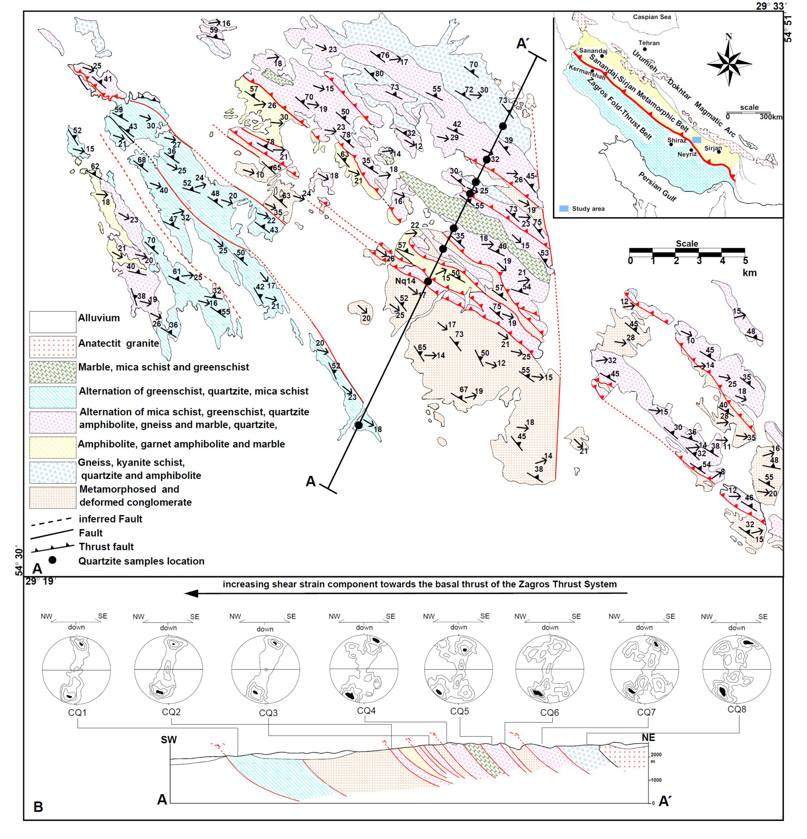

Figure 1. (a) Geological map of the study area. The inset map shows a tectonic map of Iran (modified after Alavi, 1994) with the Sanandaj–Sirjan Metamorphic Belt and the location of the study area. (b) The NE–SW transverse cross-section (A–A′) which shows spatial variation of lower hemisphere, equal-area projection of the quartz c-axis fabrics in the study area. The location of the quartzite samples and NE–SW transverse line are displayed in (a). In all these projections, the foliation is vertical and stretching lineation within the foliation is sub-horizontal.

