Geological Magazine

Evidence from the Kyrenia Range, Cyprus of the northerly, active margin of the Southern Neotethys during Late Cretaceous–Early Cenozoic time

Alastair H.F. Robertson¹, Kemal Taslı², Nurdan İnan²

¹School of GeoSciences, West Mains Road, Edinburgh EH9 3JW, UK
²Department of Geology, Mersin University, Mersin 33343, Turkey

Appendix
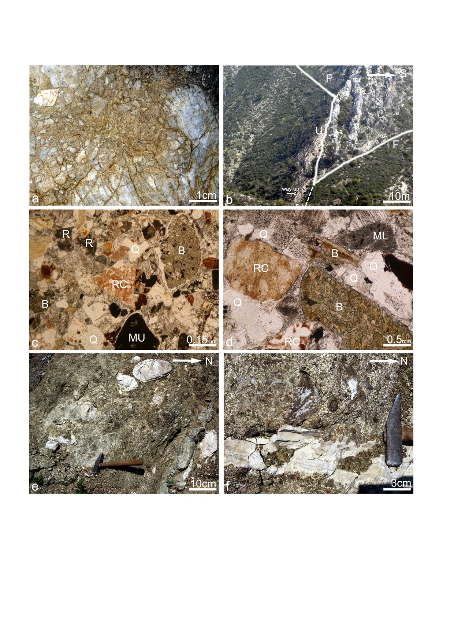
Figure A1. Field photographs and micrographs of Upper Cretaceous lithologies in the western and central Kyrenia Range. (a) Typical tectonic breccia developed from Mesozoic platform carbonate (Trypa (Tripa) Gp.); road section south of Karşıyaka (Vasileia). (b) View of the unconformity between the recrystallized platform carbonate of the Saint Hilarion (Hileryon) Formation and the overlying Upper Cretaceous Mallıdağ (Melounda) Formation. Thick-bedded marble (grey) is overlain with a low-angle discordance by basal carbonate breccia and pink pelagic carbonate of the Mallıdağ (Melounda) Formation, with softer-weathering marls above (vegetation covered). U – Unconformity; F – Fault; Y – younging direction. 2.5 km NW of Profitis Ilias Mountain on the northern flank of the Kyrenia Range. (c) Photomicrograph of coarse sandstone with detrital grains including basalt (chloritized), radiolarian chert, hemipelagic mudstone and quartz, set in calcite spar cement (viewed in plane polarized light); from section in stream cutting 1.5 km east of Ayia Marina chapel, near Beylerbey (Bellapais). Abbreviations: B – Biotite; ML – Micritic limestone; MU – Mudstone; Q – Quartz; QP – Quartz phenocryst (brecciated); RC – Radiolarian chert; R – Rhyolite (flow banded); SC – Silicic glass; ST – Silicic tuff; VM – Volcanogenic mud. (d) Another photomicrograph of coarse sandstone including detrital grains of basalt (chloritized), radiolarian chert, biotite and micritic limestone with a calcite spar cement (also viewed in plane polarized light; same locality as (c) (see c for key to abbreviations). (e) Upper Cretaceous debris flow made up of basaltic talus and rounded to angular clasts of pelagic chalk (pale). Road section 0.6 km north of Geçiköy (Panagra). (f) Pelagic carbonate (pale) containing Globotruncana sp. and other Upper Cretaceous planktonic foraminifera, interbedded with breccia composed or mainly angular clasts of altered basalt with a calcite spar cement; same locality as (e).

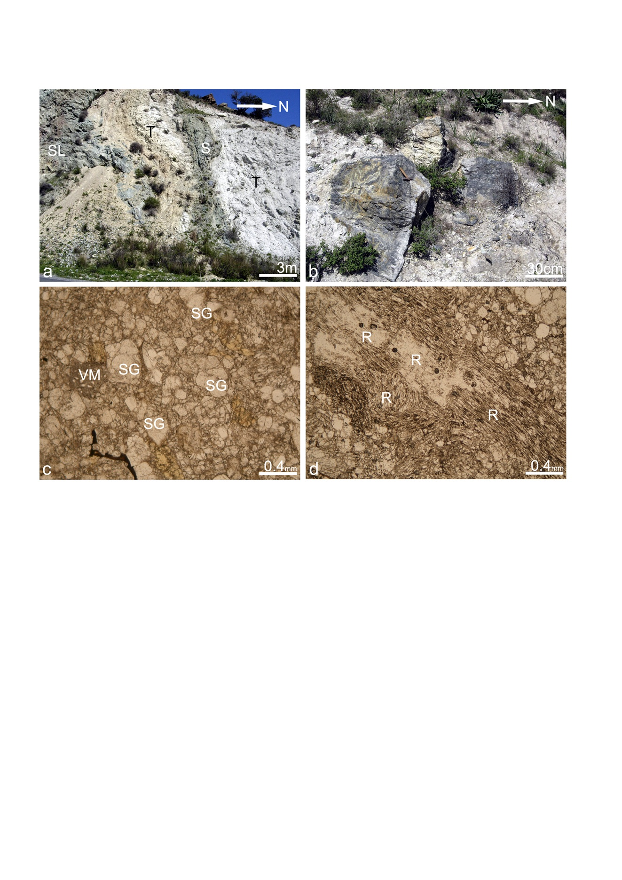
Figure A2. (a) Silicic lava flow (grey; left) interbedded with massive or thick-bedded silicic tuff and tuff breccia (right; pale) and cut by a sub-parallel altered, basaltic sill-like body. Abbreviations: SL – Silicic lava; S – Sill-like body; T – Silicic tuff and tuff breccia. Road section 0.8 km north of Geçiköy (Panagra). (b) Mega-debris flow dominated by large, mainly angular blocks of rhyolite in a pale silicic tuff matrix; road section 0.65 km north of Geçiköy (Panagra). (c) Silicic tuff mainly made up of fragmented silicic glass (isotropic); from silicic tuffs exposed along the main road east of Geçiköy (Panagra). (d) Silicic tuff (flow banded); mid part of succession near Selvelitepe (Fourkovouno). Abbreviations: R – Rhyolite (flow banded); SG – Silicic glass; VM – Volcanogenic mud.

