GEOLOGICAL MAGAZINE
Astronomical duration of polarity Chron C31r (Lower Maastrichtian): cyclostratigraphy of ODP Site 762 (Indian Ocean) and the Contessa Highway section (Gubbio, Italy)

DOROTHEE HUSSON, BRUNO GALBRUN, NICOLAS THIBAULT, SILVIA GARDIN, EMILIA HURET & RODOLFO COCCIONI

Supplementary material
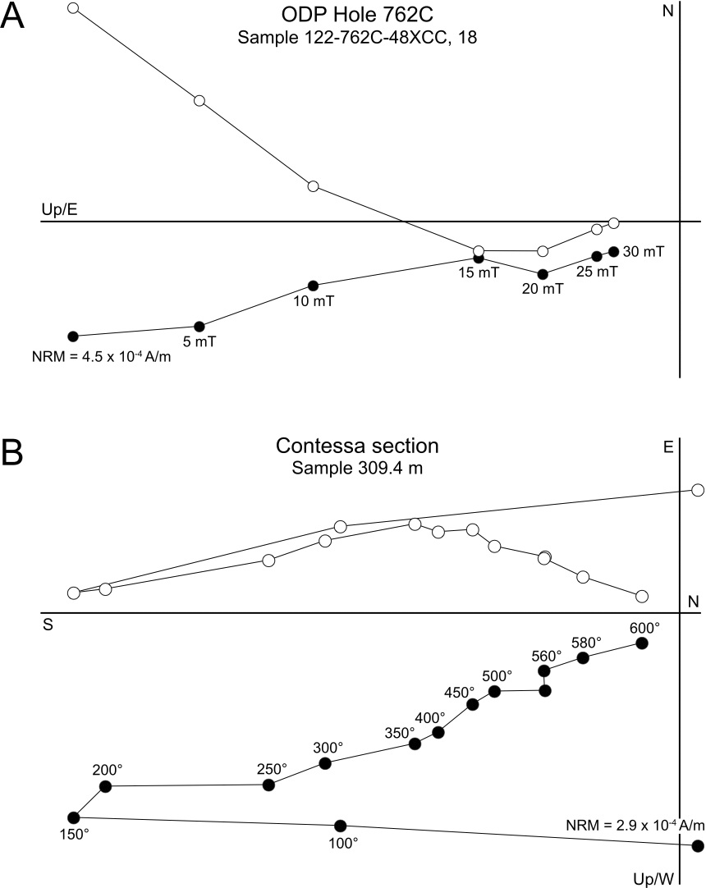
Figure A1. Vector demagnetization plots of one sample from ODP Hole 762C (A) and one sample from the Contessa Highway section (B). The Characteristic Remanent Magnetization (ChRM) of sample 122-762C-48X-CC,18 is clearly defined above 20-25 mT. The declination is arbitrary because control on core orientation is lacking, the inclination is negative and this sample is of normal polarity (Southern hemisphere). For the Contessa Highway sample, a first soft remanent magnetization is removed at 150°C, a secondary component is removed over the range 150–350°C, and the ChRM is defined above 400°C. (Black circles: projection in the vertical plane; open circles: projection in the horizontal plane).
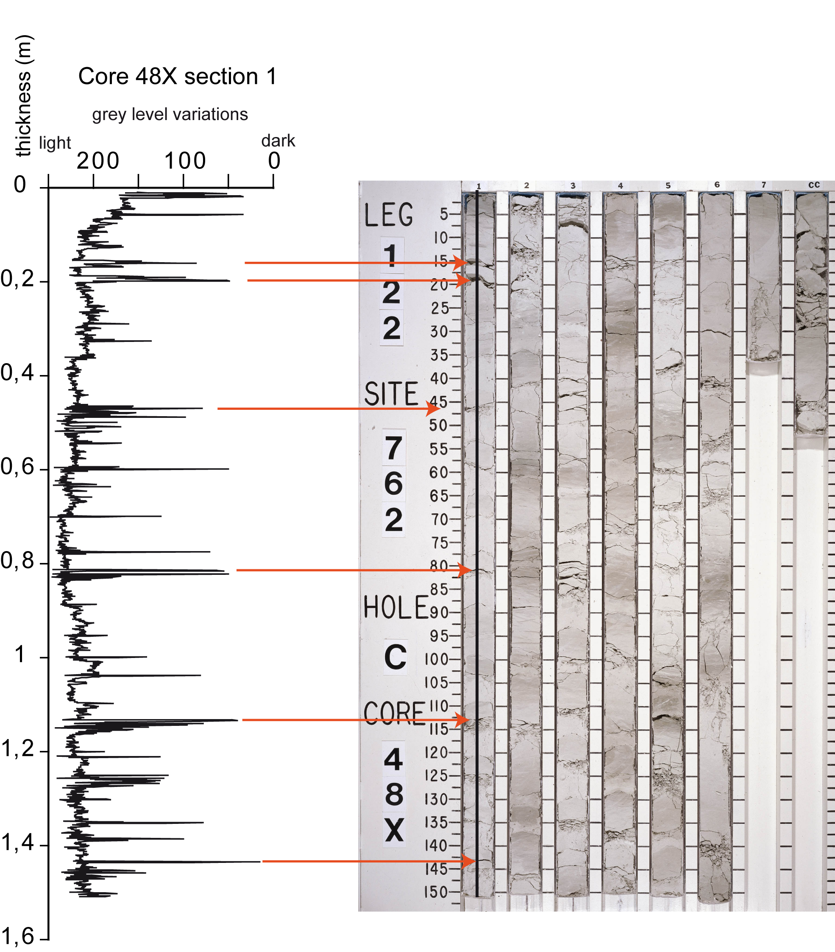
Figure A2. Photograph of Core 48X from ODP Hole 762C, showing decimetre-scale colour alternations of the sediments, corresponding to precession cycles (available at http://iodp.tamu.edu/janusweb/imaging/photo.cgi). The grey level variations obtained by scanning the first section of the core, and before the suppression of lighting effect, are shown on the left. The very low values correspond to cracks in the core, and are illustrated by red arrows.

